Source ID - 76980999
Source Title - Medical Science Monitor
Agreement URL - http://www.medscimonit.com/medscimonit/
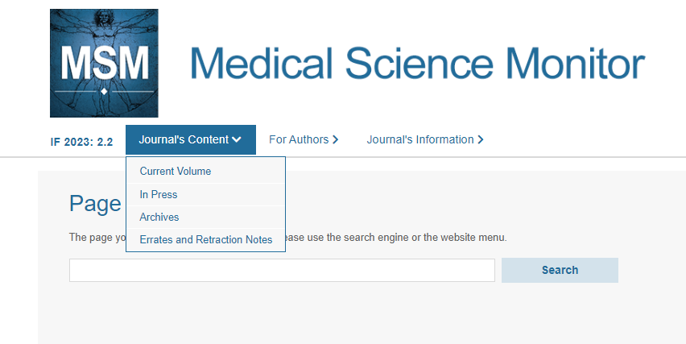
Volume
Click current volume from the journal content dropdown

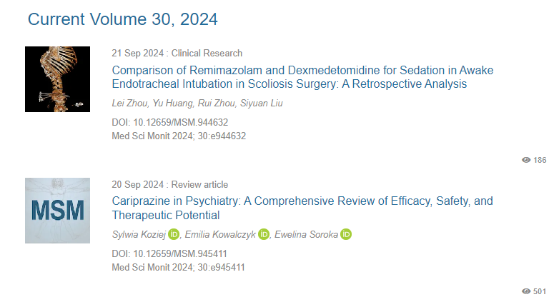
year
Click article title to capture meta data
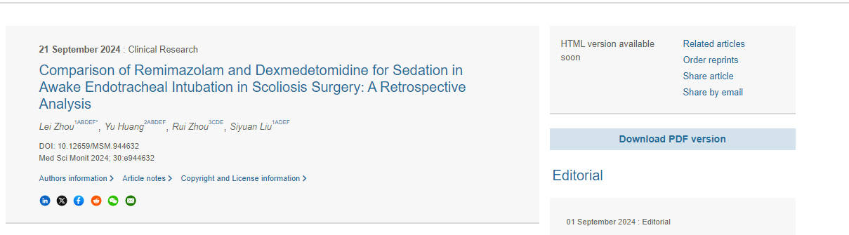
Click to download PDF
DOI number
Identifier
Article title

