Source ID - 77339199
Source title - Diqiu Kexue - Zhongguo Dizhi Daxue Xuebao/Earth Science - Journal of China University of Geosciences
Agreement URL - http://www.earth-science.net/index.htm
NOTE – Chinese TOC should be captured.
DO not select the English version of the website as it will browse to a different journal.

Click to search
Click the latest number from the dropdown

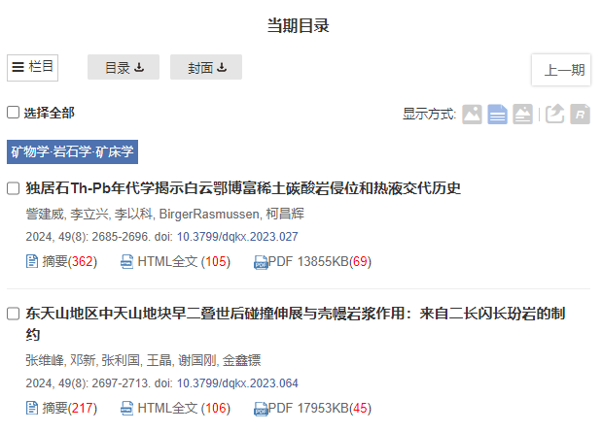
Click article title to capture meta data
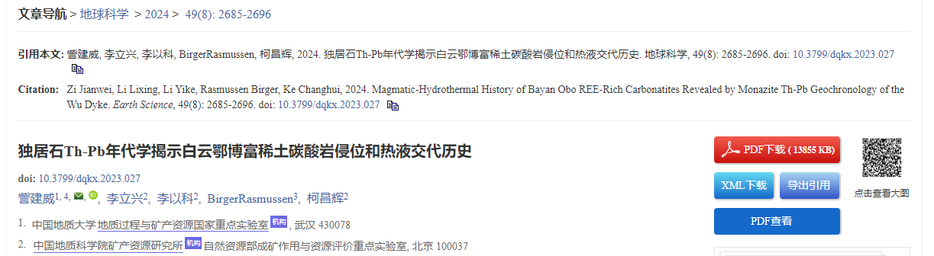
Click to download XML
Click to download PDF
DOI number
Volume issue
Page range

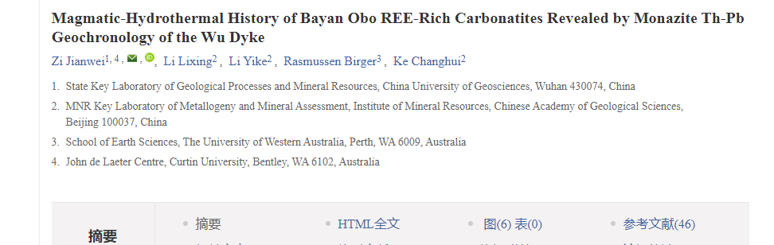
Article title

