Source ID - 77603399
Source Title - Yanshilixue Yu Gongcheng Xuebao/Chinese Journal of Rock Mechanics and Engineering
Agreement URL - http://rockmech.whrsm.ac.cn/CN/volumn/home.shtml
NOTE – English and Chinese TOC should be captured.
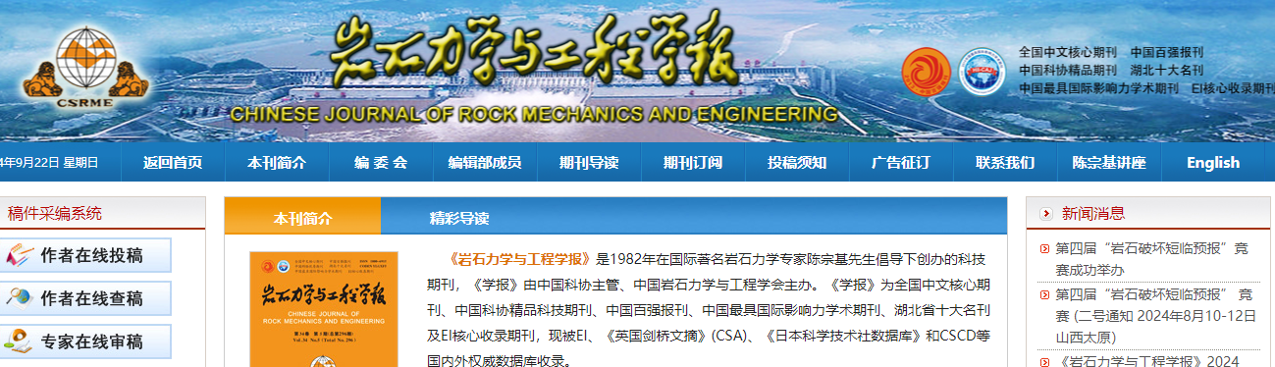
Click English to browse English translation

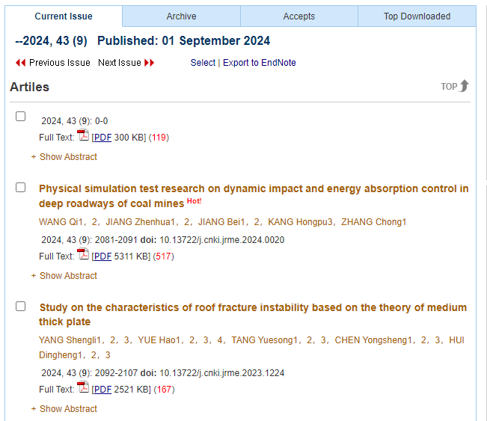
Volume issue and year
Click article title to capture meta data
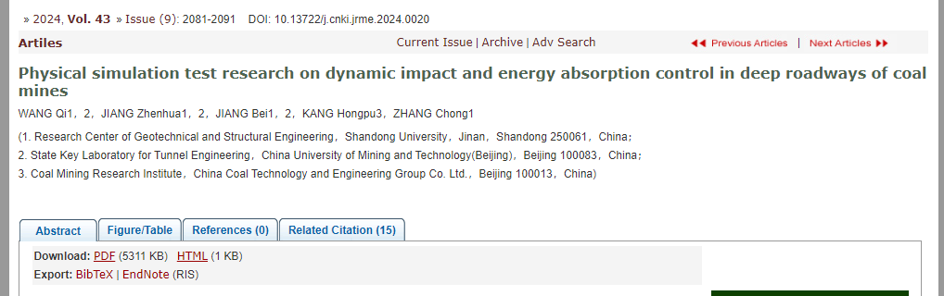
Click to download PDF
Page range
DOI number
Article title

