Source ID - 77875499
Source Title - Hedongli Gongcheng/Nuclear Power Engineering
Agreement URL - http://hdlgc.xml-journal.net/archive_list.htm
NOTE – English and Chinese TOC should be captured.
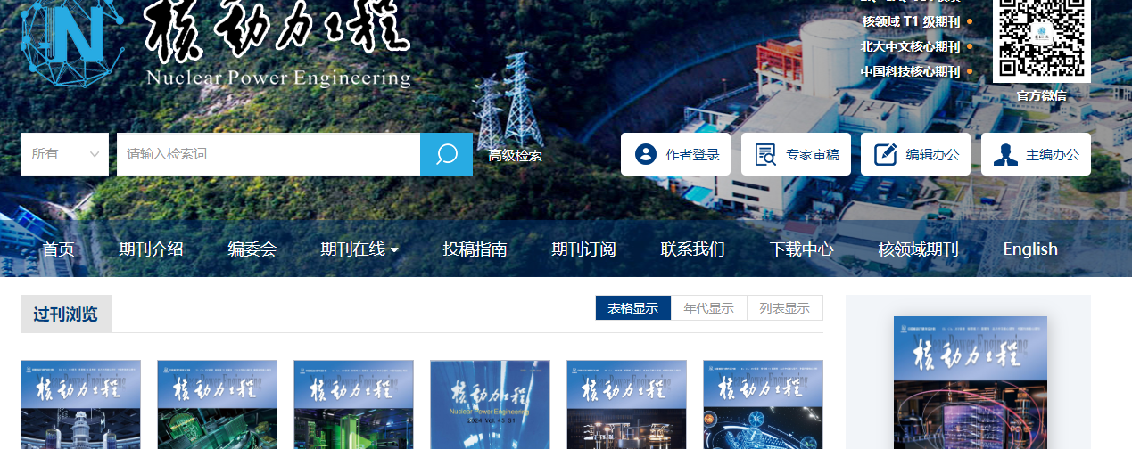
Click English to browse English translation of the website

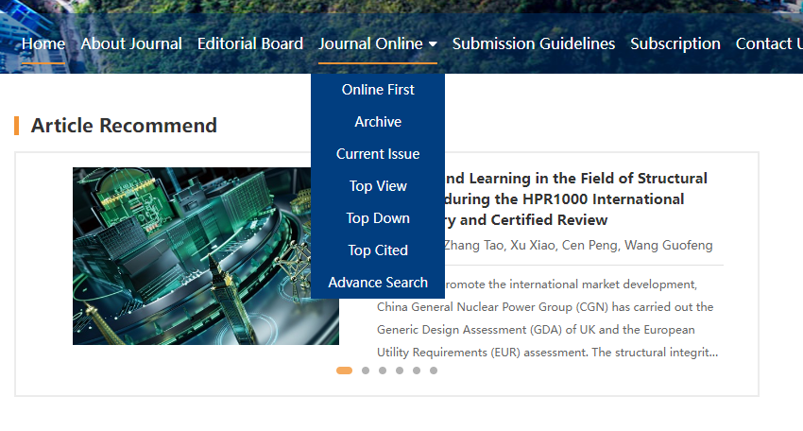
Click current issue to browse current issue

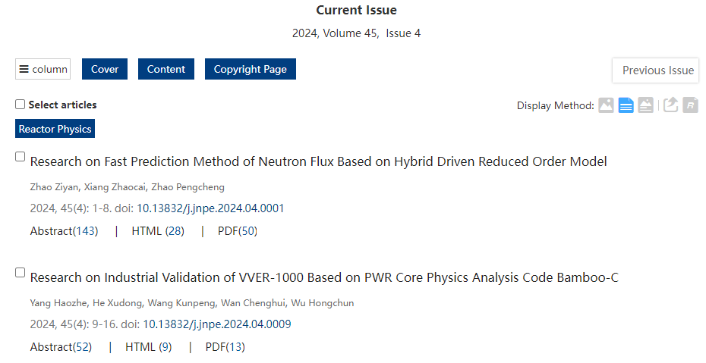
Volume issue and year

Page range
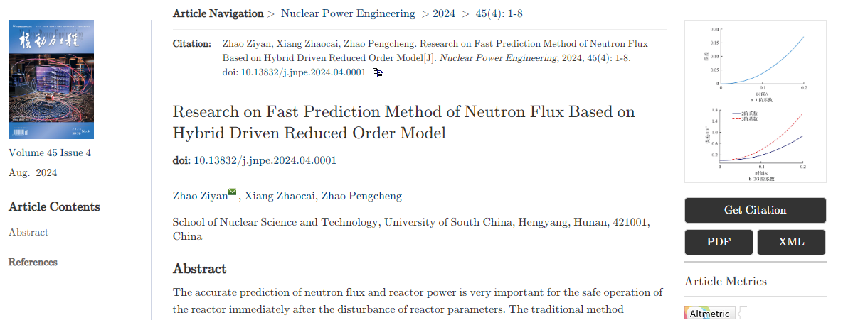
Click to download XML
Click to download PDF
Article title
Volume issue month and year
DOI number

