Source ID – 941587506
Source Title - PASOS Revista de Turismo y Patrimonio Cultural
URL - http://ojsull.webs.ull.es/index.php/Revista/about
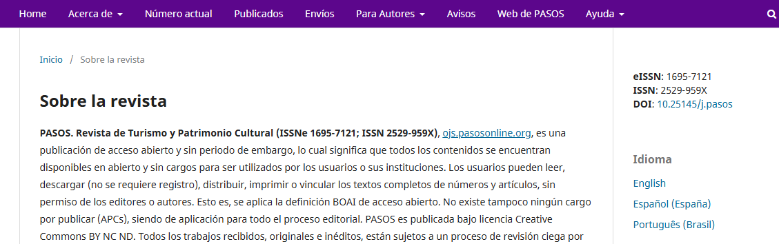
Select English

Select current issue.
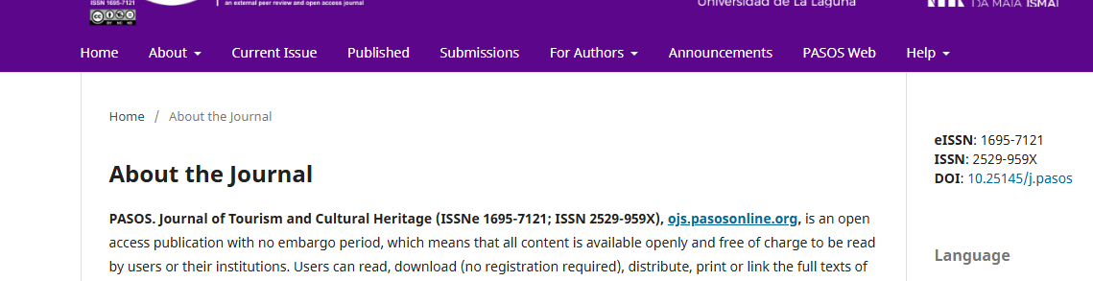

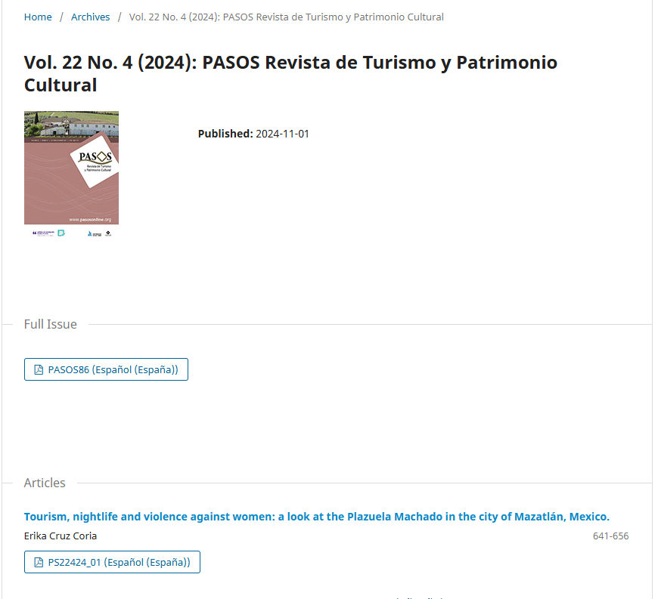
PDF
Volume
Issue
Year
Article title
Page range
Click the article title and proceed to the next page to get the DOI.
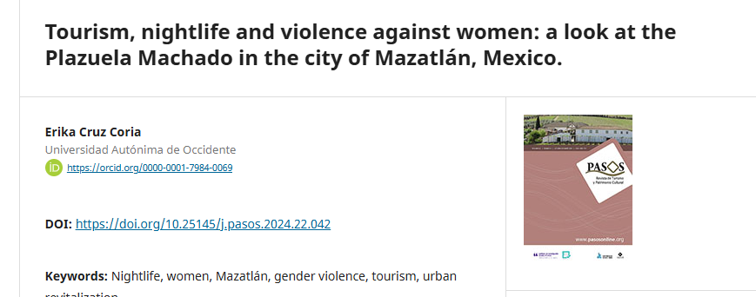
DOI

