638465131
Agreement url:
http://www.agrobiology.ru/allbr-eng.html
Publication year, volume, issue

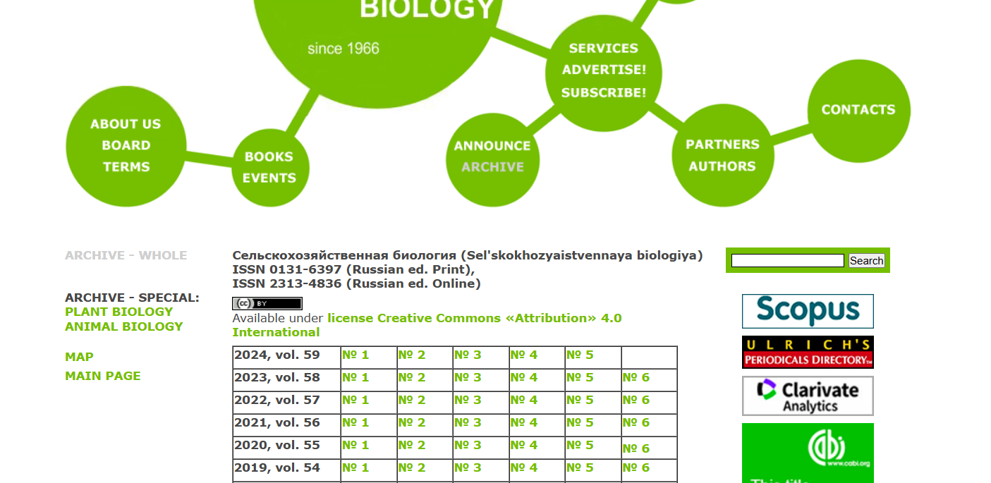
Current Issue

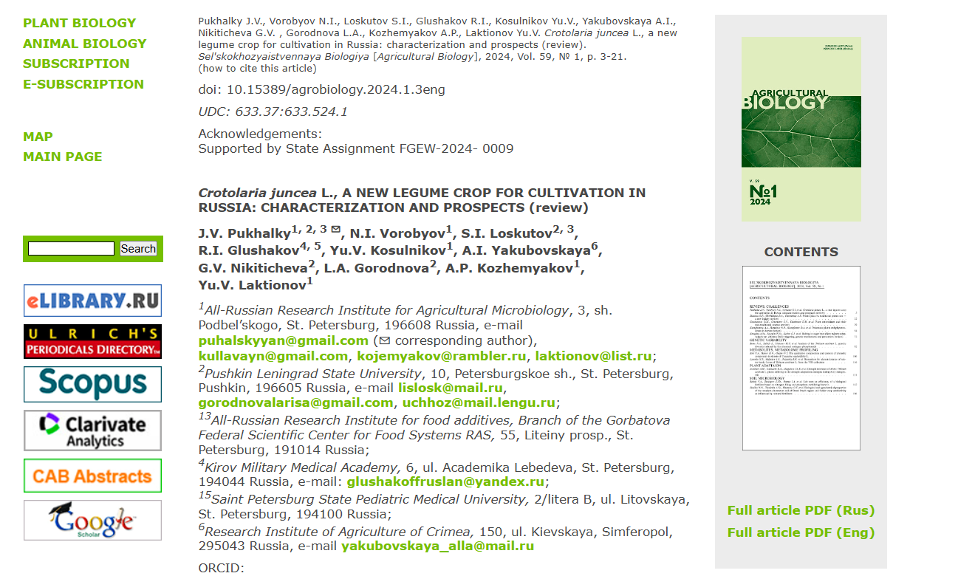
DOI
Page Range
Download the pdf
English title

