934000928

Agreement url:
caucasushistory.ru/2618-6772/index

Current Issue

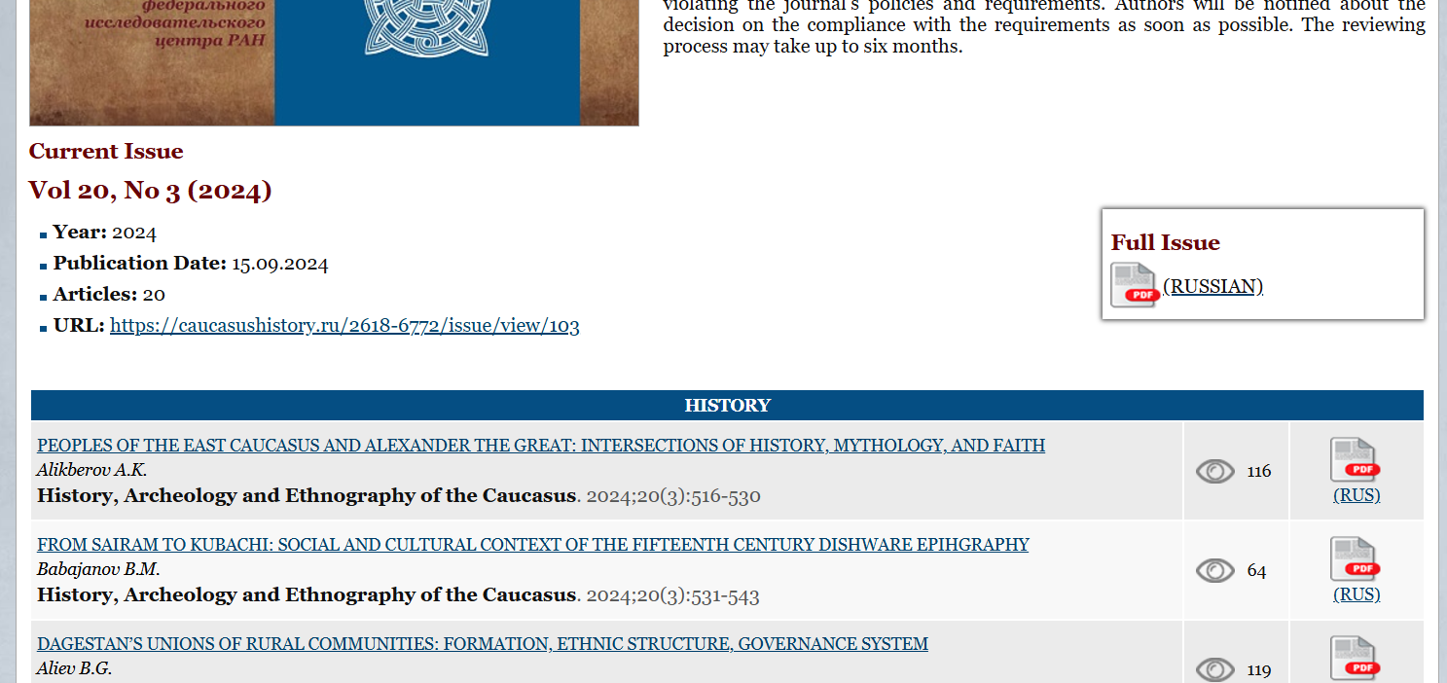
Publication year, volume, issue
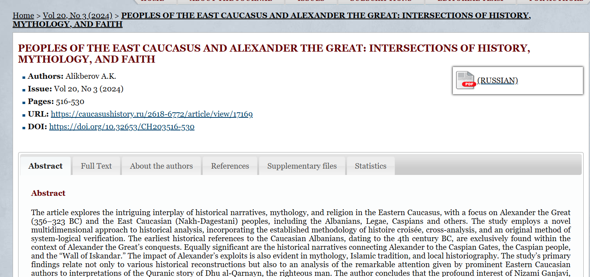
Download PDF
English Title
Page Range
DOI

- In here both English and Russian toc needs to be captured so choose language option from website language conversion . then go to the Table of content page right click and save as pdf and merge in to one.

