76407599

Agreement url:
http://www.ijpsonline.com/archive.html

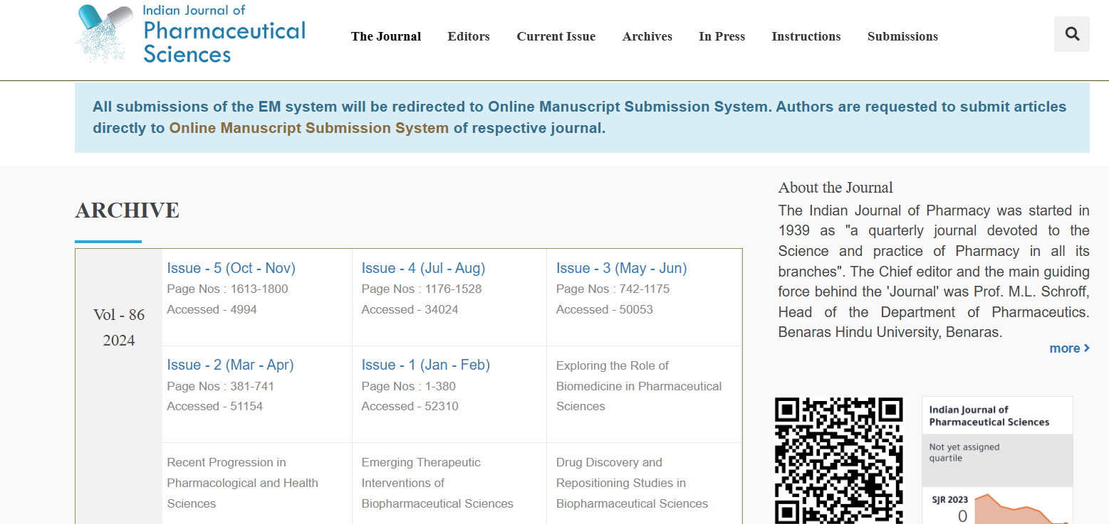
Publication year, Month, volume, issue
Current Issue

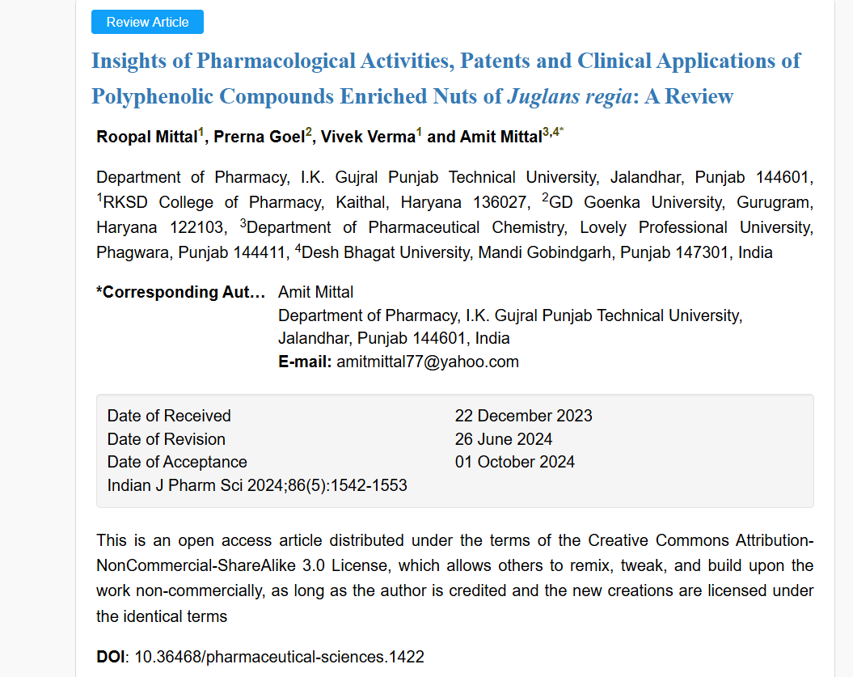
DOI
Page Range
English title
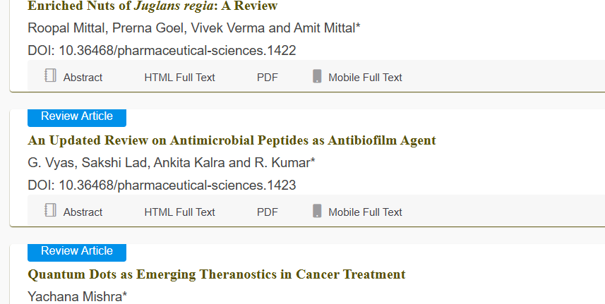
Download the pdf

