654587226

Base URL:
agreement URL : https://www.tj.kyushu-u.ac.jp/evergreen/

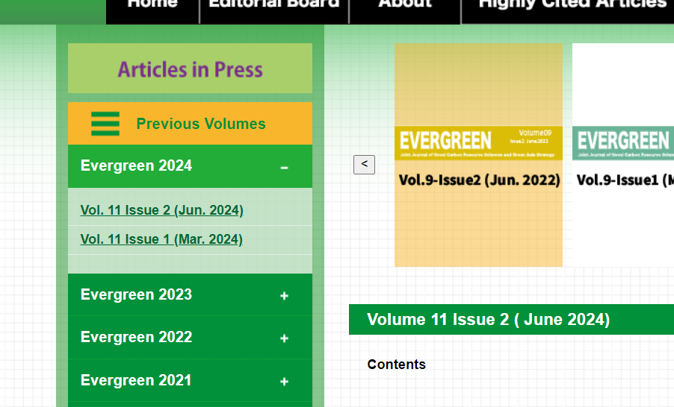

Select the current issue

- All required articles will be listed here.
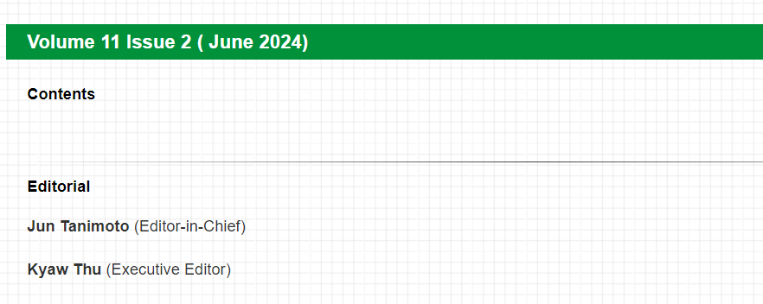
Year
Volume
Issue
Month

- Meta data can be captured as below.

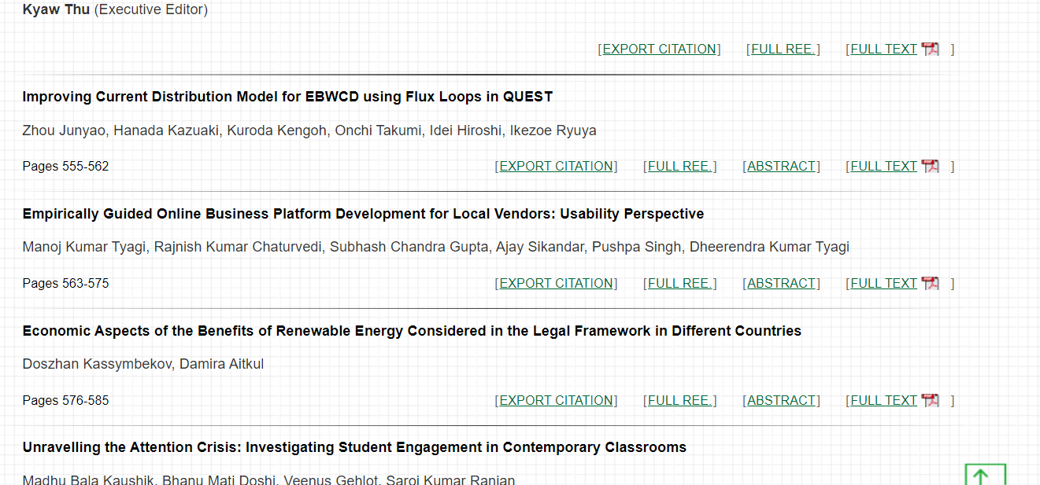
Article Name

Page range
Download pdf from here

