310167599 | https://bg.cherkasgu.press/en/archive.html
923277205 | https://ijmil.cherkasgu.press/en/archive.html
Note above url based website are having same structure
Capture issue
Click here to go to article list
Always current issue will be display in first
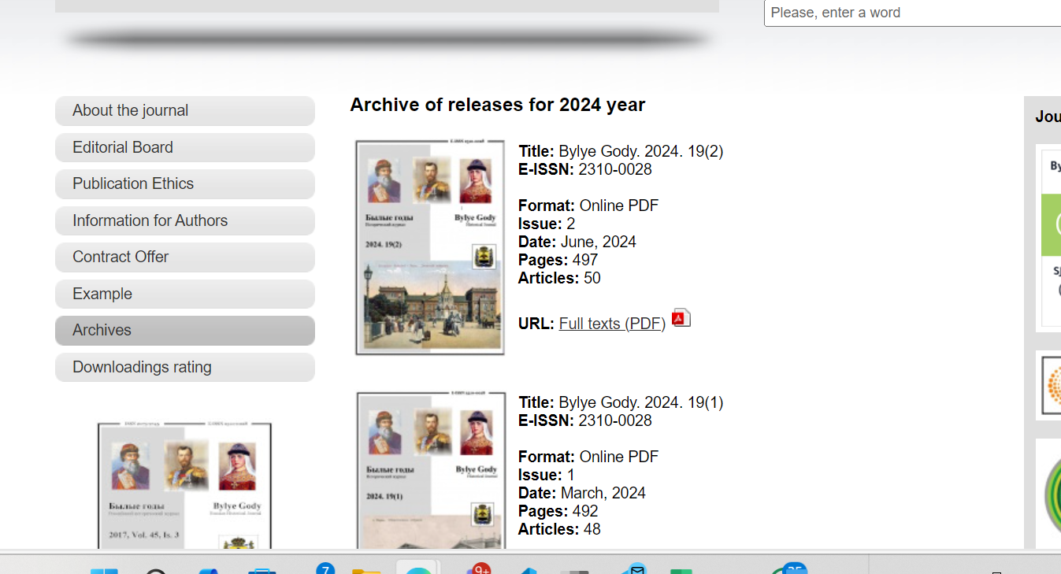
Capture volume
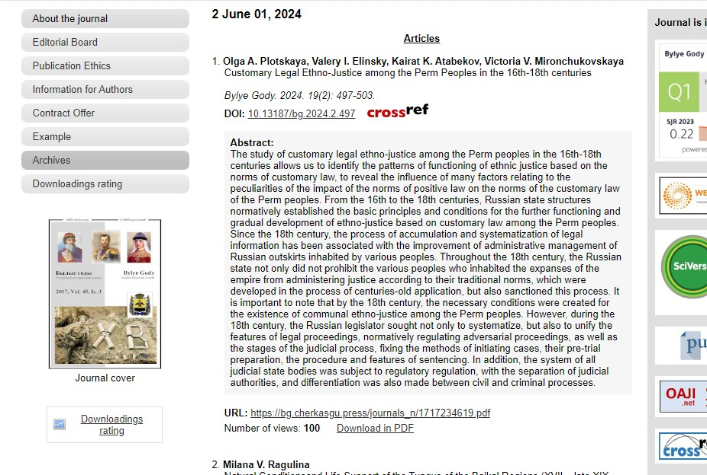
Download pdf from here
Month
Date
Year
Article Name
DOI Number
Page Range

