Compact Surveillance Radars

CK Series
24GHz Industrial Unlicensed Radars
- Smaller sites in urban and suburban environments
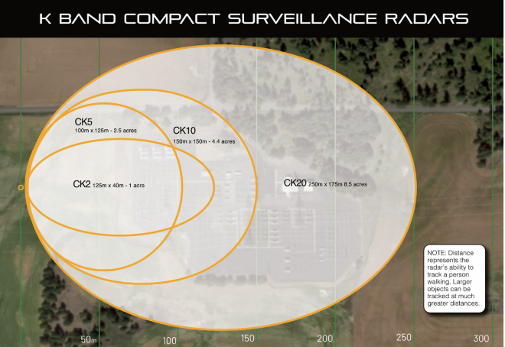
- Perfect for smaller sites such as substations in urban or suburban environments, our CK-Series radars run on the 24GHz band, which means no headaches or hassle with acquiring spectrum licenses. Combine that with the small form factor, low power draw, and quick install time, our CK-Series radars can cover your site in high heat, fog, rain, or snow.

