🔬 KITCHEN INQUIRY LAB
Progressive Experiment Curriculum · Grades 6–12
V1 — Measurement Literacy | Measurement-First Architecture

"Seeing the unsee-able through measurement."

The kitchen is a precision laboratory. Every appliance is a watt meter waiting to be read.
Every cup of water is a calorimeter. Every cooling mug is an exponential decay curve.

THE MEASUREMENT STACK

Five instruments. No specialized lab required. Every reading is a data point.

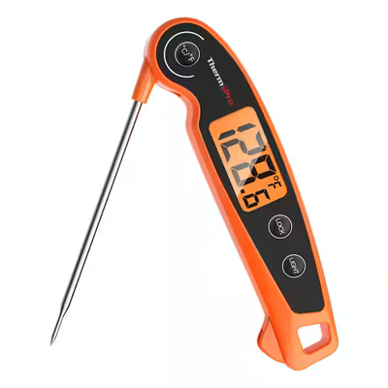  eThermometer  ThermoPro TP605W  0.1°C resolution  Probe + instant-read |  | 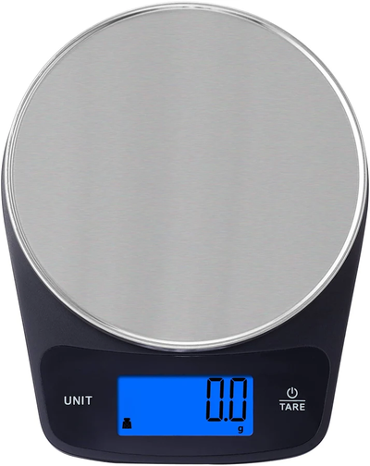  eScale  Digital Kitchen Scale  0.1 g resolution  Tare · Unit switch |  | 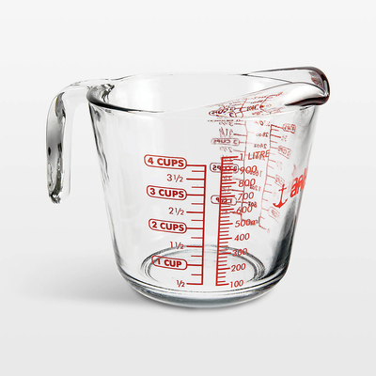  eMeasuring Cup  Anchor 4-Cup Glass  mL + Cup dual scale  Borosilicate glass

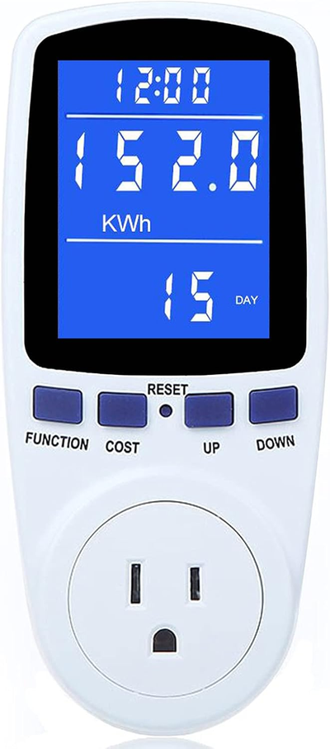  WattMinder  Plug-in Energy Monitor  Watts · kWh · Cost  Voltage · Current · PF |  | 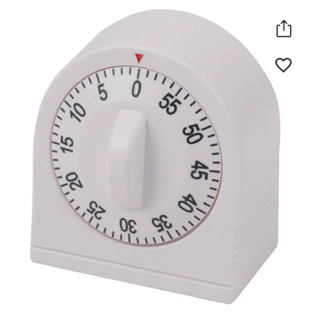  eTimer  60-min Mechanical Timer  Long ring · No battery  Analog minute hand

CURRICULUM PROGRESSION MAP

TIER 0 | Orientation — Measurement Discipline & Calibration

Learning Objective | Establish lab discipline: tare, calibration, data logging, unit literacy

Mastery | Every instrument validated before any experiment begins

Competency Check | Student produces a calibration log with known-weight and ice-bath data

Experiments | 0.1 · Scale Repeatability · 0.2 · Cup Calibration · 0.3 · Thermometer Validation

TIER 1 | Foundations — Density, Mixing & Temperature

Learning Objective | Mass-volume-density triangle; conservation of energy in thermal mixing

Mastery | Student predicts mixing temperature from mass and ΔT before measuring

Competency Check | Prediction within 2°C of measured Tmix with documented calculation

Experiments | 1.1 · Water Density Baseline · 1.2 · Solution Density · 1.3 · Thermal Mixing

TIER 2 | Models — Cooling Curves & Parameter Estimation

Learning Objective | Capture T(t), fit exponential decay, extract time constant τ

Mastery | Semi-log linearization; compare τ across containers/volumes/lids

Competency Check | Student extracts τ within 10% across two repeated trials

Experiments | 2.1 · Newton's Cooling (bare mug) · 2.2 · Variable Comparison · 2.3 · Colorimetry

TIER 3 | Applied — Energy Economics & Appliance Benchmarking

Learning Objective | Watts vs kWh vs cost; thermal efficiency = electrical in / (m·c·ΔT)

Mastery | Student calculates cost-per-cup-of-tea for three appliances from WattMinder data

Competency Check | Efficiency ratio >0 and <1; phantom load measured and quantified

Experiments | 3.1 · Kettle vs Microwave vs Hot Plate · 3.2 · Phantom Loads · 3.3 · Thermal Efficiency

TIER 4 | Integration Capstone — Full Instrument Investigation

Learning Objective | Mass + temperature + time + energy measured simultaneously in one run

Mastery | Multi-variable data table; cross-instrument consistency check

Competency Check | Complete state snapshot produced; results independently reproducible

Experiments | 4.1 · True Cost of Boiling 500 mL · 4.2 · Open Design Investigation

EXPERIMENT CARDS — TIER 0: ORIENTATION

TIER 0  0.1 | Scale Repeatability & Tare Discipline
🎯 Purpose | Establish that the eScale produces consistent, zero-referenced readings before any experiment depends on mass data.
🔧 Equipment | eScale · Glass bowl or mug · Known-weight object (e.g., coin: US quarter = 5.670 g) · Water
📐 Model | A well-calibrated scale reads the same object mass independently of history. Tare drift introduces systematic error in all downstream mass-difference measurements.
📋 Protocol | 1) Power on scale; confirm '0.0 g' display. 2) Place bowl; tare to zero. 3) Add ~100 mL water; record mass M1. 4) Remove bowl; confirm return to 0.0 g. 5) Re-tare; re-add same water; record M2. 6) Repeat 5×. 7) Weigh known object without taring; record 5 readings.
📊 Data & Analysis | Calculate: mean, std dev, CV% for M_water series. Plot: reading vs trial number (should be flat). Accept if CV < 0.5%. Compare M_known to published value — this is your accuracy check.
⚠️ Uncertainty | Resolution limit (0.1 g) sets floor on uncertainty. Vibration and breath on pan cause noise. Record room conditions. Repeatability ≠ accuracy — both matter.
🚀 Extensions | Weigh the same object on a second scale and compare. Determine the minimum detectable mass change. Investigate how temperature of the pan affects readings.

TIER 0  0.2 | Measuring Cup Calibration
🎯 Purpose | Verify printed graduation marks on the eMeasuring Cup using mass-of-water as the ground truth. Treat the printed scale as a hypothesis.
🔧 Equipment | eMeasuring Cup · eScale · Water · Eye-level reading discipline
📐 Model | For water at ~20°C: 1 mL ≡ 1 g (density ≈ 0.998 g/mL). Therefore mass of water is the reference; cup graduation is the thing being tested.
📋 Protocol | 1) Tare cup on scale. 2) Add water until meniscus aligns with 100 mL line (read at eye level). 3) Record mass. 4) Repeat for 200, 300, 400, 500, 700, 900 mL. 5) Record actual volume = mass in grams. 6) Calculate error at each graduation.
📊 Data & Analysis | Plot: measured mass vs target volume. Expected slope ≈ 1.00 g/mL. Fit linear regression; slope deviation from 1.00 quantifies systematic bias. Note parallax error at each level.
⚠️ Uncertainty | Parallax is the dominant error — must read at eye level. Meniscus bottom is the reading point. Temperature shifts density ~0.1% per °C — negligible here but worth noting.
🚀 Extensions | Test at different water temperatures. Test a second cup and compare. Calculate what a 5% volumetric error means in a recipe's salt concentration.

TIER 0  0.3 | Thermometer Validation (Ice Bath + Boiling Reference)
🎯 Purpose | Validate the eThermometer at two fixed points — ice bath (≈0°C) and boiling (≈100°C at sea level, adjusted for altitude).
🔧 Equipment | eThermometer · eMeasuring Cup or bowl · Ice (crushed or cubed) · Cold water · Kettle or stove · Boiling water
📐 Model | Phase-change points are thermodynamic constants. Ice-water equilibrium = 0.0°C; boiling water at sea level = 100.0°C (−0.34°C per 100 m altitude). Deviation from these values is instrument error, not measurement error.
📋 Protocol | ICE: 1) Fill cup ~2/3 with crushed ice; add water to cover. 2) Stir 30 s. 3) Insert probe; wait for stable reading (~60 s). 4) Record T_ice every 30 s for 3 min. BOIL: 5) Bring 300 mL water to full rolling boil. 6) Insert probe tip mid-depth. 7) Record T_boil when stable.
📊 Data & Analysis | Calculate offset = T_reading − T_expected at each point. If linear, apply correction: T_true = T_reading − offset. Stabilization time (seconds to within 0.2°C of final) is also key data.
⚠️ Uncertainty | Altitude correction required if >500 m elevation. Probe placement affects reading — tip must be fully submerged in liquid, not touching container. Allow full stabilization before recording.
🚀 Extensions | Compare stabilization time for ice vs boiling. Measure room-temperature water and compare to a second thermometer. Deliberately touch the probe to the container wall and observe the artifact.

CORE MEASUREMENT PRINCIPLES

Controlled Vocabulary  Energy ≠ Power  Repeatability ≠ Accuracy  Calibration ≠ Zeroing  Measurement ≠ Device  Model ≠ Result |  | Mass-First Philosophy  Prefer mass over volume for repeatability  1 g ≈ 1 mL ≈ 1 cm³ for water  Volume markings are hypotheses — test them  Log metadata to make results reproducible  Every printed label is a claim to be verified

STATE SNAPSHOT TEMPLATE
Lab Version: ___ | Date: ___ | Instruments confirmed: ☐ Scale ☐ Thermometer ☐ Cup ☐ WattMinder ☐ Timer
Calibration Status: ___ | Ambient Temp (°C): ___ | Altitude (m): ___
Current Experiment: ___ | Last Dataset (label): ___
Key Results: ___ | Known Issues / Quirks: ___
Next Step: ___ (include setup notes — this snapshot must allow a full cold restart)

