CO21BTECH11002

Aayush Kumar

Assignment 3

Algorithm: 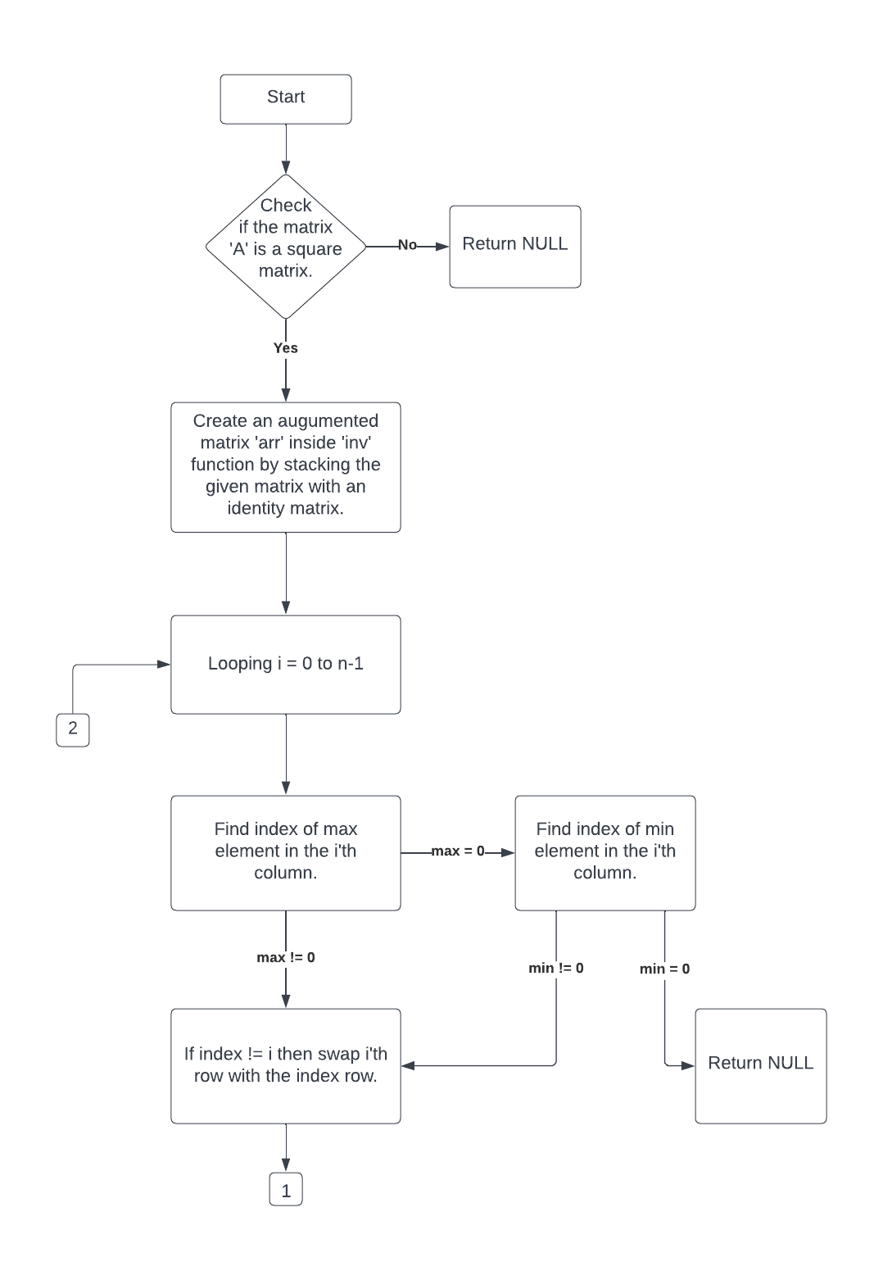

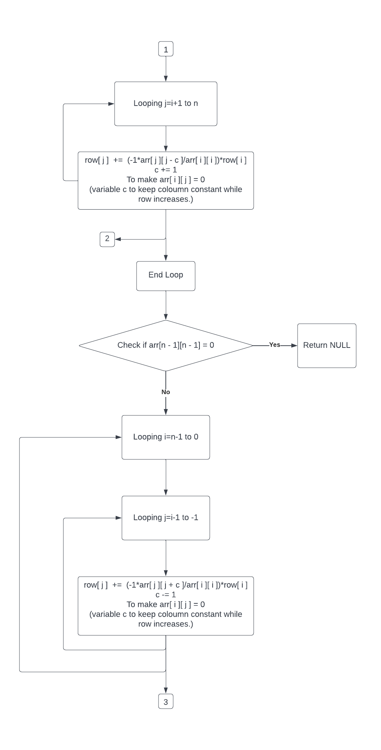

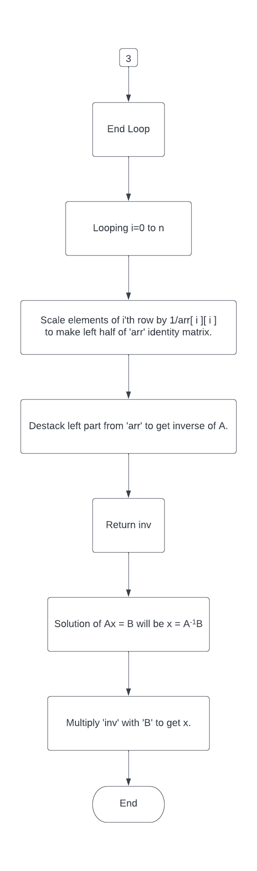

Input for 10 X 10:

A = 1 7 0 7 5 7 1 3 6 1

5 4 5 7 5 4 6 0 7 1

8 8 6 6 8 8 8 4 1 1

5 0 0 3 5 3 1 7 4 7

6 0 0 2 5 4 5 2 2 3

2 1 1 8 8 0 5 5 4 4

6 0 5 6 2 8 7 3 4 2

0 0 0 0 2 6 2 5 6 5

7 6 6 8 5 3 6 2 8 1

6 6 8 0 1 1 7 0 3 2

B = 0

1

2

1

8

3

5

2

6

0

Output for 10 X 10:

X = 1.24512

0.0392327

-2.38265

-0.396955

-1.05309

-0.680287

2.04946

1.75366

1.02329

-2.16381

Time Taken:

|  |  |
| --- | --- |
| Dimensions | Time |
| 10 | 0.003 s |
| 50 | 0.004 s |
| 100 | 0.012 s |
| 500 | 1.431 s |
| 1000 | 12.505 s |
| 5000 | 24 m 12.524 s |