CO21BTECH11002

Aayush Kumar

Assignment 4

Algorithm:

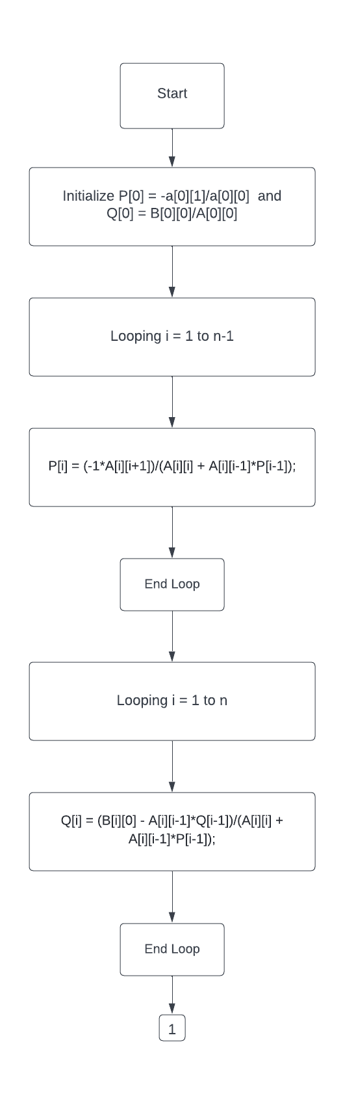

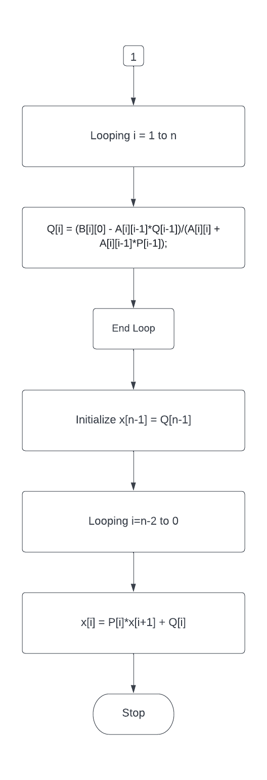

Input:

Number of divisions: 100

Initial Temperature: 500

Final Temperature: 30

Output (Temperature variation across the rod):

500 495.347 490.693 486.04 481.386 476.733 472.079 467.426 462.772 458.119 453.465 448.812 444.158 439.505 434.851 430.198 425.545 420.891 416.238 411.584 406.931 402.277 397.624 392.97 388.317 383.663 379.01 374.356 369.703 365.05 360.396 355.743 351.089 346.436 341.782 337.129 332.475 327.822 323.168 318.515 313.861 309.208 304.554 299.901 295.248 290.594 285.941 281.287 276.634 271.98 267.327 262.673 258.02 253.366 248.713 244.059 239.406 234.752 230.099 225.446 220.792 216.139 211.485 206.832 202.178 197.525 192.871 188.218 183.564 178.911 174.257 169.604 164.95 160.297 155.644 150.99 146.337 141.683 137.03 132.376 127.723 123.069 118.416 113.762 109.109 104.455 99.802 95.1485 90.495 85.8416 81.1881 76.5347 71.8812 67.2277 62.5743 57.9208 53.2673 48.6139 43.9604 39.3069 34.6535 30

Time Complexity: O(n)

Time taken:

|  |  |
| --- | --- |
| Dimension | Time taken |
| 100 | 0.002s |
| 500 | 0.003s |
| 1000 | 0.007s |
| 5000 | 0.092s |
| 10000 | 0.516s |