CO21BTECH11002

Aayush Kumar

2D-Diffusion Problem

Objective:

To find temperature variation in a 2D sheet;

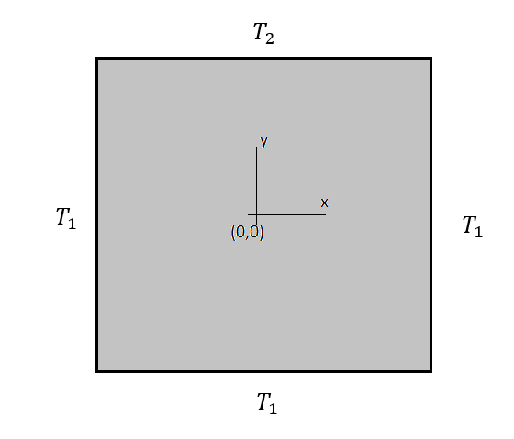

Methods used:

1. LU Decomposition
2. Gauss Seidel
3. Conjugate Gradient

Input:

Number of divisions in sheet: 100

Length of each division: 1

Value of constant (c) in $γ$: 40

$T_{1}: 50$

$T_{2}: 500$

$(γ ≡x^{2}+ y^{2}+c)$

Output:

Temperature variation across the sheet:

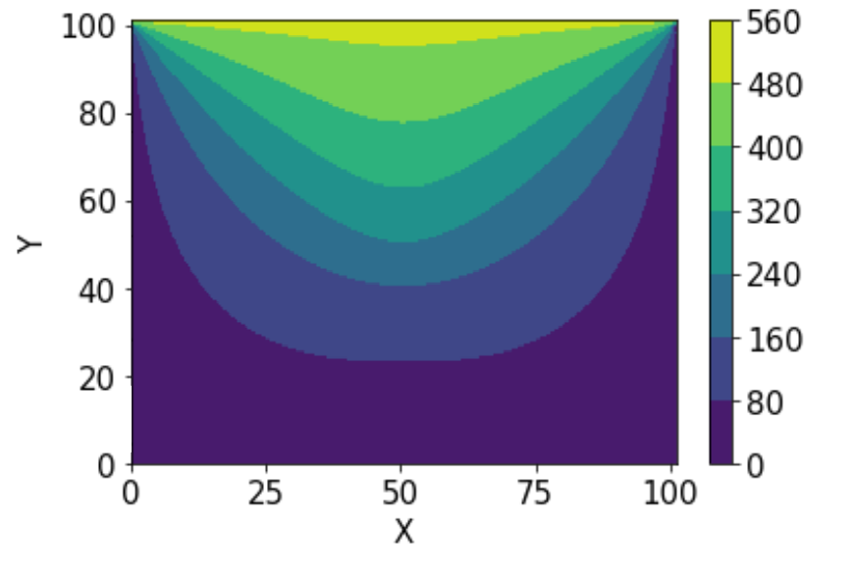

Error variation in Gauss Seidel Method:

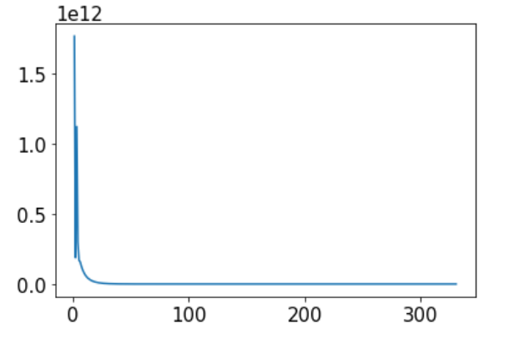

Number of iterations in Gauss Seidel: 331

Error Variation in Conjugate Gradient Method:

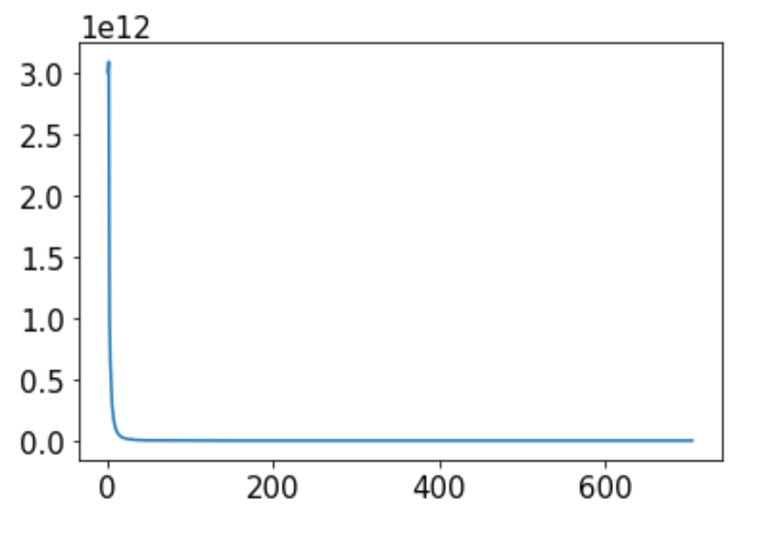

Number of iterations in Conjugate Gradient Method: 705

Time Taken:

LU Decomposition: 47m 23.549s

Gauss Seidel: 4m 32.596s

Conjugate Gradient: 4m 14.312s