CO21BTECH11002
Aayush Kumar
CH4020 Project

Q1.

We start by solving the given differential equations to get the following equations:

We define the function ‘f’ as the squared difference between actual C values and C values calculated at the current value of K.

Now we minimize the value of ‘f’ and the the final value of K.

As for the initial guess of K, we can take it to be anything such that .

The function that we have taken is a least squares function which is a convex function. Hence, it will always converge to the global minima regardless of the initial guess value of K.

I have used two techniques for minimizing the value of f, ‘optimize.fmin’ and ‘optimize.least_squares’. Both the methods give almost the same result. The value of f after using ‘optimize.fmin’ is closer to zero as compared to using ‘optimize.least_squares’.

Q2.

Plot of , blue circle in 2nd figure is the constraint:

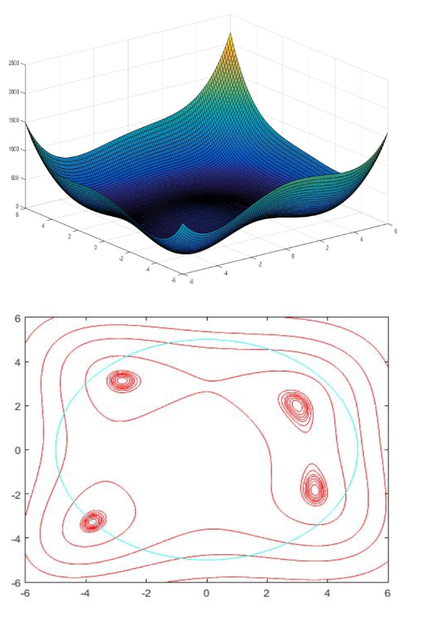

We can that only one minima (lower left) satisfies the constraint.

On taking certain guess values of K, we end up converging to some minima violating the constraint and the optimizer is not able to get out of the minima. Hence we need to take a guess value that makes sure that the optimizer converges to the desired minima. Hence, we need to take K such that both of its components are negative (preferably less than or equal to -1).

On the other hand, while using Genetic Algorithm, we do not need to make any guess for K and the optimizer makes sure that the constraint is satisfied when the function converges.

