# Game Design Document

**Teleportation**

Members: Yong Jie, Asnawi

1. **Game Overview**
   1. Game Concept  
       A 2D Hack-n-Slash Action game that revolves around normal high paced movement combined with a teleport mechanic to let you warp yourself straight into the enemy, damaging them
   2. Genre  
      2D, Action, Platformer
   3. Target Audience  
      Teenagers and Above
   4. Game Flow Summary – How does the player move through the game. Both through framing interface and the game itself.  
      The player moves through the game by warping into up enemies
   5. Look and Feel – What is the basic look and feel of the game? What is the visual style?  
      The visual style will pay homage to retro games, pixelated and parallax scrolling
2. **Gameplay and Mechanics**
   1. Gameplay
      1. Game Progression

Progress through the game by eliminating enemies in the different levels

* + 1. Mission/challenge Structure

The structure will be based on differing enemies, whether it’ll be the number of enemies or the types of enemies you face in the levels

* + 1. Objectives

Kill everything

* + 1. Play Flow

Run and teleport around, dodging enemy attacks and killing them off

* 1. Mechanics – What are the rules to the game, both implicit and explicit. This is the model of the universe that the game works under. Think of it as a simulation of a world, how do all the pieces interact? This actually can be a very large section.
     1. Movement in the game

You can run and jump normally alongside the teleportation mechanic

* 1. Combat – If there is combat or even conflict, how is this specifically modeled?

You dodge enemy fire in order to get close enough to teleport into them, dealing damage to everything around you

1. **Levels**
   1. Levels. Each level should include a synopsis, the required introductory material (and how it is provided), the objectives, and the details of what happens in the level. Depending on the game, this may include the physical description of the map, the critical path that the player needs to take, and what encounters are important or incidental.
   2. Training Level
2. **Interface**
   1. Visual System. If you have a HUD, what is on it? What menus are you displaying? What is the camera model?

Health, teleportation meter and Score

* 1. Control System – How does the game player control the game? What are the specific commands?

WASD will be regular movement, which include walking and jumping, and Left Click will be the teleport, instantly moving from current location to the cursor position

* 1. Audio, music, sound effects

1. **Artificial Intelligence**
   1. Opponent and Enemy AI – The active opponent that plays against the game player and therefore requires strategic decision making

No

* 1. Non-combat and Friendly Characters
  2. Support AI -- Player and Collision Detection, Pathfinding

Collision Detection will used mainly in collision between Player and enemies

1. **Game Art** – Key assets, how they are being developed. Intended style

License-free assets from the Unity Asset Store, Intended to be pixelated and retro like older games

Tutorial Level 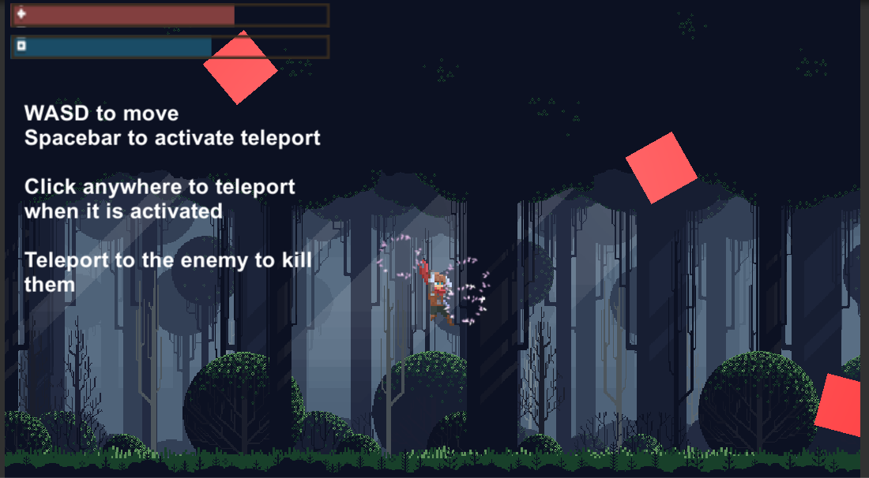

Level 1 (go from left to right)

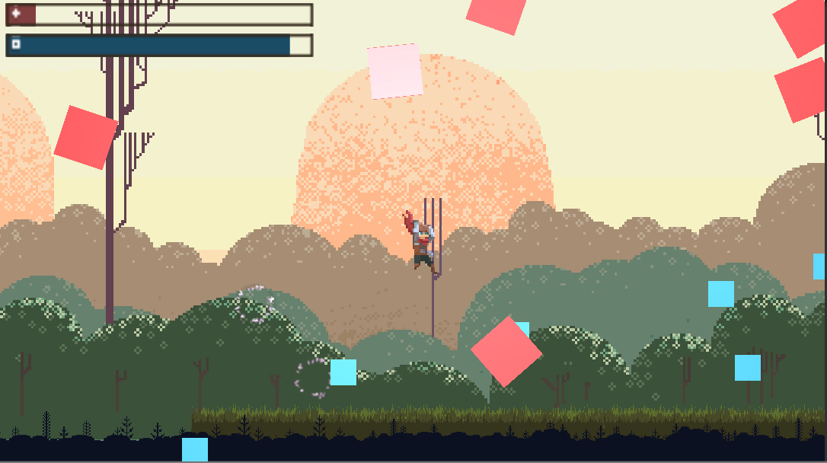

Level 2 (From right to left)