# Version Control Document

Members: Yong Jie and Asnawi

<https://github.com/Randomdudu/GIT-Mini-Project.git>

Master Branch

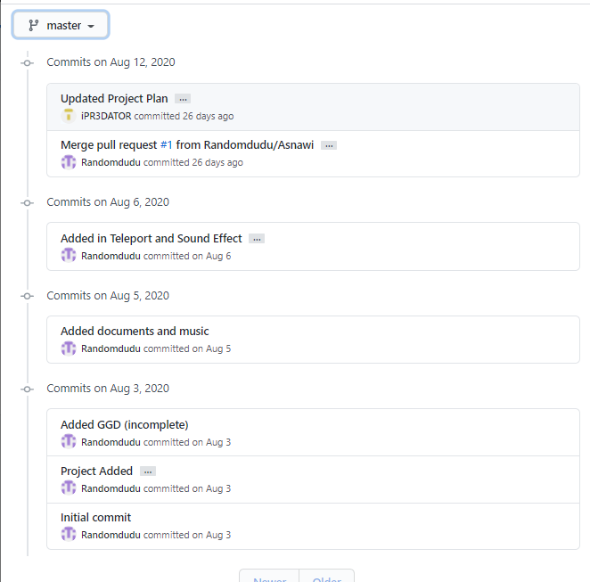

Summary: Initial Commit and Project was made, relevant documents and audio files added, then was merged to update the Project Plan

Prototype-1

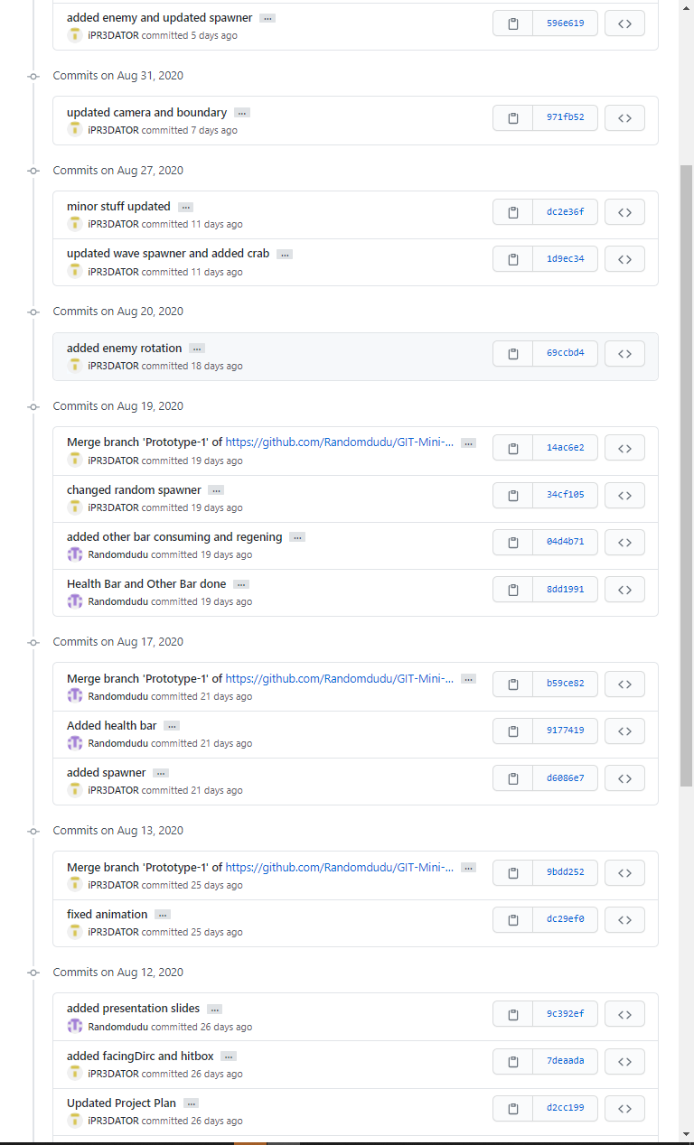

Summary: added animations, hitboxes, slides were added. UI elements (eg health and mana bars) were merged from branch UI&Sound, camera was modified to use lerp, and added spawner

Prototype-UI&Sound

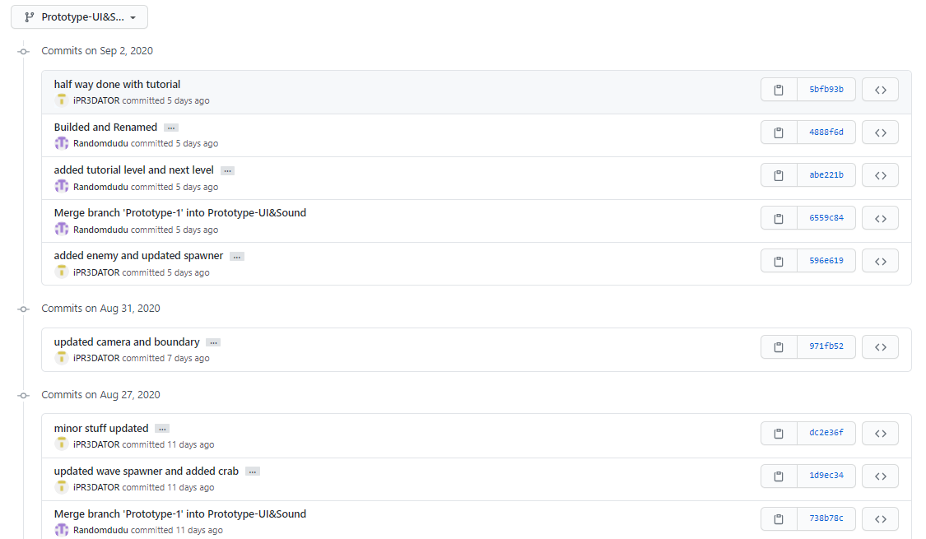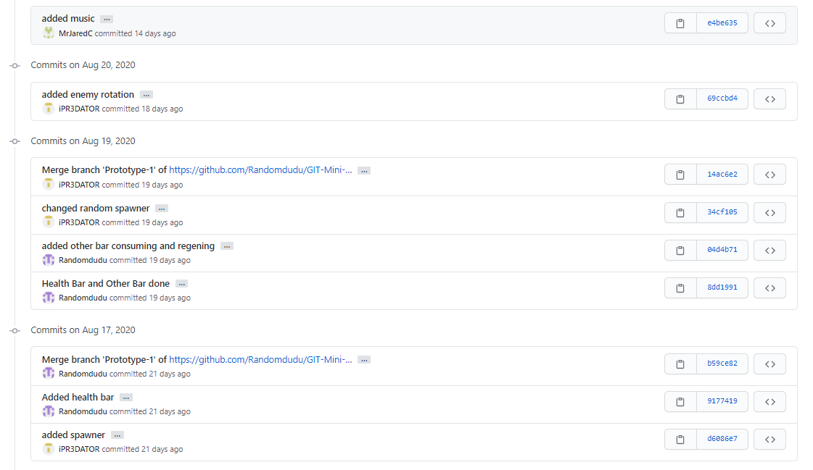

Summary: Health and Mana bars were added, and the Mana regen was implemented. Music was added and spawner was updated to use the crab sprite (later removed). Tutorial and Level 1 were made and were built to let the scene changer change the level

Prototype-2  
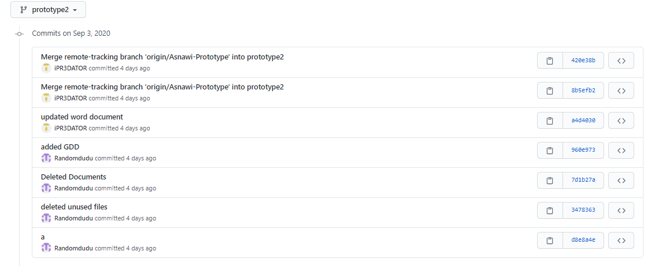

Summary: Took Prototype-1, cleaned up the unused assets and unused files

Asnawi-Prototype

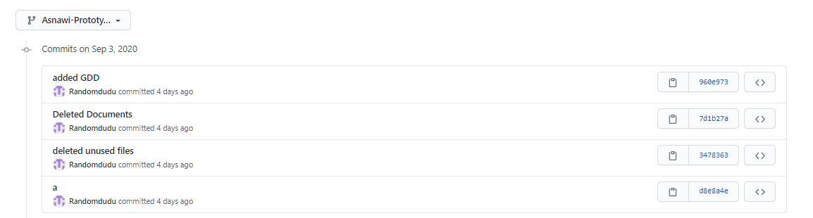

Summary: a filler branch made for much smaller changes eg adding files from earlier versions