**Week-3**

Name – Randrita Sarkar [11500219058]

IT PCC-CS593 L - OBJECT ORIENTED PROGRAMMING LAB

1.Suppose you have a Piggie Bank with an initial amount of $50 and you have to add some more amount to it. Create a class 'AddAmount' with a data member named 'amount' with an initial value of $50. Now make two constructors of this class as follows:  
1 - without any parameter - no amount will be added to the Piggie Bank  
2 - having a parameter which is the amount that will be added to Piggie Bank  
Create object of the 'AddAmount' class and display the final amount in Piggie Bank.

package com.randrita.week3;  
import java.util.Scanner;  
  
/*1.Suppose you have a Peggie Bank with an initial amount of $50 and you have to add some more amount to it. Create a class 'Peggie' with a data member named 'amount' with an initial value of $50. Now make two constructors of this class as follows:  
1 - without any parameter - no amount will be added to the Peggie Bank  
2 - having a parameter which is the amount that will be added to Peggie Bank  
*/  
  
  
public class Peggie {  
 public static void main(String[] args) {  
  
 Scanner input= new Scanner(System.*in*);  
 System.*out*.print("Enter the value you want to add to the peggie bag : ");  
 int n = input.nextInt();  
 AddAmount obj1 = new AddAmount();  
 AddAmount obj2 = new AddAmount(n);  
  
 obj1.display();  
 obj2.display();  
 }  
  
}  
  
class AddAmount{  
  
 int amount=50;  
  
 AddAmount(){  
  
 }  
  
 AddAmount(int a){  
 amount=a+amount;  
 }  
  
 void display(){  
 System.*out*.println("Total amount in peggie bag : " + amount);  
 }  
  
}

output:

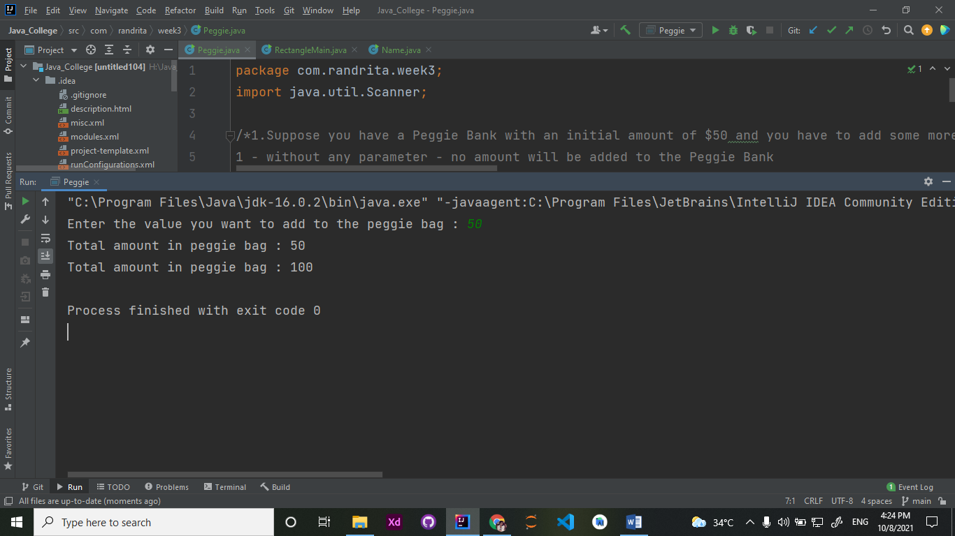

2.Create a class named 'Rectangle' with two data members- length and breadth and a method to claculate the area which is 'length*breadth'. The class has three constructors which are :  
1 - having no parameter - values of both length and breadth are assigned zero.  
2 - having two numbers as parameters - the two numbers are assigned as length and breadth respectively.  
3 - having one number as parameter - both length and breadth are assigned that number.  
Now, create objects of the 'Rectangle' class having none, one and two parameters and print their areas.

package com.randrita.week3;  
import java.util.Scanner;  
  
/*2.Create a class named 'Rectangle' with two data members- length and breadth and a method to calculate the area which is 'length*breadth'. The class has three constructors which are :  
1 - having no parameter - values of both length and breadth are assigned zero.  
2 - having two numbers as parameters - the two numbers are assigned as length and breadth respectively.  
3 - having one number as parameter - both length and breadth are assigned that number.  
Now, create objects of the 'Rectangle' class having none, one and two parameters and print their areas.*/  
  
public class RectangleMain {  
 public static void main(String[] args) {  
 Rectangle x = new Rectangle();  
 Rectangle y = new Rectangle(10,10);  
 Rectangle z = new Rectangle(5);  
 x.calculate();  
 y.calculate();  
 z.calculate();  
 }  
}  
  
class Rectangle{  
 int length;  
 int breadth;  
  
 Rectangle(){  
 length=0;  
 breadth=0;  
 }  
  
 Rectangle(int l,int b){  
 length=l;  
 breadth=b;  
 }  
  
 Rectangle(int l){  
 length=l;  
 breadth=l;  
 }  
  
 void calculate(){  
 System.*out*.println("The area is : "+ (length*breadth));  
 }  
}

Output:

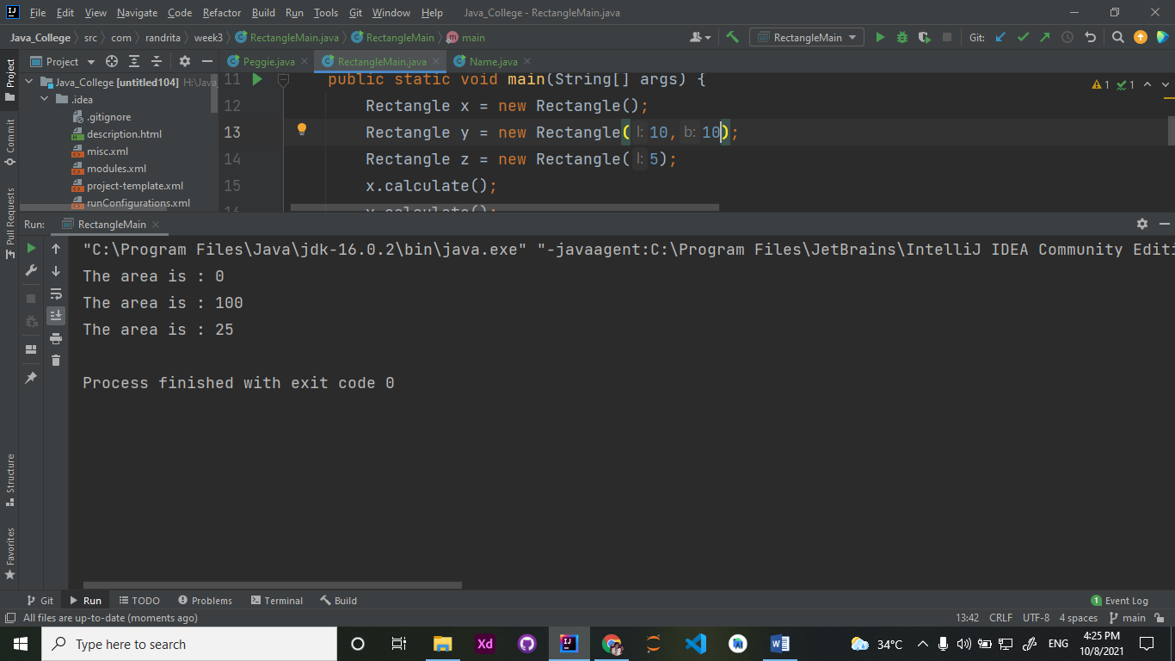

3.Write a program to print the names of students by creating a Student class. If no name is passed while creating an object of Student class, then the name should be "Unknown", otherwise the name should be equal to the String value passed while creating object of Student class.

package com.randrita.week3;  
import java.util.Scanner;  
  
/*Write a program to print the names of students by creating a Student class. If no name is passed while creating an object of Student class, then the name should be "Unknown", otherwise the name should be equal to the String value passed while creating object of Student class.*/  
  
  
public class Name {  
 public static void main(String[] args) {  
  
 Scanner input = new Scanner(System.*in*);  
 System.*out*.print("Enter the name you want to display: ");  
 String s= input.next();  
  
 Student ans = new Student();  
 Student ans1 = new Student(s);  
  
 ans.display();  
 ans1.display();  
  
 }  
}  
  
class Student{  
 String name;  
  
 Student(String s){  
 name=s;  
 }  
  
 Student(){  
 name = "unknown";  
 }  
  
 void display(){  
 System.*out*.println("The ans is: "+ name);  
 }  
}

output:

