**Week-3[Assignment-2]**

Name – Randrita Sarkar [11500219058]

IT PCC-CS593 L - OBJECT ORIENTED PROGRAMMING LAB

1.Define a class volume and then find the volume and surface_area of a cube, cylinder and rectangular box using method overloading

package com.randrita.week3;  
import java.util.Scanner;  
  
/*Define a class volume and then find the volume and surface_area of a cube, cylinder and rectangular box using method overloading.-/  
 */  
  
public class VolumeArea  
{  
 public static void main(String[] args) {  
 Volume ad=new Volume();  
 System.*out*.println(ad.vl(11));  
 System.*out*.println(ad.area(11));  
 System.*out*.println(ad.vl(11,11));  
 System.*out*.println(ad.area(11,11));  
 System.*out*.println(ad.vl(11,11,5));  
 System.*out*.println(ad.area(11,11,5));  
  
 }  
}  
class Volume  
{  
 int vl(int a)  
 {  
 return(a*a*a);  
  
 }  
 int area( int a){  
 return (6*a*a);  
  
 }  
 double vl(int r, int h){  
 return(3.14*r*r*h);  
 }  
 double area(int r, int h){  
 return(2*3.14*r*r+2*3.14*r*h);  
 }  
 int vl(int l,int w, int h)  
 {  
 return(w*h*l);  
  
 }  
 int area(int l,int w, int h)  
 {  
 return(2*(w*l+h*l+h*w));  
  
  
 }  
  
}

output:

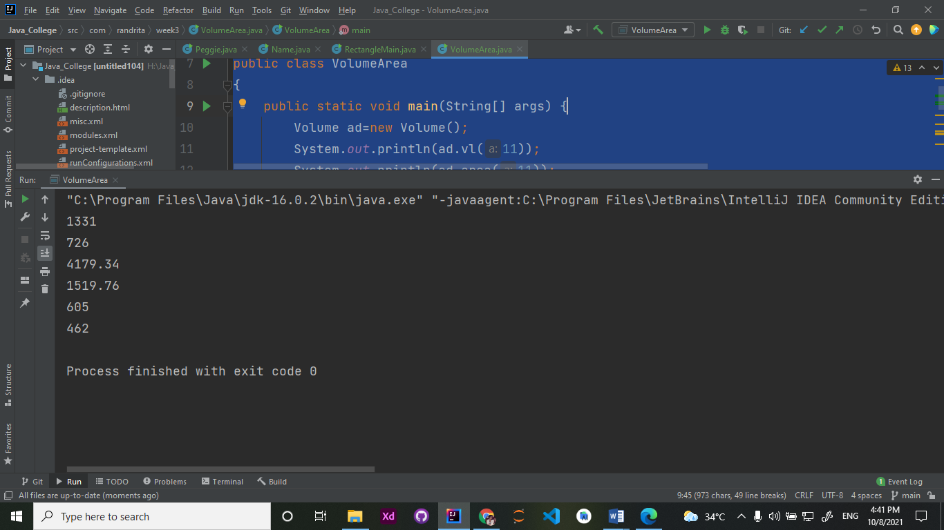

### 2.Create a class to print the area of a square and a rectangle. The class has two methods with the same name but different number of parameters. The method for printing area of rectangle has two parameters which are length and breadth respectively while the other method for printing area of square has one parameter which is side of square.

package com.randrita.week3;  
import java.util.Scanner;  
  
public class SquareArea {  
 public static void main(String[] args) {  
 Area obj = new Area();  
 Scanner input=new Scanner(System.*in*);  
 System.*out*.print("Enter the length of the side of the square: ");  
 int x= input.nextInt();  
 System.*out*.println("The area of the square is: " + obj.area(x));  
  
 System.*out*.print("Enter the length and breadth of the of the rectangle: ");  
 int a = input.nextInt();  
 int b = input.nextInt();  
 System.*out*.println("The area of the rectangle is: " + obj.area(a,b));  
 }  
  
 static class Area{  
 int area(int x){  
 return x*x;  
 }  
  
 int area(int x, int y){  
 return x*y;  
 }  
 }  
}

### Output:

