**Week-4**

Name – Randrita Sarkar [11500219058]

IT PCC-CS593 L - OBJECT ORIENTED PROGRAMMING LAB

1.Create a class 'Student' with data members which are name and marks of five subjects.You need to find out the topper based on the total marks obtained by the students(at least 10 students) using static concept(block,variable,method).

package com.randrita.week4;  
import java.util.Scanner;  
  
  
class Student{  
 //intialising static variable  
 static int *temp*=Integer.*MIN_VALUE*;  
 static String *k* = "null";  
 //counting total marks of each student  
 static void count(int[] array,String name){  
 int sum =0;  
 for(int num:array){  
 sum=sum+num;  
 }  
 Student.*compare*(sum,name);  
 }  
 //comparing it with next one  
 static void compare(int x,String name){  
  
 if(x>*temp*){  
 *temp*=x;  
 *k*=name;  
 }  
 }  
  
 static void display(){  
 System.*out*.println("The Highest Marks is "+ *temp*+" & Scored by "+*k*);  
 }  
  
}  
  
public class StudentMarks {  
  
 public static void main(String[] args) {  
  
 System.*out*.println("Representing 3 Cases with 3 Subjects");  
 System.*out*.println("------------------------------------");  
 Scanner input = new Scanner(System.*in*);  
 int t = 3;  
  
 while (t-->0) {  
 int[] arr = new int[3];  
 System.*out*.print("Enter the name of the Student : ");  
 String naam;  
 input.nextLine();  
 naam=input.nextLine();  
  
 System.*out*.print("Enter the five numbers of subject in 'PCMBC' manner : ");  
 for (int i = 0; i < 3; i++) {  
 arr[i] = input.nextInt();  
 }  
 Student.*count*(arr,naam);  
 }  
  
 Student.*display*();  
  
 }  
  
  
  
}

**Output:**

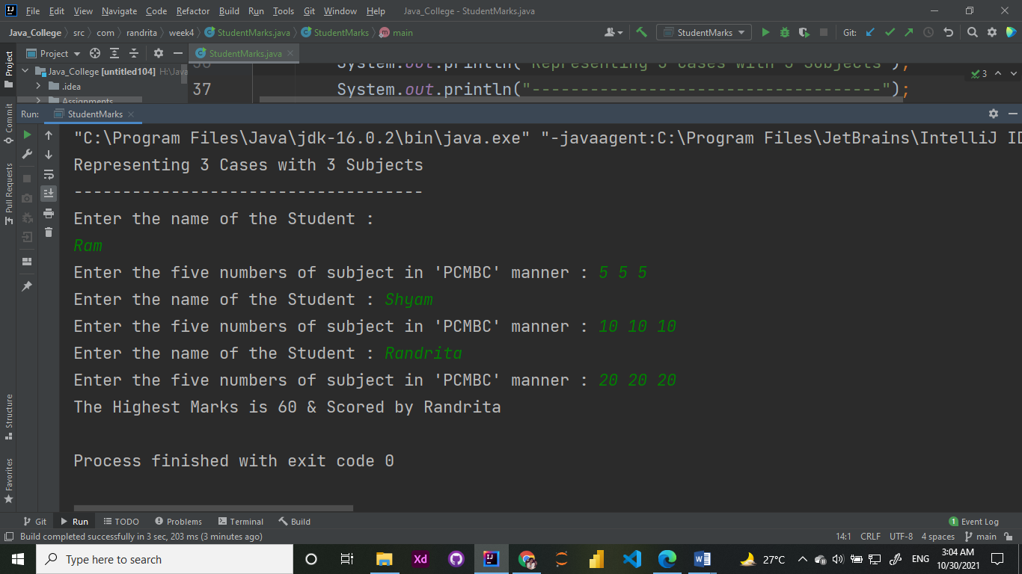

2. Create a class that represents employee. Calculate the amount paid to a given employee for a pay period and also calculate overtime pay. Make an 'OvertimeCalculator' class that can report general information about overtime pay.

package com.randrita.week4;  
import java.util.Scanner;  
  
public class Employee  
{  
 public static void main(String arg[])  
 {  
 double gs,it,pt,pf,netSalary,ov;  
 Scanner sc=new Scanner(System.*in*);  
 System.*out*.println("Enter Gross salary");  
 gs=sc.nextDouble();  
 System.*out*.println("Enter Income Tax %");  
 it=sc.nextDouble();  
 System.*out*.println("Enter Professional Tax %");  
 pt=sc.nextDouble();  
 System.*out*.println("enter Provident Fund %");  
 pf=sc.nextDouble();  
  
 System.*out*.println("Enter the extra time employee worked in hr %");  
 ov=sc.nextDouble();  
  
 netSalary=*salary*(gs,pf,pt,it);  
 System.*out*.println("Net Salary is="+netSalary);  
 OvertimeCalculator.*overtime*(ov);  
  
 }  
 static double salary(double gs,double pf,double pt,double it)  
 {  
 pf=pf*(gs/100);  
 it=it*(gs/100);  
 pt=pt*(gs/100);  
 double n=gs-it-pt-pf;  
 return n;  
 }  
}  
  
class OvertimeCalculator{  
 static void overtime(double time_worked)  
 {  
 double over_time,overtime_pay;  
 if (time_worked>40)  
 {  
 over_time = time_worked - 40;  
 overtime_pay = (12 * over_time);  
 System.*out*.println("The overtime pay is ="+overtime_pay);  
  
 }  
  
 }  
}

**Output:**

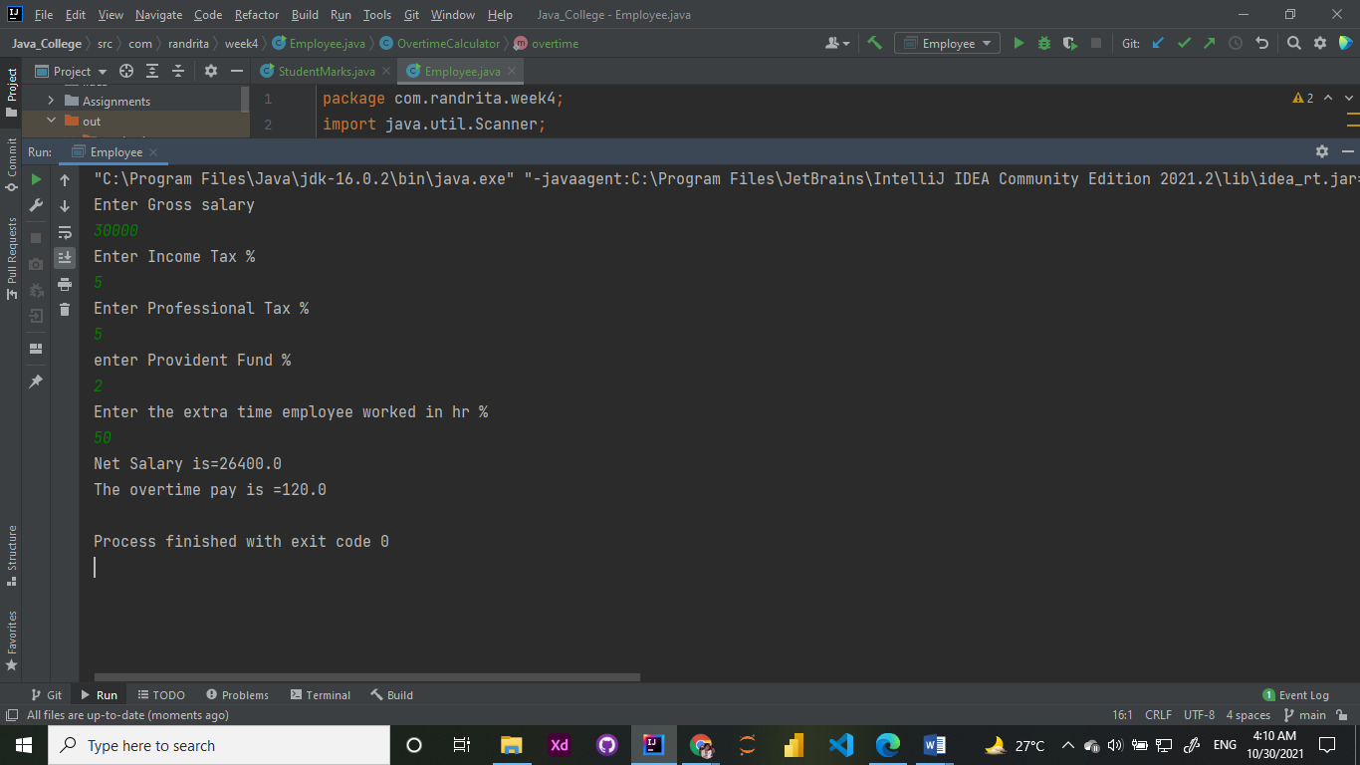

3. Write java program with  static block and check whether static block is executed before [constructor](http://moodlebppimt.ddns.net/mod/assign/view.php?id=21577) or after [constructor](http://moodlebppimt.ddns.net/mod/assign/view.php?id=21577).

package com.randrita.week4;  
  
class Blocks {  
 static String *k*=" ";  
 static {  
 System.*out*.println("Hello! I'm Static Block! ");  
 }  
 Blocks(String anything){  
 *k* = anything;  
 *display*();  
 }  
 static void display(){  
 System.*out*.println(*k*);  
 }  
}  
public class Check {  
 public static void main(String[] args) {  
 Blocks s1 = new Blocks("Hello! Constructor Here!");  
 System.*out*.println("I'am main block");  
 }  
}

**output:**

