Randrita Sarkar (11500219058)

Week_1

1. Write a Java program to convert temperature from Fahrenheit to Celsius degree

Code:

package com.randrita.week1;  
import java.util.Scanner;  
//1. Write a Java program to convert temperature from Fahrenheit to Celsius degree  
  
public class TempConversion {  
 public static void main(String[] args) {  
 System.*out*.print("Enter the temperature in celsius: ");  
 Scanner input=new Scanner(System.*in*);  
 float f = input.nextInt();  
 double temp =(f*1.8)+32;  
 System.*out*.print("The temperature in Fahrenheit: " + temp);  
  
  
 }  
}

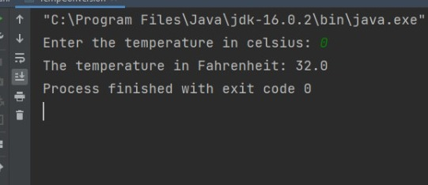Output:

2.Write a Java program to convert minutes into a number of years and days.

Code:

package com.randrita.week1;  
import java.util.Scanner;  
  
//2.Write a Java program to convert minutes into a number of years and days.  
  
public class MinToDays {  
 public static void main(String[] args) {  
 Scanner input = new Scanner(System.*in*);  
 System.*out*.print("Enter the minutes:");  
 int min = input.nextInt();  
 int year = min / 525600;  
 int day = min / 1440;  
  
 System.*out*.println("Year is:" + year);  
 System.*out*.println("Day is:" + day);  
 }  
}

Output

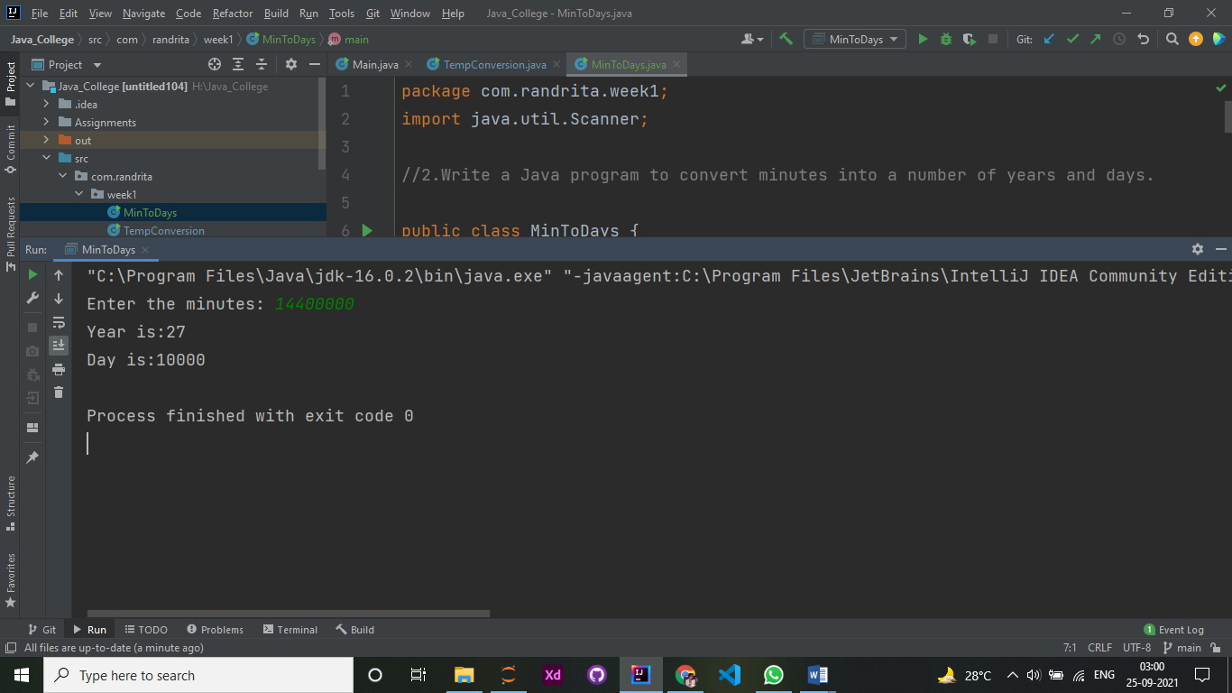

3. Write a member function for batsman class, which will take one integer as parameter. Add this integer with total run, increment no of innings and calculate other variables accordingly. Write a member function for bowler class, which will take two integers as parameter. Add one integer with runs given and another with wickets, increment no of innings and calculate other variables accordingly.

Code:

package com.randrita.week1;  
import java.util.Scanner;  
  
//3.Write a member function for batsman class, which will take one integer as parameter. Add this integer with total run, increment no of innings and calculate other variables accordingly. Write a member function for bowler class, which will take two integers as parameter. Add one integer with runs given and another with wickets, increment no of innings and calculate other variables accordingly.  
  
public class BatBowl {  
 public static void main(String[] args) {  
 Scanner input= new Scanner(System.*in*);  
 System.*out*.print("Enter the total number of innings: ");  
 int f= input.nextInt();  
 Bowlers result = new Bowlers();  
  
 result.Batman(f);  
 result.Bowlers(f);  
 }  
  
 //Batsman's End  
 static class Batsman{  
 public void Batman(int n){  
 System.*out*.println("***Batsman's End***");  
 int total_run=0;  
 Scanner input= new Scanner(System.*in*);  
 for (int i=1;i<=n;i++){  
 System.*out*.print("Enter the total run of innings "+i + ": ");  
 int x= input.nextInt(); //taking run as input  
 total_run=total_run+x;  
 }  
 System.*out*.println("Total run in " + n +" innings is " + total_run);  
 }  
  
 }  
  
 //Bowler's End  
 static class Bowlers extends Batsman {  
  
 public void Bowlers(int n){  
 System.*out*.println("***Bowler's End***");  
 int total_wicket=0;  
 Scanner input= new Scanner(System.*in*);  
 for (int i=1;i<=n;i++){  
 System.*out*.print("Enter the total wickets of innings "+i + ": ");  
 int x= input.nextInt(); //taking wicket as input  
 total_wicket=total_wicket+x;  
 }  
  
 System.*out*.println("Total run in " + n +" innings is " + total_wicket);  
 }  
  
 }  
  
}

Output:

