**Week-5**

Name – Randrita Sarkar [11500219058]

IT PCC-CS593 L - OBJECT ORIENTED PROGRAMMING LAB

1.Create a class for employee with attributes name, age and address. Create a class manager andworker,which will inherit the employee class. The manager class has extra attributes – department and salary.The worker class has attributes – no. of days worked, daily wages and total salary. Add necessary number of functions to calculate total salary of worker and display output of all classes.

package com.randrita.week5;  
import java.util.Scanner;  
  
public class Office {  
  
 public static void main(String[] args) {  
  
 Worker obj1 = new Worker();  
 String Name=obj1.Name("Rimi");  
 String Address=obj1.Address("32/B,JKM Road,Kolkata-700037");  
 int age= obj1.Age(21);  
 int noDaysWorked= obj1.nDaysWorked(20);  
 int dailyWage = obj1.DailyWage(1000);  
 int totalSalary = obj1.totalSalary(noDaysWorked,dailyWage);  
  
 System.*out*.println("Employee Details(Output Employee Class):\nName: " +Name +"\nAddress: "+Address +"\nAge: "+age );  
 System.*out*.println("----------------------------------------------------------------------------");  
 System.*out*.println("Manager Details(Output Manager Class):\nDepartment: " + obj1.Department("IT") +"\nSalary: "+ obj1.Salary(100000));  
 System.*out*.println("----------------------------------------------------------------------------");  
 System.*out*.println("Worker Details(Output Worker Class):\ntotalSalary: " + totalSalary );  
  
 }  
}  
  
class Employee{  
  
 public String Name(String name) {  
 return name;  
 }  
  
 public String Address(String address) {  
 return address;  
 }  
  
 public int Age(int age){  
 return age;  
 }  
}  
  
class Manager extends Employee{  
 public String Department(String department) {  
 return department;  
 }  
 public int Salary(int salary){  
 return salary;  
 }  
  
}  
  
class Worker extends Manager{  
  
 public int nDaysWorked(int n_days_worked){  
 return n_days_worked;  
 }  
  
 public int totalSalary(int a,int b){  
 int total_salary= a*b;  
 return total_salary;  
 }  
  
 public int DailyWage(int daily_wage){  
 return daily_wage;  
 }  
  
}

**Output:**

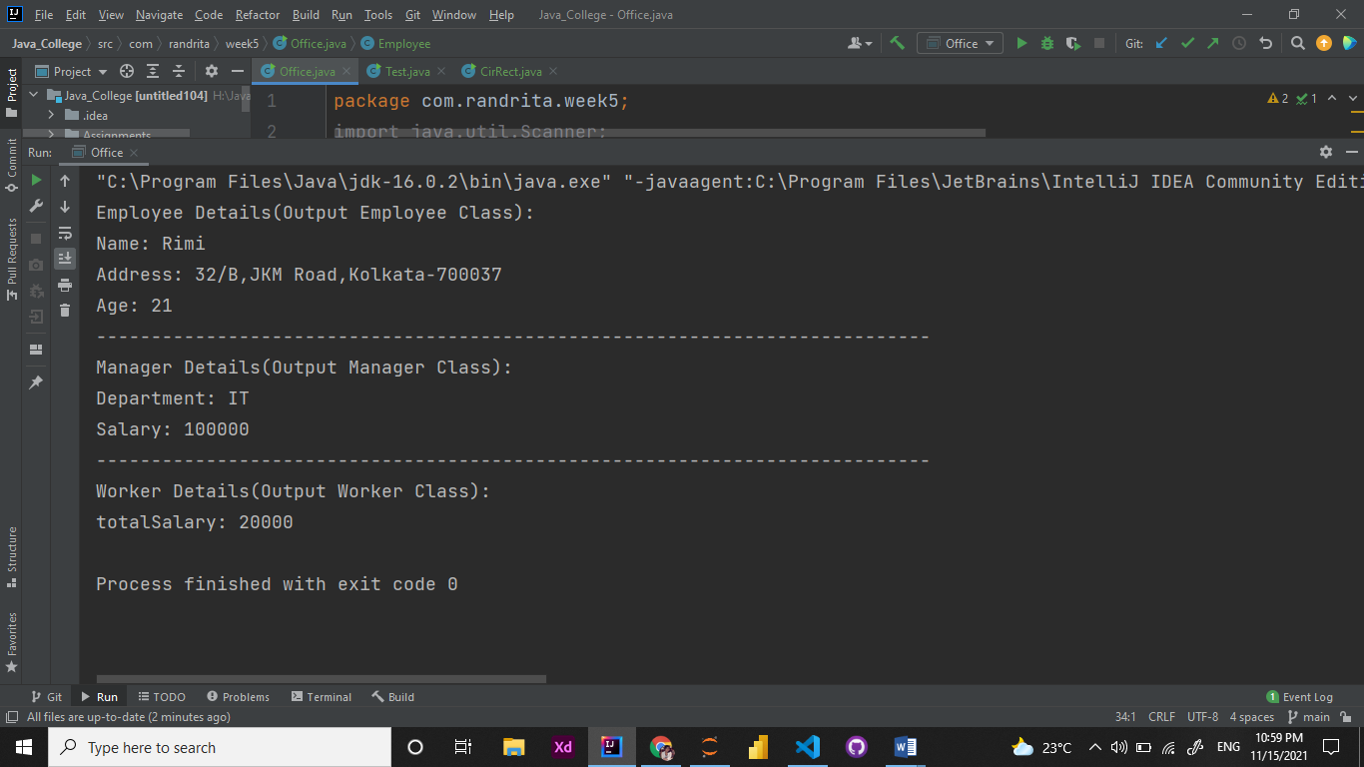

2. Write a superclass called Shape (as shown in the class diagram), which contains:

* Two instance variables color (String) and filled (boolean).
* Two constructors: a no-arg (no-argument) [constructor](http://moodlebppimt.ddns.net/mod/assign/view.php?id=21577) that initializes the color to "green" and filled to true, and a [constructor](http://moodlebppimt.ddns.net/mod/assign/view.php?id=21577) that initializes the color and filled to the given values.
* Getter and setter for all the instance variables. By convention, the getter for a boolean variable xxx is called isXXX() (instead of getXxx() for all the other types).
* A toString() method that returns "A Shape with color of xxx and filled/Not filled".

Write a test program to test all the methods defined in Shape.

Part 1 :

package com.randrita.week5;  
  
public class Test {  
 public static void main(String[] args) {  
 Shape obj1 = new Shape();  
 String s =obj1.getColor();  
 System.*out*.printf("The colour is %s and the Boolean Value of the filled condition is %b \n",obj1.getColor() , obj1.isFilled());  
 System.*out*.println(obj1.toString());  
 }  
}  
  
class Shape{  
 String color;  
 boolean filled;  
  
 Shape(){  
 color = "green";  
 filled = true;  
  
 }  
  
 Shape(String color,boolean filled){  
 this.color=color;  
 this.filled=filled;  
 }  
  
 public void setColor(String colorSet) {  
 this.color = colorSet;  
 }  
  
 public String getColor() {  
 return color;  
 }  
  
 public boolean isFilled()  
 {  
 if (filled == true)  
 {  
 return true;  
 }  
 else  
 {  
 return false;  
 }  
 }  
  
 public void setFilled(boolean filledSet)  
 {  
 this.filled = filledSet;  
 }  
  
 public String toString()  
 {  
 String isNot = "";  
 if(isFilled() == false)  
 {  
 isNot = "not ";  
 }  
 return "A Shape with color of " + color + " and is " + isNot + " filled. ";  
 }  
}

**output:**

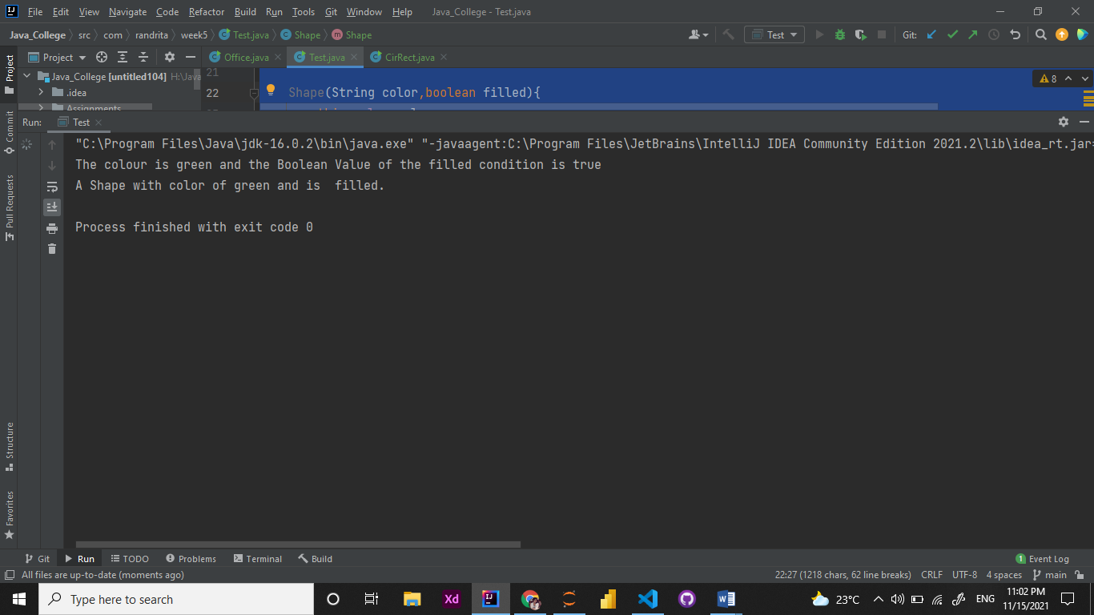

**Part:2**

Write two subclasses of Shape called Circle and Rectangle, as shown in the class diagram.

The Circle class contains:

* An instance variable radius (double).
* Three constructors as shown. The no-arg [constructor](http://moodlebppimt.ddns.net/mod/assign/view.php?id=21577) initializes the radius to 1.0.
* Getter and setter for the instance variable radius.
* Methods getArea() and getPerimeter().
* Override the toString() method inherited, to return "A Circle with radius=xxx, which is a subclass of yyy", where yyy is the output of the toString() method from the superclass.

The Rectangle class contains:

* Two instance variables width (double) and length (double).
* Three constructors as shown. The no-arg [constructor](http://moodlebppimt.ddns.net/mod/assign/view.php?id=21577) initializes the width and length to 1.0.
* Getter and setter for all the instance variables.
* Methods getArea() and getPerimeter().
* Override the toString() method inherited, to return "A Rectangle with width=xxx and length=zzz, which is a subclass of yyy", where yyy is the output of the toString() method from the superclass.

Write a class called Square, as a subclass of Rectangle. Convince yourself that Square can be modeled as a subclass of Rectangle. Square has no instance variable, but inherits the instance variables width and length from its superclass Rectangle.

* Provide the appropriate constructors (as shown in the class diagram). Hint:
* public Square(double side) {
* super(side, side); // Call superclass Rectangle(double, double)

}

* Override the toString() method to return "A Square with side=xxx, which is a subclass of yyy", where yyy is the output of the toString() method from the superclass.
* Do you need to override the getArea() and getPerimeter()? Try them out.
* Override the setLength() and setWidth() to change both the width and length, so as to maintain the square geometry.
* package com.randrita.week5;  
    
  public class CirRect {  
   public static void main(String[] args) {  
   Shapee s = new Shapee();  
   Shapee s1 = new Shapee("Orange",true);  
   s1.toString();  
   Circle c = new Circle();  
   c.setRadius(5);  
   System.*out*.println("Perimeter of circle is:" + c.getPerimeter(c.getRadius(5)));  
   System.*out*.println("Area of circle is:" + c.getArea(c.getRadius(5)));  
    
   Rectangle r = new Rectangle();  
   r.setLength(5);  
   r.setWidth(10);  
   System.*out*.println("Perimeter of rectangle is:" + r.getPerimeter(5,5));  
   System.*out*.println("Area of rectangle is:" + r.getArea(5,5));  
    
   Square sq = new Square(5);  
   System.*out*.println("Perimeter of square is:" + sq.getPerimeter());  
   System.*out*.println("Area of square is:" + sq.getPerimeter());  
    
    
   }  
  }  
    
  class Shapee {  
   String color;  
   boolean filled;  
    
   Shapee() {  
   color = "green";  
   filled = true;  
   }  
    
   Shapee(String color, boolean filled) {  
   this.color = color;  
   this.filled = filled;  
   }  
    
   public void setColor(String colorSet) {  
   this.color = colorSet;  
   }  
    
   public String getColor() {  
   return color;  
   }  
    
   public boolean isFilled() {  
   if (filled == true) {  
   return true;  
   } else {  
   return false;  
   }  
   }  
    
   public void setFilled(boolean filledSet) {  
   this.filled = filledSet;  
   }  
    
   public String toString() {  
   String isNot = "";  
   if (isFilled() == false) {  
   isNot = "not ";  
   }  
   return "A Shape with color of " + color + " and is " + isNot + " filled. ";  
   }  
  }  
    
  class Circle extends Shapee{  
   double radius;  
   Circle(){  
   this.radius=1.0;  
   }  
   Circle(double radius,String color,boolean filled){  
   this.radius=radius;  
   this.color=color;  
   this.filled=filled;  
   }  
   public void setRadius(double radius){  
   this.radius=radius;  
   }  
    
   public double getRadius(double radius){  
   return this.radius;  
   }  
    
   public double getArea(double radius){  
   return (Math.*PI*\*this.radius*this.radius);  
   }  
    
   public double getPerimeter(double radius){  
   return (Math.*PI*\*this.radius*2);  
   }  
    
   public String toString(){  
   String s = "A Circle with radius" + radius + "which is a subclass of" + super.toString();  
   return s;  
   }  
    
    
  }  
    
   class Rectangle extends Shapee{  
   double width;  
   double length;  
    
   Rectangle()  
   {  
   super();  
   width = 1.0;  
   length = 1.0;  
   }  
    
   Rectangle(double width, double length)  
   {  
   super();  
   this.width = width;  
   this.length = length;  
   }  
    
    
   Rectangle(double width,double length,String color,boolean filled){  
   super (color, filled);  
   this.width=width;  
   this.length=length;  
   this.color=color;  
   this.filled=filled;  
   }  
   //for width  
   public double getWidth(double width){  
   return width;  
   }  
    
   public void setWidth(double width){  
   this.width=width;  
   }  
    
   //for length  
   public double getLength(double length){  
   return length;  
   }  
    
   public void setLength(double length){  
   this.length=length;  
   }  
    
   public double getArea(double width,double length){  
   return (this.width*this.length);  
   }  
    
   public double getPerimeter(double width,double length){  
   return (2*this.width+2*this.length);  
   }  
    
   public String toString(){  
   String s = "A Rectangle with width " + width+" and length "+length + " which is a subclass of" + super.toString();  
   return s;  
   }  
  }  
    
  class Square extends Rectangle  
  {  
    
   public Square()  
   {  
   super();  
   double side = 1.0;  
   }  
    
   public Square(double side)  
   {  
   super(side, side);  
   side =side;  
   }  
    
   public Square(double side, String color, boolean filled)  
   {  
   super(side, side, color, filled);  
   side =side;  
   }  
    
   public double getSide()  
   {  
   return super.getWidth(10);  
   }  
    
   public void setSide(double side)  
   {  
   super.setLength(side);  
   super.setWidth(side);  
   }  
    
   public double getArea()  
   {  
   return getSide()*getSide();  
   }  
    
   public double getPerimeter()  
   {  
   return 4*getSide();  
   }  
    
    
   public String toString()  
   {  
   return "A Square with side = " + getSide() + ", which is a subclass of " + super.toString();  
   }  
  }

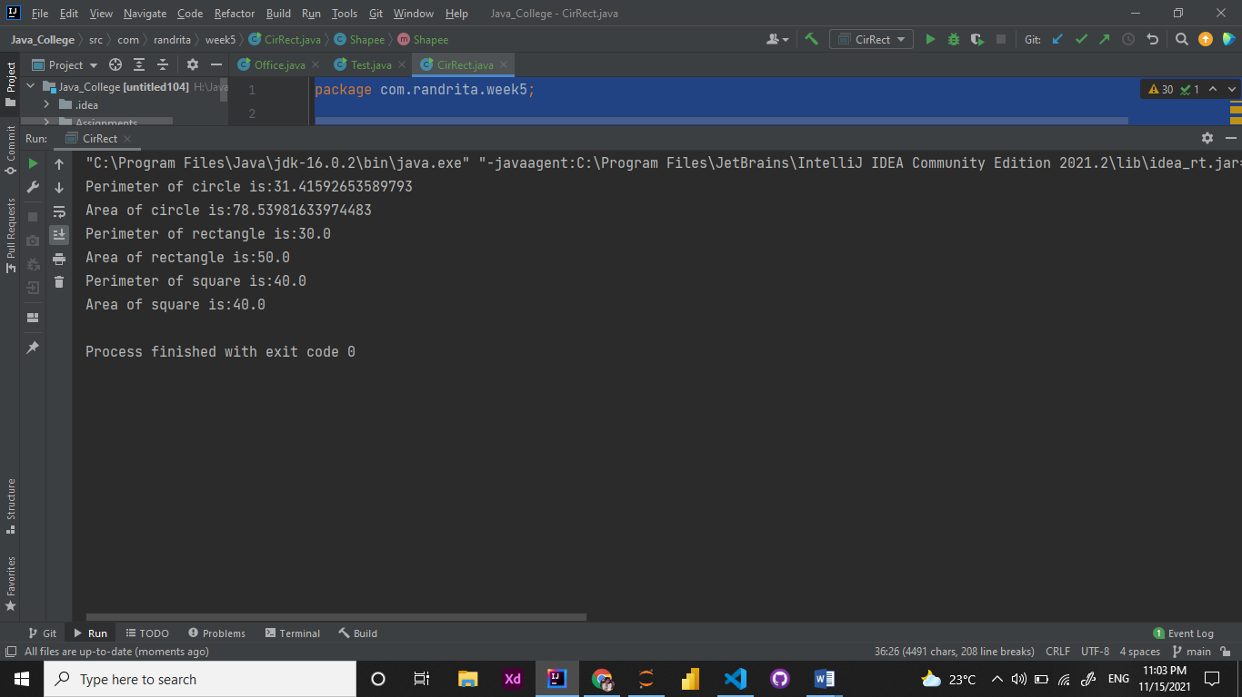**Output:**