**Week-6**

Name – Randrita Sarkar [11500219058]

IT PCC-CS593 L - OBJECT ORIENTED PROGRAMMING LAB

Consider a scenario, Bank is a class that provides functionality to get rate of interest. But, rate of interest varies according to banks. For example, SBI, ICICI and AXIS banks could provide 8%, 7% and 9% rate of interest.

package com.randrita.week6;  
  
/*  
Consider a scenario, ROI is a class that provides functionality to get rate of interest.  
But, rate of interest varies according to banks. For example, SBI, ICICI and AXIS banks could  
provide 8%, 7% and 9% rate of interest.  
*/  
  
class Bank{  
 int r;  
 void rate_of_interest(int r){  
 this.r = r;  
 }  
}  
  
//for SBI Bank  
//-------------------------------------------------  
class SBI extends Bank{  
 int r;  
  
 @Override  
 void rate_of_interest(int r)  
 {  
 super.rate_of_interest(0);  
 this.r=r;  
 }  
  
 void display(){  
 System.*out*.println("The Rate of interest in SBI Bank is : "+r+'%');  
 }  
}  
  
//for ICICI Bank  
//-------------------------------------------------  
  
class ICICI extends Bank{  
 int r;  
  
 @Override  
 protected void rate_of_interest(int r){  
 super.rate_of_interest(8);  
 this.r=r;  
 }  
  
 protected void display(){  
 System.*out*.println("The Rate of interest in ICICI Bank is : "+r+'%');  
 }  
}  
  
//for AXIS Bank  
//-------------------------------------------------  
  
class AXIS extends Bank{  
 int r;  
  
 @Override  
 public void rate_of_interest(int r){  
 this.r=r;  
 }  
  
 public void display(){  
 System.*out*.println("The Rate of interest in Axis Bank is : "+r+'%');  
 }  
}  
  
//main method  
public class ROI {  
 public static void main(String[] args) {  
  
 SBI obj_sbi = new SBI();  
 obj_sbi.rate_of_interest(8);  
 obj_sbi.display();  
  
 ICICI obj_icici = new ICICI();  
 obj_icici.rate_of_interest(7);  
 obj_icici.display();  
  
 AXIS obj_axis = new AXIS();  
 obj_axis.rate_of_interest(9);  
 obj_axis.display();  
 }  
}

**Output:**

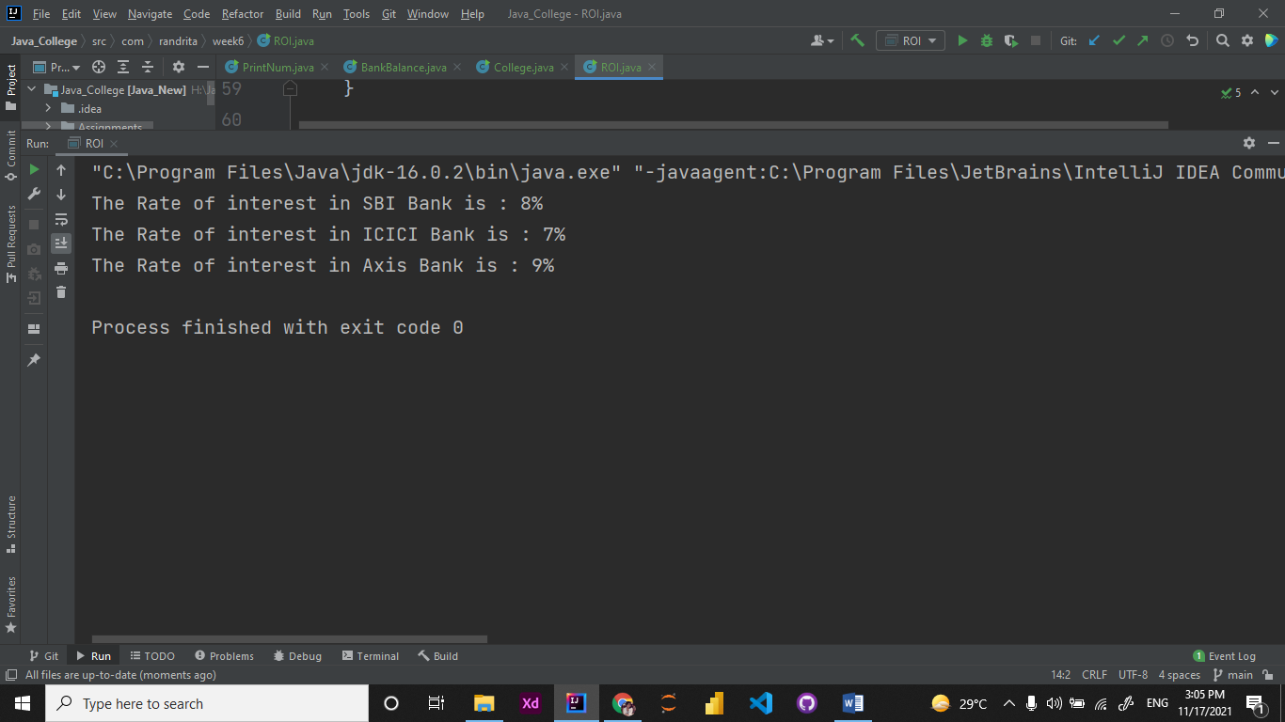

2. Create a class 'Degree' having a method 'getDegree' that prints "I got a degree". It has two subclasses namely 'Undergraduate' and 'Postgraduate' each having a method with the same name that prints "I am an Undergraduate" and "I am a Postgraduate" respectively. Call the method by creating an object of each of the three classes.

package com.randrita.week6;  
  
/*Create a class 'Degree' having a method 'getDegree' that prints "I got a degree". It has two subclasses namely 'Undergraduate'  
 and 'Postgraduate' each having a method with the same name that prints "I am an Undergraduate" and "I am a Postgraduate" respectively.  
 Call the method by creating an object of each of the three classes.*  
 */  
  
public class College {  
 public static void main(String[] args) {  
 Degree degree = new Degree();  
 Postgraduate pDegree = new Postgraduate();  
 Undergraduate uDegree = new Undergraduate();  
  
 degree.getDegree();  
 pDegree.getDegree();  
 uDegree.getDegree();  
  
 }  
}  
  
class Degree{  
 void getDegree(){  
 System.*out*.println("I got a degree");  
 }  
}  
  
class Undergraduate extends Degree{  
 void getDegree(){  
 System.*out*.println("I am an Undergraduate");  
 }  
}  
  
class Postgraduate extends Degree{  
 void getDegree(){  
 System.*out*.println("I am a Postgraduate");  
 }  
}

Output:

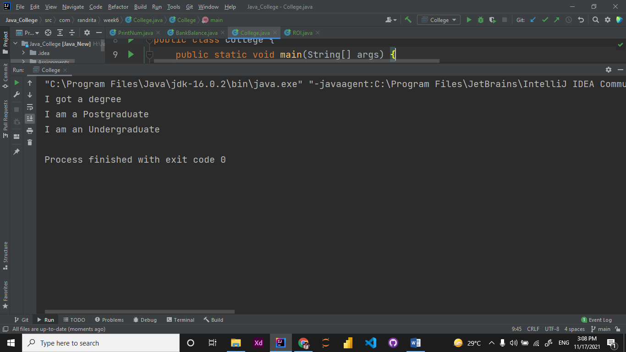

3. A class has an integer data member 'i' and a method named 'printNum' to print thevalue of 'i'. Its subclass also has an integer data member 'j' and a method named 'printNum' to print the value of 'j'. Make an object of the subclass and use it to assign a value to 'i' and to 'j'. Now call the method 'printNum' by this object.

package com.randrita.week6;  
  
/*A class has an integer data member 'i' and a method named 'printNum' to print thevalue of 'i'.  
Its subclass also has an integer data member 'j' and a method named 'printNum' to print the value of 'j'.  
Make an object of the subclass and use it to assign a value to 'i' and to 'j'. Now call the method 'printNum'  
by this object.*/  
  
public class PrintNum {  
 int i;  
 void printNum(int i){  
 this.i=i;  
 System.*out*.println("The number presents in PARENT Class is: "+i);  
 }  
  
 public static void main(String[] args) {  
 SubClass child = new SubClass();  
 child.printNum(10);  
 }  
}  
  
class SubClass extends PrintNum{  
 int j;  
  
 @Override  
 void printNum(int j){  
 super.printNum(5);  
 this.j=j;  
 System.*out*.println("The number presents in CHILD Class is: "+j);  
 }  
}

output:

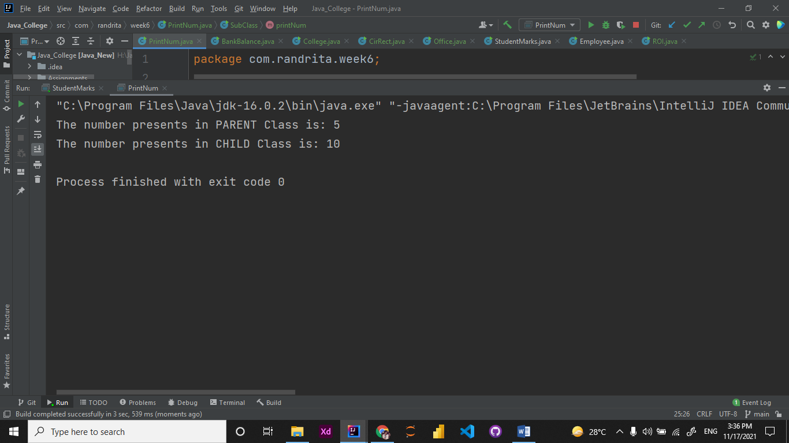

4.

package com.randrita.week6;  
  
/*A boy has his money deposited $1000, $1500 and $2000 in banks-Bank A, Bank B and Bank C respectively. We have to print the money deposited by him in a particular bank.  
Create a class 'Bank' with a method 'getBalance' which returns 0. Make its three subclasses named 'BankA', 'BankB' and 'BankC' with a method with the same name 'getBalance' which returns the amount deposited in that particular bank. Call the method 'getBalance' by the object of each of the three banks.*/  
  
public class BankBalance {  
 public static void main(String[] args) {  
 BankA a = new BankA();  
 BankB b = new BankB();  
 BankC c = new BankC();  
  
 //printing elements  
 System.*out*.println("The amount deposited in BankA : $" + a.getBalance());  
 System.*out*.println("The amount deposited in BankB : $" + b.getBalance());  
 System.*out*.println("The amount deposited in BankC : $" + c.getBalance());  
 }  
  
}  
  
class bank1{  
 int getBalance(){  
 return 0;  
 }  
}  
  
class BankA extends bank1{  
 int getBalance(){  
 return 1000;  
 }  
}  
  
class BankB extends bank1{  
 int getBalance(){  
 return 1500;  
 }  
}  
  
class BankC extends bank1{  
 int getBalance(){  
 return 2000;  
 }  
}

output:

