**Week-7**

Name – Randrita Sarkar [11500219058]

IT PCC-CS593 L - OBJECT ORIENTED PROGRAMMING LAB

Inner Class

Show that an inner class has access to the **private** elements of its outer class. Determine whether the reverse is true

package com.randrita.week7;  
  
/*Show that an inner class has access to the private elements of  
its outer class. Determine whether the reverse is true*/  
  
public class OuterClass {  
  
 private int k=5;  
 class InnerClass{  
 void display(){  
 System.*out*.println("The number defined in outerClass is "+ k);  
 }  
 }  
 void show(){  
 InnerClass inner = new InnerClass();  
 inner.display();  
 }  
  
 public static void main(String[] args) {  
 OuterClass number = new OuterClass();  
 number.show();  
  
 }  
}

Output:

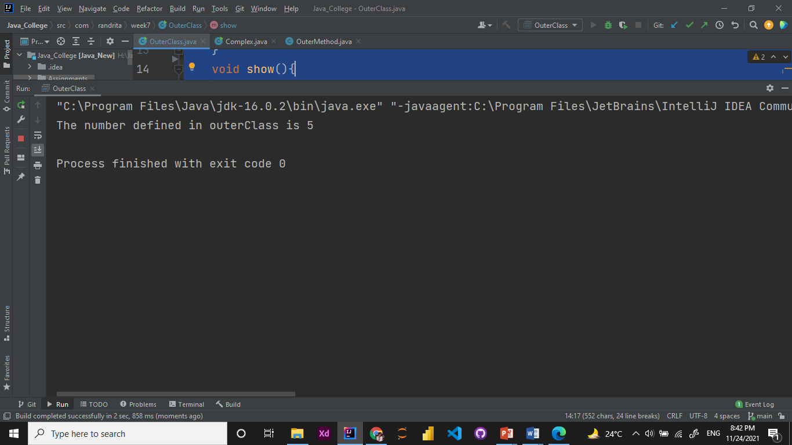

2. Create an inner class with a method that modifies the outer class field and calls the outer class method. In a second outer class method, create an object of the inner class and call its method, then show the effect on the outer class object.

package com.randrita.week7;  
  
public class OuterMethod {  
  
 public void modify(){  
 System.*out*.println("I am in the OuterClass");  
 }  
  
 class InnerMethod{  
 public void modify(){  
 System.*out*.println("I am in the InnerClass");  
 }  
 }  
  
 public void display(){  
 InnerMethod inner = new InnerMethod();  
 inner.modify();  
 }  
  
 public void outerDisplay(){  
 modify();  
 }  
  
 public static void main(String[] args) {  
 OuterMethod outer = new OuterMethod();  
 outer.display();  
 outer.outerDisplay();  
 }  
}

Output:

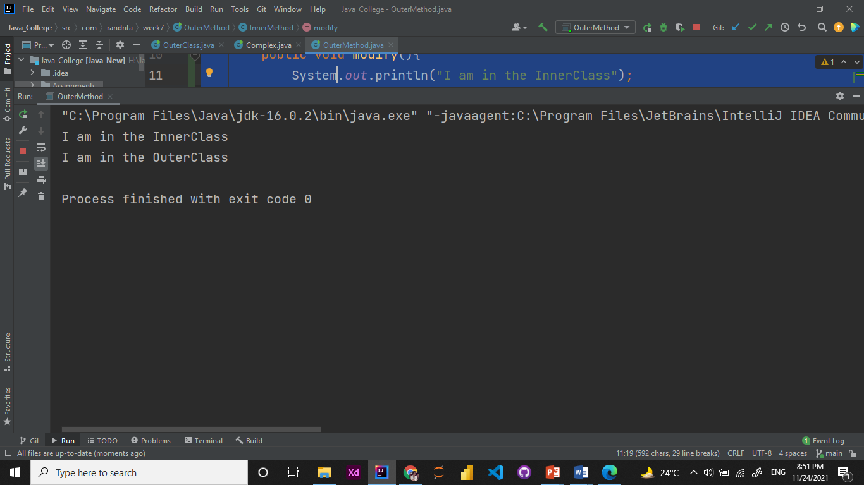

3. Create a class containing an inner class that itself contains an inner class. Repeat this using nested classes. Note the names of the .class files produced by the compiler.

package com.randrita.week7;  
  
class Outer {  
 class Inner{  
 class NestedInner{  
 void display(){  
 System.*out*.println("Hello!I am the Nested Class Method!");  
 }  
 }  
  
 }  
 void display(){  
 Inner.NestedInner variable = new Inner().new NestedInner();  
 variable.display();  
 }  
}  
  
public class NestedClass {  
 public static void main(String[] args) {  
 Outer variableOuter = new Outer();  
 variableOuter.display();  
  
 }  
}

Output:

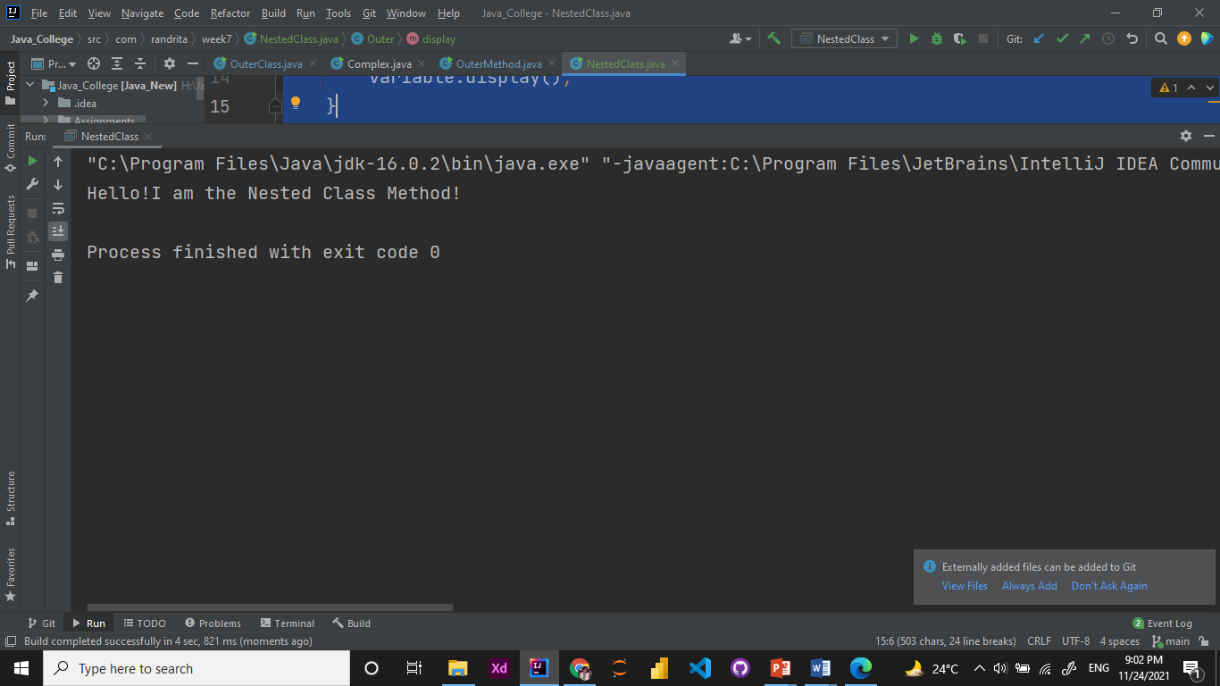

4. Create a class with an inner class that has a nondefault constructor (one that takes arguments). Create a second class with an inner class that inherits from the first inner class.

package com.randrita.week7;  
  
/*Create a class with an inner class that has a non default constructor (one that takes arguments). Create a  
second class with an inner class that inherits from the first inner class.*/  
  
public class InnerInherit extends OuterInheritedSecondClass {  
 public static void main(String[] args) {  
 OuterInheritedSecondClass secondInner = new OuterInheritedSecondClass();  
 secondInner.display("Second Class");  
 }  
}  
  
class OuterInheritedFirstClass {  
 class InheritedClass {  
 InheritedClass(String name) {  
 System.*out*.printf("Hello I am first %s \n", name);  
 }  
 }  
}  
  
class OuterInheritedSecondClass extends OuterInheritedFirstClass{  
 InheritedClass inner = new InheritedClass("InheritedClass");  
  
 void display(String name){  
 System.*out*.printf("I am the Second %s\n",name);  
 }  
}

Output:

