**Week-8**

Name – Randrita Sarkar [11500219058]

IT PCC-CS593 L - OBJECT ORIENTED PROGRAMMING LAB

Abstract Class & Interface

package com.randrita.week8;  
  
public class Area {  
 public static void main(String[] args) {  
 Rectangle r = new Rectangle();  
 Circle c = new Circle();  
  
 System.*out*.println("The area of Rectangle: "+ r.calculate(10,10));  
 System.*out*.println("The area of Circle: "+ c.calculate(5,5));  
 }  
}  
  
interface A {  
 public double calculate(double x,double y);  
}  
  
class Rectangle implements A{  
 @Override  
 public double calculate(double x, double y) {  
 return x*y;  
 }  
}  
  
class Circle implements A{  
 public double calculate(double x,double y){  
 return x*x*Math.*PI*;  
 }  
}

Output:

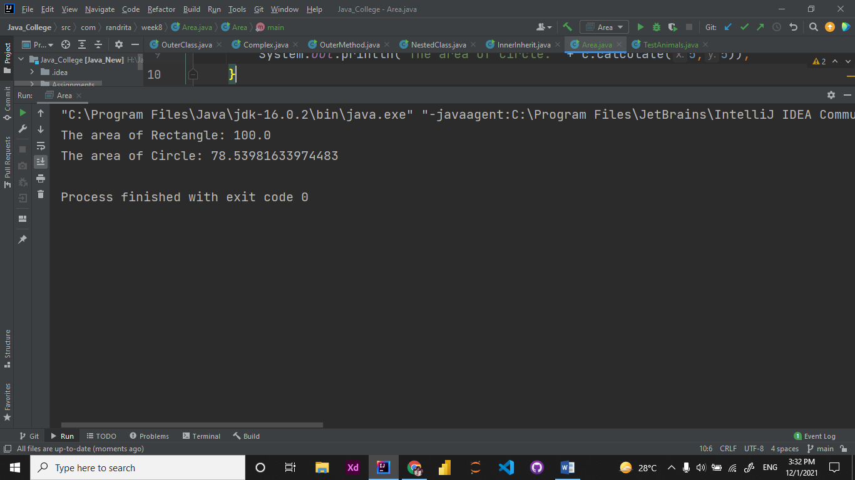

2.

package com.randrita.week8;  
  
abstract class Animal {  
 protected int legs;  
  
 protected Animal(int legs){  
 this.legs=legs;  
 }  
  
 abstract void eat();  
  
 public void walk(){  
 System.*out*.println("I have:"+legs+" legs.");  
 }  
}  
  
class Spider extends Animal{  
 Spider(){  
 super(8);  
 }  
  
 public void eat(){  
 System.*out*.println("I like to eat meat!");  
 }  
}  
  
interface pet{  
 public String getName();  
 public void setName(String petName);  
 public void play();  
}  
  
class Cat extends Animal implements pet{  
 String petName;  
 Cat(String petName){  
 super(4);  
 this.petName=petName;  
 }  
  
 Cat(){  
 this("");  
 }  
  
 public String getName(){  
 return petName;  
 }  
  
 public void setName(String petName){  
 this.petName=petName;  
 }  
  
 @Override  
 public void play() {  
 System.*out*.println("I love to walk!");  
 }  
  
 @Override  
 void eat() {  
 System.*out*.println("I love milk!");  
 }  
}  
  
class Fish extends Animal implements pet {  
 Fish() {  
 super(0);  
 }  
  
 private String fishName;  
  
 public void eat() {  
 System.*out*.println("I like to eat insects!");  
 }  
  
 public String getName() {  
 return fishName;  
 }  
  
 public void setName(String fishName) {  
 this.fishName = fishName;  
 }  
  
 public void play() {  
 System.*out*.println("I love to swim");  
 }  
  
 public void walk() {  
 System.*out*.println("I have:" + legs + " legs.");  
 }  
}  
public class TestAnimals {  
 public static void main(String[] args) {  
 Cat c = new Cat("Fluffy");  
  
 Animal a = new Fish();  
  
 Animal e = new Spider();  
  
 pet p = new Cat();  
  
 //spider  
 System.*out*.println("Hello I'm Spider Class!");  
 e.eat();  
 e.walk();  
 System.*out*.println("==================");  
  
 //pet  
 System.*out*.println("Hello I'm Pet Interface!");  
 p.setName("Leo");  
 System.*out*.println("My pet's name is: "+p.getName());  
 p.play();  
 System.*out*.println("==================");  
  
 //cat  
 System.*out*.println("Hello I'm Cat Class!");  
 System.*out*.println("My cat's name is:"+c.getName());  
 c.walk();  
 c.eat();  
 c.play();  
 System.*out*.println("==================");  
  
 //fish  
 System.*out*.println("Hello I'm Fish Class!");  
 a.walk();  
 a.eat();  
 System.*out*.println("==================");  
  
  
 }  
}

Output:

