**[B6S3]-ECS204: Programming Project & Competitions**

Interim Project Report

Second Year - Batch 6

Agricultural Forum

Group A

Information and Communication Engineering

Sri Lanka Technological Campus

2020

**Declaration**

**“**We declare that this thesis is our own work and has not been submitted in any form for another degree or diploma at any university or other institution of tertiary education. Information derived from the published or unpublished work of others has been acknowledged in the text and a list of references is given.”

|  |  |  |  |
| --- | --- | --- | --- |
| Group member | Contact number | E-mail Address | Signature |
| Thushan Devinda | 0716831398 | thushand@sltc.ac.lk |  |
| Randunu Bandara | 0711495252 | thimiraran@sltc.ac.lk |  |
| Bathiya Lakruwan | 0712294741 | bathiyalakruwan99@gmail.com |  |
| Anuradha Kandewaththe | 0716938625 | indeewareek@sltc.ac.lk |  |
|  |  |  |  |

Project supervisor name: …………………………………………….

Signature: …………………………………………….

**Abstract**

Cultivation is an important sector in Sri Lanka. In cultivation, lot of parties are involved in it. Such as Agricultural department, weather department, Water suppliers, third party, sellers, buyers, transport services, fertilizer weed killer and insecticide making companies, labors etc. with enrolment of these parties ,get the results of severe price fluctuations ,high post-harvest losses and high cost of business activities and finally low income for the farmer. It is very unfair for the farmer. we should minimize contribution of third party for this process. Within this application we will be able to find solution for this problem.

**Chapter 1 – Introduction**

Today there is a difficulty for the farmers to sell their harvest and also the haven’t a place to discuss their problems. It is also difficult for farmers to know the market prices of crops. If a farmer wants a help a from a specialist in that field, they haven’t a good platform for it.

This application is an online application that Farmers can share their information, farmers can get updates on daily market prices, Agricultural consultative can update their accounts with information about agriculture, and also farmers can discuss their problems with those consultative. To buy the harvest buyers can add their daily purchase prices, transport service owners also can add their information.

**Chapter 2 – Solutions in general**

|  |  |
| --- | --- |
| Identified problem | Solution |
| * There is no place for farmers to discuss their problems that they are facing when doing farmers. | * We are going to create an online platform that the farmers can discuss their problems with the agricultural specialist. |
| * It is difficult for the farmers to know the price of the vegetables in the market on a specific day. | * In our application there is a future that the farmers can get the updates on daily market. |
| * Farmers can’t share their experiences in farming with other farmers around the country. | * Through our application farmers can share their experiences with others. |
| * Farmers have a difficulty to find a transport service to carry their harvest to the market. | * There are transport servise owners In our system that they can fin the farmers that need their service. |

**Chapter 3 – Similar approaches**

**Top Apps Used in Sri Lanka**

**1.Govi Mithuru.**

Govi Mithuru is an application that used in Sri Lanka for digital Farming. In this app Farmers can have information about pest and disease-management. This app provides emergency alerts related to ever-changing agricultural conditions, including pest attacks, incidence of disease and other risks, allowing early warnings and adequate time to respond.

**2.Krushi Advisor.**

This application gives information to the user about field establishment with nursery management, fertilizer recommendation, water management, weed management, pest management, disease management, nutrient deficiency and physical disorders, harvesting and post harvesting and special crop management systems available for selected food crop by user. And also, there is a feature to give a mobile call to a mobile number if the user needs more clarifications.

**2.Krushi Advisor.**

Govipala is an app that creating a digital market for the users.

When comparing those applications with our application, there are some more special features in our application. In our application, users can ask their questions from the specialists without giving a call, they can ask them through online forum. And also, there is a feature that the farmers can get the updates of the daily market price of the vegetables not only that but also farmers can sell there harvest easily through our application. Buyers also can easily find the farmers who wants to sell their harvest. we connect transport service owners also to this system so, farmers can transport their harvest easily through the app.

**Chapter 4 – Technologies Adopted**

* We used online tools to draw the diagrams.
* We will use HTML, php, JavaScript to develop our application.
* As this is a software, we do not need any hardware.

**Chapter 5 - Analysis and Design**

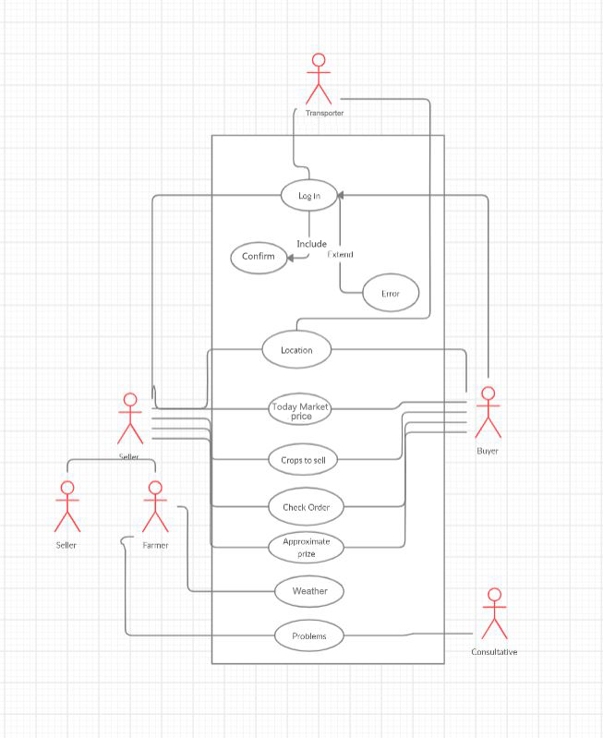Use case Diagram

Sequence diagram

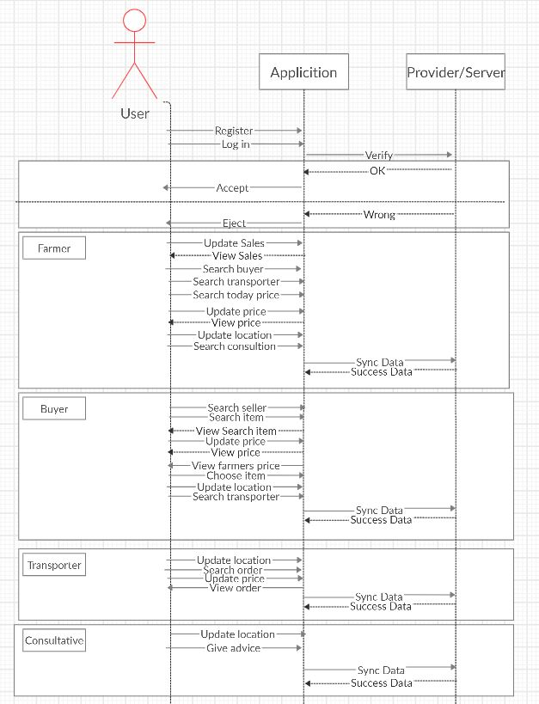

Class diagram

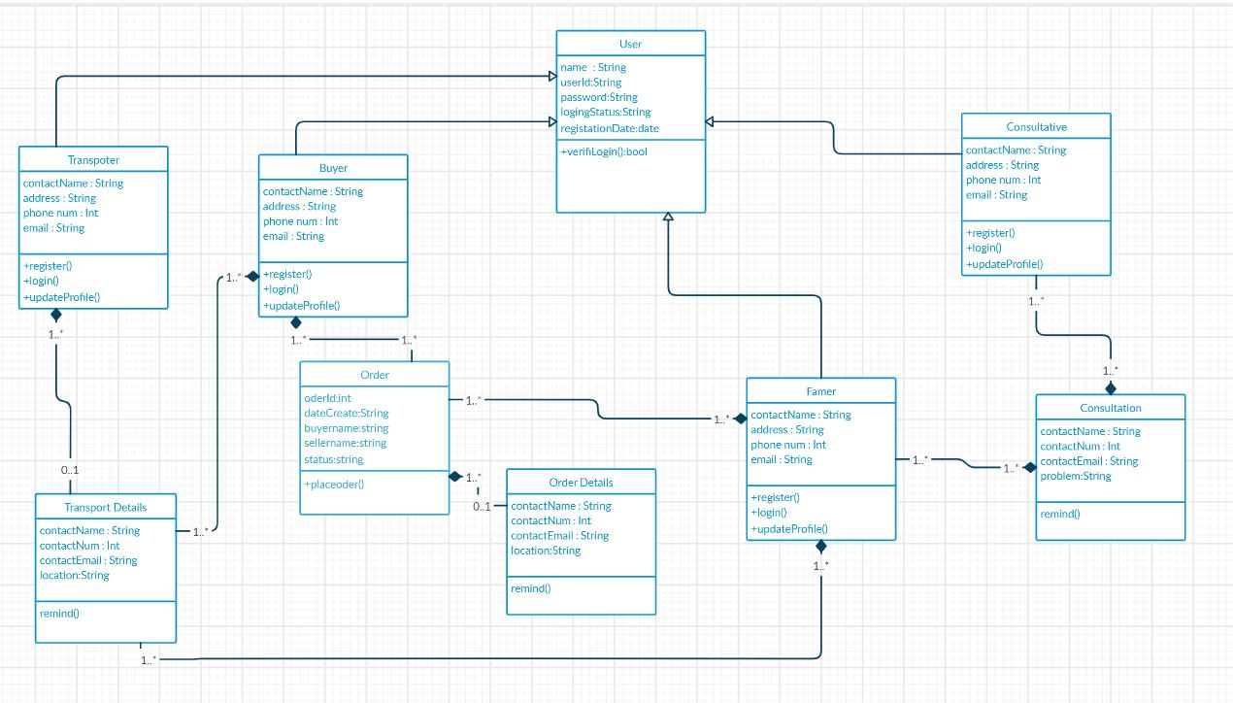

ER diagram

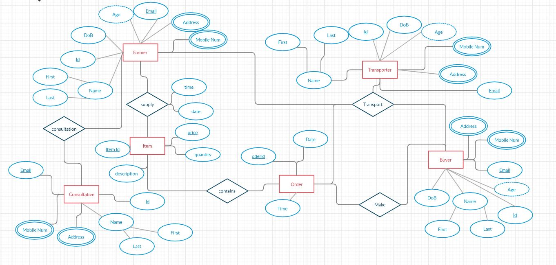

Activity diagram

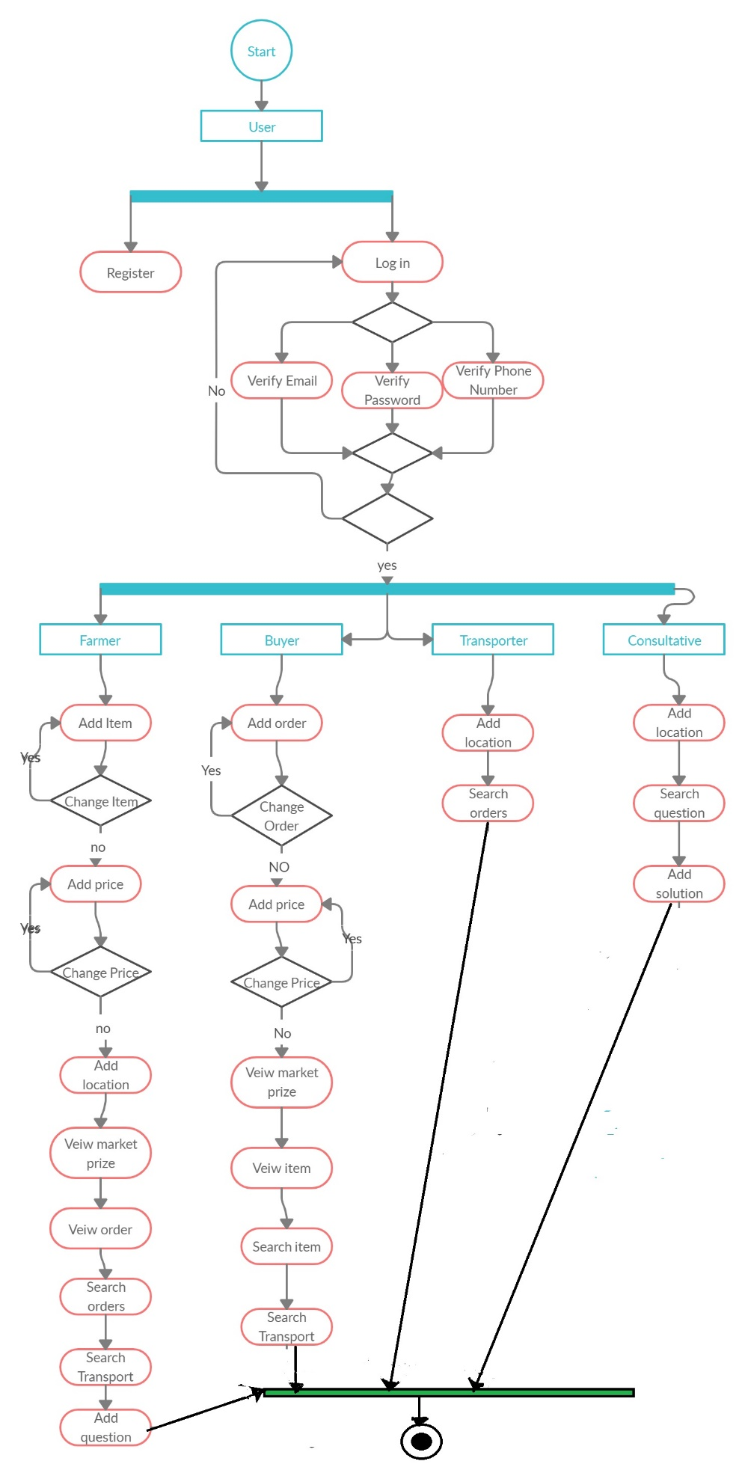

**Chapter 6 - Reference**

|  |  |
| --- | --- |
| Article title: | Top 10 Web service security requirements |
| Website title: | TechRepublic |
| URL: | <https://www.techrepublic.com/article/top-10-web-service-security-requirements/> |

|  |  |
| --- | --- |
| Author | Ulf Eriksson |
| Article title: | Functional Requirements vs Non-Functional Requirements |
| Website title: | ReQtest |
| URL: | <https://reqtest.com/requirements-blog/functional-vs-non-functional-requirements/> |

|  |  |
| --- | --- |
| Article title: | Use Case Pre-conditions and Post-Conditions[Discrete work Unit] |
| Website title: | Ooportal.com |
| URL: | <https://www.ooportal.com/project-life-cycle/module5/pre-conditions-post-conditions.php> |

|  |  |
| --- | --- |
| Article title: | 5 Biggest Challenges You Need to Face in Website Creation | StayOnSearch |
| Website title: | Stayonsearch.com |
| URL: | <https://www.stayonsearch.com/5-biggest-challenges-you-need-to-face-in-website-creation> |

|  |  |
| --- | --- |
| Article title: | W3Schools Online Web Tutorials |
| Website title: | W3schools.com |
| URL: | <https://www.w3schools.com/> |

|  |  |
| --- | --- |
| Article title: | Creately |
| Website title: | App.creately.com |
| URL: | <https://app.creately.com/diagram/> |

* <https://play.google.com/store/apps/details?id=com.arimaclanka.android.govimithuru&hl=en>
* <https://play.google.com/store/apps/details?id=com.prasadbandra.krushiadvisor&hl=en>

**Appendix A: Glossary**

* ER Diagrams - Entity Relationship diagram

**Appendix C: Individual Performance**

|  |  |  |
| --- | --- | --- |
| Reg.No. | Name | Contribution |
| 806 | Randunu Bandara | * Did the Abstract, Chapter 1 -Introduction, Chapter 3 - Similar Approaches, chapter 2 - Solutions in the report * Making the final report. |
| 858 | Thushan Dewinda | * Did the Chapter 4 – Technologies Adopted. * Gave Ideas and Created all the Interfaces and how our application should work. |
| 883 | Bathiya Lakruwan | * Draw all the Diagrams (Class diagrams, ER Diagrams, use case Diagrams, Activity Diagrams, Sequence diagrams) that needed for the report. |
| 1090 | Anuradha Kandewaththa | * Marked and corrected all the mistakes in the report. * Did the Reference part (Chapter 6) |

We all worked together and every member helped others when someone need a help.