Software Requirements Specification

for

Agricultural Forum

<Version number approved>

Prepared by - Group A

Sri Lanka Technological Campus

29th April 2020

Contents

1.Introduction ii

1.0 Purpose ii

1.1 Document Conventions ii

1.2 Intended Audience and Reading Suggestions ii

1.3 Project Scope ii

1.4 References ii

3.Overall Description iii

2.1Product Perspective iii

2.2Product Features iii

2.3User Classes and Characteristics iii

2.4 Operating Environment iv

2.5 Design and Implementation Constraints iv

2.6 User Documentation v

2.7Assumptions and Dependencies v

3.System Features vi

3.1System Feature 1 vi

3.1System Feature 2 vii

3.1System Feature 3 viii

3.1System Feature 4 x

4 External Interface Requirements xii

4.1User Interfaces xii

4.2Hardware Interfaces xv

4.3 Software Interfaces xv

4.4Communications Interfaces xv

5 Other Nonfunctional Requirements xvi

5.1Performance Requirements xvi

5.2 Safety Requirements xvi

5.3 Security Requirements xvii

# 1.Introduction

## Purpose

Cultivation is an important sector in Sri Lanka. In cultivation, lot of parties are involved in it. Such as Agricultural department, weather department, Water suppliers, third party, sellers, buyers, transport services, fertilizer weed killer and insecticide making companies, labors etc. with enrolment of these parties ,get the results of severe price fluctuations ,high post-harvest losses and high cost of business activities and finally low income for the farmer. It is very unfair for the farmer. we should minimize contribution of third party for this process. Within this application we will be able to find solution for this problem.

## Document Conventions

SRS - Software Requirements Specification

## Intended Audience and Reading Suggestions

The intended audience fir this document is:

* Group members (Group members are the Developers, project managers, marketing staff, users, testers)
* The project Supervisors: Mr. Yohan and Ms. Dinithi Shakya.

This document will be read by this audience frequently to check that the project is being completed with the mentioned features and requirements. So, if there are any changers to do to the project it is easy to identify and make the necessary changers.

## Project Scope

Today there is a difficulty for the farmers to sell their harvest and also the haven’t a place to discuss their problems. So, this is an application that Farmers can share their information, farmers can get updates on daily market prices, Agricultural consultative can update their accounts with information about agriculture, and also farmers can discuss their problems with those consultative. To buy those crops buyers can add their daily purchase prices, transport service owners also can add their information.

## References

<https://www.techrepublic.com/article/top-10-web-service-security-requirements/>

<https://reqtest.com/requirements-blog/functional-vs-non-functional-requirements/>

<https://www.ooportal.com/project-life-cycle/module5/pre-conditions-post-conditions.php>

<https://www.stayonsearch.com/5-biggest-challenges-you-need-to-face-in-website-creation>

# 2.Overall Description

## 2.1Product Perspective

This is an application that comes under e-farming. Farmers can discuss their problems with agricultural consultative and also, they can sell their harvest easily through this application.

## 2.2Product Features

* Conversation facility between two users.
* Special online meetings with agricultural Consultative.
* Find the location of farmers, buyers, transport service owners.
* Online ordering.
* Online paying.

## 2.3User Classes and Characteristics

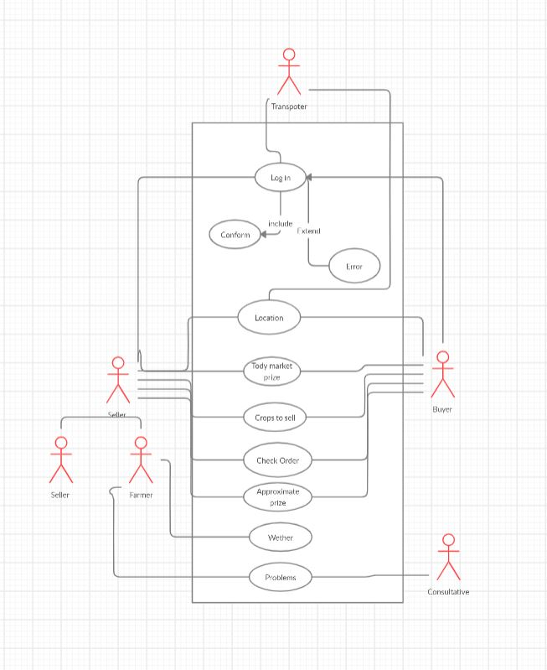

## 2.4 Operating Environment

An operating environment is the environment which users run the application.

|  |  |
| --- | --- |
| OS | Version |
| Windows | Windows XP  Windows Vista  Windows 7  Windows 8  Windows 8.1  Windows 10 |
| Linux | Ubuntu  Mint  Debian  Fedora  Red Hat Enterprise Linux  openSUSE |
| Android | Any version that supports a web browser |
| IOS | Any version that supports a web browser |

As this is a web application it is compulsory to have a web browser in the device.

## 2.5 Design and Implementation Constraints

**1. Accessibility**

There are people of various backgrounds, abilities and disabilities. We need to design and develop it in a way that all users have an equal access to the information, functionality and features of the site.

2**. Browser** **Compatibility**

To test our website for compatibility, we need to check it on different browsers, operating systems and monitor resolution.

3. **Usability**

Our website should be easy to use and the information should be easy to retrieve for users.

4. **Navigability**

If users are unable to easily navigate through our website, they will leave as quickly as they come.

5. **Readability**

When creating our website, we should focus on making it readable for all users. Always we have to choose a font which is clear on screen and is easy to read. The same goes with the layout of the content and text color.

## 2.6 User Documentation

We will be delivering an online help along with the application.

## 2.7Assumptions and Dependencies

<List any assumed factors (as opposed to known facts) that could affect the requirements stated in the SRS. These could include third-party or commercial components that you plan to use, issues around the development or operating environment, or constraints. The project could be affected if these assumptions are incorrect, are not shared, or change. Also identify any dependencies the project has on external factors, such as software components that you intend to reuse from another project, unless they are already documented elsewhere (for example, in the vision and scope document or the project plan).>

# 3.System Features

There are different uses who will be using this product, they are Farmers, Agricultural consultative, Buys, Transport Service Owners. So different users have different features.

## 3.1System Feature 1

* Conversation facility between two users.

3.1.1 Description and Priority

This is a feature that our all users can have. In here two users get connected together. It may be A farmer with another farmer, a farmer with an agricultural consultative, a farmer with a buyer, farmer with a transport service provider, a buyer with a transport service provider. After connecting, they can share their information with the other user. In our application this feature has a high priority.

|  |  |
| --- | --- |
|  | Rating (0-9) |
| Priority | 9 |
| Benefit to the user | 9 |
| Cost | 3 |
| Risk | 5 |

3.1.2 Stimulus/Response Sequences

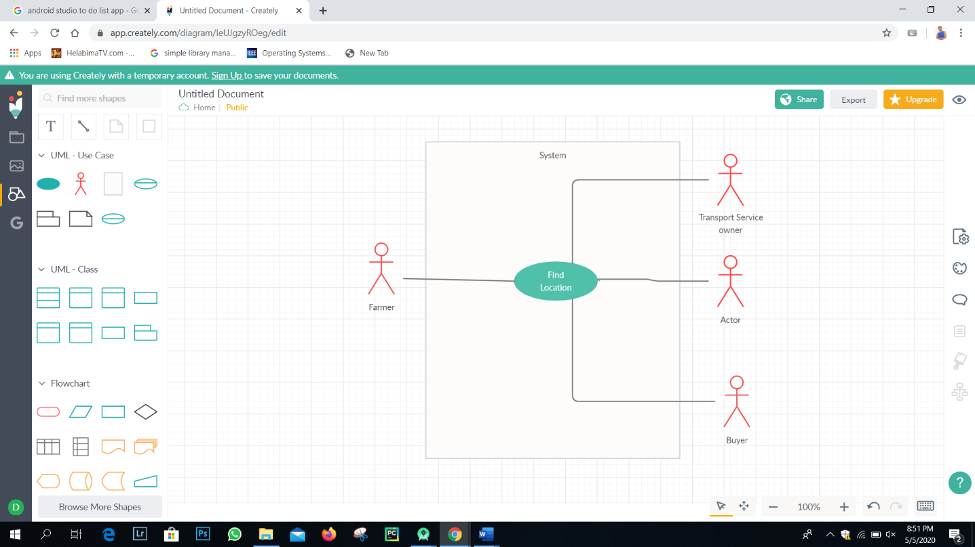

|  |  |
| --- | --- |
| Use Case Name | Conversation facility between two users |
| Assumptions | The actors must log in to the system before use this feature |
| Pre-conditions | The user has permission to use this feature |
| Initiation (Triggering event) | This use case starts when the user chooses this option |
| Main flow of events | 1.User have to select with whom he needs to start the conversation.  2.Conversation starts.  3.Conversation ends. |
| Exceptional flow of events |  |
| Post-conditions | Both uses have to stop the conversation |

## 3.1System Feature 2

* Special online meetings with agricultural Consultative.

3.2.1 Description and Priority

This is a feature that a farmer and an agricultural consultative can have. If a group of farmers have the same problem to solve with an agricultural consultative, they can arrange a meeting and can discuss with their problem.

|  |  |
| --- | --- |
|  | Rating (0-9) |
| Priority | 9 |
| Benefit to the user | 9 |
| Cost | 3 |
| Risk | 6 |

3.2.2 Stimulus/Response Sequences

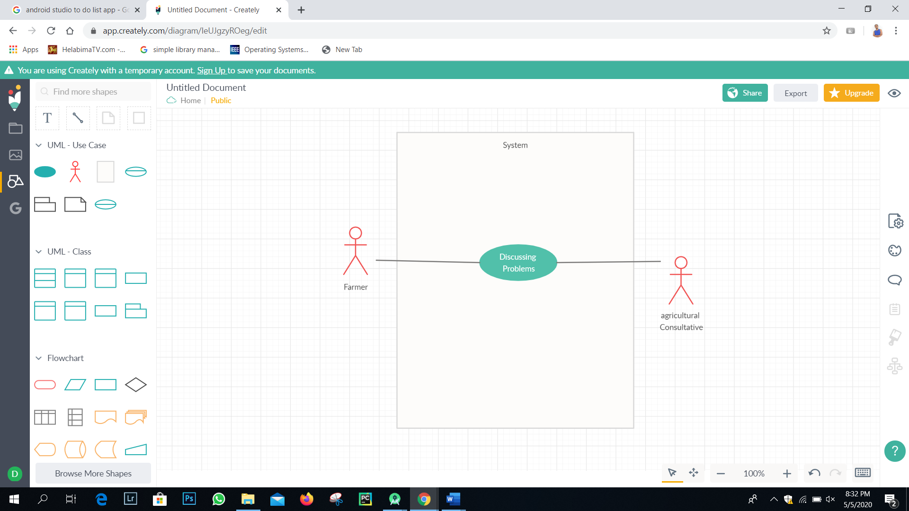

|  |  |
| --- | --- |
| Use Case Name | Special online meetings with agricultural Consultative |
| Assumptions | The actors must log in to the system before use this feature |
| Pre-conditions | The user has permission to use this feature |
| Initiation (Triggering event) | This use case starts when the user chooses this option |
| Main flow of events | 1.Users have to Schedule a meeting.  2.User can invite others who using this application.  3.Meeting starts at the scheduled time.  4.Meeting ends. |
| Exceptional flow of events |  |
| Post-conditions | The meeting is over. |

## 3.1System Feature 3

* Find the location of farmers, buyers, transport service owners.

3.3.1 Description and Priority

This feature is mostly targeting Farmers and Transport service owners. When a farmer wants to sell his harvest, he needs to carry his harvest to the market so he needs a transport facility. So, when the transport service owners can find the place through the application where the farmer is, it is easy for them to reach the farmers place. And also, buyers can find the location of transport service providers farmers.

|  |  |
| --- | --- |
|  | Rating (0-9) |
| Priority | 8 |
| Benefit to the user | 8 |
| Cost | 4 |
| Risk | 8 |

3.3.2 Stimulus/Response Sequences

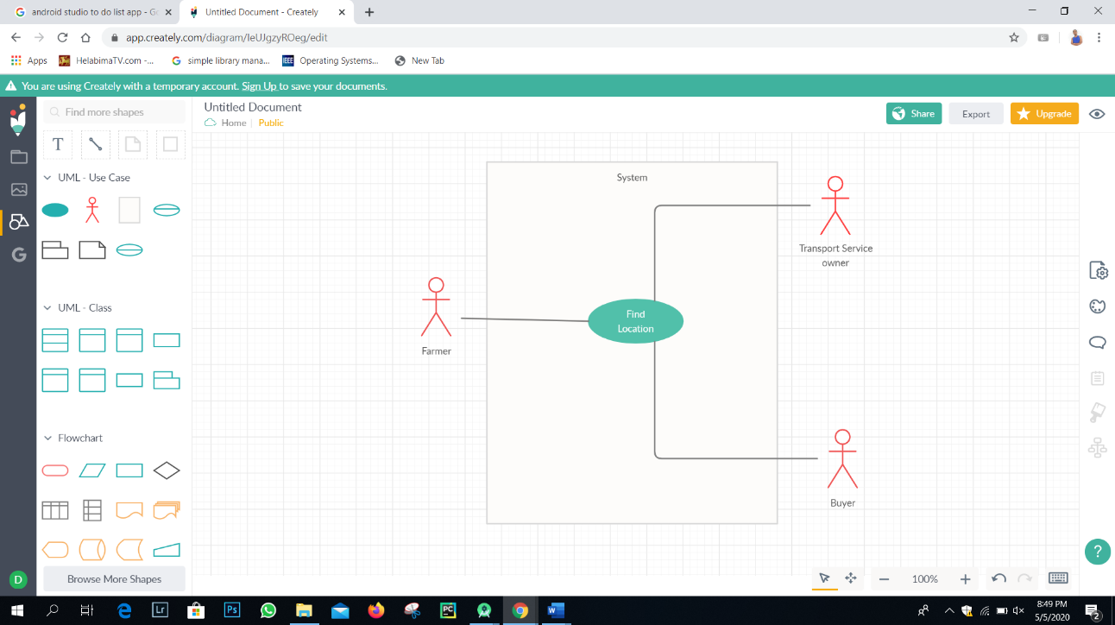

|  |  |
| --- | --- |
| Use Case Name | Find the location of farmers, buyers, transport service owners |
| Assumptions | The actors must log in to the system before use this feature |
| Pre-conditions | The user has permission to use this feature |
| Initiation (Triggering event) | Use case starts when the user chooses this option |
| Main flow of events | 1.User Chooses the person that he wants to find the location.  2.Search the location. |
| Exceptional flow of events |  |
| Post-conditions |  |

## 3.1System Feature 4

* Online ordering and paying.

3.4.1 Description and Priority

Farmers, Buyers and the transport service providers are the once who deal with money, so if there is an online paying method in our application it will be very easy for them.

|  |  |
| --- | --- |
|  | Rating (0-9) |
| Priority | 7 |
| Benefit to the user | 8 |
| Cost | 3 |
| Risk | 6 |

3.4.2 Stimulus/Response Sequences

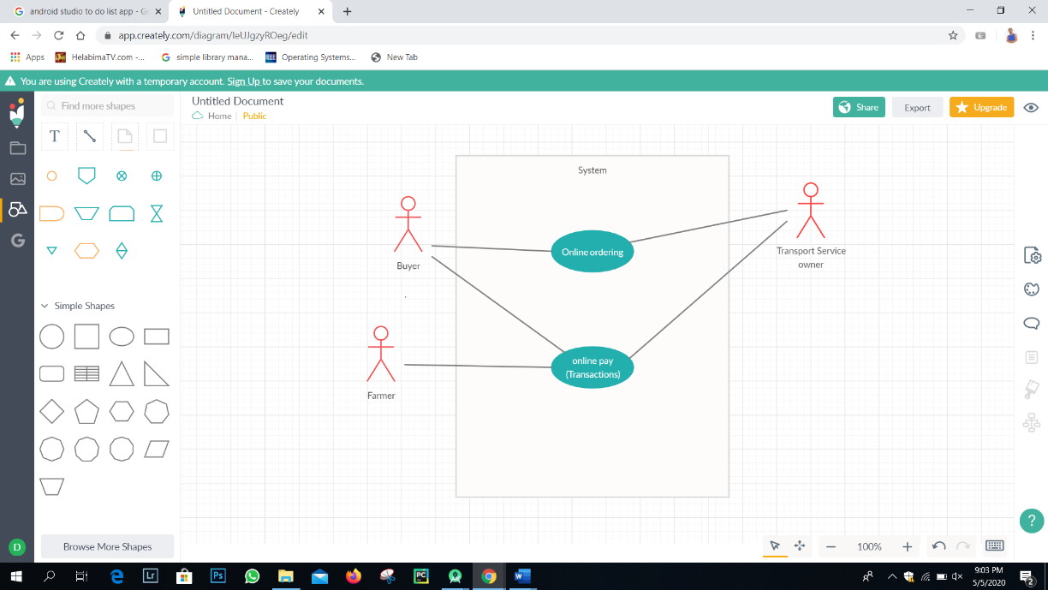

|  |  |
| --- | --- |
| Use Case Name | Online ordering. |
| Assumptions | The actors must log in to the system before use this feature |
| Pre-conditions | The user has permission to use this feature |
| Initiation (Triggering event) | Use case starts when the user chooses this option |
| Main flow of events | 1.User make an order.  2.Another user get the order. |
| Exceptional flow of events |  |
| Post-conditions | User close the order |

|  |  |
| --- | --- |
| Use Case Name | Online paying. |
| Assumptions | The actors must log in to the system before use this feature |
| Pre-conditions | The user has permission to use this feature |
| Initiation (Triggering event) | Use case starts when the user chooses this option |
| Main flow of events | 1.Choose the way of paying.  2.Select the account that he wants to pay.  3.Select the amount.  4.Pay |
| Exceptional flow of events |  |
| Post-conditions |  |

# 4 External Interface Requirements

## 4.1User Interfaces

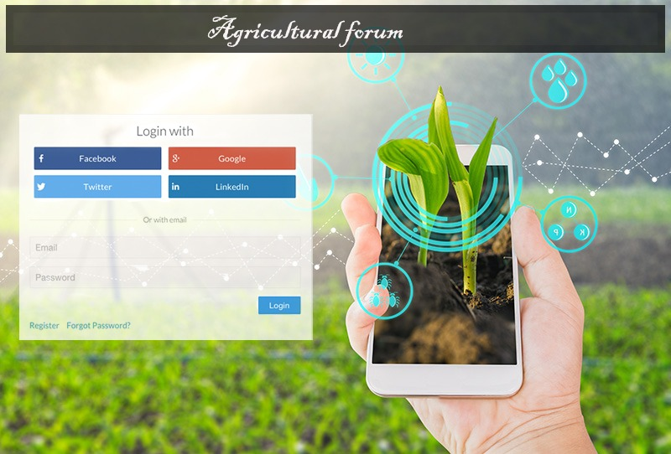

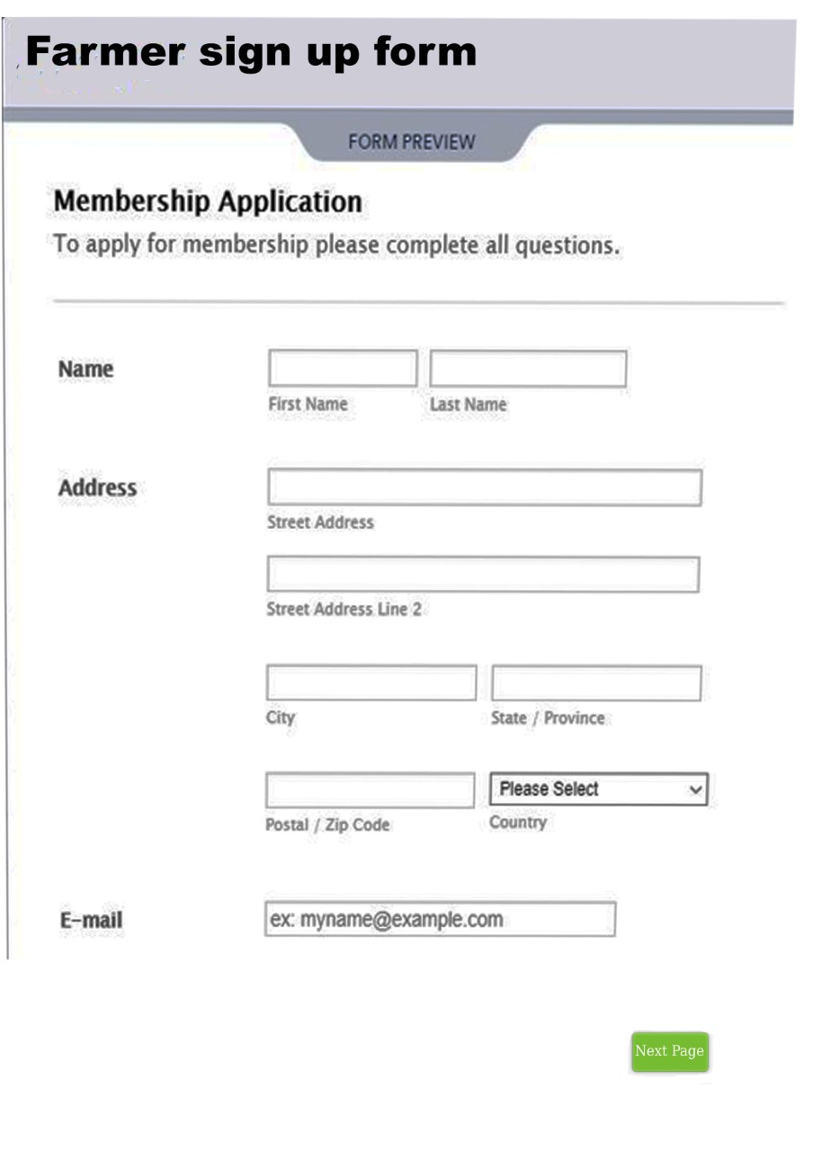

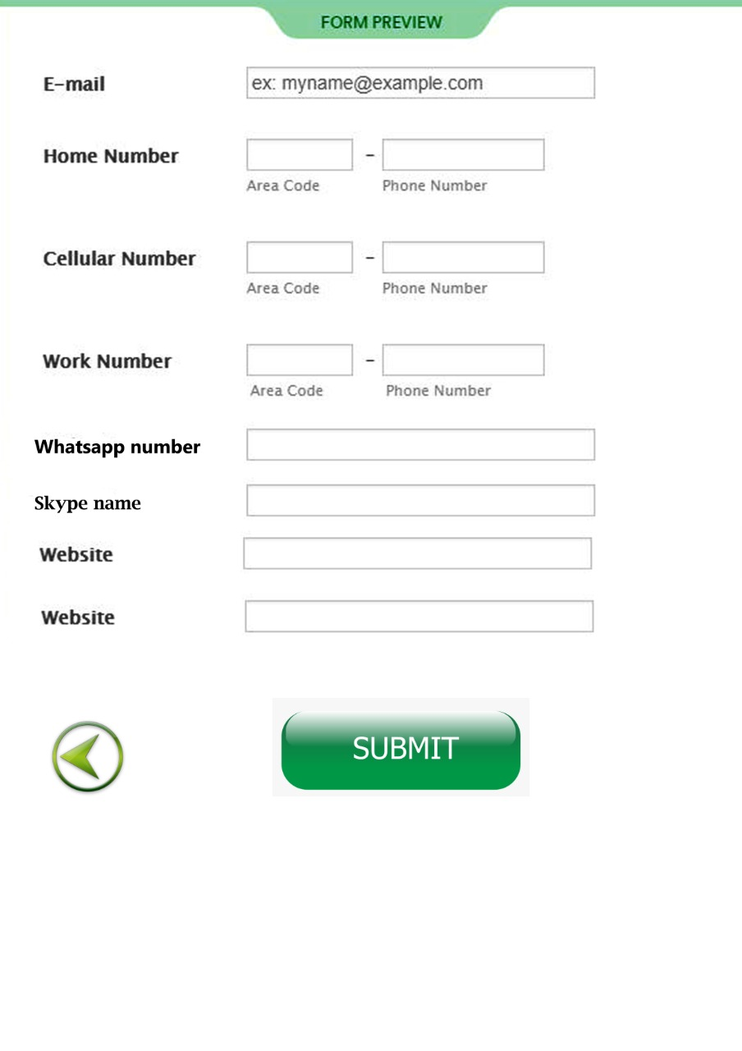

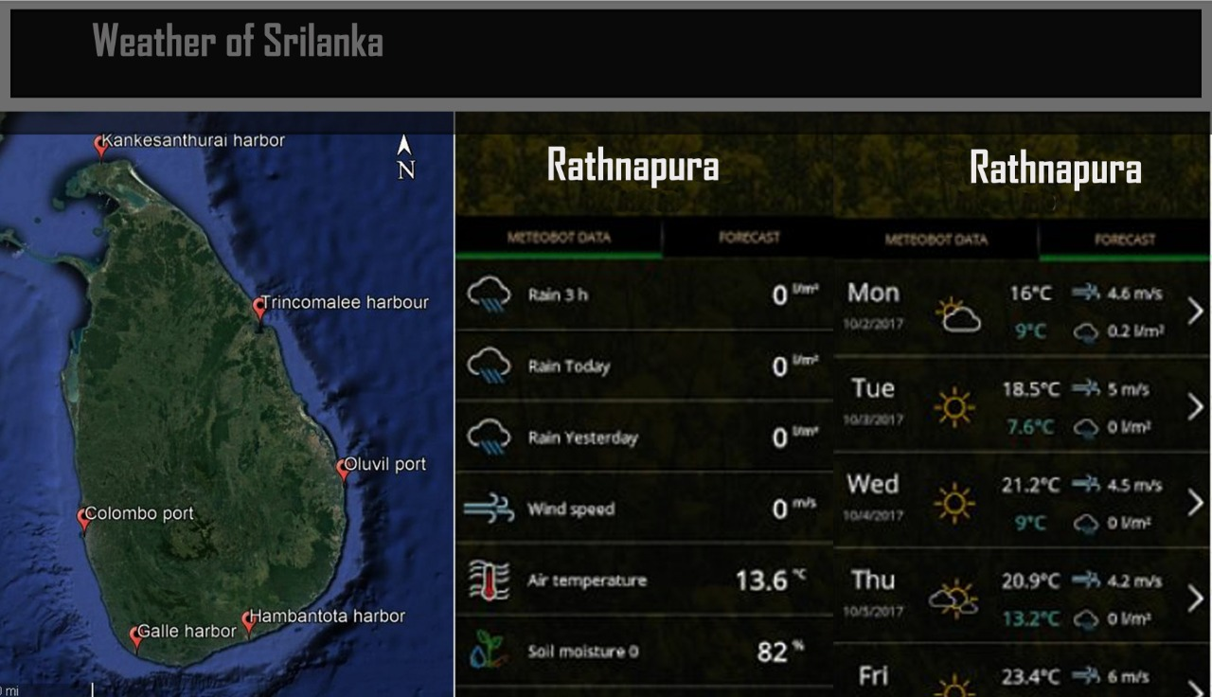

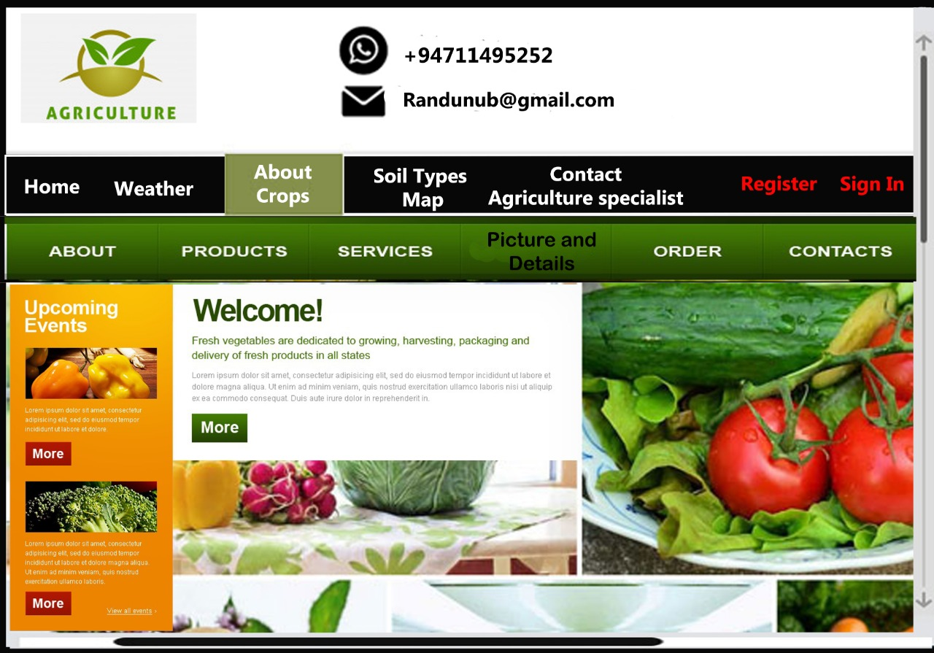

## 4.2Hardware Interfaces

We are not using External hardware components in our system.

## 4.3 Software Interfaces

Web Browser

## 4.4Communications Interfaces

This is a web application. So, we need,

E-mails, Network servers, web browsers, Communication Standards (HTTP).

# Other Nonfunctional Requirements

## 5.1Performance Requirements

* Scalability
* Capacity
* Availability
* Reliability
* Recoverability
* Maintainability
* Serviceability
* Security
* Regulatory
* Manageability
* Environmental
* Data Integrity
* Usability
* Interoperability

## Safety Requirements

Authentication  
Authentication ensures that each entity involved in using a Web service—the requestor, the provider, and the broker (if there is one)—is what it actually claims to be. Authentication involves accepting credentials from the entity and validating them against an authority.  
  
Authorization  
Authorization determines whether the service provider has granted access to the Web service to the requestor. Basically, authorization confirms the service requestor’s credentials. It determines if the service requestor is entitled to perform the operation, which can range from invoking the Web service to executing a certain part of its functionality.  
  
Data Protection  
Data protection ensures that the Web service request and response have not been tampered with a route. It requires securing both data integrity and privacy. It’s worth mentioning that data protection does not guarantee the message sender’s identity

### 5.3 Security Requirements

* Apply network security measures
* Provide the right permissions
* The app should request only the minimum number of permissions necessary to function properly.
* Store data safely
* The app might require access to sensitive user information, users will grant your app access to their data only if they trust that we safeguard it properly.
* Store all private user data that other web applications cannot access those files.