**F74044070 Project3 Report**

*UML Diagram

|  |
| --- |
| MainWindow: inherit QMainWindow |
| -scene: QGraphicsScene * |
| -world: b2World * |
| -itemList: QList<GameItem *> |
| -timer: QTimer |
| +mushroom: Bird * |
| +goomBa: FloppyBird * |
| +kirby: SprintBird * |
| +turtle: StrikeBird * |
| +fist: Bird * |
| +BirdList: QList<GameItem *> |
| +bgm: QMediaPlayer |
| +wood: Barrier * |
| +wood2: Barrier * |
| +hori_wood: Barrier * |
| +lbj: Bird * |
| +x_cor: float |
| +y_cor: float |
| +mousePosition: b2Vec2 |
| +mousePressed: bool |
| +basePt_x: float |
| +basePt_y: float |
| +forceVector: b2Vec2 |
| +score: QLabel * |
| +scoreNum: int |
| +scoreStart: bool |
| +isConnected: bool |
| +click: int |
| +cnt: int |
| +enemyExist: bool |
| +<<explicit>> MainWindow(QWidget *parent = 0): void |
| +~MainWindow() |
| +showEvent(QShowEvent *): void |
| +eventFilter(QObject *,event: QObject): bool |
| +closeEvent(QCloseEvent *): void |
| +keyPressEvent(event: QKeyEvent *): void |
| +resetBirds(): void |
| +resetBarriers_n_Enemy(): void |
| +scoreIncrement(): void |
| +<<signals>>quitGame(): void |
| -<<slots>>tick(): void |
| -<<slots>>QUITSLOT(): void |
| -<<slots>>resetGame(): void |
| -<<slots>>closeGame(): void |

|  |
| --- |
| GameItem: inherit QObject |
| +g_body: b2Body * |
| +g_pixmap: QGraphicsPixmapItem |
| +g_size: QSizeF |
| +g_world: b2World * |
| +g_worldsize: static QSizeF |
| +g_windowsize: static QSizeF |
| +GameItem(world: b2World *) |
| +~GameItem() |
| +setGlobalSize(worldsize:QSizeF, windowsize: QSizeF): static void |
| +<<slots>>paint(): void |

|  |
| --- |
| Barrier: inherit GameItem |
| +Barrier(x: float, y: float, w: float, h: float, timer: QTimer *, pixmap: QPixmap, world: b2World *, scene: QGraphicsScene *) |

|  |
| --- |
| Bird: inherit GameItem |
| +Bird(x: float, y: float, radius: float, timer: QTimer *, pixmap: QPixmap, world: b2World *, scene: QGraphicsScene *) |
| +setLinearVelocity(velocity: b2Vec2):void |
| +birdFunction(): virtual void |

|  |
| --- |
| FloppyBird: inherit GameItem |
| +FloppyBird(x: float, y: float, radius: float, timer: QTimer *, pixmap: QPixmap, world: b2World *, scene: QGraphicsScene *) |
| +setLinearVelocity(velocity: b2Vec2):void |
| +birdFunction(): virtual void |

|  |
| --- |
| SprintBird: inherit GameItem |
| +SprintBird(x: float, y: float, radius: float, timer: QTimer *, pixmap: QPixmap, world: b2World *, scene: QGraphicsScene *) |
| +setLinearVelocity(velocity: b2Vec2):void |
| +birdFunction(): virtual void |

|  |
| --- |
| StrikeBird: inherit GameItem |
| +StrikeBird(x: float, y: float, radius: float, timer: QTimer *, pixmap: QPixmap, world: b2World *, scene: QGraphicsScene *) |
| +setLinearVelocity(velocity: b2Vec2):void |
| +birdFunction(): virtual void |

|  |
| --- |
| Land: inherit GameItem |
| +Land(x: float, y: float, w: float, h: float, timer: QTimer *, pixmap: QPixmap, world: b2World *, scene: QGraphicsScene *) |

*Inheritance Relationship

**MainWindow**

Land

**SprintBird**

**FloppyBird**

**GameItem**

**Bird**

**StrikeBird**

**Barrier**

How To Play

**Gameplay:**

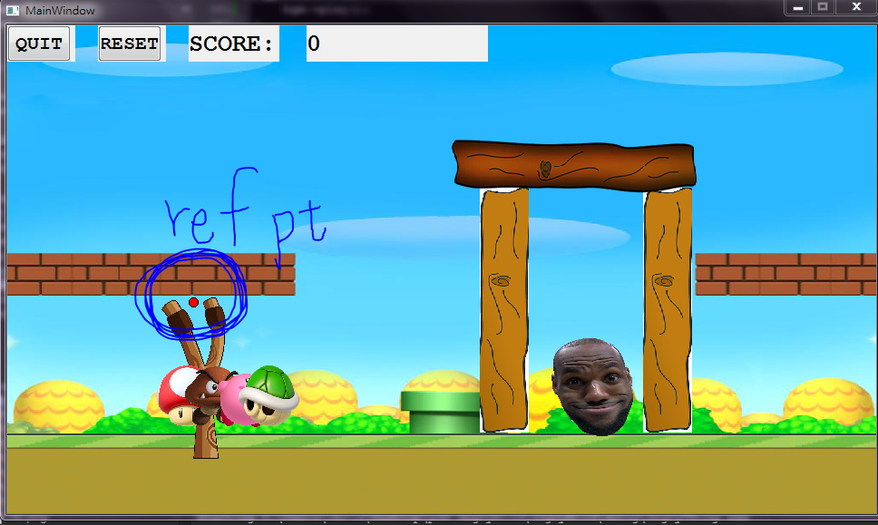

As you can see, I placed a red dot in the middle of the screen, which represents the reference point (6.0,9.0).

I drag the characters to the left of the sling shot, and record the point by the time I release my mouse, and multiply (reference point – release point) by k, the spring constant, to get the elastic force. (Formula: F = k*deltax)

*The goal is to reach 600 points, and eliminate the enemy on the right.

**Character Speial Skills: (Hit SPACEBAR to activate ability)**



MUSHROOM

Normal, no ability, simply launch it to hit the enemy.



GOOMBA

It has the ability of floppy bird, when I hit space bar, it launches midair with a smaller speed.



KIRBY

When I hit space bar midair, Kirby sprints down towards the enemy with high speed.



TURTLE

It summons the “FIST OF GOD” when I hit space bar, and creates a disaster.