Heading Level 1
Paragraph text with a blank line above and below. This tests basic paragraph rendering.
Heading Level 2
Heading Level 3
Heading Level 4
Heading Level 5
Heading Level 6
Text Formatting
This is bold text and this is also bold. This is italic text and this is also italic. This is bold and italic together. This is strikethrough text. This is _{subscript} and this is ^{superscript}. This is underlined text.
Escaped special characters: {not italic} and not a heading.
Line break with two trailing spaces:
This is on the next line.
Line break with backslash:
This is also on the next line.
And a
hard break via HTML.
Links
Here is an inline link and a link to a section.
Here is a relative link to another file.
Bare URL autolink: https://github.com
GitHub references: @octocat and issue #42.
Images
Standard markdown image (no size control):

HTML image with custom width:
HTML image with custom height only (width should auto-calculate from aspect ratio):

HTML image with custom width and height:

HTML image with percentage width:

Picture element for light/dark theme variants:

Large wide image (should be clamped to page width):
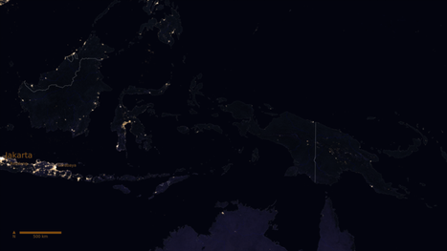
Large tall image (should be clamped to page height):
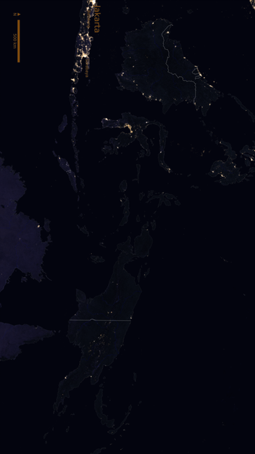
Blockquotes
This is a blockquote.
It can span multiple lines.
This is a nested blockquote with actual content inside it.
Alerts
Note
This is a note alert with helpful information.
Tip
This is a tip alert with a suggestion.
Important
This is an important alert.
Warning
This is a warning alert.
Caution
This is a caution alert.
Unordered Lists
• First item
• Second item
• Nested item A
• Nested item B
• Deeply nested item
• Third item
Alternative markers:
• Star item one
• Star item two
• Plus item one
• Plus item two
Ordered Lists
1. First step
2. Second step
1. Sub-step A
2. Sub-step B
3. Third step
Task Lists
☑ Completed task
☐ Incomplete task
☑ Another done task
☐ Nested incomplete subtask
☑ Nested complete subtask
Inline Code
Use the println() function to print output. The config file is at ~/.config/app.json.
Fenced Code Blocks
fun main() {
val greeting = "Hello, World!"
println(greeting)
}
<uses-permission android:name="android.permission.INTERNET" />
#!/bin/bash
echo "No language-specific highlighting"
Plain code block with no language specified.
Tables
Feature | Status | Notes
Bold | Supported | Uses **text**
Italic | Supported | Uses *text*
Tables | Supported | You're looking at one
Left, center, and right alignment:
Left | Center | Right
L1 | C1 | R1
L2 | C2 | R2
Horizontal Rules

Footnotes
Here is a sentence with a footnote reference ^{[1]} . And another ^{[longnote]} .
Emoji
Emoji shortcodes: :rocket: 🚀, :tada: 🎉, :warning: ⚠️
Color Codes
GitHub renders color swatches for these inline code formats:
#FF5733 #28A745 rgb(54, 95, 145) hsl(210, 45%, 39%)
HTML Comments

Visible text after a hidden comment.
Mixed Nesting
1. Ordered item with bold and code
• Unordered sub-item with a link
• Another sub-item with italic
> A blockquote inside a list
2. Second ordered item
# Code block inside a list
print("hello")
3. Third item with strikethrough

Footnotes
1. This is the first footnote.
longnote. This is a longer footnote with multiple words.

