BACK

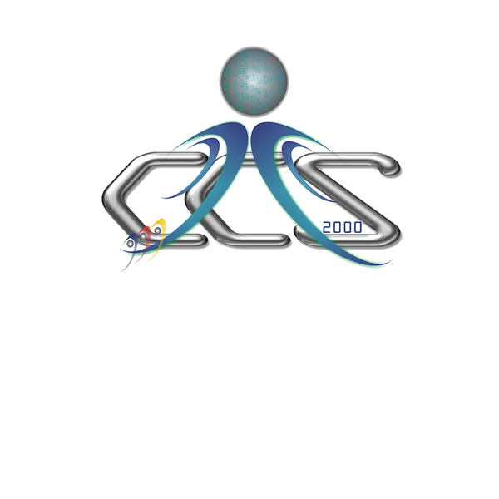


PROGRAMS

The Information Technology (IT) specialization aims to produce quality graduates who have the knowledge and skills to understand business and organizational problems, as well as to analyze, formulate, and evaluate IT and business solutions. The program includes 500 hours on-the-job training program that is supported by strategic alliances with cutting-edge IT partners in the ICT Industry.
BACHELOR OF SCIENCE IN INFORMATION TECHNOLOGY

The Software Technology (ST) specialization trains students to have the ability to develop and manage complex and reliable software systems. It provides a comprehensive and in-depth treatment of the different bodies of knowledge in Computer Science. The program trains students in the discipline of software engineering, focusing on the design of efficient, reliable, and quality software products. This makes ST students more capable of doing intensive ICT research.
The Software Technology program prepares students to become mature software engineers and researchers.
BACHELOR OF SCIENCE IN COMPUTER SCIENCE

