Knowledge Base

How to attach equipment to socket

On begin play or anytime you want to equip an item:

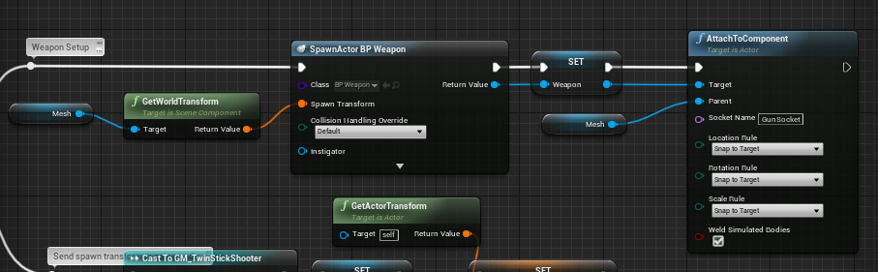Mesh represents the player skeletal mesh