EDP Changes:

VS:

1. Addes userrole

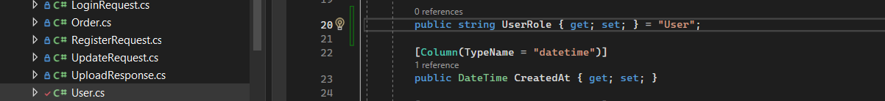

1. A computer screen with text

   Description automatically generated
2. Created admin controller