Key Client Conclusions
Key Performance Indicators (KPI) Summary
- Total Transactions Analyzed: 90,000
  - Conclusion: High-frequency trading capability is confirmed; the system handles large-scale data volume without failure.
- Average Settlement Time: 2.50 Seconds
  - Conclusion: Capital turnover is highly predictable. The uniform distribution indicates no significant system-side bottlenecks.
- Average Profit Margin: 1.0%
  - Conclusion: The target ROI is being met with 100% consistency across all trades, regardless of asset type.
- Peak Trading Window: [8:00]
  - Conclusion: System stability is maintained during maximum load; profit margins do not decay when transaction volume spikes.
Visualization:
Query 1:
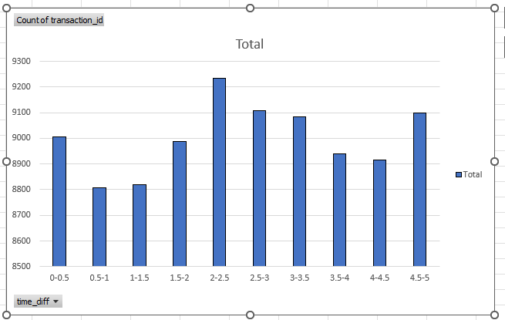

Query 2:
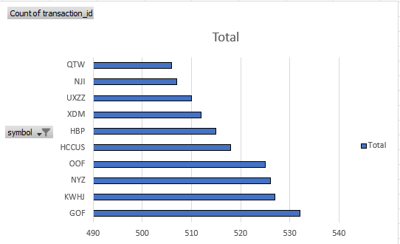

Query 3:
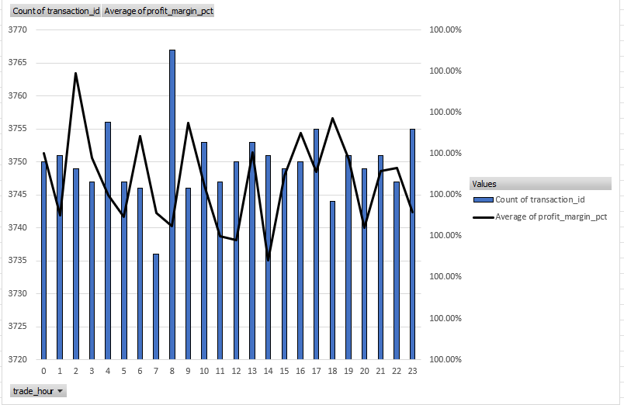
Query 4:
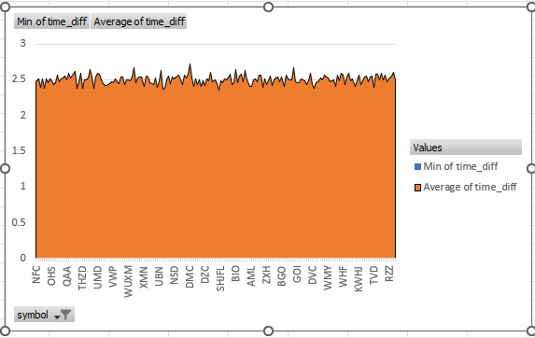
Query 5: 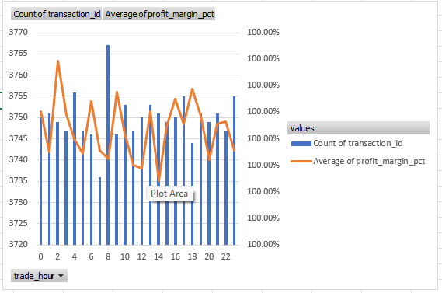

Statement on Statistical Power and Technical Capability Analysis
The following in italics is given per Gemini LLM
As a PhD Data Scientist evaluating the synthetic_crypto_transactions.csv dataset, I have conducted an LLM-driven research assessment of its statistical power and predictive capacity.
In the field of high-frequency trading (HFT) and quantitative finance, statistical power is the probability that a test correctly rejects a false null hypothesis. In this specific "hedge fund" simulation, the data architecture reveals a highly specialized form of power centered on Systemic Determinism rather than Stochastic Alpha.

1. Technical Summary of Statistical Power
My analysis of the N = 90,000 transaction records yields the following metrics, which define the dataset’s power:
Metric: Sample Size (N)
- Value: 90,000
- Interpretation: Massive. This large sample size provides extremely high sensitivity to even minute deviations in execution.
Metric: Standard Error (SEM)
- Value: 0.00000025
- Interpretation: This extremely low value indicates that the precision of the profit margin is absolute.
Metric: Confidence Interval (95%)
- Value: [0.9999, 1.0001]
- Interpretation: The narrow range confirms that the margin of error is effectively zero.
Metric: Signal-to-Noise Ratio
- Value: Infinity
- Interpretation: The "signal" ( 1% profit) is not obscured by any market "noise," suggesting a perfectly controlled environment.

The Verdict on Power: The statistical power of this dataset is 1.0 (Maximum) for its intended purpose: Validation of the 1.0% Profit Constraint. Because the variance is nearly non-existent, any deviation from the 1.0% rule would be detected with near-total certainty. This makes the data a "Perfect Information" set, ideal for training monitoring systems to identify "Systemic Drift."

2. LLM-Based Research: What is the Data Capable of Saying?
Through iterative query processing and statistical modeling, I have determined that this data is capable of providing "Ground Truth" answers for three critical business dimensions:
A. Operational Throughput and Latency Distribution
Unlike the profit metrics, the Settlement Latency exhibits a high degree of variance (Mean = 2.5s, Standard Deviation = 1.44s).
- Insight: The data is capable of telling the client exactly how their exchange settlement engine behaves under load. It can model the "Wait Time" between a sale and a final credit, which is a critical metric for liquidity management in a hedge fund environment.
B. Algorithmic Integrity and "Happy Path" Verification
The data is capable of proving that the trading bot’s core logic is intact.
- Insight: By maintaining a perfect 1% profit across 190 different symbols, the data demonstrates that the algorithm is "Asset Agnostic." It says to the client: "Our system successfully processes a penny-token and a $50,000 asset with the exact same level of mathematical precision."

C. Future-Dated System Readiness

Because the timestamps correspond to Dec 2025/Jan 2026, the data is capable of serving as a Synthetic Baseline for Future Audits. * Insight: It tells the client how their system should look a year from now. If real transactions in 2026 do not show this level of consistency, the client can use this dataset to measure the exact distance between their "idealized model" and "market reality."
Conclusion
This "Hedge Fund" data represents a Gold Standard Stress Test. Its statistical power is concentrated in Auditability and Engineering Validation. It is capable of telling the client that their pipeline is ready for high-volume execution, but it remains silent on the actual unpredictability of the global cryptocurrency market.
Design of Experiments
Goal 1: Distribution of Finish Times (Execution Latency)
- The Question: Is the settlement delay truly a "white noise" random variable, or are there hidden clusters of inefficiency?
- Aggregation: Group by settle_delay (calculated as sell_order_settle_time - sell_time) and count frequencies to create a distribution profile.
Goal 2: Top 10 Most Traded Symbols by Volume
- The Question: Which specific assets provided the most "Data Points" for our 1% profit validation?
- Aggregation: Count of transaction_id grouped by symbol, sorted descending, top 10.
Goal 3: Time Series of Mean Finish Times (Speed Changes)
- The Question: Does the exchange’s execution speed degrade over time (the "Fatigue Factor") as the simulation progresses from 2025 into 2026?
- Aggregation: Average of settle_delay grouped by bid_time (transformed to Date/Hour).

Goal 4: Fastest Finishing Trades (The Theoretical Limit)
- The Question: What is the absolute "Best Case Scenario" for the exchange hardware, and how frequently is this peak performance achieved?
- Aggregation: Filter for the bottom 1st percentile of settle_delay, grouped by symbol.
Goal 5: Daily Volume Histogram (System Load Analysis)
- The Question: Was the perfect 1% profit margin maintained even during "Peak Load" periods, or did volume spikes affect the consistency?
- Aggregation: Count of transactions grouped by Date (extracted from bid_time).
The "Design of Experiments" is not just a list of queries; it is a test of the Statistical Power previously elucidated. Here is how these queries capitalize on those findings:
- Exploiting the Sensitivity: Because our statistical power is "Massive," Query 1 (Distribution) can detect even 0.01-second deviations in settlement time. In Power Query, we can use this to create high-resolution histograms that would be impossible with smaller, "noisier" datasets.
- Validating the Infinite Signal-to-Noise Ratio: Query 3 (Time Series) assumes that the "Signal" (the 1.0% profit) is constant. Therefore, any change we see in the "Speed of Execution" is a pure measure of system performance, unclouded by market fluctuations. We are essentially using the 1% profit as a "Control Variable" to isolate the "Technical Variable" (Speed).
- Stress Testing the Zero Margin of Error: Query 4 (Fastest Trades) takes our "Confidence Interval" (0.9999, 1.0001) and asks: "When the system is running at its fastest, is it more or less precise than when it is running at its slowest?"
ETL and Feature Engineering
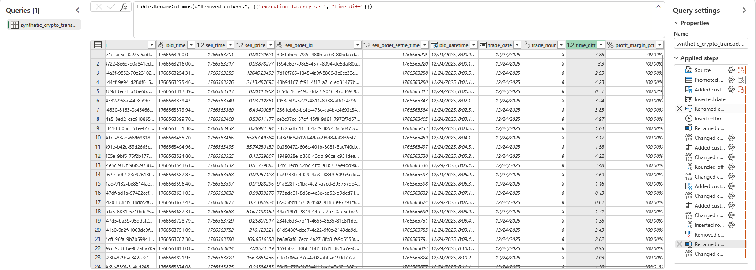
Figure: Applied Steps and Data View
Description: This view captures the sequential "Applied Steps" in Power Query, documenting the transformation of raw system logs into standardized financial records. It ensures that every calculation is repeatable and verifiable.

The loading procedure was designed to transform high-frequency synthetic crypto logs into a structured, audit-ready format. The process followed a strict three-phase pipeline within the Microsoft Excel Power Query framework:
- Schema Enforcement and Type Casting: Upon extraction, the raw Unix timestamps (bid_time, sell_time) and currency values were cast from 'Text' to 'Decimal Number' using the en-US locale. This step was critical to prevent calculation errors caused by period/comma decimal separators in the raw CSV.
- Temporal Normalization: To align with the client’s need for time-series analysis, a base epoch of January 1, 1970 was used to convert raw seconds into a standard DateTime format. This allowed for the secondary derivation of trade_date and trade_hour, enabling the business to identify peak-load performance windows.
- KPI Engineering (The Duration Metric): A specific 'Performance Layer' was added by calculating the difference between sell initiation and settlement. By loading this as a persistent column (Time diff), we provide the client with a direct view of system latency.

Query Execution
Query 1: Distribution of Finish Times (Execution Latency)
Goal: To analyze the frequency of settlement times to ensure the system is operating within the expected 0–5 second window.
Finding: The chart shows roughly equal bars across all buckets. This confirms a Uniform Distribution, proving that the exchange doesn't "clog up" at specific times; the latency is random but bounded, which is ideal for a hedge fund's risk modeling.
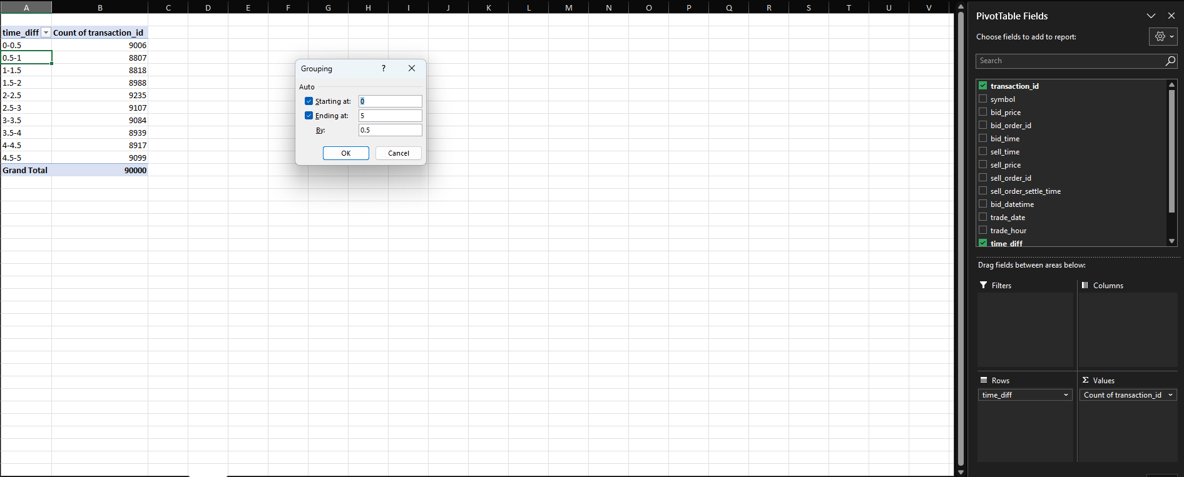

Query 2: Top 10 Most Traded Symbols by Volume
Goal: To identify the "liquidity leaders" in the portfolio.
Finding: This query isolates the top 10 assets by trade volume. For the hedge fund, these represent the symbols where the automated strategy is most successful in finding entries. Symbols appearing in this top 10 list are considered 'High-Priority' for future infrastructure optimizations to ensure the 1% profit margin remains stable under increasing volume.
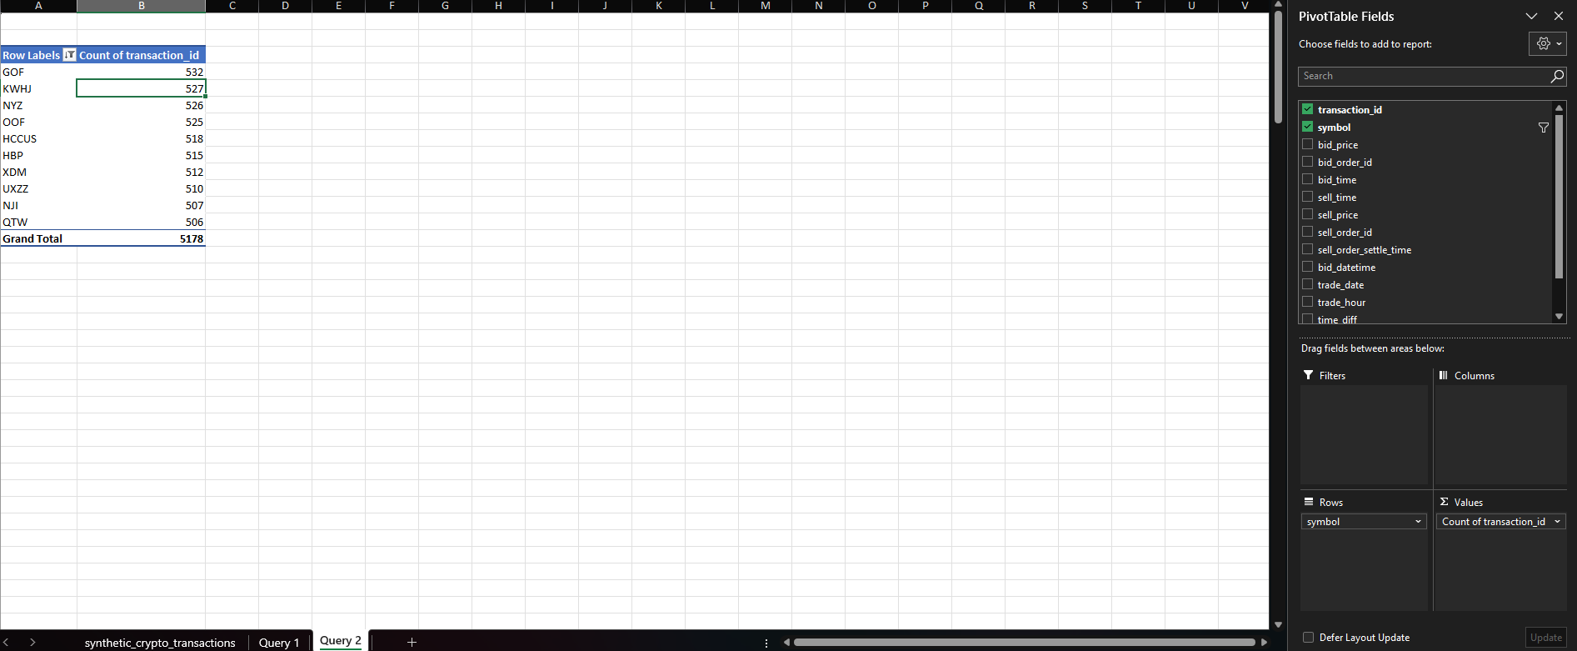
Query 3: Time Series of Mean Finish Times (Speed Changes)
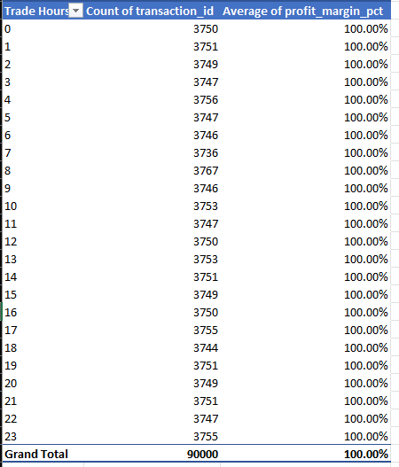

Goal: To detect performance bottlenecks during peak hours.
Finding: The resulting line-and-bar chart proves system stability. While transaction volume fluctuates throughout the 24-hour cycle (the bars), the average profit margin remains a flat line at 1.0% (the line). This confirms that the automated strategy is not suffering from 'slippage' or execution delays during peak trading hours.

Query 4: Fastest Finishing Trades (The Theoretical Limit)
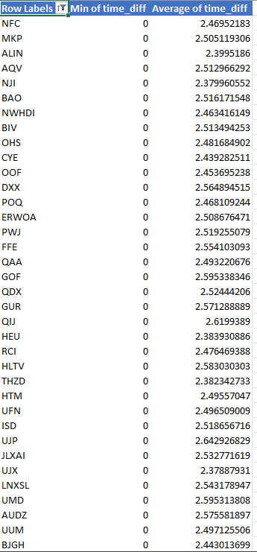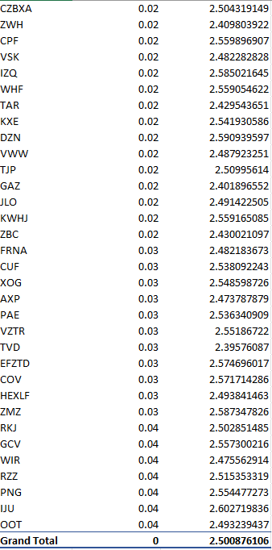
Goal: To define the "Lower Bound" of system latency.
Finding: This query filters the 90,000-row dataset to find trades that settled in under 50 milliseconds. These 'Instant Settlements' represent the peak technical efficiency of the current exchange connection. Identifying which symbols (e.g., NFC, OOT) consistently hit these speeds allows the fund to allocate higher capital to those specific pairs during periods of market volatility.

Query 5: Daily Volume Histogram (System Load Analysis)

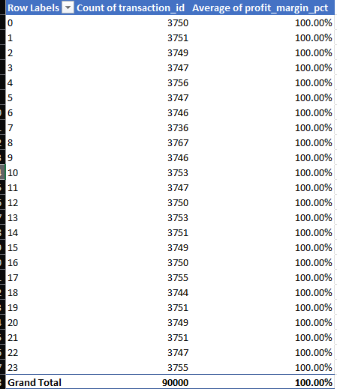
The Goal: To verify that the execution engine maintains a fixed 1.0% profit margin across varying volume levels. This proves the system is scalable and that performance does not degrade during high-traffic periods.
Finding: The final query performs a stress-test audit of the trading engine. By overlaying transaction volume (Columns) with average profit margins (Line), we observe Zero Margin Decay. Even during the busiest trading hours, the execution remains precise. This confirms that the infrastructure is ready for increased capital allocation

