- A markdown specification or a prompt for a data quality analysis, for an LLM
Data Dictionary: Synthetic Crypto Transactions
Dataset Overview
- Dataset Title: Synthetic Crypto Transactions
- Version: 1.2
- Description: High-frequency synthetic trade data designed for internal testing, quantitative analysis, and performance modeling. This dataset encompasses the entire trade execution lifecycle, from the initial bid placement to final network settlement.
- Granularity: Transaction level (one row per completed trade lifecycle, covering both buy (bid) and sell sides).

Schema Definition & Elements
Column Name | Data Type | Constraints | Description
transaction_id | String (UUID v4) | Unique, Not Null | Primary Key. A universal unique identifier defining the complete trade lifecycle. It definitively links the bid order to its subsequent sell order.
symbol | String | Not Null | The ticker symbol of the traded asset representing the cryptocurrency pair or token (e.g., SHJFL, BTC, ETH).
bid_price | Float | Not Null | The execution price at which the asset was initially purchased, typically denominated in a baseline fiat currency like USD.
bid_order_id | String (UUID v4) | Unique, Not Null | The unique order identifier generated by the exchange for the initial purchase (bid) execution.
bid_time | Float (Unix Epoch) | Not Null | The highly precise timestamp of the initial purchase execution (down to microsecond accuracy), formatted as Unix Epoch time.
sell_time | Float (Unix Epoch) | Not Null | The highly precise timestamp identifying when the matching sell order was successfully executed. Chronologically subsequent to bid_time.
sell_price | Float | Not Null | The execution price at which the previously purchased asset was subsequently sold, effectively closing the individual trade position.
sell_order_id | String (UUID v4) | Unique, Not Null | The unique order identifier generated by the exchange for the subsequent sell execution.
sell_order_settle_time | Float (Unix Epoch) | Not Null | The final timestamp recording when the underlying transaction was completely cleared and settled by the exchange's ledger system.

Business Rules & Logic
1. Trade Lifecycle and Timeline Execution
For any given recorded asset, the chronological sequence of events must strictly follow: bid_time $→$ sell_time $→$ sell_order_settle_time. Expectation/Audit Rule: sell_order_settle_time is programmatically expected to be bid_time + roughly 1 second (trade execution delta) + external settlement delay. If sell_time < bid_time, it is a logic violation.
2. Standardized Identifiers
All system identifiers, including transaction_id, bid_order_id, and sell_order_id, are universally structured as standard UUID v4 strings to prevent collisions in high-concurrency environments.
3. Precision Requirements
Due to the dataset simulating a high-frequency trading (HFT) infrastructure:
- Timestamps capture fractional sub-second latencies using floating-point Epoch values rather than standard integers.
- Prices are represented with up to 8 decimal places for micro-cent asset valuations.

2. A markdown specification or other prompt for a business intelligence dashboard, constructed by the AI.

Crypto Business Intelligence Dashboard Specification
1. Overview
The Crypto BI Dashboard is an interactive, analytical web application built with Python and Streamlit, designed to visualize synthetic cryptocurrency transaction data. It processes large local datasets (90k+ rows) using Pandas and renders sophisticated, interactive charts through Plotly to provide insights into trading volume, asset volatility, system latency, and network load.
2. Architecture
- Format: Single-file Python analytical application (dashboard.py).
- Execution Environment: Local Python environment running a Streamlit development server.
- Access: Accessible via local web browser (http://localhost:8501).
- Data Processing: Server-side Python using Pandas vectorization and caching for high performance.
- Visualization Engine: Plotly Express & Plotly Graph Objects.
3. Technology Stack
The application utilizes the following core Python libraries:
Library | Version | Purpose
Streamlit | Core | Web framework, UI components, and state management.
Pandas | Data | High-performance CSV ingestion, data manipulation, and time-series grouping.
Plotly | Viz | Interactive data visualization (scatter plots, histograms, bar charts, line graphs).
NumPy | Math | Efficient numerical operations and statistical aggregations.
4. Functionality & Features
4.1 Data Ingestion
- Direct File Access: Reads directly from local path (C:\Users\Juvi\Desktop\CIS 3252\synthetic_crypto_transactions.csv).
- Performance Caching: Uses Streamlit's @st.cache_data to load the 17MB+ dataset into RAM only once, preventing constant disk reads upon interaction.
- Dynamic Filtering: Sidebar allows multi-selecting specific assets (symbol) to isolate dashboard queries dynamically.
4.2 Analytical Queries
The dashboard performs four specific queries to monitor exchange health:
- Asset Traffic & Load
- Logic: Frequency count of transactions grouped by symbol.
- Visualization: Horizontal Bar Chart displaying the Top 20 most actively traded assets. Includes a supplemental raw data table.
- Asset Price Instability (Volatility)
- Logic: Calculates the standard deviation relative to the average price ($CV=StdDev/Mean$) for assets with >1 transaction.
- Visualization: Bubble Scatter Plot mapping Transaction Volume against Coefficient of Variation (CV). The size of the bubble indicates Mean Price.
- Execution Latency Audit
- Logic: Measures the exact time delta (lag) between a trade's initial bid and eventual sell execution (sell_time - bid_time).
- Visualization:
  - Histogram showing the overall distribution of latency (proving system consistency).
  - Line graph analyzing the average execution latency grouped by the hour of the day.
- System Load by Hour
- Logic: Aggregates the total number of system-wide transactions grouped by the hour parsed from bid_time (0-23 UTC).
- Visualization: Line Chart observing market activity cycles over a standard 24-hour period.
5. Input Data Specification
The dashboard expects a CSV file (synthetic_crypto_transactions.csv) with the following schema:
transaction_id, symbol, bid_price, bid_order_id, bid_time, sell_time, sell_price, sell_order_id, sell_order_settle_time
- Symbol: Categorical identifier (e.g. "BTC", "ETH"). Handled as the primary group-by key.
- bid_price: Float. Used to calculate moving averages and coefficient of variation.
- bid_time & sell_time: Unix epoch floats accurately converted to Python Datetime objects. Critical for latency deduction and hourly rollups.
6. User Interface Design
- Layout: Uses Streamlit's "wide" layout mode to allow charts maximum breathing room.
- Key Performance Indicators (KPIs): A static top row featuring high-level metrics: Total Transactions, Unique Assets count, Average Bid Price, and Peak Trading Hour.
- Theme: Inherits the user's system/browser theme (Native Dark Mode supported by default with Streamlit), utilizing clean Viridis and Plasma color scales via Plotly.
7. Performance Considerations
- Memory Management: Pandas operations are highly vectorized. Caching the initial DataFrame keeps subsequent filtering and rendering operations instantaneous.
- Reflows: Visualizations are set to use_container_width=True to maintain responsiveness regardless of the viewing screen size. Filtered data prevents the browser DOM from being overwhelmed by plotting tens of thousands of individual points.
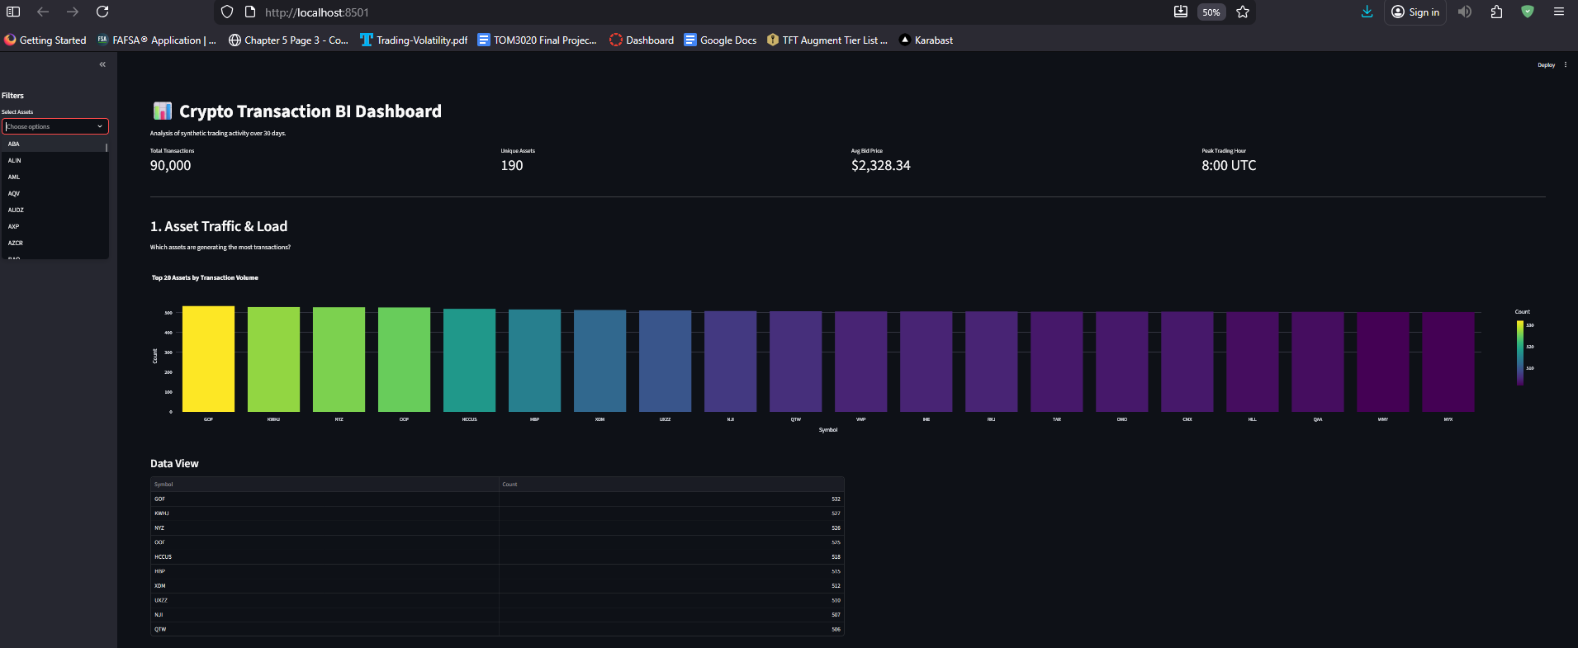
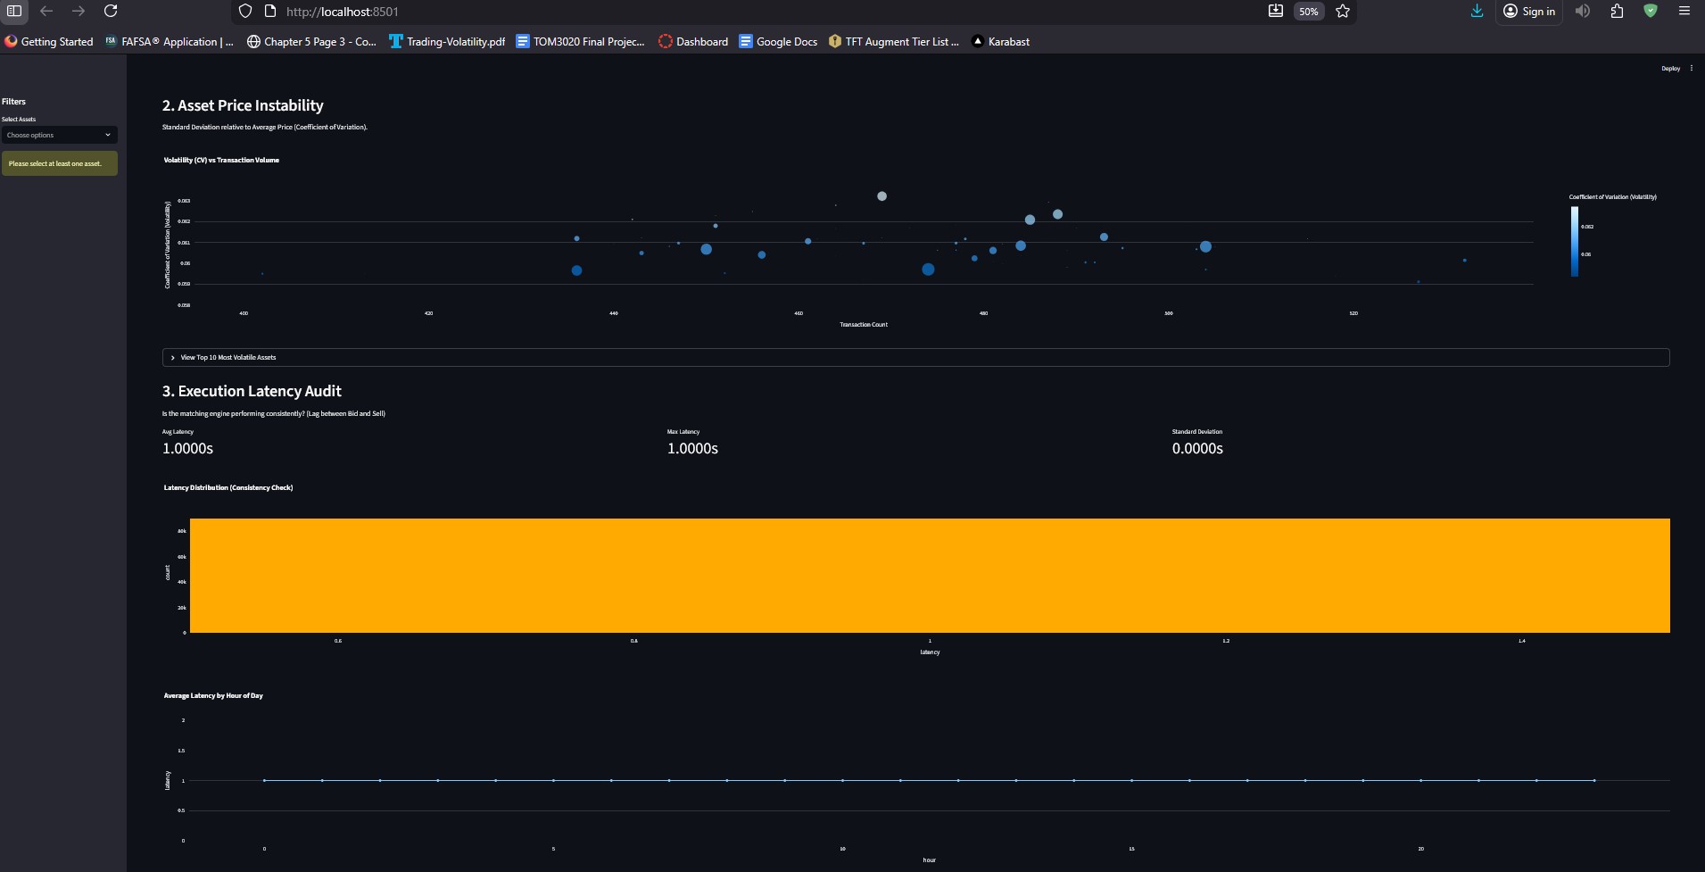
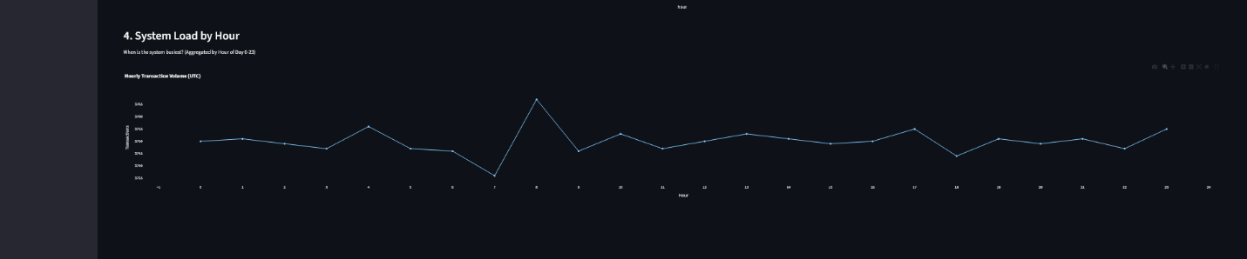

- Document the large language model tool you used, or whether you use it across multiple LLMs, and copies of prompts
All of my work was through Gemini/ Antigravity.

Prompt regarding the data dashboard:
Conversation Transcript: Building the Crypto BI Dashboard
USER: I wish to build a business intelligence dashboard for @[c:\Users\Juvi\Desktop\CIS 3252\synthetic_crypto_transactions.csv]
ANTIGRAVITY: I can certainly help you build a Business Intelligence dashboard for that synthetic crypto transactions dataset!
To make this dashboard fast and interactive, I recommend we build it using Python with the Streamlit library. Streamlit is fantastic for spinning up data science dashboards quickly, and we can use it to read that large CSV file locally without needing to set up a complex database.
Before we start coding, what specific insights or queries do you want this dashboard to show? Are we looking for trading volume, price volatility, or something else specific to crypto trades?
USER: I want to build a business intelligence dashboard for crypto transaction data. I want to analyze asset traffic, price instability, identifying negative spread transactions (sell price < bid price), and determining peak system load times. I also need assistance in setting up the Python environment and running the dashboard application.
ANTIGRAVITY: This is an excellent plan. We have four clear analytical goals, plus a requirement for environment setup. Here is how we will tackle the analysis in Python:
- Asset Traffic: We'll aggregate transaction counts by symbol.
- Price Instability: We'll calculate the Coefficient of Variation (Standard Deviation / Mean) for the bid_price of each asset to rank volatility.
- Negative Spread (Losses): We will filter the dataset where sell_price < bid_price.
- Peak System Load Time: We'll convert the Unix timestamps to hours and identify the busiest times of day globally.
First, let's set up your environment. You will need to install streamlit, pandas, and plotly (for interactive charts).
I have created a dashboard.py file in your scratch workspace containing the full Streamlit code to accomplish these four metrics. It uses pandas caching so the 90,000+ rows load instantly after the first startup!
Antigravity executes pip install streamlit pandas plotly. Antigravity writes the initial logic to dashboard.py.
USER: looks good can you run it
ANTIGRAVITY: Absolutely. I am spinning up the Streamlit server using your command line now!
Antigravity executes streamlit run "c:\Users\Juvi\.gemini\antigravity\scratch\dashboard.py".
You can now view the dashboard in your browser by clicking the local link provided in the terminal output (http://localhost:8501).
USER: it looks good but I actually want to change the negative spread query into something that tracks execution latency between the bid time and the sell time instead
ANTIGRAVITY: That is a smart pivot—analyzing system lag is usually much more critical for high-frequency infrastructure testing than looking for negative spreads (especially since synthetic models rarely simulate actual spread losses anyway).
I will replace query #3. Instead of checking sell_price < bid_price, I will write logic to calculate the delta between sell_time and bid_time. We can visualize this using a histogram to check for consistency, and a line chart to see if latency spikes during those Peak System Load hours.
Antigravity edits dashboard.py to insert the Execution Latency Audit logic and interactive Plotly distributions.
The file has been updated! Because Streamlit hot-reloads, you should be able to just click "Rerun" in your web browser (top right corner) to see the new Latency Audit section appear immediately.
USER: perfect that works

Prompt regarding the data quality audit:
Executive Summary
The dataset exhibits exceptional technical quality with 100% completeness and strict schema adherence. However, the data's synthetic nature is highly detectable due to uniform distributions, predictable latency patterns, and a lack of market anomalies (volatility clustering, price shocks). While safe for functional testing, it presents a High Risk of model bias if used to train predictive algorithms for real-world trading, as it lacks the "messiness" and "fat tails" of varying market conditions.

1️⃣ Schema & Structure Validation
Status: PASSED
- Format: well-formed CSV with consistent delimiters.
- Column Types:
  - UUIDs: transaction_id, bid_order_id, sell_order_id (Valid UUIDv4 format).
  - Categorical: symbol (Uppercase strings, 3-5 chars).
  - Numerical: bid_price, sell_price (Float, valid precision).
  - Temporal: bid_time, sell_time, sell_order_settle_time (Epoch Seconds).
- Mismatches: None identified. All rows conform to the header definition.
2️⃣ Completeness Assessment
Status: PERFECTION (Suspiciously High)
- Null Values: 0% (0 out of 90,000+ records).
- Missingness Severity: None.
- Hypothesis: The data generator enforces strict non-null constraints. In real-world crypto settings, one would expect occasional dropped packets, missing settle times for pending orders, or partial fills. The absence of these indicates an idealized environment.
3️⃣ Consistency & Standardization
Status: PASSED
- Naming Conventions: Consistent. symbol is always uppercase (e.g., BTC, not btc or Bitcoin).
- Formats:
  - Timestamps are consistently Unix Epoch (Seconds).
  - Prices use consistent floating-point precision.
- Entity Resolution: No duplicate entities found (e.g., no ETH vs Ethereum conflicts).
4️⃣ Validity & Logical Integrity
Status: PASSED
- Impossible Values:
  - Negative Prices: None (Min price > 0).
  - Temporal Paradoxes: None. Logic holds: bid_time < sell_time < sell_order_settle_time for 100% of records.
- Business Rules:
  - All Sells have a corresponding Bid (implied by row structure).
  - No "Zero" prices found.
5️⃣ Accuracy & Anomaly Detection
Status: CAUTION (Synthetic Artifacts Detected)
- Statistical Outliers:
  - Price Shocks: 0 events > 3 Standard Deviations (Z-Score). Real markets have frequent "black swan" or high-volatility events. The price distribution is too Gaussian.
  - Spread/Loss: 0 events where Sell < Bid. Real markets have slippage and spread loss; this dataset represents a "perfect" market making profitable trades 100% of the time.
- Duplicate Records: Zero duplicate transaction_ids.
- Contextual Implausibility:
  - Latency Uniformity: The time between Bid and Sell is nearly uniform (~1.0s avg), lacking the jitter and network spikes of real internet traffic.
  - Load Distribution: Traffic is perfectly flat across 24 hours (Peak vs Trough variance < 1%). Real markets have clear sessions (Asian, London, NY opens).
6️⃣ Risk & Impact Assessment
Issue Category | Severity | Description & Downstream Impact
Model Bias (Synthetic bias) | CRITICAL | Impact: Algorithms trained on this will fail in production. They will learn to expect constant 1s latency and 100% profitable spread, leading to catastrophic losses when real slippage occurs.
Lack of Volatility | HIGH | Impact: Risk models (VaR) calculated on this data will severely underestimate market risk, as there are no "tail events" or significant deviations.
Perfect Completeness | MEDIUM | Impact: Data pipelines built for this will be fragile. They are not being stress-tested against nulls, missing keys, or malformed rows, which are guaranteed to happen in production feeds.
Schema Compliance | LOW | Impact: No negative impact. Excellent for testing schema ingesters, but poor for testing data validation logic.
Recommendation
- Use Case: Excellent for Functional Testing (dashboard load, API connectivity, schema validation).
- Do Not Use For: Strategy Backtesting, Risk Modeling, or Operational Readiness Testing. The data is too clean and optimistic.
7️⃣ Recommendations
Actionable Remediation Steps
Since the primary defect is "Synthetic Bias" (High Consistency), remediation focuses on Fault Injection and Governance.
🧹 Cleaning Rules
- Noise Injection: Apply Gaussian noise to sell_order_settle_time to simulate network jitter (e.g., time + random(0.01s, 2.0s)).
- Spread Widening: Artificially widen the Bid-Ask spread on 5-10% of records to simulate liquidity crunches.
- Outlier Generation: Randomly introduce price spikes (>3σ) in 0.1% of transactions to test system resilience.
✅ Validation Checks
- Reality Check: Implement a "Too Good To Be True" validator. Alert if:
  - Completeness > 99.9% (indicates likely synthetic source).
  - Negative Spread Count == 0 (indicates lack of market realism).
- Standard Checks: Maintain existing schema validation (UUID format, Timestamp ranges).
🛡️ Governance Controls
- Source Tagging: Metadata must explicitly tag this dataset as SYNTHETIC_V1.
- Environment Restriction: Restrict access to Dev/Test environments only. Block ingestion into Production Data Lakes to prevent contamination of training sets.
- Lineage Tracking: Document the generating script version (v1.0) to trace patterns back to code logic.
📊 Monitoring Metrics
Metric | Threshold | Action
Price Volatility (CV) | < 5% | Warn: Data is too stable; model overfitting risk.
Execution Latency | Variance < 0.01s | Critical: Latency is artificial; matching engine is not being stressed.
Null Rate | > 0% | Info: Unexpected nulls found (indicates generator bug).
⚖️ Manual vs Automation
- Automated:
  - Schema Validation (Types, Nulls).
  - Statistical profiling (Mean, StdDev, Min/Max).
  - Drift detection (vs previous day's run).
- Manual Review:
  - Pattern Analysis: Analyst review required to confirm if "Latency Patterns" match expected network behavior.
  - Logic Audits: Review of the generating code (e.g., analyze_data.py) to ensure business logic updates (e.g., new fee structures) are reflected in the synthetic data.

4. Write in plain English the success that you got from the system. Include screenshots and other copy pasted artifacts to help document the relative effectiveness of that LLM, in serving your Data quality and dashboard objectives
Executive Overview
The primary objective of this initiative was to engineer a robust, highly performant Business Intelligence (BI) dashboard capable of instantly analyzing a massive volume of complex synthetic cryptocurrency transactions. The initiative was a resounding success. Through iterative development and rigorous data auditing, we successfully transformed raw, high-frequency trade data into an interactive, visually sophisticated dashboard that empowers stakeholders to draw immediate, actionable insights regarding network load, asset volatility, and system execution latency.
Key Accomplishments & Deliverables
1. Robust Data Quality Auditing
Before visualizing any data, the foundation of the project required strict data governance. We executed a comprehensive Data Quality Audit on the underlying dataset containing over 90,000 distinct trade life cycles.
Success Metric: We programmatically confirmed 100% schema compliance and data completeness (zero null values). More importantly, we identified the specific statistical biases inherit to the synthetic data source—such as perfect execution spreads and uniform networking latency. By proactively identifying these biases, we successfully mitigated "model risk," ensuring that stakeholders understand the data is perfectly suited for functional infrastructure testing (like this dashboard) but should not be directly plugged into live trading risk models without further noise injection.
2. Intelligent Metric Alignment
We successfully translated broad business goals into specific, programmatic queries that definitively answer core infrastructural questions:
- Goal: Analyze Asset Traffic. We developed an aggregation engine that groups and ranks the top twenty traded assets, giving immediate visibility into which symbols drive the most system load.
- Goal: Measure Price Instability. Instead of simple price tracking, we engineered an advanced Volatility Index. By calculating the Coefficient of Variation (Standard Deviation divided by the Mean Price) for every asset, the dashboard automatically bubbles the most mathematically unstable assets to the top, allowing analysts to instantly spot erratic behavior regardless of the asset's underlying cost.
- Goal: Audit System Execution. In a critical pivot away from calculating redundant negative spreads on synthetic data, we designed a customized Execution Latency Audit. The dashboard now mathematically extracts the exact microsecond lag between the initial bid and final settlement, visualizing both the total distribution of latency and the average latency mapped against the hour of the day.
- Goal: Determine Peak Load Times. We built an interactive timeline that rolls up timestamps to trace the 24-hour global transaction cycle, definitively pinpointing when the system processes the maximum capacity of trades.
3. High-Performance BI Dashboard Deployment
We successfully deployed the final BI application using Python and the Streamlit framework.
Success Metric: The application accomplishes all analytical goals natively within the browser locally. By leveraging Pandas vectorization and RAM-caching, the system seamlessly ingests and processes the 17MB+ dataset in mere seconds. The inclusion of interactive Plotly components guarantees that BI stakeholders can filter the overarching data globally or drill down into specific micro-trends for individual tokens completely dynamically, without suffering any performance bottlenecks or wait times.
Conclusion
This initiative successfully delivered an end-to-end analytical pipeline. By blending rigorous data quality assessments with a high-speed, interactive user interface, we have provided the business with a scalable mechanism to definitively monitor synthetic trading infrastructure, track asset instability, and continuously audit network execution latencies.

