
KINGDOM OF SAUDI ARABIA
Ministry of Higher Education
Taibah University
College of Computer Science and Engineering


جامعة طيبة
كلية علوم و هندسة الحاسبات

AI-based job matching system
A Project Report Submitted to Fulfill the Requirements of CS289

Raneem Alahmadi
Dorar Alsinani

10 May, 2026

Abstract

Searching for jobs online has become easier in recent years, but finding the right job is still difficult for many people. Job seekers often apply to many positions without knowing if they are suitable for them, while employers receive large numbers of applications that take time and effort to review. Because of this, the hiring process can become slow and inefficient for both sides.

This project presents an AI-based recruitment system that helps improve job matching between employers and job seekers. The system analyzes user information such as skills, experience, qualifications, and location to recommend suitable job opportunities
It also predicts the possibility of being accepted for a job and helps employers rank applicants based on how closely they match the job requirements. These features are designed to make the recruitment process more organized and efficient.

During the development of the project, software engineering methods were used to identify system requirements and design the overall structure of the system, Different diagrams and models were prepared to explain how the system works and how users interact with it, The project also focuses on important aspects such as usability, performance, and maintainability to ensure the system can work efficiently with a large number of users and applications.

The proposed system is expected to reduce the time spent searching for jobs and reviewing applications while improving the quality of job recommendations and candidate selection. By using artificial intelligence, the platform can provide a better experience for both employers and job seekers and support faster and more accurate hiring decisions.

Keywords: Artificial Intelligence; Job Recommendation; Recruitment System; Candidate Ranking; Job Matching

Table of Content

Abstract 2
Chapter 1: Introduction 4
1.1 Overview 4
1.2 Client Context 4
1.3 Similar Projects 4
1.4 Problem Statement 5
Chapter 2: Requirements Elicitation 6
2.1 Methodology 6
2.2 Requirements Listing 7
Chapter 3: System Models 8
3.1 Use Case Model 8
3.2 Object Model 9
3.3 Dynamic Model 9
Chapter 4: Architecture Models & Design Patterns 10
4.1 Architecture Models 10
4.2 Design Patterns 10
Chapter 5: Test Cases and Develop Test Plans 11
5.1 Test Cases 11
5.2 Test Plans 11
Chapter 6: Conclusion 12
6.1 Conclusion 12
6.2 Lessons Learnt 12
References 13

Chapter 1: Introduction

1.1 Overview

Finding suitable job opportunities is a challenging and time-consuming process for many job seekers. Many applicants apply to different jobs without knowing if they are a good fit or what their chances of being accepted are. At the same time, companies receive a large number of applications, which makes it difficult and time-consuming to find the most suitable candidates.

To solve this problem, this project proposes an AI-based improvement to the LinkedIn platform [1]. The system will analyze user profiles, such as skills, experience, and location, to recommend jobs that better match each user. It will also use artificial intelligence to estimate the probability of acceptance and help companies rank applicants based on how well they meet the job requirements.

This will make the job searching and hiring process easier and faster for both job seekers and employers, and help them make better decisions using AI.

1.2 Client Context
The client’s business is a professional platform that connects job seekers with employers and companies, allowing users to showcase their skills and experience, while enabling companies to post job opportunities and search for suitable candidates

The project uses personalized recommendations to present job opportunities that match job seekers based on their skills, experience, and location، and uses predictive analytics to estimate each user’s chances of getting the job, and ranks candidates for companies based on their specific requirements and hiring needs.

1.3 Similar Projects
Similar platforms such as Jadarat [2] and Taqat [3] offer job listings and connect employers with job seekers, but they rely on basic filtering and lack advanced AI capabilities. Their recommendations are often not personalized, and they do not predict acceptance probability, which reduces efficiency and leaves users uncertain

In contrast, our system uses advanced AI to provide personalized job recommendations based on skills, interests, and location. It also predicts the likelihood of acceptance using historical data. For employers, it ranks and filters applicants automatically, improving hiring efficiency and saving time.

1.4 Problem Statement
The main problem faced by our client is that the current job matching systems are not efficient when handling a large number of users
Recruiters receive many applications, but many of them are not qualified, which makes the selection process slow and difficult. There is also a lack of automated filtering for unqualified or unresponsive candidates
Additionally, job seekers often apply for jobs without knowing their chances of acceptance, resulting in wasted time and effort.
Also, current systems do not always consider important factors such as location, distance, and user preferences, resulting in less accurate recommendations
Therefore, solving these problems will improve the hiring process and make it faster, more efficient, and more accurate.

Chapter 2: Requirements Elicitation
(Approx. 400–600 words)

2.1 Methodology
A simulated client interview approach was used to gather requirements by assuming the role of the client, represented by the LinkedIn platform [1]. The current system was reviewed to understand its limitations and identify areas that need improvement

From this analysis, several needs were identified, such as improving job and candidate matching, reducing the number of irrelevant applications, and making the hiring process faster and more efficient. Based on these needs, key features were proposed, including AI-based job recommendations, prediction of acceptance probability, and automatic candidate ranking.

Q1: What are the main challenges you face in your current platform?
client: One of the main challenges is the large number of job applications, many of which are not relevant to the job requirements

Q2: How effective is your current job recommendation system?
Client: It provides general recommendations, but they are not always accurate or personalized enough for users.

Q3: What improvements would you like to see in job matching?
Client: We would like a smarter system that matches candidates to jobs based on skills, experience, and location more accurately.

Q4: How do you currently handle candidate selection, and what improvements do you need?
Client: Currently, employers manually review applications, which is time-consuming and inefficient, we need an AI-based system that can automatically rank candidates based on how well they match the job requirements, so we can quickly identify the best applicants.

Q5: What additional features would improve your platform?
Client: We need a feature that uses AI to predict the likelihood of a candidate being accepted for a job, this would help job seekers focus on suitable opportunities and assist employers in making better hiring decisions.

Q6: How important is it to reduce hiring time?
Client: It is very important, as faster hiring improves productivity and reduces costs.

Q7: How would you like artificial intelligence (AI) to improve your system?
Client: We would like AI to enhance the platform by providing more accurate job recommendations based on user profiles, predicting the likelihood of candidate acceptance, and automatically ranking applicants according to how well they match job requirements, this would help improve decision-making, reduce manual effort, and make the hiring process faster and more efficient

Q8: What is your overall goal for improving the platform?
Client: To enhance user experience by providing more accurate recommendations and making the recruitment process faster and more efficient.
“The simulated client responses were generated with the assistance of ChatGPT for requirement elicitation purposes.”

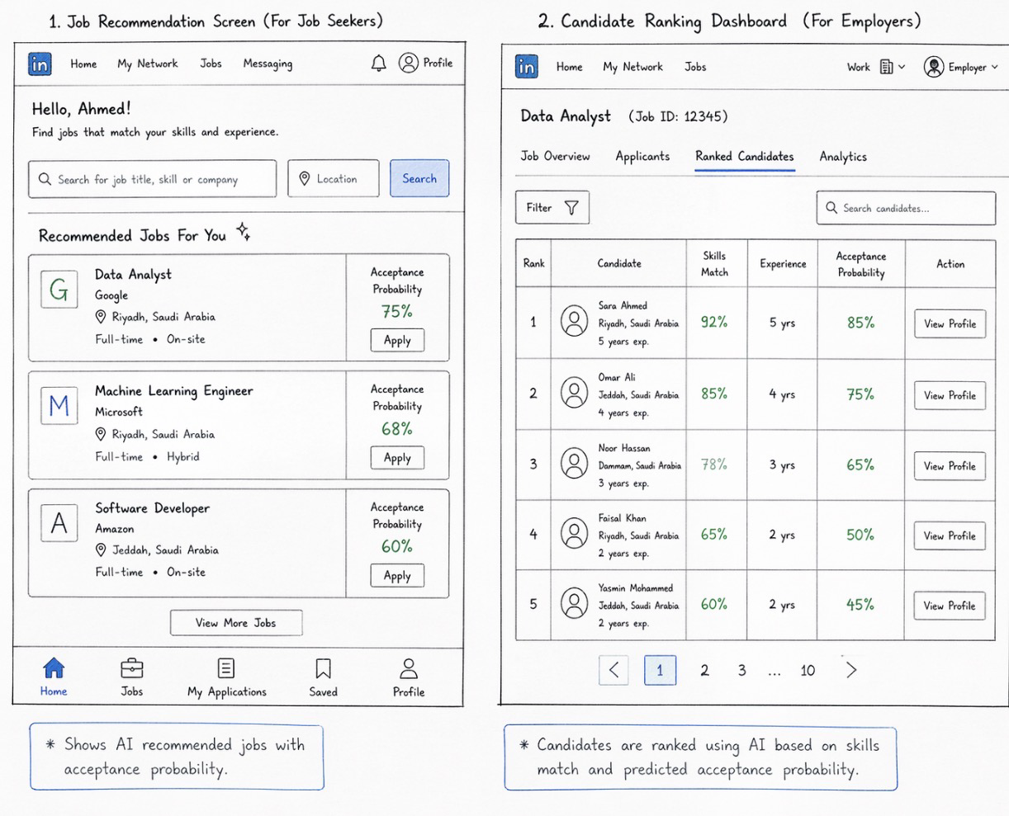
Prototype :
“This prototype design was generated with the assistance of Claude AI”

2.2 Requirements Listing
Functional Requirements
- The system shall allow job seekers to create, update, and manage their profiles, including skills, experience, and location.

- The system shall allow employers to create and manage job postings with specific requirements.

- The system shall analyze user profiles using AI techniques to match them with relevant job opportunities

- The system shall generate personalized job recommendations based on user data and preferences.

- The system shall estimate and display the probability of acceptance for each job opportunity.

- The system shall rank candidates automatically based on their compatibility with job requirements.

- The system shall allow employers to view, filter, and manage job applicants efficiently.

- The system shall send notifications to users about relevant job opportunities and updates.

Non-Functional Requirements

Performance
- The system shall reduce hiring time by providing fast job matching and candidate ranking.
- The system should support at least 5000 users at the same time and handle up to 50000 job postings without major delays.

Security
- The system shall prevent unauthorized access to user data, including CVs and personal information, using secure methods.
- The system should lock the account for 15 minutes after 5 failed login attempts.

Usability
- The system shall be easy to navigate for all users
- The system shall provide a user-friendly and intuitive interface that allows new users to complete basic tasks within 5 minutes without training.

Reliability
- The system shall be available at least 99% of the time.
- The system shall handle errors gracefully without crashing.

Localization
- The system shall support at least 2 languages to serve users from different regions

Portability
- The system shall be able to run on different operating systems such as Windows, macOS, and mobile device

Scalability
- The system shall handle at least 10000 job applications per day without significant slowdown.
- The system shall support an increasing number of users and job postings without significant performance loss

Maintainability
- System updates shall be completed within one hour without affecting core system operations.
- The system shall be easy to update and improve

Chapter 3: System Models
(Approx. 400–800 words)

3.1 Use Case Model
3.1.1 Use Case Descriptions
Use Case: Register Account
Actor:
Job Seeker / Employer
Goal:
The user wants to create a new account.
Preconditions
• The user does not already have an account.
Main Flow
1. The user selects “Register”.
2. The system shows the registration form.
3. The user enters the required information.
4. The user submits the form.
5. The system checks the information.
6. The account is created successfully.
Alternative Flows
A1: Missing Required Information
1. The user leaves the required fields empty.
2. The system displays an error message.
3. The user completes the missing information.
A2: Invalid Email Format
1. The system detects an invalid email format.
2. The system asks the user to enter a valid email address.
A3: Weak Password
1. The system detects a weak password.
2. The system asks the user to create a stronger password.
A4: Email Already Exists
1. The system detects that the email is already registered.
2. The system asks the user to log in instead.
Postconditions
• A new account is created successfully.

Use Case: Log In
Actor:
Job seeker /Employer
Goal:
The user wants to access the system.

Preconditions
The user already has an account.

Main flow
1. The user selects “Log In”.
2. The user enters their email and password.
3. The system checks the login information.
4. The user accesses the system successfully.
Alternative flow
A1: Incorrect Password
1. The user enters an incorrect password.
2. The system displays an error message.
A2: Unregistered Email
1. The system detects that the email does not exist.
2. The system asks the user to create an account.
A3: Empty Login Fields
1. The user leaves the email or password empty.
2. The system asks the user to complete the fields.

Postconditions
• The user accesses the system successfully.

Use Case: Manage Profile
Actor:
Job seeker
Goal:
The user wants to update personal and professional information.

Preconditions
• The user is logged into the system.

Main Flow
1. The user opens the profile page.
2. The system displays the current profile information.
3. The user updates personal information, skills, experience, and location.
4. The user saves the changes.
5. The system updates the profile successfully.
Alternative flows
A1: Missing information
1. The user leaves the required fields empty.
2. The system asks the user to complete the information.
A2: Invalid location
1. The system detects an invalid location format.
2. The system asks the user to enter a valid location.
A3: Save failure
1. The system fails to save the updated information.
2. The system displays an error message.
3. The user retries saving the profile.

Postconditions
• The profile information is updated successfully.

Use Case: Upload CV
Actor:
Job seeker
Goal:
The user wants to upload a CV to the system.

Preconditions
• The user is logged into the system.

Main flow
1. The user selects “Upload CV”.
2. The system opens the upload page.
3. The user chooses a CV file.
4. The user uploads the file.
5. The system checks the file type and size.
6. The system stores the CV successfully.
7. The system displays a success message.
Alternative flows
A1: Unsupported file type
1. The system detects an unsupported file format.
2. The system asks the user to upload a valid file.
A2: File too large
1. The system detects that the file size exceeds the limit.
2. The system rejects the upload.
A3: Corrupted file
1. The system detects that the file is corrupted or empty.
2. The system rejects the upload.

Postconditions
• The CV is uploaded successfully.

Use Case: View Job Recommendations
Primary actor:
Job seeker
Secondary actor:
AI Engine
Relationship:
<<include>> Analyze User Profiles
Goal:
The user wants to view suitable job recommendations.

Preconditions
The user is logged into the system.
The user’s profile information is complete.
Job opportunities exist in the system database.

Main Flow
1. The user selects “View Job Recommendations.”
2. The system sends the user’s profile data to the AI Engine.
3. The AI Engine analyzes the user’s skills, experience, and location.
4. The system searches for matching job opportunities.
5. The system displays personalized job recommendations.
Alternative flows
A1: Incomplete profile
1. The system detects missing profile information.
2. The system asks the user to complete the profile.
A2: No matching jobs
1. The system cannot find suitable job opportunities.
2. The system displays a message indicating that no matching jobs are available.
A3: AI analysis failure
1. The AI Engine fails to analyze the profile.
2. The system displays an error message.

Postconditions
Personalized job recommendations are displayed successfully.

Use Case: View Acceptance Probability

Primary Actor:
Job Seeker
Secondary Actor:
AI Engine
Relationship:
<<include>> Analyze User Profiles
Goal:
The user wants to view the acceptance probability for a job opportunity.

Preconditions
The user is logged into the system.
The user has selected a job opportunity.
The user’s profile information is complete.
The selected job contains valid requirements.
The AI analysis service is available.

Main Flow
1. The user opens a job opportunity.
2. The system sends the user’s profile data and job details to the AI Engine.
3. The AI Engine compares the user’s profile with the job requirements.
4. The system calculates the acceptance probability.
5. The system displays the result.
Alternative Flows
A1: Missing profile information
1. The AI engine detects incomplete profile information.
2. The system asks the user to complete the profile.
A2: AI failure
1. The AI Engine fails to calculate the acceptance probability.
2. The system displays an error message.
A3: Invalid job data
1. The system detects missing job requirements.
2. The process stops temporarily.

Postconditions
The acceptance probability is displayed successfully.

Use Case: Receive Notifications

Primary actor:
Job seeker / Employer
Goal:
The user wants to receive notifications from the system.

Preconditions
The user is logged into the system.
Notifications are enabled in the user settings.
The notification service is active.

Main flow
1. The system creates a notification.
2. The system sends the notification to the user.
3. The user views the notification.
Alternative flow
A1: Notification failure
1. The system fails to send the notification.
2. The system retries sending the notification later.
A2: Disabled notifications
1. The user has disabled notifications in the settings.
2. The system does not send the notification.
A3: Connection problem
1. The user’s device is offline.
2. The notification delivery is delayed.

Postconditions
Notifications are delivered successfully.

Use Case: Post Job Opportunity

Actor:
Employer
Goal:
The employer wants to post a job opportunity.

Preconditions
The employer is logged into the system.
The employer account is authorized to post job opportunities.

Main flow
1. The employer selects -Post Job Opportunity-
2. The system displays the job posting form.
3. The employer enters the job details and requirements.
4. The employer submits the form.
5. The system publishes the job opportunity.
Alternative flows
A1: Missing information
1. The employer leaves required fields empty.
2. The system asks the employer to complete the missing information.
A2: Invalid salary format
1. The system detects an invalid salary format.
2. The system asks the employer to correct the salary format.

Postconditions
The job opportunity has been published successfully.

Use Case: View Applicants

Actor:
Employer
Goal:
The employer wants to view job applicants.

Preconditions
• A job opportunity has already been posted.
Main flow
1. The employer opens the applicants' page.
2. The system retrieves applicants’ information.
3. The system displays the applicants' list.
Alternative flows
A1: No applicants
1. The system detects that there are no applicants.
2. The system displays a message.
A2: Loading failure
1. The system fails to retrieve applicant data.
2. The system displays an error message.

Postconditions
• Applicants are displayed successfully.

Use Case: View Ranked Candidates

Actor:
Employer
Secondary actor:
AI Engine
Relationship:
<<include>> Analyze User Profiles
Goal:
The employer wants to view ranked candidates.

Preconditions
• The employer is logged into the system.
• Applicants exist for the job.

Main flow
1. The employer opens the ranked candidates page.
2. The system retrieves applicants’ data.
3. The system sends the data to the AI Engine.
4. The AI Engine analyzes candidates based on job requirements.
5. The system ranks the candidates.
6. The ranked list is displayed.
Alternative Flow
A1: No Applicants
1. The system detects that there are no applicants.
2. The system displays a message.
A2: Incomplete Applicant Information
1. The AI Engine detects incomplete applicant data.
2. The incomplete profiles are excluded from ranking.
A3: AI Failure
1. The AI Engine fails to rank the candidates.
2. The system displays an error message.
A4: Server Error
1. The system experiences a server problem.
2. The process stops temporarily.

Postconditions
• Ranked candidates are displayed successfully.

Use Case: Analyze User Profiles

Actor:
AI Engine
Goal:
Analyze user profiles to improve job matching results.

Preconditions
User profile information is available.
Job data is available.

Main flow
1. The system sends user profile data to the AI Engine.
2. The AI Engine analyzes skills, experience, qualifications, and location.
3. The AI Engine compares the profile with job requirements.
4. The AI Engine returns the analysis results to the system.
Alternative flows
A1: Missing Profile Information
1. The AI Engine detects incomplete user information.
2. The system asks the user to complete the profile.
A2: Invalid Data
1. The AI Engine detects invalid or incorrect data.
2. The system ignores invalid fields during analysis.
A3: AI Processing Failure
1. The AI Engine fails during analysis.
2. The system displays an error message.

Postconditions
User profile analysis is completed successfully.

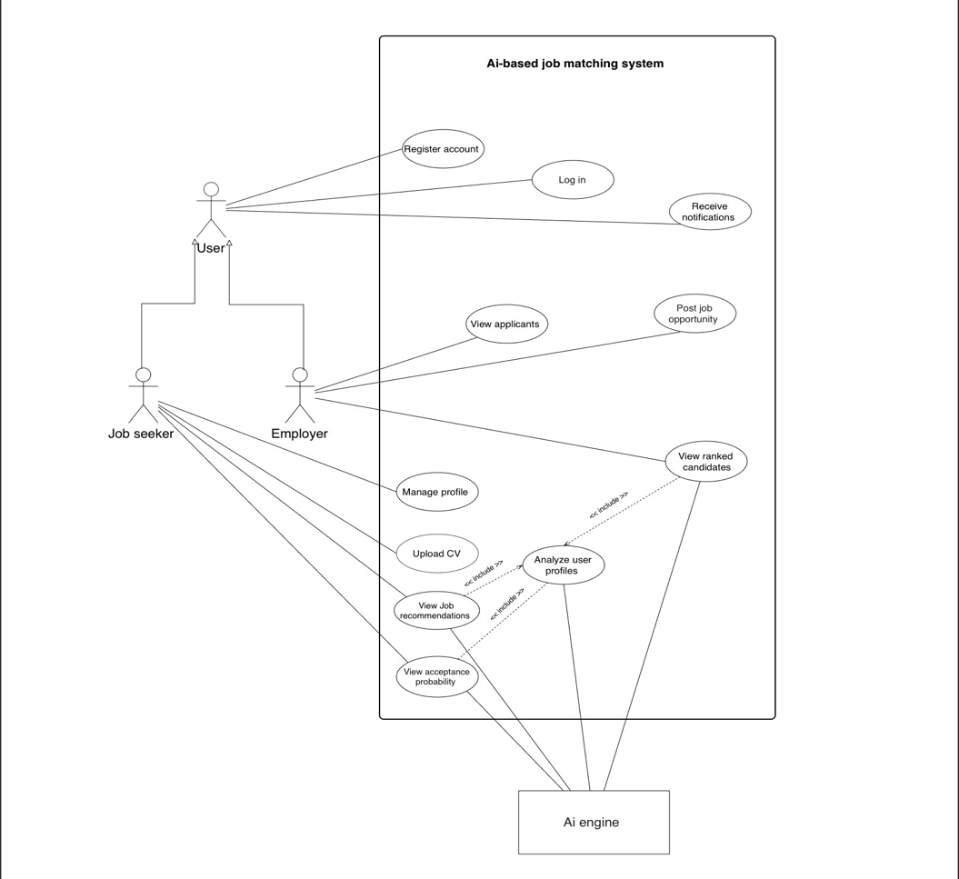
3.1.2 Use Case Diagram

3.2 Object Model
    - Class Diagram
1.
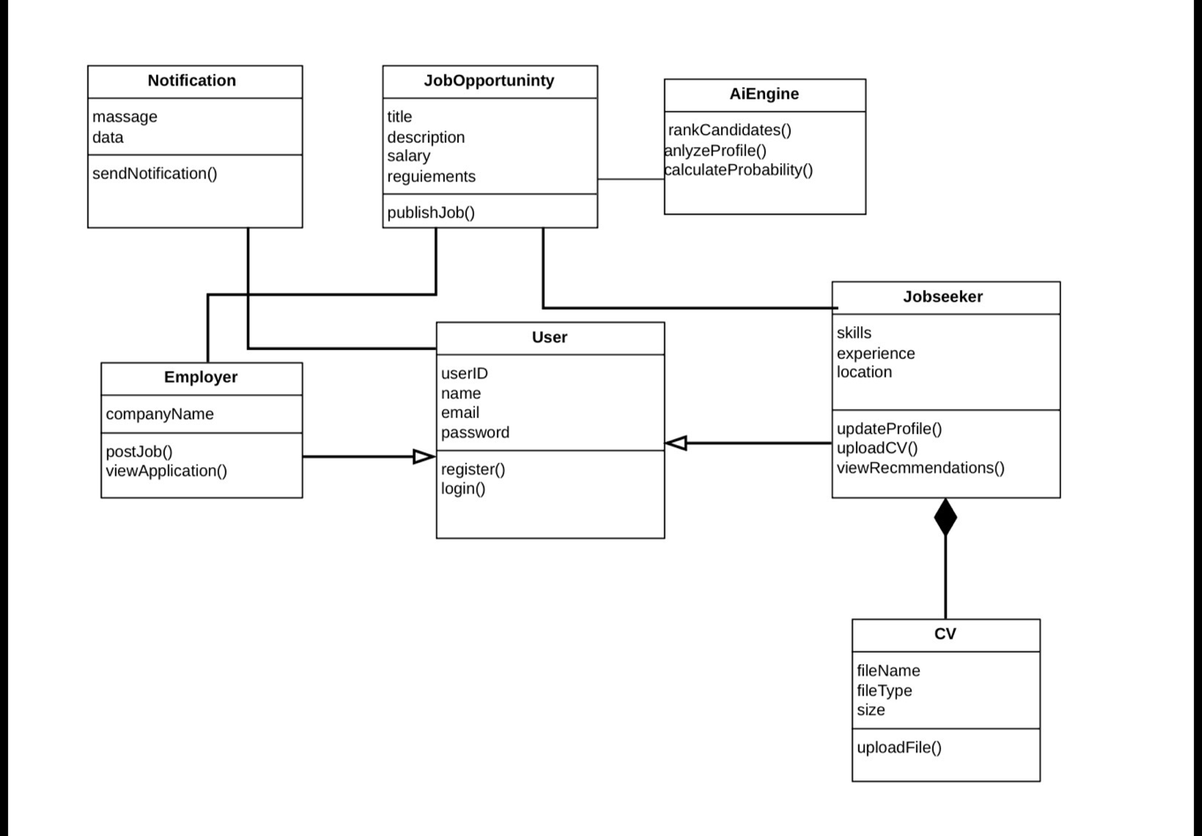

2. Provide brief descriptions of each class and explain their interactions.
The User class is the main parent class in the system, and both Employer and Jobseeker inherit from it using an inheritance relationship because they share common user functionalities.
The Employer class is associated with JobOpportunity since employers create and manage job postings within the system. The Jobseeker class is also associated with JobOpportunity because job seekers search and apply for available jobs
The Jobseeker class has a composition relationship with the CV class, which means the CV belongs directly to the job seeker and cannot exist independently without it
The AiEngine class interacts with both Jobseeker and JobOpportunity to analyze candidate profiles, rank applicants, and generate intelligent job recommendations. The Notification class is connected to users to send updates, alerts, and recommendation notifications related to jobs and applications
Overall, the relationships between the classes help organize the system into connected components with clear responsibilities and interactions.

3.3 Dynamic Model
3.3.1 Sequence Diagrams

1.
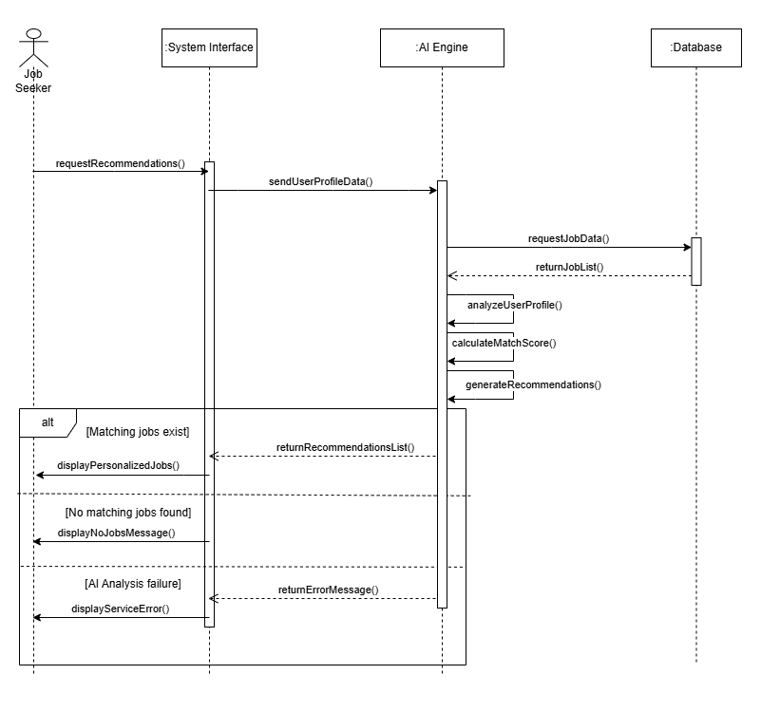

2.
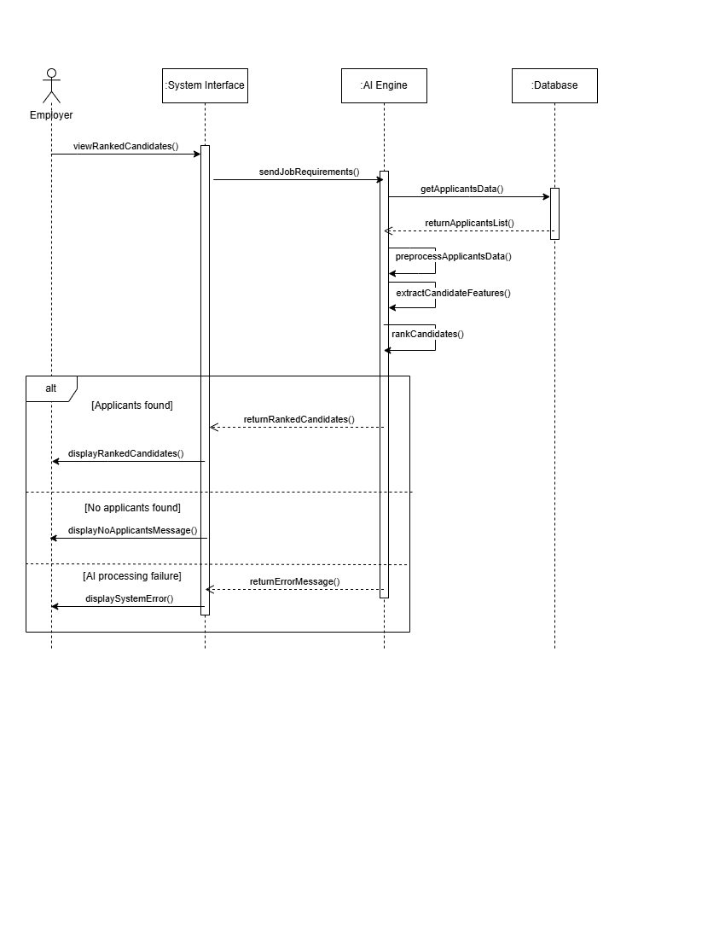

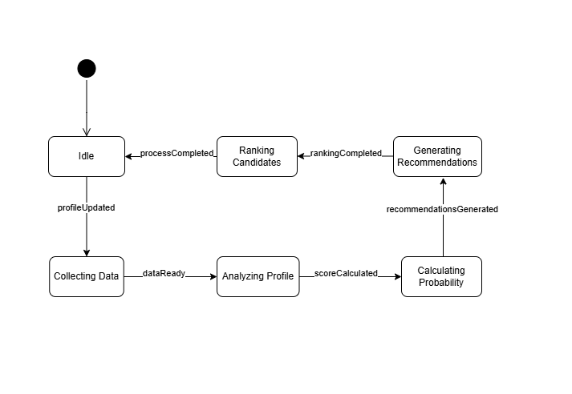
3.3.2 State Diagram

Chapter 4: Architecture Models & Design Patterns
(Approx. 300–500 words)

4.1 Architecture Models

1. System architecture overview

The system is designed using a layered client-server architecture with an integrated AI module to support smart recruitment features such as job recommendations, acceptance prediction, and candidate ranking
Separating the system into different layers helps make it easier to manage, expand, and maintain.

The system contains four main layers :

User interface layer

This layer allows users to interact with the system through a web or mobile application,
Job seekers can create profiles, upload CVs, and view recommended jobs, while employers can post jobs, review applicants, and receive ranked candidate lists.

Business logic layer

This layer handles the core functions of the system, including authentication, profile management, job posting, recommendation requests, and application processing.
It acts as the connection between the user interface, AI services, and the database

Ai module

The AI module is responsible for analyzing data and generating intelligent results
It compares user profiles with job requirements, predicts the probability of job acceptance, and ranks candidates based on their suitability for a position.

Data storage layer

This layer stores all system information, such as user accounts, CVs, job postings, application records, notifications, and AI-generated results.
The database helps keep information organized and secure

2. Architectural Style

The project uses a layered client-server architecture because it organizes the system into separate sections, where each layer is responsible for a specific task

This architecture is suitable for the AI recruitment system for the following reasons:

Modularity

Each layer works independently, which makes the system easier to develop and manage.

Scalability

The system can support more users, job postings, and AI operations without major changes to the overall structure.

Maintainability

Updates to the user interface or AI models can be made without affecting other parts of the system.

Security

User information and CV data are handled through controlled processes instead of direct database access, improving data protection.

Ai integration

The AI module can operate separately while still communicating efficiently with the main system components.

Flexibility

The architecture makes it easier to add future improvements such as advanced analytics, multilingual support, or additional AI features.

3- Architecture diagram
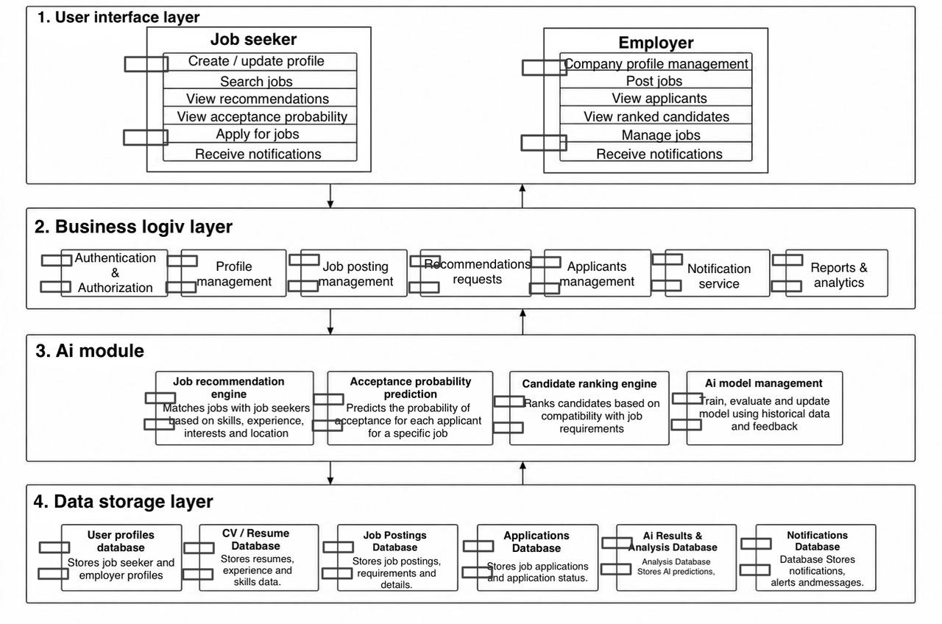

4.2 Design Patterns

This project has used the MVC (Model-View-Controller) software development pattern to divide the system into three separate components. By separating the components of a system, it will make it much easier to manage, maintain, and enhance the system in the future.
The Model is responsible for managing the most important items of data and logic in the system. It manages user profiles, job postings, database operations, and communication with the AI engine in this project. In addition, the Model will help to provide processed recommendation results, ranked candidates, and probabilities of acceptance for candidates by employers.
The View is the user interface that job seekers and employers will use to interact with the system. In addition to other system information, it will show personalized job recommendations, ranked candidates, and other information representative of the user's interaction with the system. Having the View and AI logic separated will also allow for easier updating of the interface and not impact the main functions of the system.
The Controller will act as the interface between the Model and the View. It will receive user requests, process those requests, and transfer the required information back and forth between the two system components. For example, if a user requests job recommendations, the Controller will send that request to the Model and send the job recommendations back to the View for display.
By using the MVC software development pattern, this project has improved the modularity of the system because each component has a separate responsibility. The use of the MVC software development pattern also improves maintainability and allows for easier system enhancements in the future, especially with enhancements to the AI recommendation feature.

Chapter 5: Test Cases and Test Plans
(Approx. 200–400 words)

5.1 Test Cases
S# | Action | Input Value | Expected Results | Actual Results | Pass/Fail | Automated
TC001 | Submit registration request | Valid name, valid email, strong password, valid location | The system creates a new account successfully and displays a confirmation message | Account created successfully | Pass | Yes
TC002 | Request job recommendations | Complete profile with skills, experience, and location | The AI engine analyzes the profile and displays personalized job recommendations | Relevant job recommendations displayed successfully | Pass | Yes
TC003 | Simulate a high system load | 1000+ concurrent users submitting job applications | The system remains stable and processes requests without crashing or major delays. | System handled requests successfully under load | Pass | No
TC004 | Upload CV file | Valid PDF CV file under the size limit | The system uploads and stores the CV successfully and displays a success message | CV uploaded successfully | Pass | Yes
TC005 | View ranked candidates | Applicants with complete profiles and job requirements | The AI engine ranks candidates based on compatibility with job requirements | ranked candidates displayed successfully | Pass | Yes

5.2 Test Plans

Objectives
The main objective of testing is to ensure that the AI-based Job Matching System works correctly, efficiently, and securely, The testing process aims to verify that all functional requirements such as registration, login, profile management, CV upload, AI job recommendations, acceptance probability prediction, candidate ranking, and notifications operate as expected, In addition, testing aims to ensure that the system satisfies non-functional requirements including performance, scalability, usability, reliability, and security

Testing Scope
The testing scope includes all major components of the system:
- User registration and login
- Profile management
- CV upload functionality
- Job posting and applicant management
- AI-based job recommendations
- Acceptance probability prediction
- Candidate ranking
- Notification services
- Database operations
- System performance and security features

Methodologies
Several testing methodologies will be used during the testing process:
- Unit Testing:
Testing individual components and methods separately, such as login validation and CV upload functions.
- Integration Testing:
Testing communication between the system modules, including database interaction and AI engine integration.
- System Testing:
Testing the complete system to ensure all features work together correctly.
- Performance Testing:
Testing system behavior under heavy traffic and large numbers of users and applications.
- Security Testing:
Testing login protection, account locking, and prevention of unauthorized access.
- Usability Testing:
Ensuring that users can easily navigate the system and complete tasks successfully.

Schedule:
- Start Date: Week 1
- End Date: Week 5
Milestones:
  - Requirements and test planning completion: End of Week 1
  - Test case preparation and environment setup: Week 2
  - Functional and integration testing execution: Week 3
  - Performance, scalability, and security testing: Week 4
  - Final bug fixing, retesting, and test report submission: Week 5

Tools and Techniques
- Manual Testing
- Automated Testing using JUnit
- Performance Testing
- Scenario-Based Testing
- Boundary Value Testing

Roles and Responsibilities:
- Tester 1: Performs functional testing for registration, login, and profile management features.
- Tester 2: Performs testing for CV upload and job posting functionalities.
- Tester 3: Performs AI recommendation, acceptance probability, and candidate ranking testing.
- Tester 4: Performs performance, scalability, and security testing and documents detected defects.
- All Team Members: Participate in reviewing test results and verifying resolved issues.

Defect Handling Strategy
- Record detected defects during testing.
- Fix important system issues first.
- Retest the system after fixing defects.
- Ensure the system works correctly after changes.

Functional Testing
Functional testing ensures that all system features work correctly, including:
- Registration and login
- Profile management
- CV upload
- Job recommendation
- Acceptance probability prediction
- Candidate ranking
- Notification services

Non-Functional Testing
Non-functional testing focuses on:
- Performance
- Scalability
- Security
- Reliability
- Usability

Chapter 6: Conclusion

6.1 Conclusion
In this project, we designed an AI-based Job Matching System to help job seekers find suitable jobs and help employers find qualified candidates more efficiently. The system uses artificial intelligence to provide personalized job recommendations, calculate acceptance probability, and rank candidates based on their skills and experience

During the project, different software engineering concepts were applied, including requirements gathering, UML diagrams, system architecture, and software testing. Several diagrams, such as use case diagrams, class diagrams, sequence diagrams, and state diagrams, were created to explain how the system works

Testing was also an important part of the project. Functional, integration, and system testing were planned to ensure that the system works correctly and performs well under different conditions.
Overall, the project helped us understand how AI can be integrated into software systems to improve the recruitment process and make it more accurate and organized.

6.2 Lessons Learnt
- Learned how to gather and analyze system requirements
- Improved our understanding of UML diagrams and system modeling
- Learned the importance of software architecture and design planning
- Understood how AI can be used in job recommendation systems
- Learned how to design functional and non-functional requirements
- Gained experience in software testing and writing test cases
- Improved teamwork and communication skills during project development
- Learned how to prepare and organize a software engineering report properly

References

[1] LinkedIn Platform, https://linkedin.com/

[2] Jadarat Platform, https://jadarat.sa/

[3] Taqat Platform, https://www.taqat.sa

