

**Periodo**: *Enero – Junio 2024*

Ranfery Josua Peregrina Morales

1924910

Décimo

Temas Selectos de IA

001

17/04/2024

Raymundo Said Zamora Pequeño

Nombre:

Matrícula:

Semestre:

Materia:

Docente:

Grupo:

Fecha:

**Trabajo hecho en clase**

Grados de pertenencia con Pokémon✨

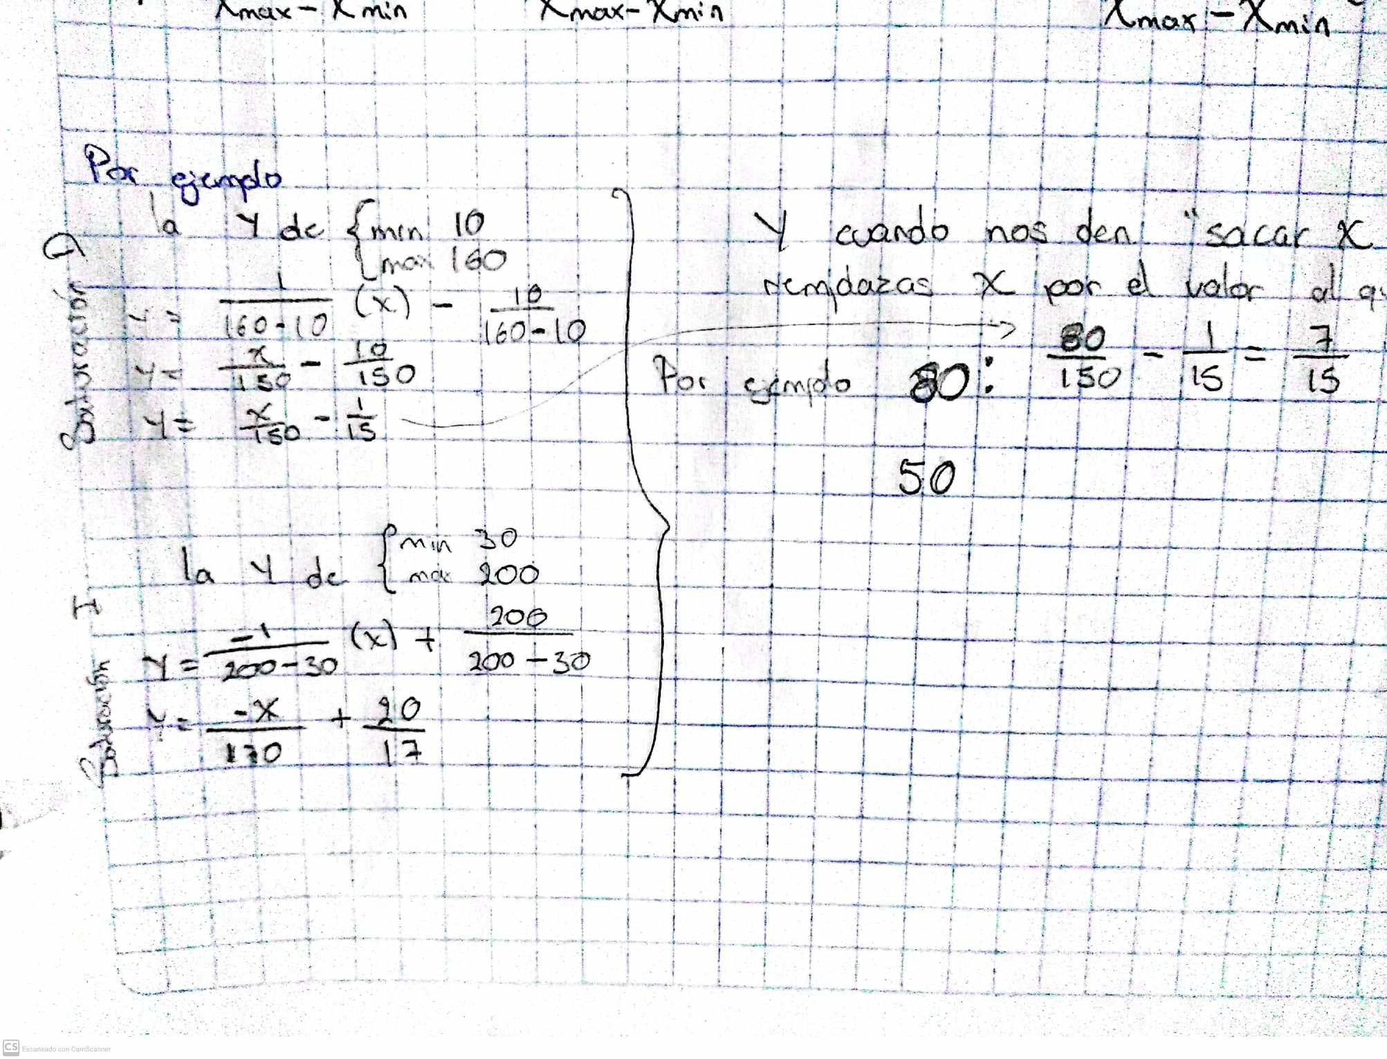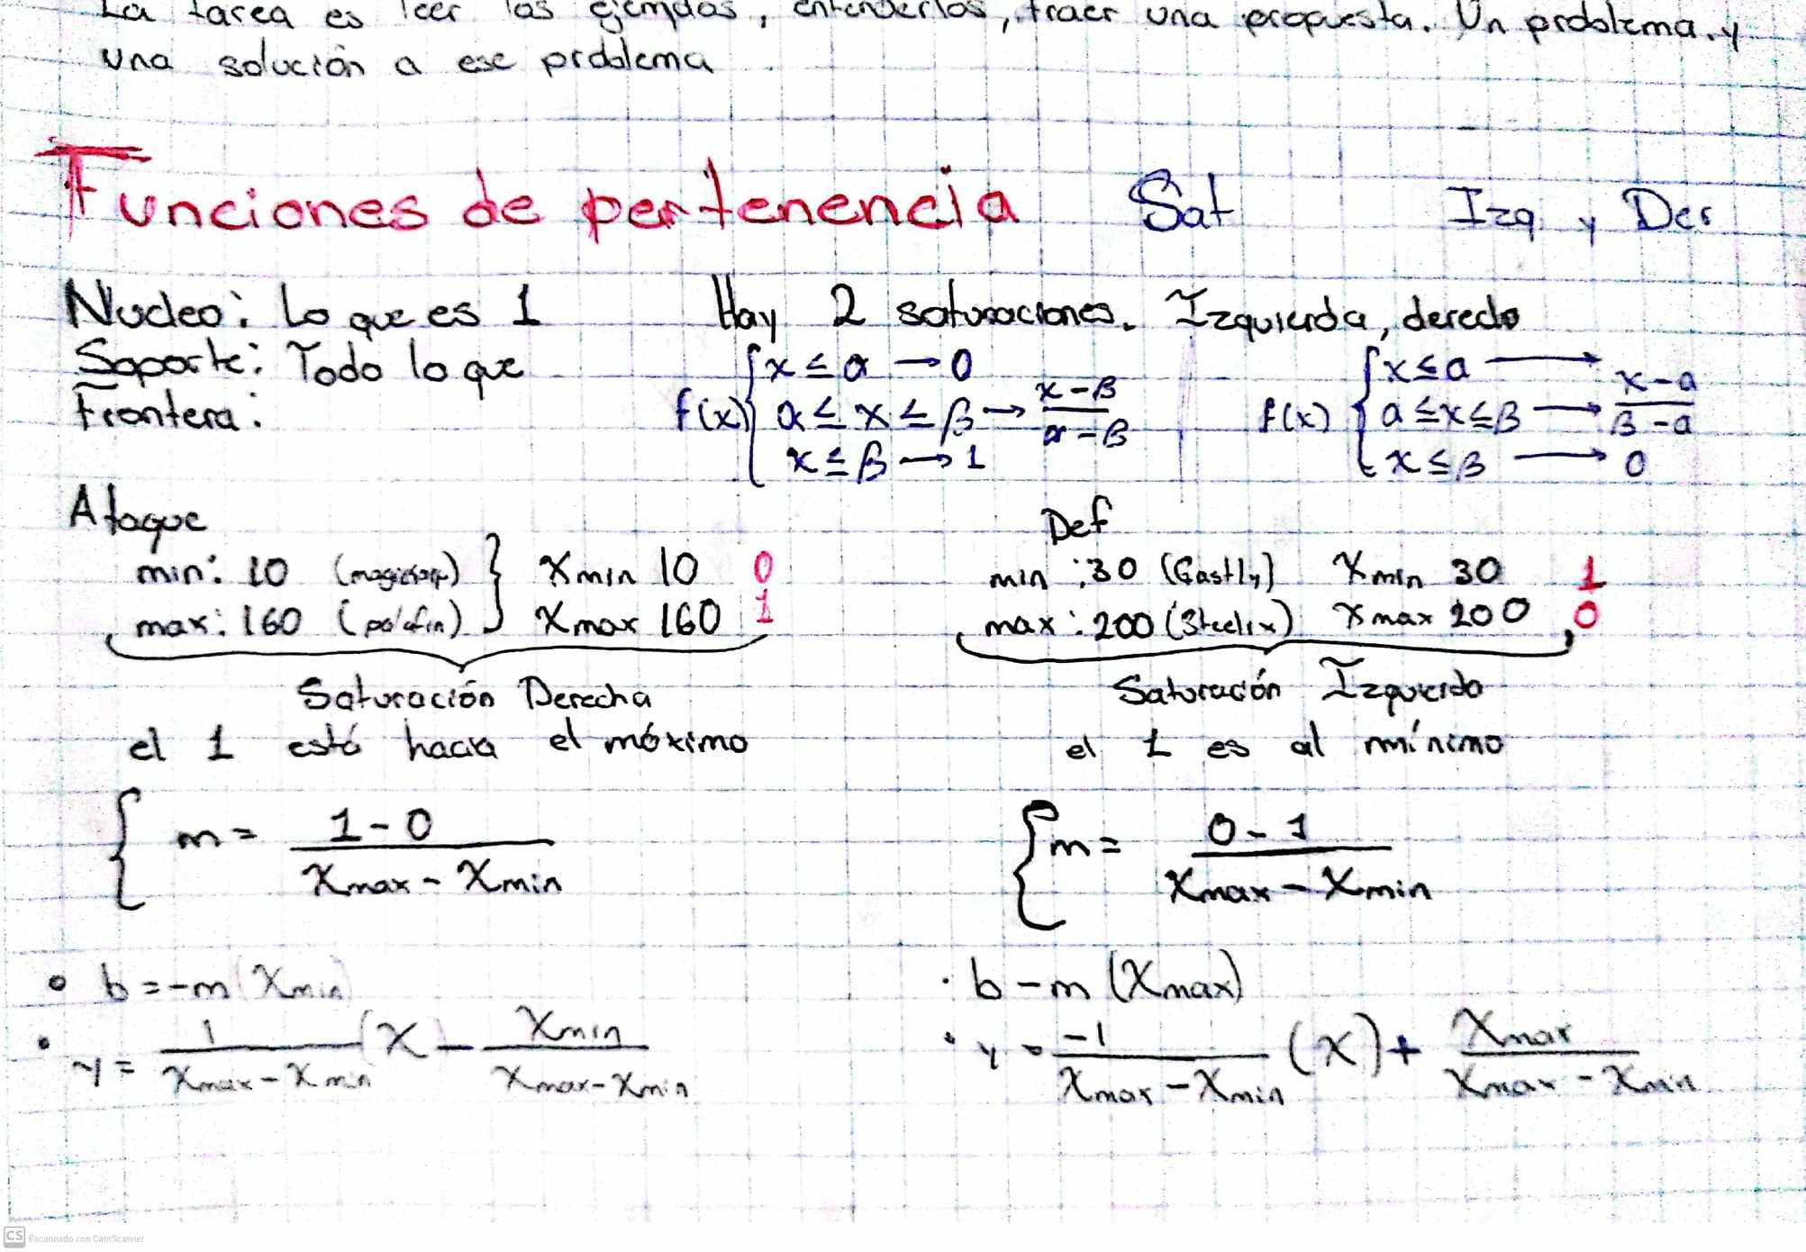

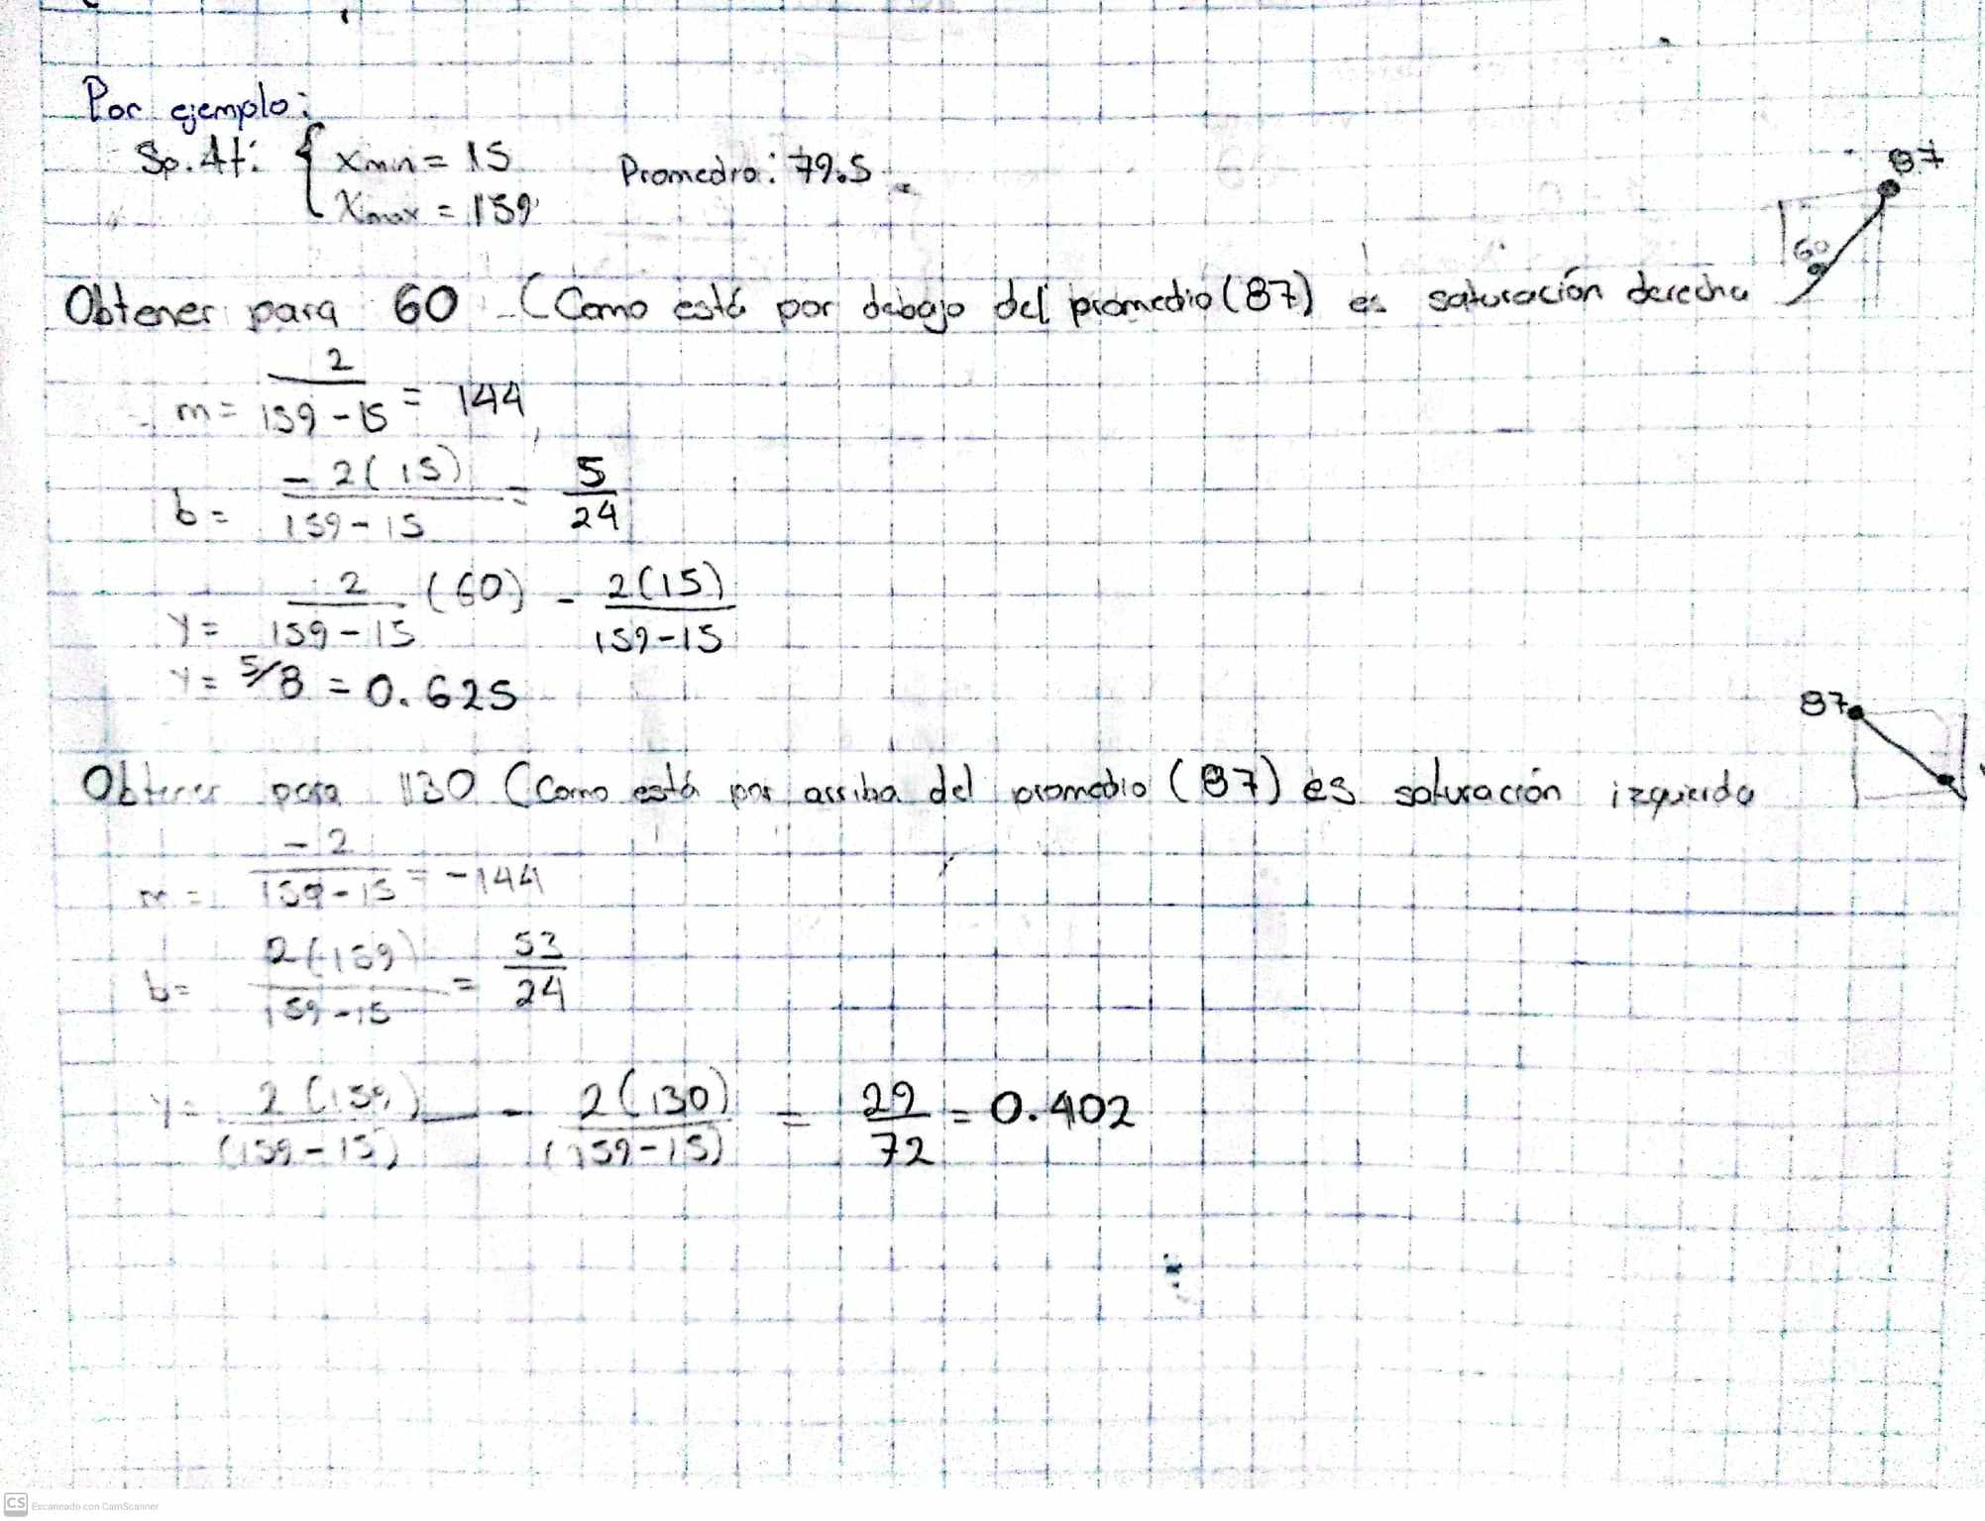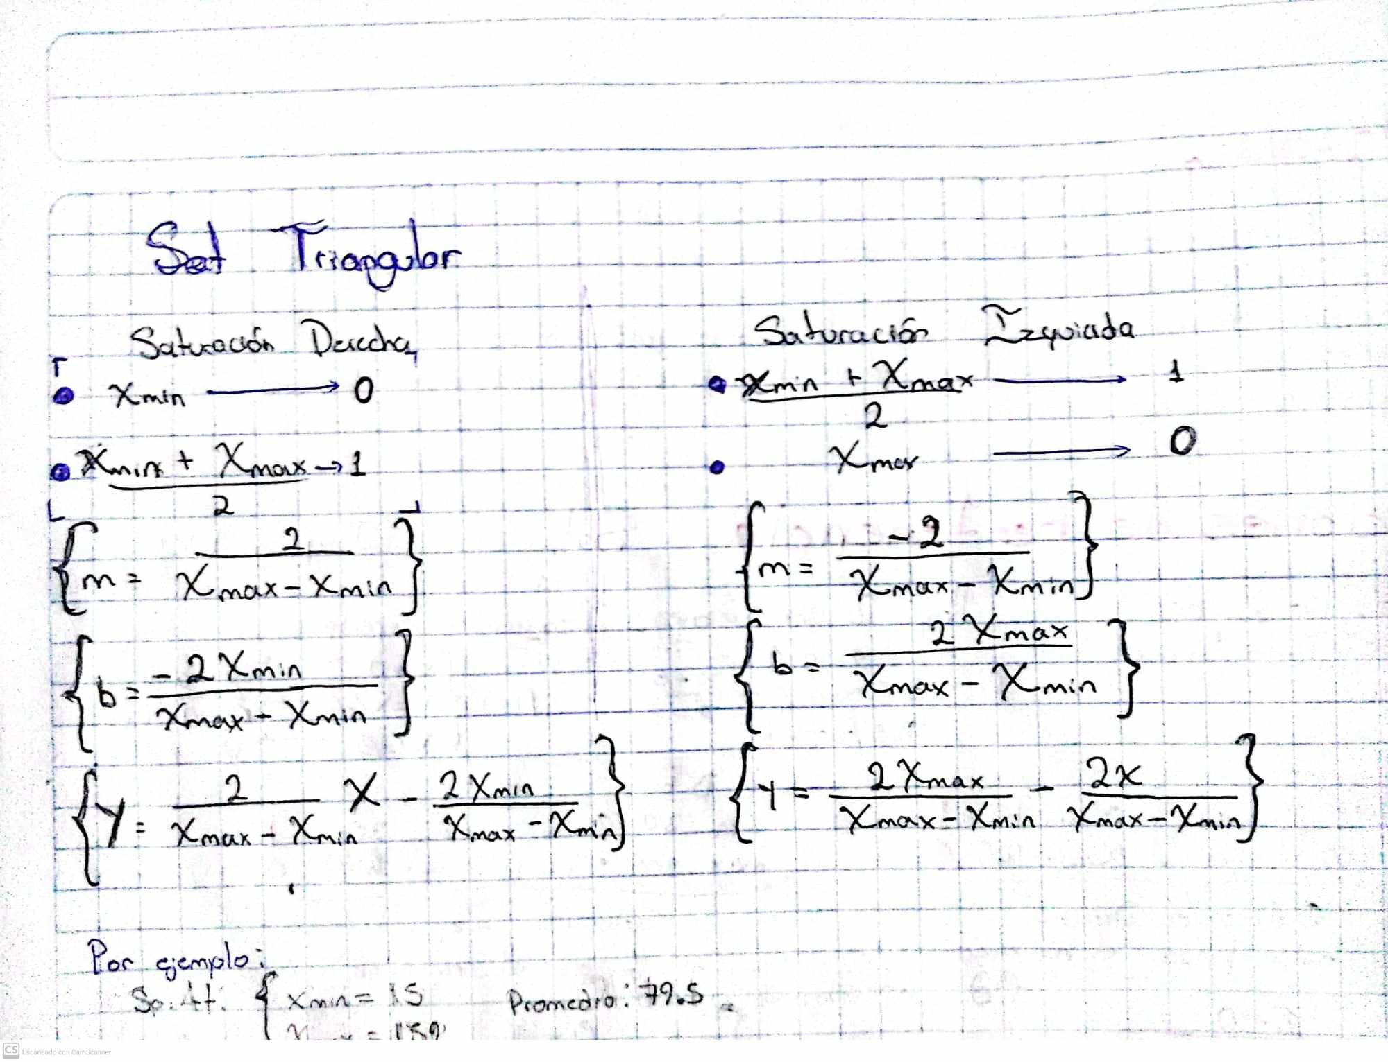

|  |  |  |  |  |  |  |  |  |  |
| --- | --- | --- | --- | --- | --- | --- | --- | --- | --- |
| **Or** | **Nombre** | **HP** | **Atk** | **Def** | **Vel** | **SpeAtk** | **SpeDef** |  |  |
| 1 | squirtle | 44 | 48 | 65 | 43 | 50 | 64 |  | **Mayor HP:** |
| 2 | wartortle | 59 | 63 | 80 | 58 | 65 | 80 |  | Wailord |
| 3 | blastoise | 79 | 83 | 100 | 78 | 85 | 105 |  | Wailord | Pokédex   |  | | --- | |  | |
| 4 | psyduck | 50 | 52 | 48 | 55 | 65 | 50 |  |  |
| 5 | golduck | 80 | 82 | 78 | 85 | 95 | 80 |  |  |
| 6 | poliwag | 40 | 50 | 40 | 90 | 40 | 40 |  |  |
| 7 | poliwhirl | 65 | 65 | 65 | 90 | 50 | 50 |  |  |
| 8 | poliwrath | 90 | 95 | 95 | 70 | 70 | 90 |  |  |
| 9 | tentacool | 40 | 40 | 35 | 70 | 50 | 100 |  | HP: 170 |
| 10 | tentacruel | 80 | 70 | 65 | 100 | 80 | 120 |  |  |
| 11 | slowpoke | 90 | 65 | 65 | 15 | 40 | 40 |  | **Mayor Ataque:** |
| 12 | slowbro | 95 | 75 | 110 | 30 | 100 | 80 |  | Palafin (Heróico) |
| 13 | seel | 65 | 45 | 55 | 45 | 45 | 70 |  | |  | | --- | |  | |
| 14 | dewgong | 90 | 70 | 80 | 70 | 70 | 95 |  |  |
| 15 | shellder | 30 | 65 | 100 | 40 | 45 | 25 |  |  |
| 16 | cloyster | 50 | 95 | 180 | 70 | 85 | 45 |  |  |
| 17 | krabby | 30 | 105 | 90 | 50 | 25 | 25 |  |  |
| 18 | kingler | 55 | 130 | 115 | 75 | 50 | 50 |  |  |
| 19 | horsea | 30 | 40 | 70 | 60 | 70 | 25 |  | Atk: 160 |
| 20 | seadra | 55 | 65 | 95 | 85 | 95 | 45 |  |  |
| 21 | goldeen | 45 | 67 | 60 | 63 | 35 | 50 |  | **Mayor Defensa:** |
| 22 | seaking | 80 | 92 | 65 | 68 | 65 | 80 |  | Cloyster | Pokédex   |  | | --- | | Cloyster | |
| 23 | staryu | 30 | 45 | 55 | 85 | 70 | 55 |  |  |
| 24 | starmie | 60 | 75 | 85 | 115 | 100 | 85 |  |  |
| 25 | magikarp | 20 | 10 | 55 | 80 | 15 | 20 |  |  |
| 26 | gyarados | 95 | 125 | 79 | 81 | 60 | 100 |  |  |
| 27 | lapras | 130 | 85 | 80 | 60 | 85 | 95 |  |  |
| 28 | vaporeon | 130 | 65 | 60 | 65 | 110 | 95 |  |  |
| 29 | omanyte | 35 | 40 | 100 | 35 | 90 | 55 |  | Def: 180 |
| 30 | omastar | 70 | 60 | 125 | 55 | 115 | 70 |  |  |
| 31 | kabuto | 30 | 80 | 90 | 55 | 55 | 45 |  | **Mayor Velocidad:** |
| 32 | kabutops | 60 | 115 | 105 | 80 | 65 | 70 |  | Ferrosaco |
| 33 | totodile | 50 | 65 | 64 | 43 | 44 | 48 |  | Ferrosaco - WikiDex, la enciclopedia Pokémon   |  | | --- | |  | |
| 34 | croconaw | 65 | 80 | 80 | 58 | 59 | 63 |  |  |
| 35 | feraligatr | 85 | 105 | 100 | 78 | 79 | 83 |  |  |
| 36 | chinchou | 75 | 38 | 38 | 67 | 56 | 56 |  |  |
| 37 | lanturn | 125 | 58 | 58 | 67 | 76 | 76 |  |  |
| 38 | marill | 70 | 20 | 50 | 40 | 20 | 50 |  |  |
| 39 | azumarill | 100 | 50 | 80 | 50 | 60 | 80 |  | Spe: 136 |
| 40 | politoed | 90 | 75 | 75 | 70 | 90 | 100 |  |  |
| 41 | wooper | 55 | 45 | 45 | 15 | 25 | 25 |  |  |
| 42 | quagsire | 95 | 85 | 85 | 35 | 65 | 65 |  |  |
| 43 | slowking | 95 | 75 | 80 | 30 | 100 | 110 |  |  |
| 44 | qwilfish | 65 | 95 | 85 | 85 | 55 | 55 |  |  |
| 45 | corsola | 65 | 55 | 95 | 35 | 65 | 95 |  |  |
| 46 | remoraid | 35 | 65 | 35 | 65 | 65 | 35 |  |  |
| 47 | octillery | 75 | 105 | 75 | 45 | 105 | 75 |  |  |
| 48 | mantine | 85 | 40 | 70 | 70 | 80 | 140 |  |  |
| 49 | kingdra | 75 | 95 | 95 | 85 | 95 | 95 |  | **Mayor Ataque Especial:** |
| 50 | suicune | 100 | 75 | 115 | 85 | 90 | 115 |  | Kyogre (Primigenio) |
| 51 | mudkip | 50 | 70 | 50 | 40 | 50 | 50 |  | Primal Kyogre | Pokédex | The official Pokémon Website in Singapore   |  | | --- | |  | |
| 52 | marshtomp | 70 | 85 | 70 | 50 | 60 | 70 |  |  |
| 53 | swampert | 100 | 110 | 90 | 60 | 85 | 90 |  |  |
| 54 | lotad | 40 | 30 | 30 | 30 | 40 | 50 |  |  |
| 55 | lombre | 60 | 50 | 50 | 50 | 60 | 70 |  |  |
| 56 | ludicolo | 80 | 70 | 70 | 70 | 90 | 100 |  |  |
| 57 | wingull | 40 | 30 | 30 | 85 | 55 | 30 |  | SpAtk: 180 |
| 58 | pelipper | 60 | 50 | 100 | 65 | 95 | 70 |  |  |
| 59 | surskit | 40 | 30 | 32 | 65 | 50 | 52 |  | **Mayor Defensa Especial:** |
| 60 | carvanha | 45 | 90 | 20 | 65 | 65 | 20 |  | Kyogre (Primigenio) |
| 61 | sharpedo | 70 | 120 | 40 | 95 | 95 | 40 |  | Primal Kyogre | Pokédex | The official Pokémon Website in Singapore   |  | | --- | |  | |
| 62 | wailmer | 130 | 70 | 35 | 60 | 70 | 35 |  |  |
| 63 | wailord | 170 | 90 | 45 | 60 | 90 | 45 |  |  |
| 64 | barboach | 50 | 48 | 43 | 60 | 46 | 41 |  |  |
| 65 | whiscash | 110 | 78 | 73 | 60 | 76 | 71 |  |  |
| 66 | corphish | 43 | 80 | 65 | 35 | 50 | 35 |  |  |
| 67 | crawdaunt | 63 | 120 | 85 | 55 | 90 | 55 |  | SpDef: 160 |
| 68 | feebas | 20 | 15 | 20 | 80 | 10 | 55 |  |  |
| 69 | milotic | 95 | 60 | 79 | 81 | 100 | 125 |  |  |
| 70 | spheal | 70 | 40 | 50 | 25 | 55 | 50 |  |  |
| 71 | sealeo | 90 | 60 | 70 | 45 | 75 | 70 |  |  |
| 72 | walrein | 110 | 80 | 90 | 65 | 95 | 90 |  |  |
| 73 | clamperl | 35 | 64 | 85 | 32 | 74 | 55 |  |  |
| 74 | huntail | 55 | 104 | 105 | 52 | 94 | 75 |  |  |
| 75 | gorebyss | 55 | 84 | 105 | 52 | 114 | 75 |  |  |
| 76 | relicanth | 100 | 90 | 130 | 55 | 45 | 65 |  |  |
| 77 | luvdisc | 43 | 30 | 55 | 97 | 40 | 65 |  |  |
| 78 | kyogre | 100 | 100 | 90 | 90 | 150 | 140 |  |  |
| 79 | piplup | 53 | 51 | 53 | 40 | 61 | 56 |  |  |
| 80 | prinplup | 64 | 66 | 68 | 50 | 81 | 76 |  |  |
| 81 | empoleon | 84 | 86 | 88 | 60 | 111 | 101 |  |  |
| 82 | bibarel | 79 | 85 | 60 | 71 | 55 | 60 |  |  |
| 83 | buizel | 55 | 65 | 35 | 85 | 60 | 30 |  |  |
| 84 | floatzel | 85 | 105 | 55 | 115 | 85 | 50 |  |  |
| 85 | shellos | 76 | 48 | 48 | 34 | 57 | 62 |  |  |
| 86 | gastrodon | 111 | 83 | 68 | 39 | 92 | 82 |  |  |
| 87 | finneon | 49 | 49 | 56 | 66 | 49 | 61 |  |  |
| 88 | lumineon | 69 | 69 | 76 | 91 | 69 | 86 |  |  |
| 89 | mantyke | 45 | 20 | 50 | 50 | 60 | 120 |  |  |
| 90 | palkia | 90 | 120 | 100 | 100 | 150 | 120 |  |  |
| 91 | phione | 80 | 80 | 80 | 80 | 80 | 80 |  |  |
| 92 | manaphy | 100 | 100 | 100 | 100 | 100 | 100 |  |  |
| 93 | oshawott | 55 | 55 | 45 | 45 | 63 | 45 |  |  |
| 94 | dewott | 75 | 75 | 60 | 60 | 83 | 60 |  |  |
| 95 | samurott | 95 | 100 | 85 | 70 | 108 | 70 |  |  |
| 96 | panpour | 50 | 53 | 48 | 64 | 53 | 48 |  |  |
| 97 | simipour | 75 | 98 | 63 | 101 | 98 | 63 |  |  |
| 98 | tympole | 50 | 50 | 40 | 64 | 50 | 40 |  |  |
| 99 | palpitoad | 75 | 65 | 55 | 69 | 65 | 55 |  |  |
| 100 | seismitoad | 105 | 95 | 75 | 74 | 85 | 75 |  |  |
| 101 | basculin-red-striped | 70 | 92 | 65 | 98 | 80 | 55 |  |  |
| 102 | tirtouga | 54 | 78 | 103 | 22 | 53 | 45 |  |  |
| 103 | carracosta | 74 | 108 | 133 | 32 | 83 | 65 |  |  |
| 104 | ducklett | 62 | 44 | 50 | 55 | 44 | 50 |  |  |
| 105 | swanna | 75 | 87 | 63 | 98 | 87 | 63 |  |  |
| 106 | frillish | 55 | 40 | 50 | 40 | 65 | 85 |  |  |
| 107 | jellicent | 100 | 60 | 70 | 60 | 85 | 105 |  |  |
| 108 | alomomola | 165 | 75 | 80 | 65 | 40 | 45 |  |  |
| 109 | keldeo-ordinary | 91 | 72 | 90 | 108 | 129 | 90 |  |  |
| 110 | froakie | 41 | 56 | 40 | 71 | 62 | 44 |  |  |
| 111 | frogadier | 54 | 63 | 52 | 97 | 83 | 56 |  |  |
| 112 | greninja | 72 | 95 | 67 | 122 | 103 | 71 |  |  |
| 113 | binacle | 42 | 52 | 67 | 50 | 39 | 56 |  |  |
| 114 | barbaracle | 72 | 105 | 115 | 68 | 54 | 86 |  |  |
| 115 | skrelp | 50 | 60 | 60 | 30 | 60 | 60 |  |  |
| 116 | clauncher | 50 | 53 | 62 | 44 | 58 | 63 |  |  |
| 117 | clawitzer | 71 | 73 | 88 | 59 | 120 | 89 |  |  |
| 118 | volcanion | 80 | 110 | 120 | 70 | 130 | 90 |  |  |
| 119 | popplio | 50 | 54 | 54 | 40 | 66 | 56 |  |  |
| 120 | brionne | 60 | 69 | 69 | 50 | 91 | 81 |  |  |
| 121 | primarina | 80 | 74 | 74 | 60 | 126 | 116 |  |  |
| 122 | wishiwashi-solo | 45 | 20 | 20 | 40 | 25 | 25 |  |  |
| 123 | mareanie | 50 | 53 | 62 | 45 | 43 | 52 |  |  |
| 124 | toxapex | 50 | 63 | 152 | 35 | 53 | 142 |  |  |
| 125 | dewpider | 38 | 40 | 52 | 27 | 40 | 72 |  |  |
| 126 | araquanid | 68 | 70 | 92 | 42 | 50 | 132 |  |  |
| 127 | wimpod | 25 | 35 | 40 | 80 | 20 | 30 |  |  |
| 128 | golisopod | 75 | 125 | 140 | 40 | 60 | 90 |  |  |
| 129 | pyukumuku | 55 | 60 | 130 | 5 | 30 | 130 |  |  |
| 130 | bruxish | 68 | 105 | 70 | 92 | 70 | 70 |  |  |
| 131 | tapu-fini | 70 | 75 | 115 | 85 | 95 | 130 |  |  |
| 132 | sobble | 50 | 40 | 40 | 70 | 70 | 40 |  |  |
| 133 | drizzile | 65 | 60 | 55 | 90 | 95 | 55 |  |  |
| 134 | inteleon | 70 | 85 | 65 | 120 | 125 | 65 |  |  |
| 135 | chewtle | 50 | 64 | 50 | 44 | 38 | 38 |  |  |
| 136 | drednaw | 90 | 115 | 90 | 74 | 48 | 68 |  |  |
| 137 | cramorant | 70 | 85 | 55 | 85 | 85 | 95 |  |  |
| 138 | arrokuda | 41 | 63 | 40 | 66 | 40 | 30 |  |  |
| 139 | barraskewda | 61 | 123 | 60 | 136 | 60 | 50 |  |  |
| 140 | dracovish | 90 | 90 | 100 | 75 | 70 | 80 |  |  |
| 141 | arctovish | 90 | 90 | 100 | 55 | 80 | 90 |  |  |
| 142 | basculegion-male | 120 | 112 | 65 | 78 | 80 | 75 |  |  |
| 143 | quaxly | 55 | 65 | 45 | 50 | 50 | 45 |  |  |
| 144 | quaxwell | 70 | 85 | 65 | 65 | 65 | 60 |  |  |
| 145 | quaquaval | 85 | 120 | 80 | 85 | 85 | 75 |  |  |
| 146 | wiglett | 10 | 55 | 25 | 95 | 35 | 25 |  |  |
| 147 | wugtrio | 35 | 100 | 50 | 120 | 50 | 70 |  |  |
| 148 | finizen | 70 | 45 | 40 | 75 | 45 | 40 |  |  |
| 149 | palafin | 100 | 70 | 72 | 100 | 53 | 62 |  |  |
| 150 | veluza | 90 | 102 | 73 | 70 | 78 | 65 |  |  |
| 151 | dondozo | 150 | 100 | 115 | 35 | 65 | 65 |  |  |
| 152 | tatsugiri | 68 | 50 | 60 | 82 | 120 | 95 |  |  |
| 153 | iron-bundle | 56 | 80 | 114 | 136 | 124 | 60 |  |  |
| 154 | walking-wake | 99 | 83 | 91 | 109 | 125 | 83 |  |  |
| 155 | rotom-wash | 50 | 65 | 107 | 86 | 105 | 107 |  |  |
| 156 | castform-rainy | 70 | 70 | 70 | 70 | 70 | 70 |  |  |
| 157 | basculin-blue-striped | 70 | 92 | 65 | 98 | 80 | 55 |  |  |
| 158 | keldeo-resolute | 91 | 72 | 90 | 108 | 129 | 90 |  |  |
| 159 | blastoise-mega | 79 | 103 | 120 | 78 | 135 | 115 |  |  |
| 160 | gyarados-mega | 95 | 155 | 109 | 81 | 70 | 130 |  |  |
| 161 | swampert-mega | 100 | 150 | 110 | 70 | 95 | 110 |  |  |
| 162 | sharpedo-mega | 70 | 140 | 70 | 105 | 110 | 65 |  |  |
| 163 | slowbro-mega | 95 | 75 | 180 | 30 | 130 | 80 |  |  |
| 164 | kyogre-primal | 100 | 150 | 90 | 90 | 180 | 160 |  |  |
| 165 | greninja-battle-bond | 72 | 95 | 67 | 122 | 103 | 71 |  |  |
| 166 | greninja-ash | 72 | 145 | 67 | 132 | 153 | 71 |  |  |
| 167 | wishiwashi-school | 45 | 140 | 130 | 30 | 140 | 135 |  |  |
| 168 | araquanid-totem | 68 | 70 | 92 | 42 | 50 | 132 |  |  |
| 169 | cramorant-gulping | 70 | 85 | 55 | 85 | 85 | 95 |  |  |
| 170 | cramorant-gorging | 70 | 85 | 55 | 85 | 85 | 95 |  |  |
| 171 | urshifu-rapid-strike | 100 | 130 | 100 | 97 | 63 | 60 |  |  |
| 172 | blastoise-gmax | 79 | 83 | 100 | 78 | 85 | 105 |  |  |
| 173 | kingler-gmax | 55 | 130 | 115 | 75 | 50 | 50 |  |  |
| 174 | lapras-gmax | 130 | 85 | 80 | 60 | 85 | 95 |  |  |
| 175 | inteleon-gmax | 70 | 85 | 65 | 120 | 125 | 65 |  |  |
| 176 | drednaw-gmax | 90 | 115 | 90 | 74 | 48 | 68 |  |  |
| 177 | urshifu-rapid-strike-gmax | 100 | 130 | 100 | 97 | 63 | 60 |  |  |
| 178 | samurott-hisui | 90 | 108 | 80 | 85 | 100 | 65 |  |  |
| 179 | palkia-origin | 90 | 100 | 100 | 120 | 150 | 120 |  |  |
| 180 | basculin-white-striped | 70 | 92 | 65 | 98 | 80 | 55 |  |  |
| 181 | basculegion-female | 120 | 92 | 65 | 78 | 100 | 75 |  |  |
| 182 | tauros-paldea-aqua-breed | 75 | 110 | 105 | 100 | 30 | 70 |  |  |
| 183 | palafin-hero | 100 | 160 | 97 | 100 | 106 | 87 |  |  |
| 184 | tatsugiri-droopy | 68 | 50 | 60 | 82 | 120 | 95 |  |  |
| 185 | tatsugiri-stretchy | 68 | 50 | 60 | 82 | 120 | 95 |  |  |
| 186 | ogerpon-wellspring-mask | 80 | 120 | 84 | 110 | 60 | 96 |  |  |

|  |  |  |  |  |  |  |  |  |  |  |
| --- | --- | --- | --- | --- | --- | --- | --- | --- | --- | --- |
| **Or** | **Nombre** | **HP** | **Atk** | **Def** | **Vel** | **SpAt** | **SpDf** |  |  |  |
| 1 | bulbasaur | 45 | 49 | 49 | 45 | 65 | 65 |  |  |  |
| 2 | ivysaur | 60 | 62 | 63 | 60 | 80 | 80 |  | **Mayor HP:** |  |
| 3 | venusaur | 80 | 82 | 83 | 80 | 100 | 100 |  | Eternatus Eternamax |  |
| 4 | weedle | 40 | 35 | 30 | 50 | 20 | 20 |  | Eternatus Dinamax infinito   |  | | --- | |  | |  |
| 5 | kakuna | 45 | 25 | 50 | 35 | 25 | 25 |  |  |  |
| 6 | beedrill | 65 | 90 | 40 | 75 | 45 | 80 |  |  |  |
| 7 | ekans | 35 | 60 | 44 | 55 | 40 | 54 |  |  |  |
| 8 | arbok | 60 | 95 | 69 | 80 | 65 | 79 |  |  |  |
| 9 | nidoran-f | 55 | 47 | 52 | 41 | 40 | 40 |  |  |  |
| 10 | nidorina | 70 | 62 | 67 | 56 | 55 | 55 |  | HP: 255 |  |
| 11 | nidoqueen | 90 | 92 | 87 | 76 | 75 | 85 |  |  |  |
| 12 | nidoran-m | 46 | 57 | 40 | 50 | 40 | 40 |  | **Mayor Defensa:** |  |
| 13 | nidorino | 61 | 72 | 57 | 65 | 55 | 55 |  | Eternatus Eternamax |  |
| 14 | nidoking | 81 | 102 | 77 | 85 | 85 | 75 |  | Eternatus Dinamax infinito   |  | | --- | |  | |  |
| 15 | zubat | 40 | 45 | 35 | 55 | 30 | 40 |  |  |  |
| 16 | golbat | 75 | 80 | 70 | 90 | 65 | 75 |  |  |  |
| 17 | oddish | 45 | 50 | 55 | 30 | 75 | 65 |  |  |  |
| 18 | gloom | 60 | 65 | 70 | 40 | 85 | 75 |  |  |  |
| 19 | vileplume | 75 | 80 | 85 | 50 | 110 | 90 |  |  |  |
| 20 | venonat | 60 | 55 | 50 | 45 | 40 | 55 |  | Def: 250 |  |
| 21 | venomoth | 70 | 65 | 60 | 90 | 90 | 75 |  |  |  |
| 22 | bellsprout | 50 | 75 | 35 | 40 | 70 | 30 |  | **Mayor Ataque:** |  |
| 23 | weepinbell | 65 | 90 | 50 | 55 | 85 | 45 |  | Mega-Bedrill |  |
| 24 | victreebel | 80 | 105 | 65 | 70 | 100 | 70 |  | Beedrill | Pokédex   |  | | --- | |  | |  |
| 25 | tentacool | 40 | 40 | 35 | 70 | 50 | 100 |  |  |  |
| 26 | tentacruel | 80 | 70 | 65 | 100 | 80 | 120 |  |  |  |
| 27 | grimer | 80 | 80 | 50 | 25 | 40 | 50 |  |  |  |
| 28 | muk | 105 | 105 | 75 | 50 | 65 | 100 |  |  |  |
| 29 | gastly | 30 | 35 | 30 | 80 | 100 | 35 |  |  |  |
| 30 | haunter | 45 | 50 | 45 | 95 | 115 | 55 |  | Atk: 150 |  |
| 31 | gengar | 60 | 65 | 60 | 110 | 130 | 75 |  |  |  |
| 32 | koffing | 40 | 65 | 95 | 35 | 60 | 45 |  | **Mayor Velocidad:** |  |
| 33 | weezing | 65 | 90 | 120 | 60 | 85 | 70 |  | Mega-Bedrill |  |
| 34 | spinarak | 40 | 60 | 40 | 30 | 40 | 40 |  | Beedrill | Pokédex   |  | | --- | |  | |  |
| 35 | ariados | 70 | 90 | 70 | 40 | 60 | 70 |  |  |  |
| 36 | crobat | 85 | 90 | 80 | 130 | 70 | 80 |  |  |  |
| 37 | qwilfish | 65 | 95 | 85 | 85 | 55 | 55 |  |  |  |
| 38 | dustox | 60 | 50 | 70 | 65 | 50 | 90 |  |  |  |
| 39 | roselia | 50 | 60 | 45 | 65 | 100 | 80 |  |  |  |
| 40 | gulpin | 70 | 43 | 53 | 40 | 43 | 53 |  | Speed: 141 |  |
| 41 | swalot | 100 | 73 | 83 | 55 | 73 | 83 |  |  |  |
| 42 | seviper | 73 | 100 | 60 | 65 | 100 | 60 |  |  |  |
| 43 | budew | 40 | 30 | 35 | 55 | 50 | 70 |  |  |  |
| 44 | roserade | 60 | 70 | 65 | 90 | 125 | 105 |  |  |  |
| 45 | stunky | 63 | 63 | 47 | 74 | 41 | 41 |  |  |  |
| 46 | skuntank | 103 | 93 | 67 | 84 | 71 | 61 |  | **Mayor Ataque.Especial** |  |
| 47 | skorupi | 40 | 50 | 90 | 65 | 30 | 55 |  | Mega-Gengar |  |
| 48 | drapion | 70 | 90 | 110 | 95 | 60 | 75 |  | Gengar | Pokédex   |  | | --- | |  | |  |
| 49 | croagunk | 48 | 61 | 40 | 50 | 61 | 40 |  |  |  |
| 50 | toxicroak | 83 | 106 | 65 | 85 | 86 | 65 |  |  |  |
| 51 | venipede | 30 | 45 | 59 | 57 | 30 | 39 |  |  |  |
| 52 | whirlipede | 40 | 55 | 99 | 47 | 40 | 79 |  |  |  |
| 53 | scolipede | 60 | 100 | 89 | 112 | 55 | 69 |  |  |  |
| 54 | trubbish | 50 | 50 | 62 | 65 | 40 | 62 |  | Sp.Atk: 170 |  |
| 55 | garbodor | 80 | 95 | 82 | 75 | 60 | 82 |  |  |  |
| 56 | foongus | 69 | 55 | 45 | 15 | 55 | 55 |  | **Mayor Defensa Especial:** |  |
| 57 | amoonguss | 114 | 85 | 70 | 30 | 85 | 80 |  | Eternatus Eternamax |  |
| 58 | skrelp | 50 | 60 | 60 | 30 | 60 | 60 |  | Eternatus Dinamax infinito   |  | | --- | |  | |  |
| 59 | dragalge | 65 | 75 | 90 | 44 | 97 | 123 |  |  |  |
| 60 | mareanie | 50 | 53 | 62 | 45 | 43 | 52 |  |  |  |
| 61 | toxapex | 50 | 63 | 152 | 35 | 53 | 142 |  |  |  |
| 62 | salandit | 48 | 44 | 40 | 77 | 71 | 40 |  |  |  |
| 63 | salazzle | 68 | 64 | 60 | 117 | 111 | 60 |  |  |  |
| 64 | nihilego | 109 | 53 | 47 | 103 | 127 | 131 |  | SpDef: 250 |  |
| 65 | poipole | 67 | 73 | 67 | 73 | 73 | 67 |  |  |  |
| 66 | naganadel | 73 | 73 | 73 | 121 | 127 | 73 |  |  |  |
| 67 | toxel | 40 | 38 | 35 | 40 | 54 | 35 |  |  |  |
| 68 | toxtricity-amped | 75 | 98 | 70 | 75 | 114 | 70 |  |  |  |
| 69 | eternatus | 140 | 85 | 95 | 130 | 145 | 95 |  |  |  |
| 70 | sneasler | 80 | 130 | 60 | 120 | 40 | 80 |  |  |  |
| 71 | overqwil | 85 | 115 | 95 | 85 | 65 | 65 |  |  |  |
| 72 | shroodle | 40 | 65 | 35 | 75 | 40 | 35 |  |  |  |
| 73 | grafaiai | 63 | 95 | 65 | 110 | 80 | 72 |  |  |  |
| 74 | varoom | 45 | 70 | 63 | 47 | 30 | 45 |  |  |  |
| 75 | revavroom | 80 | 119 | 90 | 90 | 54 | 67 |  |  |  |
| 76 | glimmet | 48 | 35 | 42 | 60 | 105 | 60 |  |  |  |
| 77 | glimmora | 83 | 55 | 90 | 86 | 130 | 81 |  |  |  |
| 78 | clodsire | 130 | 75 | 60 | 20 | 45 | 100 |  |  |  |
| 79 | iron-moth | 80 | 70 | 60 | 110 | 140 | 110 |  |  |  |
| 80 | okidogi | 88 | 128 | 115 | 80 | 58 | 86 |  |  |  |
| 81 | munkidori | 88 | 75 | 66 | 106 | 130 | 90 |  |  |  |
| 82 | fezandipiti | 88 | 91 | 82 | 99 | 70 | 125 |  |  |  |
| 83 | pecharunt | 88 | 88 | 160 | 88 | 88 | 88 |  |  |  |
| 84 | venusaur-mega | 80 | 100 | 123 | 80 | 122 | 120 |  |  |  |
| 85 | gengar-mega | 60 | 65 | 80 | 130 | 170 | 95 |  |  |  |
| 86 | beedrill-mega | 65 | 150 | 40 | 145 | 15 | 80 |  |  |  |
| 87 | grimer-alola | 80 | 80 | 50 | 25 | 40 | 50 |  |  |  |
| 88 | muk-alola | 105 | 105 | 75 | 50 | 65 | 100 |  |  |  |
| 89 | salazzle-totem | 68 | 64 | 60 | 117 | 111 | 60 |  |  |  |
| 90 | slowbro-galar | 95 | 100 | 95 | 30 | 100 | 70 |  |  |  |
| 91 | weezing-galar | 65 | 90 | 120 | 60 | 85 | 70 |  |  |  |
| 92 | slowking-galar | 95 | 65 | 80 | 30 | 110 | 110 |  |  |  |
| 93 | toxtricity-low-key | 75 | 98 | 70 | 75 | 114 | 70 |  |  |  |
| 94 | eternatus-eternamax | 255 | 115 | 250 | 130 | 125 | 250 |  |  |  |
| 95 | venusaur-gmax | 80 | 82 | 83 | 80 | 100 | 100 |  |  |  |
| 96 | gengar-gmax | 60 | 65 | 60 | 110 | 130 | 75 |  |  |  |
| 97 | garbodor-gmax | 80 | 95 | 82 | 75 | 60 | 82 |  |  |  |
| 98 | toxtricity-amped-gmax | 75 | 98 | 70 | 75 | 114 | 70 |  |  |  |
| 99 | toxtricity-low-key-gmax | 75 | 98 | 70 | 75 | 114 | 70 |  |  |  |
| 100 | qwilfish-hisui | 65 | 95 | 85 | 85 | 55 | 55 |  |  |  |
| 101 | sneasel-hisui | 55 | 95 | 55 | 115 | 35 | 75 |  |  |  |
| 102 | wooper-paldea | 55 | 45 | 45 | 15 | 25 | 25 |  |  |  |