# Analysis findings and **recommendations – see page 3 for a forecast of crimes over the next 3 months**

Increases in crimes within Seattle are driven by **property-based crimes,** with **person-based crimes** having a secondary impact as seen in Figure 1 below.

Figure 1

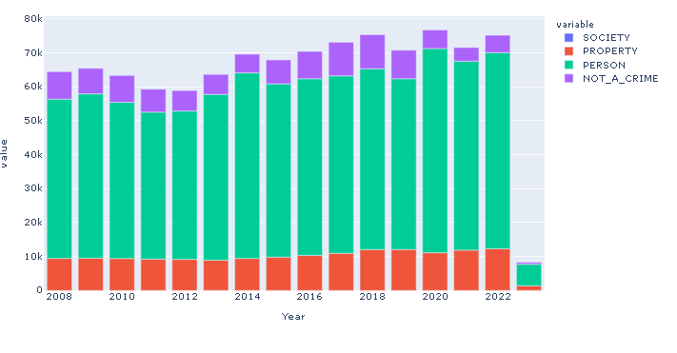

Crime in Seattle as seen in the two panels of Figure 2 below vary based on income levels; society crimes – where property is not the objective per the FBI’s definition ([crimes-against-persons-property-and-society (fbi.gov)](https://ucr.fbi.gov/nibrs/2012/resources/crimes-against-persons-property-and-society) - are prevalent in those areas with lower and average incomes. Property crimes become more prevalent as we move towards the north of the city, getting into Lake City, Ravenna as well as Alki and West Seattle.

Demographic data is from: [The Highest and Lowest Income Areas in Seattle, WA | BestNeighborhood.org](https://bestneighborhood.org/household-income-seattle-wa/)

**This analysis allows the SPD to focus their staffing based on crime type e.g. focusing on property crimes prevention in North and West Seattle.**

The GitHub repo supporting this analysis can be found here: <https://github.com/Ranga2904/CrimeinSeattle_Hackathon>. A key part of this script – and in following analysis – is encoding crime data, thereby transforming provided dataframes from long to wide. This allowed to track crimes over time. Provided time stamps were also used to extract hour, month, and year to allow for more granular analysis.

Figure 2

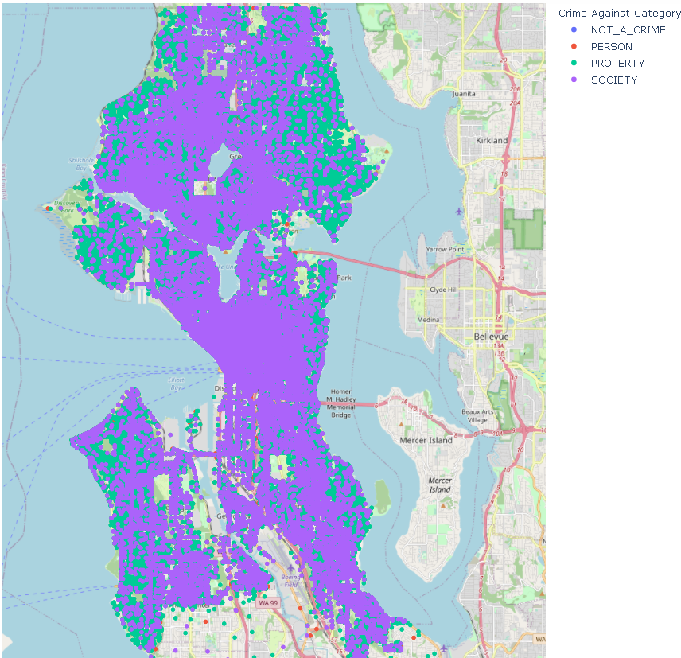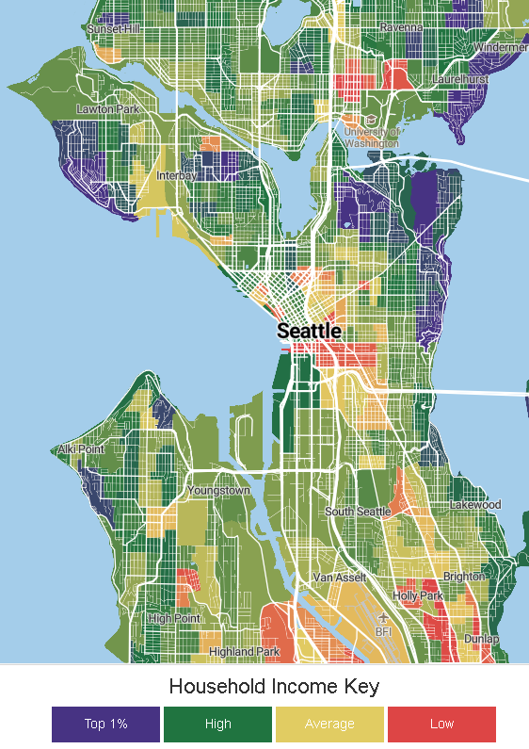

By trending specific offenses over the years, we observe the following:

* Crimes 240 and 26F – Motor vehicle theft and identity theft – are declining
* The following crimes have all increased over the last 1 – 2 years, suggesting that they drive current trends:
  + Property crimes: 26A (false pretense), 26C (impersonation), 23B (purse snatching)
  + Person crimes: 11D (fondling), 36B (statutory rape), 64B (human trafficking)
  + Society crimes: 520 (weapon law violations, trespassing)

This suggests that the **SPD should reorient training programs and focus personnel, investment towards the above offenses** driving recent increases. Figure 3 below illustrates a sample of these trends, with the rest found in the GitHub repo (https://github.com/Ranga2904/CrimeinSeattle_Hackathon)

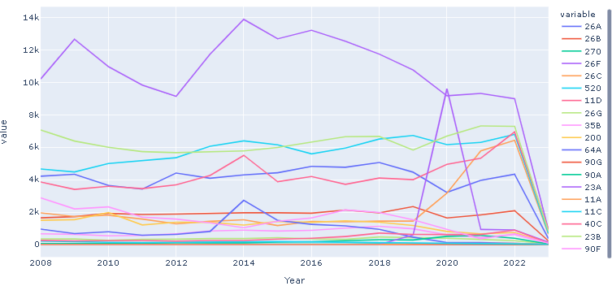

With an understanding of the crimes of concern, let’s next focus on those precincts that are the source of greatest concern. In Figure 3 below, all colors are separated by white grids with the same sequence of precincts from bottom to top: E, N, S, SW, W. T**he graph below suggests that the Seattle Police Department focus on the North precinct** which has consistently been the source of most crimes, with increases particularly noticeable for 26A (False pretense) and 26C (impersonation). **The South precinct has also begun to see increases in 26C**

Figure 4

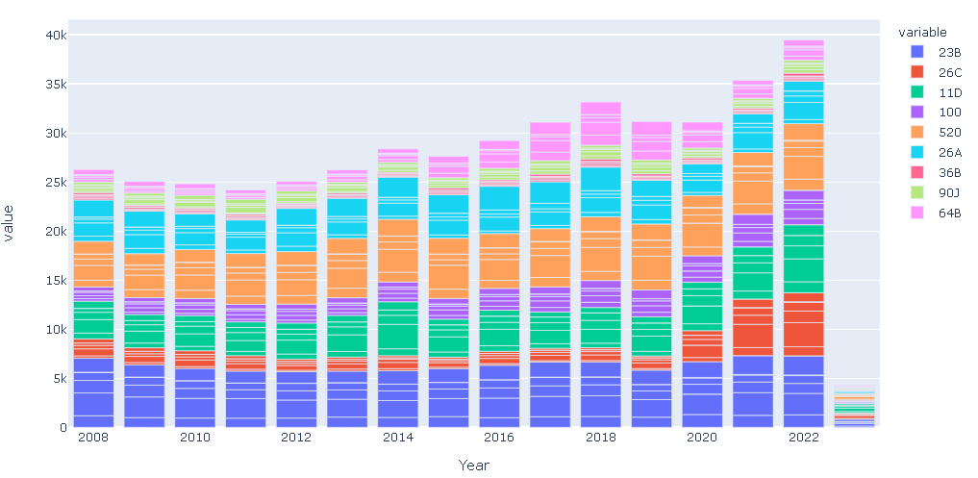

# **Predictions using time series forecasting**

By first grouping an encoded dataset, I produced a dataframe that had society, property, and person crimes by month and year

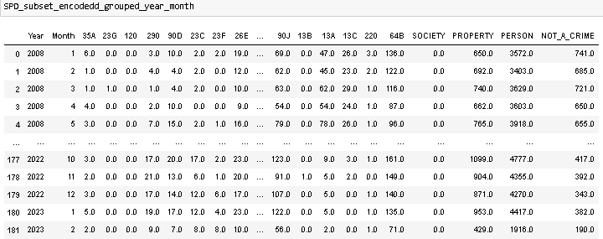

ARIMA models were then fit to a sample of this data for training and then evaluated for their ability to predict specific classes of crimes – below in red are predicted vs blue (actual) crimes, and corresponding model performances. The model for property-based crimes had the largest bias, given the non-zero mean – below are results for property and people, which are larger impacts to total crime than society

Property Crimes – the observed RMSE is approximately 16 – 18% of actual values

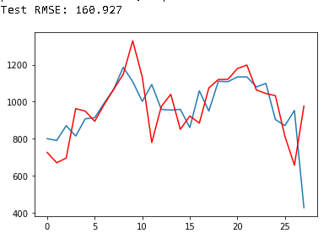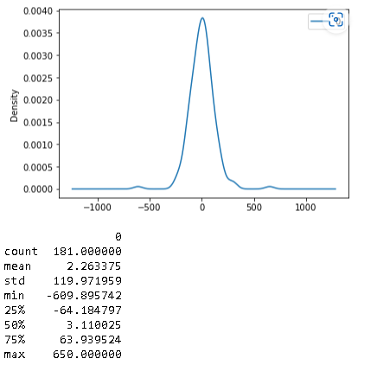

People Crimes – the observed RMSE is approximately 15% of actual values:

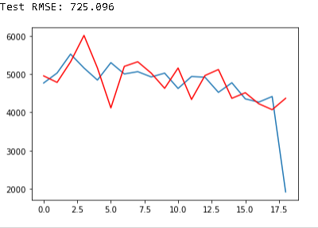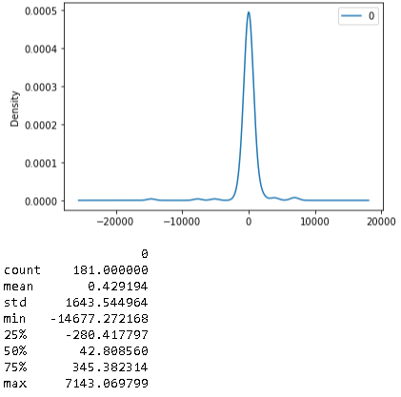

These ARIMA models were then used to forecast actual crimes per class, for the next 3 months: