SQL

1. Database & DBMS
Database
- A collection of related data stored in an organized manner.
DBMS (Database Management System)
- Software used to create, store, retrieve, update, and manage databases.
Examples:
- MySQL
- Oracle
- PostgreSQL
- SQL Server

2. SQL (Structured Query Language)
Used to communicate with a database.
Main operations:
- Create
- Read
- Update
- Delete (CRUD)

3. Basic SELECT
Display all columns:
SELECT * FROM Students;
Display specific columns:
SELECT Name, CGPA
FROM Students;

4. WHERE
Used to filter rows.
Example:
SELECT *
FROM Students
WHERE CGPA > 9;
Execution Order:
FROM
WHERE

5. ORDER BY
Used to sort results.
Ascending (default):
ORDER BY Name;
Descending:
ORDER BY CGPA DESC;

6. Aggregate Functions
Function | Purpose
COUNT() | Counts rows
AVG() | Average value
MAX() | Maximum value
MIN() | Minimum value
SUM() | Total sum
Example:
SELECT AVG(CGPA)
FROM Students;

7. COUNT vs COUNT(DISTINCT)
COUNT(Branch)
Counts all non-NULL branch values.
Example:
ECE
ECE
CSE
Answer = 3

COUNT(DISTINCT Branch)
Counts unique branches.
Example:
ECE
ECE
CSE
Answer = 2

8. Primary Key
- Uniquely identifies each row.
- Cannot contain NULL.
- Must be unique.
Example:
Student_ID

9. Foreign Key
Creates a relationship between two tables.
Example:
Students
Student_ID (PK)
Orders
Student_ID (FK)

10. Why Normalization?
Purpose:
- Avoid duplicate data
- Save storage
- Improve consistency
- Organize data

11. SQL Joins
INNER JOIN
Returns only matching rows.
A ∩ B

LEFT JOIN
Returns:
- All rows from Left Table
- Matching rows from Right Table
No match → NULL

RIGHT JOIN
Returns:
- All rows from Right Table
- Matching rows from Left Table
No match → NULL

FULL OUTER JOIN
Returns:
- All rows from both tables
No match → NULL

SELF JOIN
A table joins with itself.
Uses aliases.
Example:
Employee → Manager relationship.

CROSS JOIN
Returns every possible combination.
Rows Returned:
Rows(Table1) × Rows(Table2)
Example:
5 × 3 = 15 rows

12. GROUP BY
Groups identical values.
Mostly used with aggregate functions.
Example:
SELECT Branch, COUNT(*)
FROM Students
GROUP BY Branch;

13. HAVING
Filters groups, not rows.
Example:
SELECT Branch, COUNT(*)
FROM Students
GROUP BY Branch
HAVING COUNT(*) > 2;

WHERE vs HAVING
WHERE | HAVING
Filters rows | Filters groups
Before GROUP BY | After GROUP BY
Cannot use aggregate functions | Can use aggregate functions

14. SQL Execution Order
Most important interview question.
1. FROM
2. WHERE
3. GROUP BY
4. Aggregate Functions
5. HAVING
6. SELECT
7. ORDER BY

15. GROUP BY Rule
If you write:
SELECT A, B
Every selected column must satisfy one of these:
- Included in GROUP BY
- OR wrapped inside an aggregate function
Wrong:
SELECT Name, AVG(CGPA)
FROM Students
GROUP BY Branch;
Reason:
SQL doesn't know which Name to display.
Correct:
SELECT Branch, AVG(CGPA)
FROM Students
GROUP BY Branch;

16. Subqueries
Definition:
A query inside another query.
General Form:
SELECT ...
FROM ...
WHERE Column >
(
SELECT ...
);
Execution:
- Execute inner query.
- Replace with result.
- Execute outer query.

Example:
SELECT Name
FROM Students
WHERE CGPA >
(
SELECT AVG(CGPA)
FROM Students
);

17. Single-Row Subquery
Returns exactly one value.
Examples:
AVG()
MAX()
MIN()
COUNT()
SUM()
Use operators:
>
<
=
>=
<=
<>
Example:
WHERE Salary >
(
SELECT AVG(Salary)
FROM Employees
);

18. Multi-Row Subquery (Introduction)
Returns multiple values.
Examples:
60000
70000
80000
Use:
IN
NOT IN
ANY
ALL
EXISTS

19. Common Interview Mistakes
❌ Using aggregate functions in WHERE
WHERE AVG(CGPA) > 9
✅ Correct:
HAVING AVG(CGPA) > 9

❌ Selecting a non-grouped column
SELECT Name, AVG(CGPA)
FROM Students
GROUP BY Branch;

❌ Grouping by the wrong column
GROUP BY CGPA
When finding average per branch.
Correct:
GROUP BY Branch

20. Interview Memory Tricks
SQL Execution
FROM
↓
WHERE
↓
GROUP BY
↓
HAVING
↓
SELECT
↓
ORDER BY

Aggregate Functions
COUNT
AVG
SUM
MAX
MIN

WHERE vs HAVING
WHERE → Rows

HAVING → Groups

Single Row Subquery
AVG
MAX
MIN
COUNT
SUM

↓

Use

>,<,=

Multi Row Subquery
IN
NOT IN
ANY
ALL
EXISTS

IN
- Used with multiple values
- Works even if duplicates exist
- A NULL in the list doesn't stop matching values from being found.

NOT IN
- Used with multiple values
- ⚠️ If the subquery returns NULL, the result may unexpectedly return no rows.
- This is why experienced SQL developers often use NOT EXISTS instead.
- Remember: NOT IN + NULL = Dangerous

Operator |  |  | Shortcut
> ANY |  |  | > MIN(subquery)
> ALL |  |  | > MAX(subquery)
< ANY |  |  | < MAX(subquery)
< ALL |  |  | < MIN(subquery)
ANY
Compares with at least one value.
- > ANY = Greater than MIN
- < ANY = Less than MAX

ALL
Compares with every value.
EXISTS
- Checks if at least one row exists.
- Ignores selected value (1, *, NULL all work).
WHERE EXISTS
(
SELECT 1 ...
);
Execution: Outer row → Subquery → TRUE/FALSE → Repeat.

NOT EXISTS
- TRUE if no row exists.
- Safer than NOT IN when NULL is present.
WHERE NOT EXISTS
(
SELECT 1 ...
);

EXISTS vs IN
IN | EXISTS
Checks values | Checks rows
Usually runs once | Usually runs for each outer row

Correlated Subquery
Depends on the outer query.
SELECT Name
FROM Employee E
WHERE Salary >
(
SELECT AVG(Salary)
FROM Employee
WHERE Department = E.Department
);
Runs once for each outer row.

Independent Subquery
Does not depend on outer query.
WHERE Salary >
(
SELECT AVG(Salary)
FROM Employee
);
Runs only once.

Common Patterns
Requirement | Think Of
More than one | COUNT + GROUP BY + HAVING
Number of | COUNT()
Average | AVG()
Highest | MAX()
Lowest | MIN()
Total | SUM()
Never ordered | NOT EXISTS / LEFT JOIN
Same table comparison | SELF JOIN
Second/Third Highest | Window Function / Subquery
Each department | GROUP BY
Above department average | Correlated Subquery

Debug Checklist
✅ One row or multiple rows from subquery?
✅ Independent or Correlated?
✅ Any NULL in NOT IN?
✅ Read the English question first, then choose the SQL concept.

⭐ Golden Rules
- NOT IN + NULL = No rows
- EXISTS checks rows, not values.
- Correlated subquery → Runs for every outer row.
- Independent subquery → Runs once.
- "More than / Number of / Total" → Think GROUP BY + HAVING.

SOME INTERVIEW QS
- TO FIND NAMES F THE CITY WHERE ID IS EVEN:
SELECT DISTINCT CITY FROM STATION WHERE MOD(ID, 2) = 0;

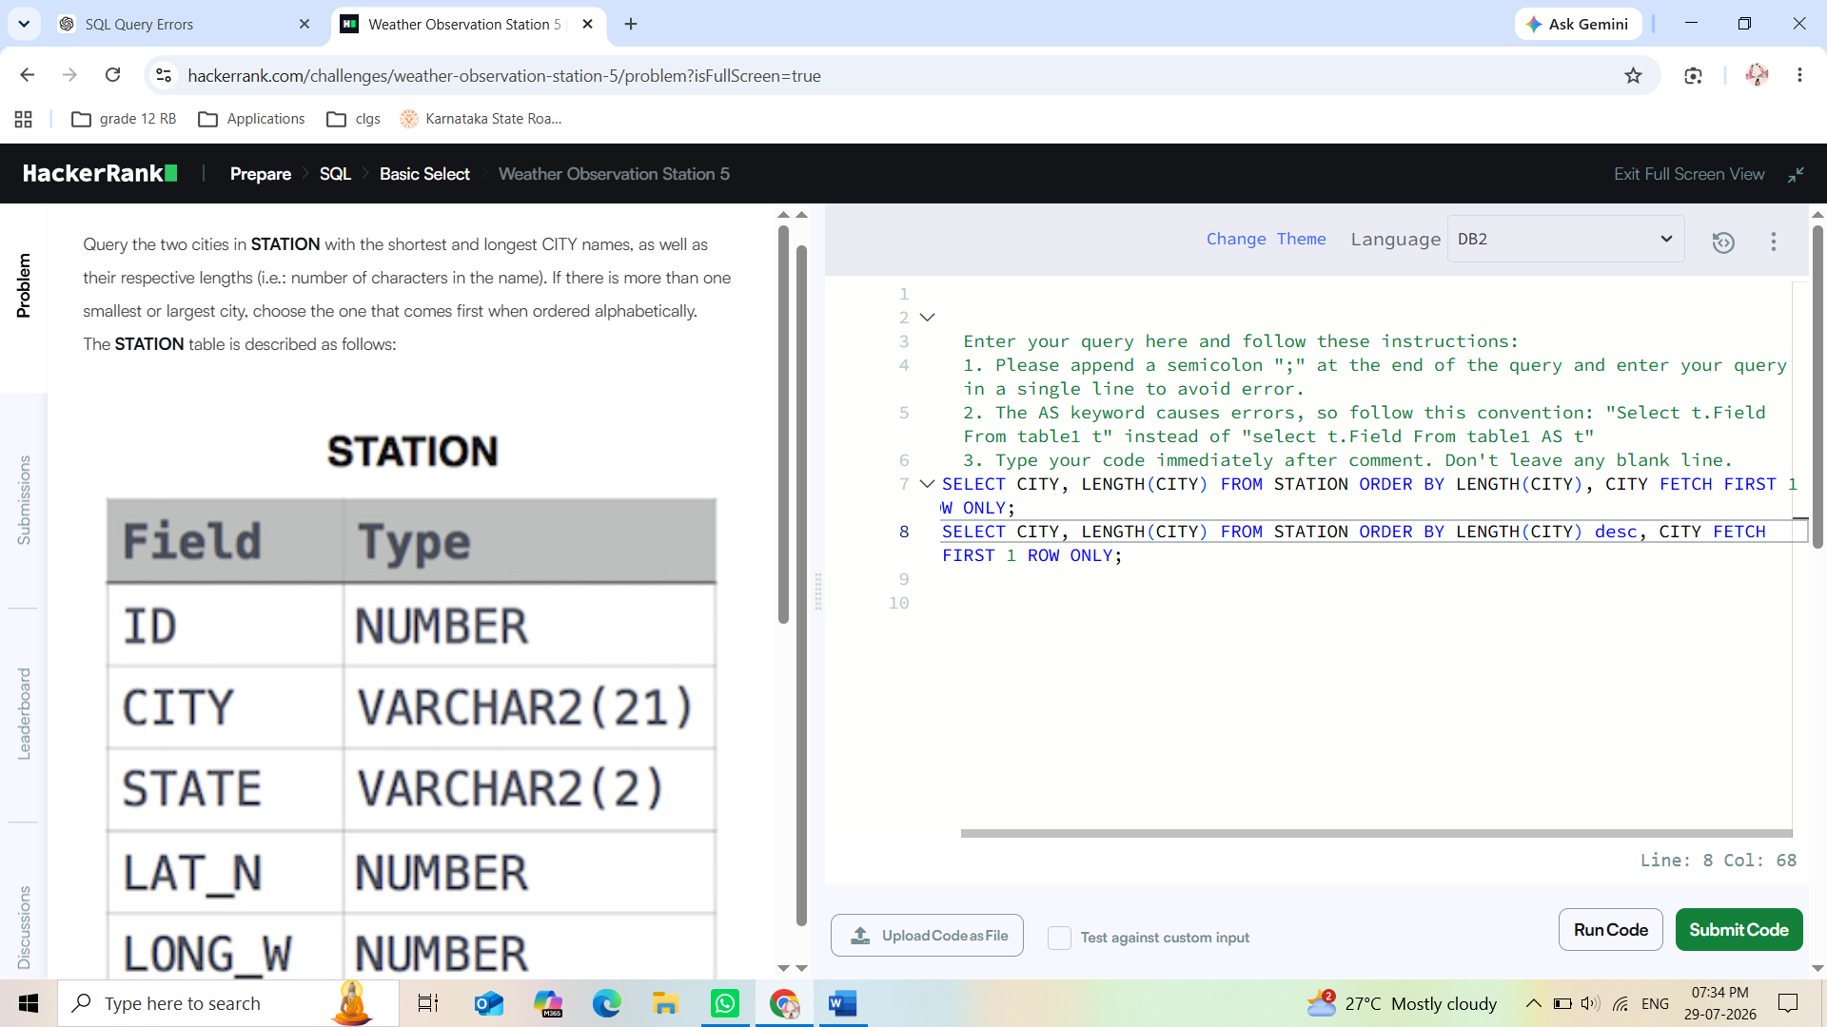

- To get names (or cities) starting with vowels (A, E, I, O, U), use the LIKE operator.
SELECT DISTINCT CITY From STATION WHERE CITY LIKE 'A%' OR CITY LIKE 'E%' OR CITY LIKE 'I%' OR CITY LIKE 'O%' OR CITY LIKE 'U%';

- Query the Name of any student in STUDENTS who scored higher than 75 Marks. Order your output by the last three characters of each name. If two or more students both have names ending in the same last three characters (i.e.: Bobby, Robby, etc.), secondary sort them by ascending ID.

SELECT Name FROM STUDENTS WHERE Marks > 75 ORDER BY RIGHT(Name, 3), ID;

- Type of triangle

SELECT
CASE
WHEN A+B<=C OR A+C<=B OR B+C<=A
THEN 'Not A Triangle'

WHEN A=B AND B=C
THEN 'Equilateral'

WHEN A=B OR A=C OR B=C
THEN 'Isosceles'

ELSE 'Scalene'
END
FROM TRIANGLES;

Remember
Always check Not A Triangle first.
Always check Equilateral before Isosceles because CASE stops at the first TRUE condition.

1. CASE Statement
Used to perform conditional logic in SQL.
Syntax
CASE
WHEN condition1 THEN result1
WHEN condition2 THEN result2
ELSE result
END
Important
- SQL checks top to bottom.
- The first TRUE condition is returned.
- Remaining conditions are not checked.

2. Triangle Problem
Check Order
1. Not A Triangle
2. Equilateral
3. Isosceles
4. Scalene
Conditions
Type | Condition
Not A Triangle | A+B<=C OR A+C<=B OR B+C<=A
Equilateral | A=B AND B=C
Isosceles | A=B OR A=C OR B=C
Scalene | A<>B AND A<>C AND B<>C

3. CONCAT()
Used to join strings together.
Syntax
CONCAT(value1, value2, value3...)
Example
SELECT CONCAT('Hello ', 'Mythri');
Output
Hello Mythri

4. SUBSTRING()
Extracts part of a string.
Syntax
SUBSTRING(column, start_position, length)
Example
SUBSTRING('Doctor',1,1)
Output
D

SUBSTRING('Professor',2,3)
Output
rof

5. LOWER()
Converts text to lowercase.
Example
LOWER('Doctor')
Output
doctor

6. The PADS (Part 1)
Goal
Print:
Ashley(P)
Julia(A)
Maria(A)
Query Pattern
SELECT CONCAT(
Name,
'(',
SUBSTRING(Occupation,1,1),
')'
)
FROM OCCUPATIONS
ORDER BY Name;

7. The PADS (Part 2)
Goal
Print
There are a total of 2 actors.
There are a total of 3 professors.
Concepts Used
- COUNT(*)
- GROUP BY
- LOWER()
- CONCAT()
- ORDER BY
Query Pattern
SELECT CONCAT(
'There are a total of ',
COUNT(*),
' ',
LOWER(Occupation),
's.'
)
FROM OCCUPATIONS
GROUP BY Occupation
ORDER BY COUNT(*), Occupation;

8. ORDER BY with GROUP BY
After grouping, you can sort using:
ORDER BY COUNT(*)
or
ORDER BY Occupation
Multiple sorting:
ORDER BY COUNT(*), Occupation;
Meaning:
- Sort by COUNT first.
- If counts are equal, sort by Occupation alphabetically.

Quick Revision
Function | Purpose
CASE | Conditional logic
CONCAT() | Join strings
SUBSTRING() | Extract characters
LOWER() | Convert to lowercase
COUNT() | Count rows
GROUP BY | Group similar values
ORDER BY | Sort output

Interview Tips
✅ CASE stops at the first TRUE condition.
✅ CONCAT() joins strings and values.
✅ SUBSTRING(text, start, length) extracts characters.
✅ LOWER() converts text to lowercase.
✅ GROUP BY is commonly used with COUNT(), SUM(), AVG(), MIN(), and MAX().

