**Assignment Cover Sheet**

|  |  |  |  |
| --- | --- | --- | --- |
| **Qualification** | | **Module Number and Title** | |
| HD in Computing and Software Engineering /Network Technology and Cyber Security | | CSE 4002  Fundamentals in Programming | |
| **Student Name & No.** | | **Assessor** | |
| T.P.G. Ravindu Rangana CL/HDCSE/CMU/116/61 | | Mr. Isuru | |
| **Hand over date** | | | **Submission Date** |
|  | | |  |
| **Assessment type** | **Duration/Length of**  **Assessment Type** | | **Weighting of Assessment** |
| **Coursework** | Software Submission and demonstration | | 100% |

|  |  |
| --- | --- |
| **Learner declaration** | |
| I, T.P.G. Ravindu Rangana - CL/HDCSE/CMU/116/61, certify that the work submitted for this assignment is my own and research sources are fully acknowledged. | |
| |  |  |  |  | | --- | --- | --- | --- | | **Marks Awarded** | | | | | First assessor | |  | | | IV marks | |  | | | Agreed grade | |  | | | Signature of the assessor |  | Date |  | |

**Feedback Form**

**International College of Business & Technology**

**Module :** CSE 4002

**Student :**

**Assessor : Mrs. Nisansala Athapaththu**

**Assignment** **:** Bun Talk business automation system

**Assessor Feedback:**

**Marks Awarded:**

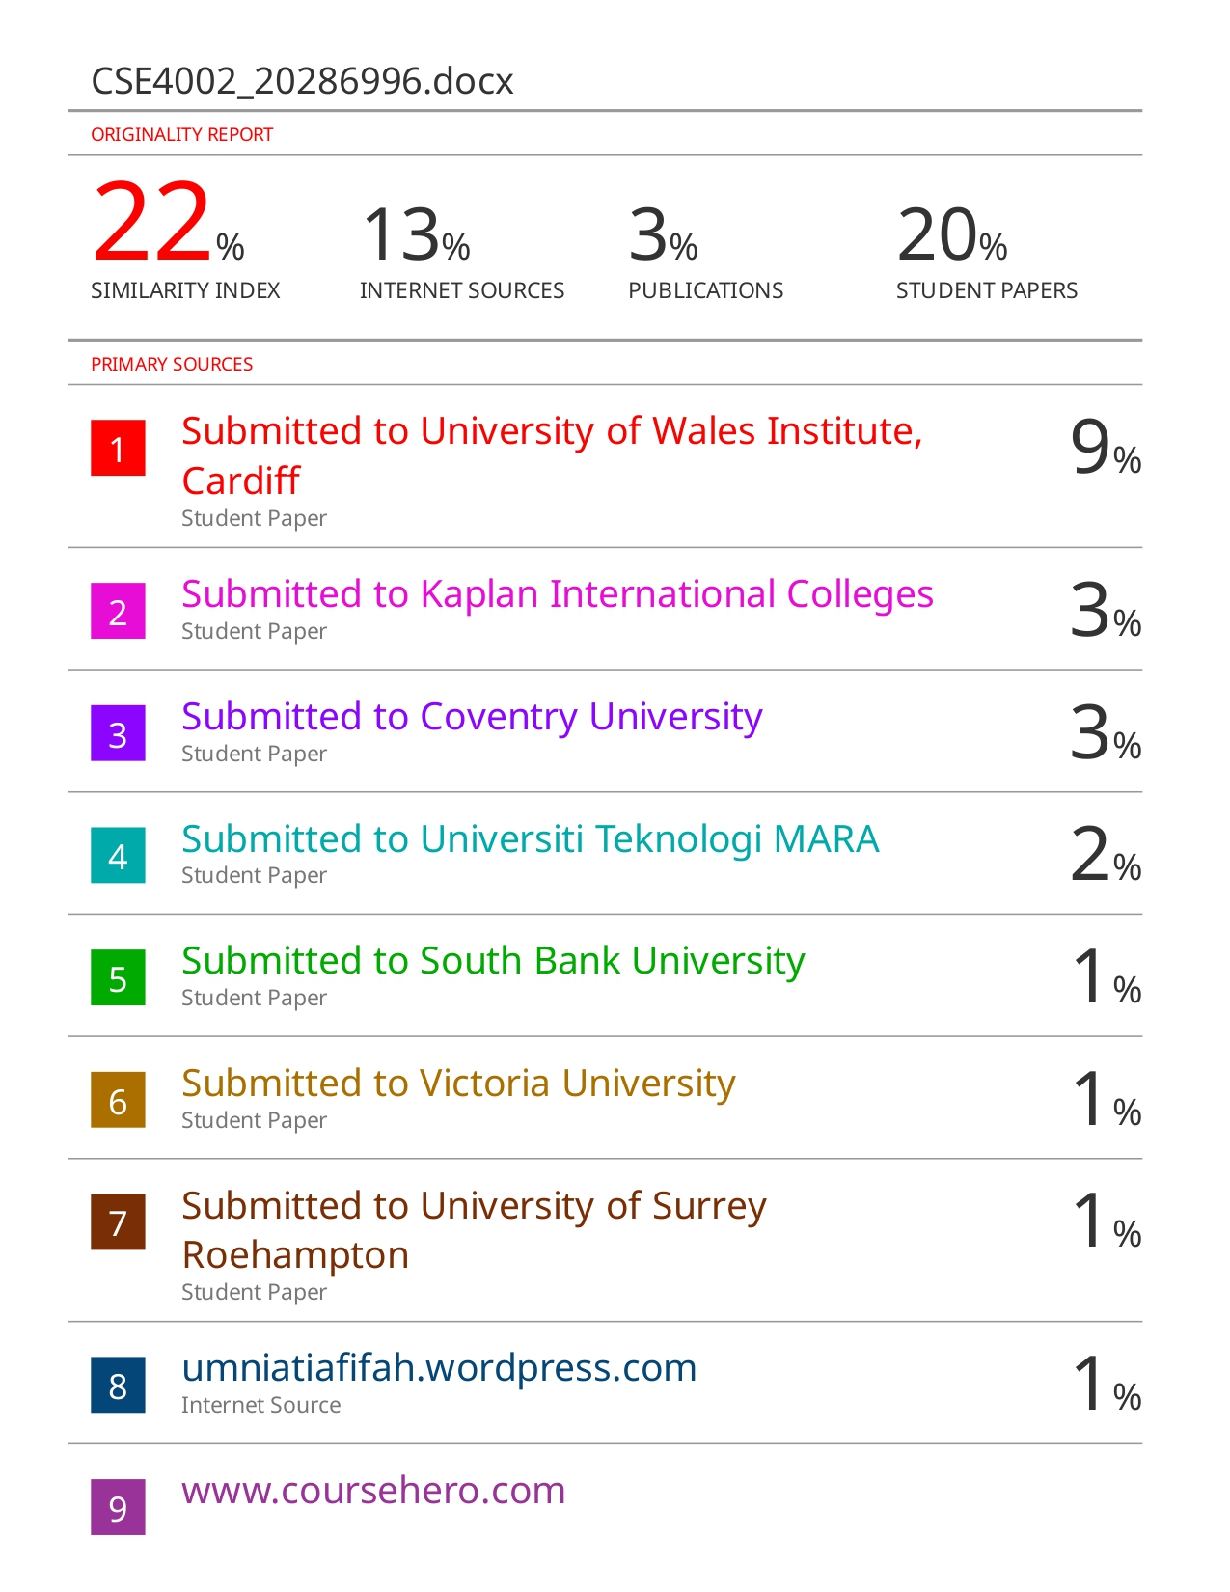

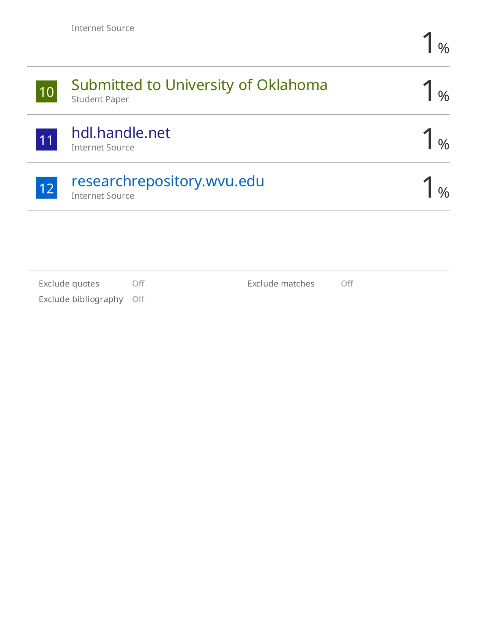

**Task 01**

**Software Requirements Specification (SRS) for Bun Talk Bakery Automation**

1. Introduction

**Purpose**

The purpose of this document is to define the requirements for the Bun Talk Bakery Automation program. This program aims to automate the billing procedure for Bun Talk, a local bakery, by providing a user-friendly interface to customers, displaying the bakery menu, allowing select items, calculate and generate the bill, and providing help and exit options.

**Scope**

The Bun Talk Bakery Automation program will provide a reliable and efficient solution for Bun Talk to improve customer service. It includes features like show menu, select items, generate bill, and basic help. The program does not cover advanced features like user authentication or persistent data storage.

2. Final Description

**Product View**

The Bun Talk Bakery Automation program is an independent application that interacts with customers to automate the bakery billing procedure. It does not have any external dependencies.

**User Classes and Characteristics**

Customers: Users of the program who visit Bun Talk to order bakery items.

**Running Environment**

The program is designed to run on a computer with a C++ development environment.

**Limitations in Design and Implementation**

The program is implemented in C++ and does not include advanced features like authentication or data storage. Data storage is limited to runtime memory.

3. Functional Requirements

**Login**

The login functionality is a vital component of the Bun Talk Bakery Automation program. It authenticates users before allowing access to the main features of the program.

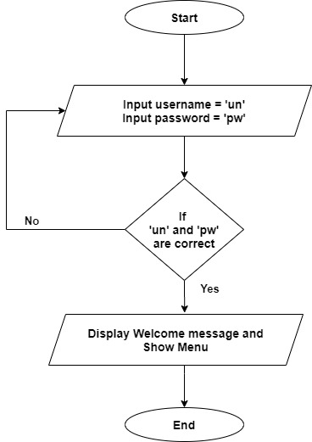

**Display Menu**

The program will display the bakery menu with available items and their prices.

**Item Selection**

Users can select one or more items from the menu by entering the item number. The program will validate and store the selections.

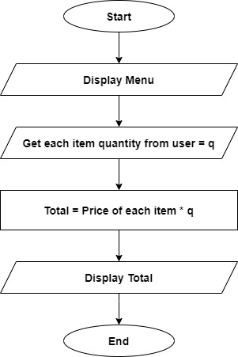

**Calculate Bill**

Customers can calculate the total bill for their selected items. The program will sum the prices of the selected items and display the total.

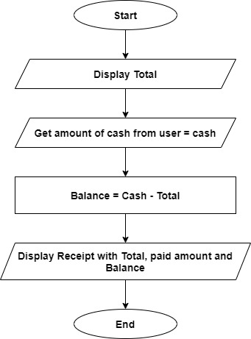

4. User Interface

The program provides a simple command-line interface where users can interact with the options mentioned above.

5. Non-Functional Requirements

**Performance**

The program should respond to user input promptly and calculate bills accurately.

**Usability**

The user interface should be easy to understand and use, even for individuals with minimal computer experience.

6. Future Enhancements

Implement user authentication for employee access.

Add data storage to keep track of customer orders and sales.

7. Conclusion

This Software Requirements Specification defines the requirements for the Bun Talk Bakery Automation program, outlining its scope, features, and constraints. It serves as a basis for program development and enhancement.

**Task 02**

#include <iostream>

#include <fstream>

#include <string>

using namespace std;

void display() // Heading of the first screen in the program

{

    cout << " _________________________________________________________________________________________________________________\n";

    cout << "                                                                                                                  \n";

    cout << " 8888888888888888888888888888888888~~~~~~~~~~~~~~~~~~~~~~~~~~~~~~~~~~~88888888888888888888888888888888888888888888\n";

    cout << " 8888888888888888888888888888888888~~~~~~~~~~~~~~~~~~~~~~~~~~~~~~~~~~~88888888888888888888888888888888888888888888\n";

    cout << "                                                                                                                  \n";

    cout << " <<<<<<<<<<<<<<<<<<<<<<<<<<<<<<<<<<          BUN TALK BAKERY          >>>>>>>>>>>>>>>>>>>>>>>>>>>>>>>>>>>>>>>>>>>>\n";

    cout << "                                                                                                                  \n";

    cout << " 8888888888888888888888888888888888~~~~~~~~~~~~~~~~~~~~~~~~~~~~~~~~~~~88888888888888888888888888888888888888888888\n";

    cout << " 8888888888888888888888888888888888~~~~~~~~~~~~~~~~~~~~~~~~~~~~~~~~~~~88888888888888888888888888888888888888888888\n";

    cout << "                                                                                                                  \n";

    cout << " _________________________________________________________________________________________________________________\n";

}

int main()

{

    string password, pw;

    string username, un;

    string name;

    char key;

    int E, F, S, C, B;

    int option, num;

    int cash;

    bool exitProgram = false;

    do

    {

        display(); // Call display function

        cout << "\n\n Please select an option: \n\n 1. Register \n 2. Login \n 3. Help";

        cout << "\n\n Option: ";

        cin >> option;

        if (option == 1)

        {

            cout << "Give a username: ";

            cin >> username;

            cout << "Give a password (Please include both characters & numbers): ";

            cin >> password;

            ofstream file; // create a file and store data

            file.open("userD\\" + username + ".txt");

            file << username << endl

                 << password;

            file.close();

        }

        else if (option == 2)

        {

            do

            {

                cout << "Enter Username: ";

                cin >> username;

                cout << "Enter Password: ";

                cin >> password;

                ifstream read("userD\\" + username + ".txt"); // open file and get data

                getline(read, un);

                getline(read, pw);

                if (un != username || pw != password)

                {

                    cout << "Invalid username or password. Please try again." << endl;

                }

            } while (un != username || pw != password);

            cout << "\n\n Welcome to Bun Talk Bakery !";

            cout << "\n\n\t\t########################## Here is the Menu ########################## \n\n";

            cout << "\t\tItem No\t\tMenu Item\t\tPrice\n\n";

            cout << "\t\t======================================================================\n\n";

            cout << "\t\t111\t\tEgg Roll\t\tRs.150.00\n\n";

            cout << "\t\t112\t\tFish Roll\t\tRs.130.00\n\n";

            cout << "\t\t116\t\tSandwich\t\tRs.200.00\n\n";

            cout << "\t\t114\t\tChocolate Cookie\tRs.120.00\n\n";

            cout << "\t\t115\t\tBurger\t\t\tRs.500.00\n\n";

            cout << "\n\n\t\t########################## Place Your Order ########################## \n\n";

            cout << "\n\n Enter your name: ";

            cin >> name;

            cout << "\n How many Egg Rolls do you want: ";

            cin >> E;

            cout << "\n How many Fish Rolls do you want: ";

            cin >> F;

            cout << "\n How many Sandwiches do you want: ";

            cin >> S;

            cout << "\n How many Chocolate Cookies do you want: ";

            cin >> C;

            cout << "\n How many Burgers do you want: ";

            cin >> B;

            int bill = (E * 150.00 + F * 130.00 + S * 200.00 + C * 120.00 + B * 500.00); // Calculate Total

            cout << "\n\n Your Total Bill is: Rs. " << bill;

            cout << "\n\n Please Enter your cash amount: ";

            cin >> cash;

            int bal = (cash - bill); // Calculate the Balance

            cout << "\n\n\t\t####################### Here is your Receipt, ####################### \n\n";

            cout << "\n\n \t\t Customer Name: \t (" << name << ")";

            cout << "\n \t\t Egg Rolls \t\t\t" << E;

            cout << "\n \t\t Fish Rolls \t\t\t" << F;

            cout << "\n \t\t Sandwiches \t\t\t" << S;

            cout << "\n \t\t Chocolate Cookies \t\t" << C;

            cout << "\n \t\t Burgers \t\t\t" << B;

            cout << "\n \t\t...................................................";

            cout << "\n \t\t Paid Amount:\t Rs. " << cash;

            cout << "\n \t\t Total Amount:\t Rs. " << bill;

            cout << "\n \t\t Your Balance:\t Rs. " << bal;

            cout << "\n\n \t\t Thanks For Visiting Bun Talk Bakery, Come Again !!!";

            cout << "\n\n \t\t Press 'E' to exit or any other key to return to the main menu...";

            cin >> key;

            if (key == 'E' || key == 'e')

            { // Exit from the application

                exitProgram = true;

            }

        }

        else if (option == 3) // Check if the option is for Help

        {

            cout << "\n\n Help: \n";

            cout << "1. To register, select option 1 and provide a username and password.\n";

            cout << "2. To log in, select option 2 and enter your username and password.\n";

            cout << "3. Enter your name and the quantity of items you want to order.\n";

            cout << "4. Enter the cash amount to pay, and the program will calculate your bill and balance.\n";

            cout << "5. Press 'E' to exit the application.\n";

            cout << "\n Press Enter to return to the main menu...";

            cin.ignore();

            cin.get(); // Wait for Enter key

        }

    } while (!exitProgram);

    return 0;

}

**Task 03**

**Test Plan,**

Login and Register Functionality

Test Case 1: User Registration

Test Case 2: Valid login credentials

Test Case 3: Invalid login credentials

Display Breakfast Items

Test Case 4: Displaying the bakery menu

Print Bill

Test Case 5: Selecting bakery items and calculating the bill

Help

Test Case 6: Provide help details

Exit Application

Test Case 7: Exit from the application when pressing ‘E’ or ‘e’

**Test Results**

Test Case 1: Passed (Successfully registered a new user and save user data to database)

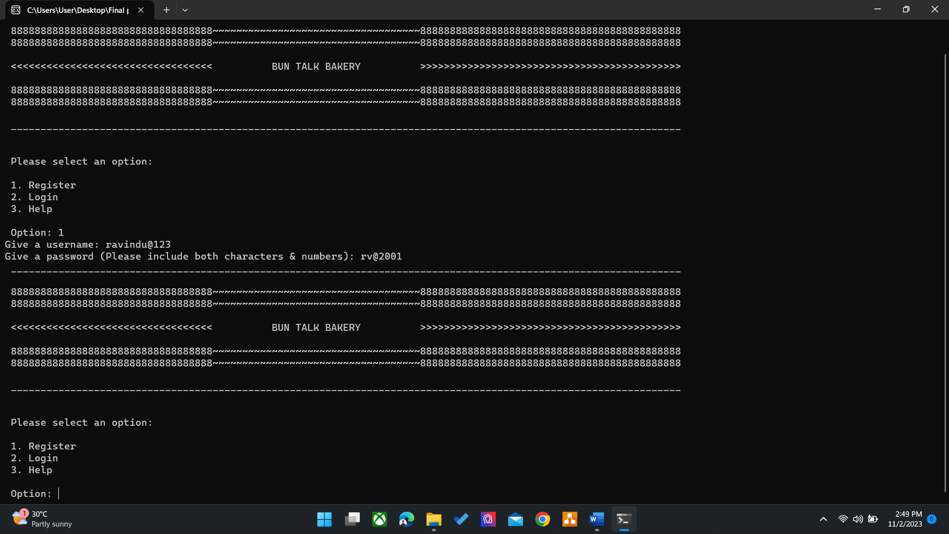

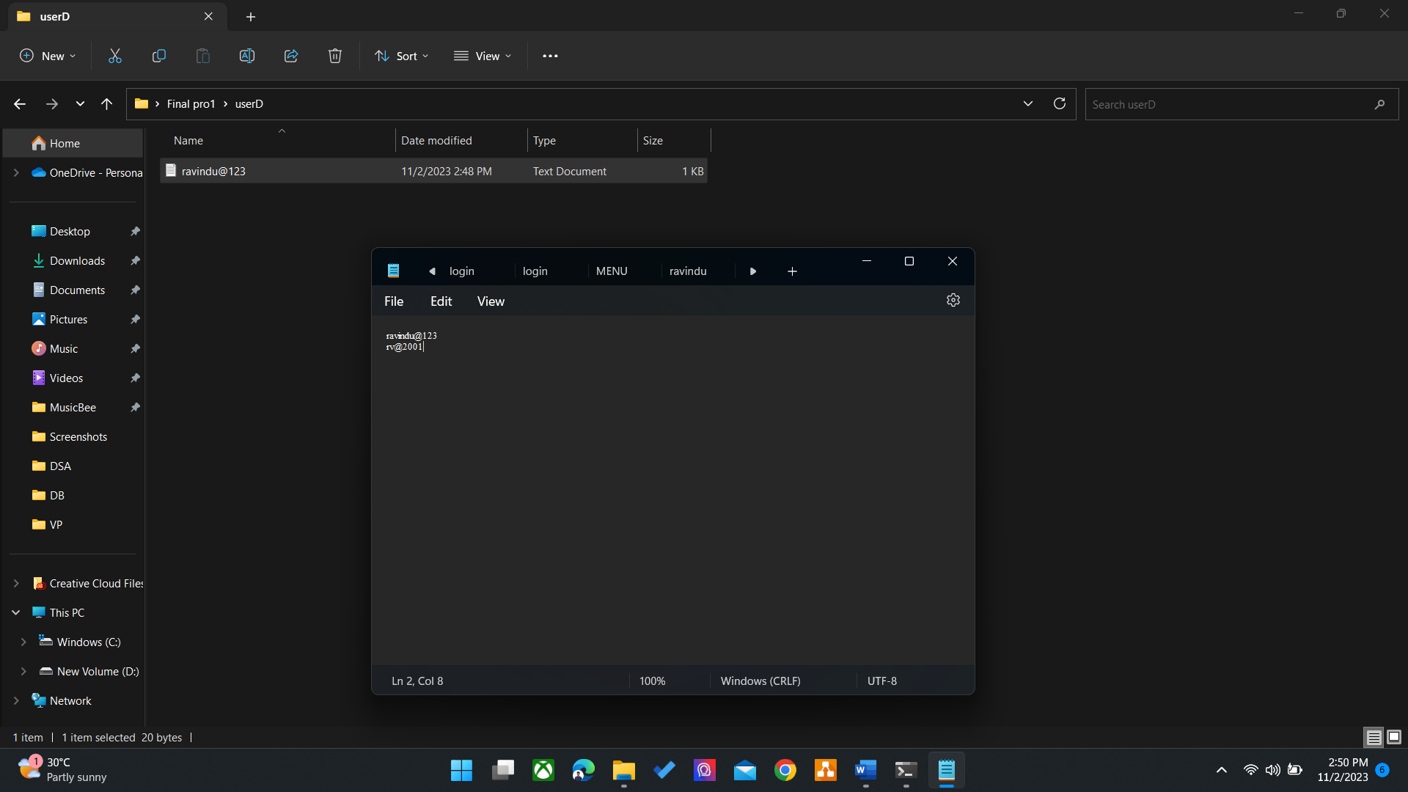

Test Case 2: Passed (Successfully logged in and start the process)

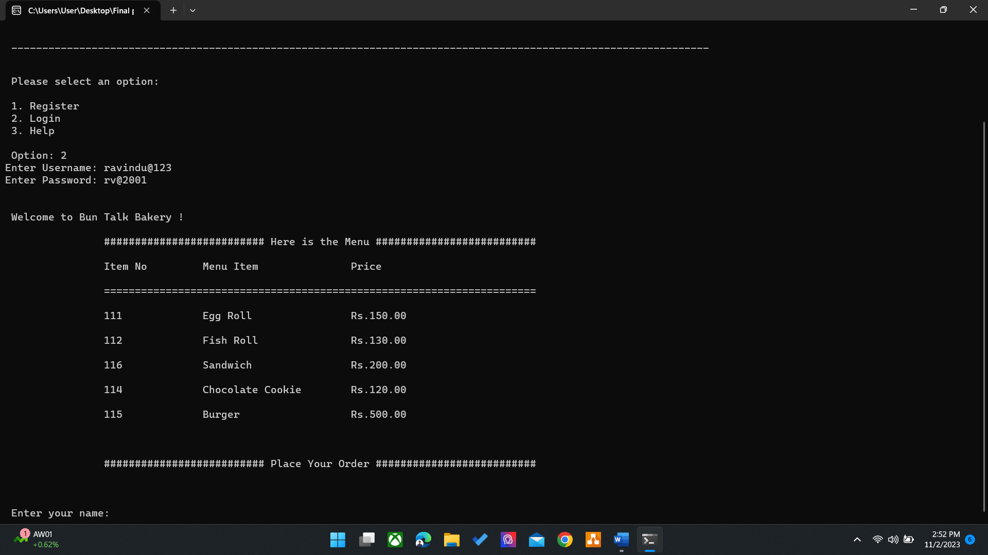

Test Case 3: Passed (Login failed and redirect to enter credentials after showing invalid credentials message)

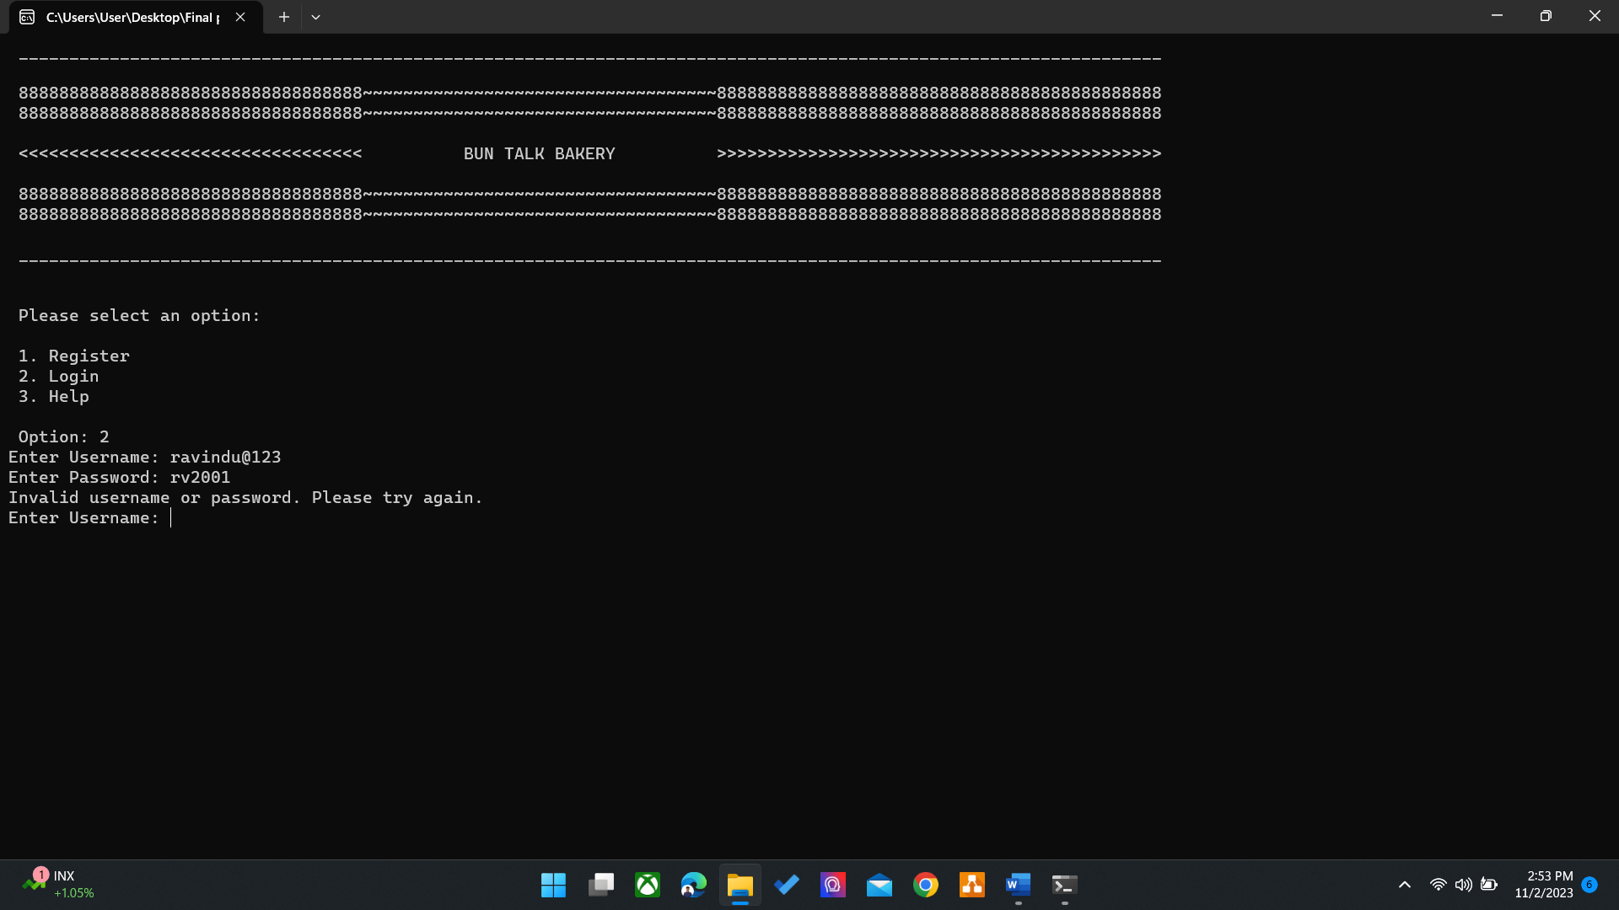

Test Case 4: Passed (Bakery menu displayed successfully)

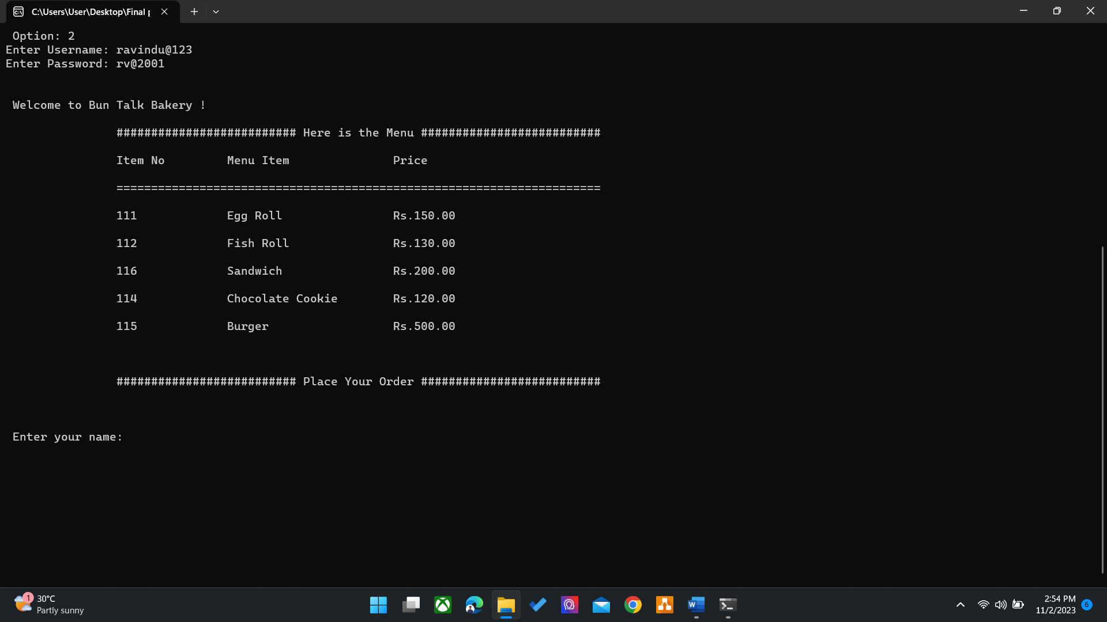

Test Case 5: Passed (Get selections from user and successfully generated the bill)

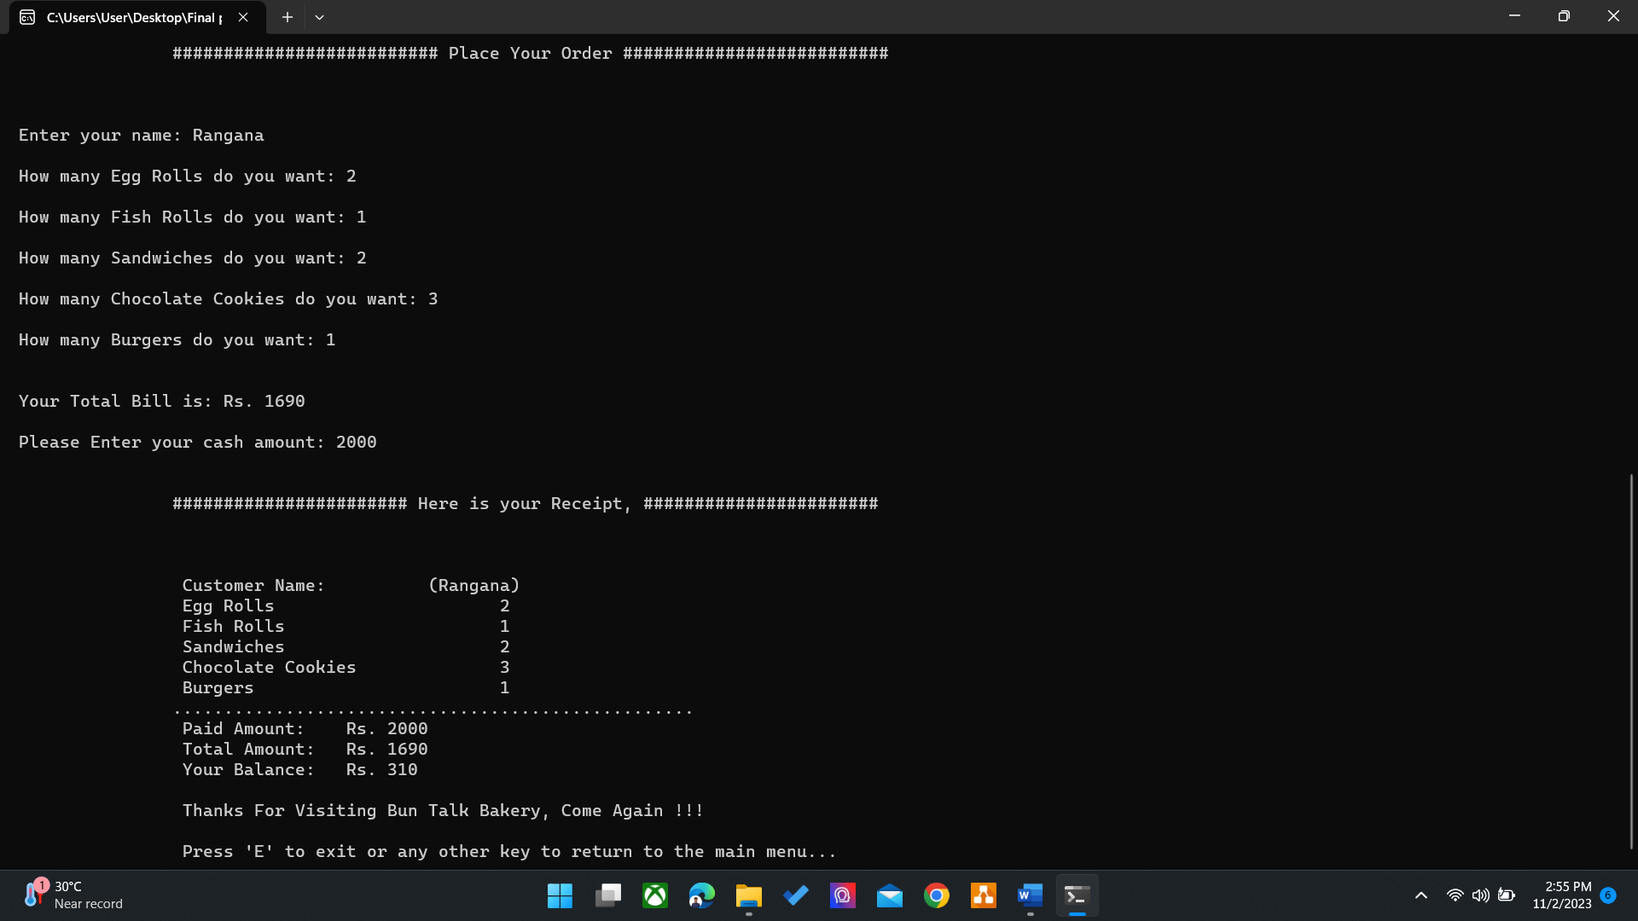

Test Case 6: Passed (Successfully show help details and return to main menu when pressing Enter)

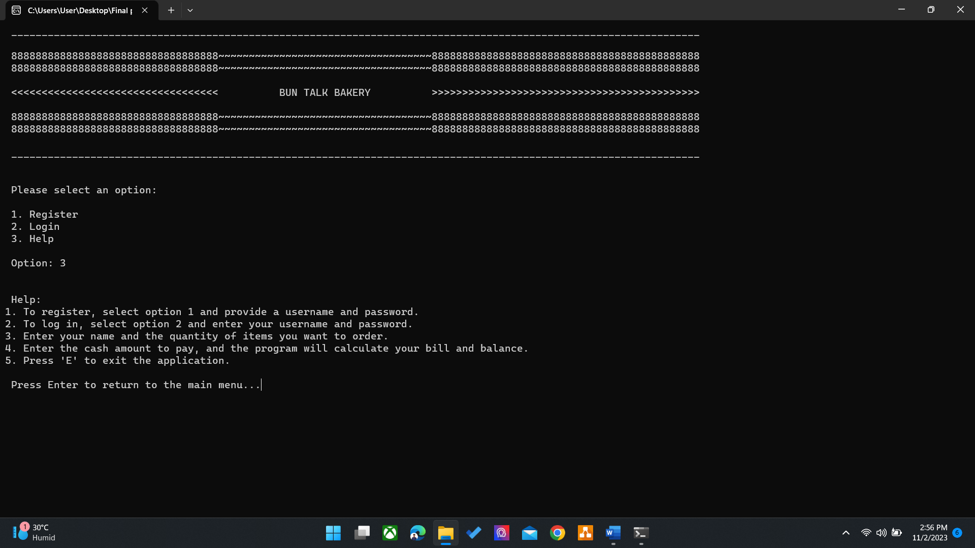

Test Case 7: Passed (Successfully exit from the application when pressing ‘E’ or ‘e’)



**User Acceptance Testing**

Feedback from User Acceptance Testing was collected using sample questionnaires:

User Interface

Question 1: How user-friendly is the program's interface?

Response: Mostly user-friendly, easy to understand.

Functionality

Question 2: Were you able to log in successfully?

Response: Yes, it worked as expected.

Menu Display

Question 3: Was the bakery menu displayed correctly?

Response: Yes, items were listed clearly.

Billing

Question 4: Did the program correctly calculate the bill?

Response: Yes, the bill was accurate.

Overall Satisfaction

Question 5: Overall, how satisfied are you with the program?

Response: Satisfied, but it could have more features.

Overall, the user feedback is positive, with suggestions for additional features.

**References**

*C++ DO/while loop* (no date) *C++ Do While Loop*. Available at: <https://www.w3schools.com/cpp/cpp_do_while_loop.asp> (Accessed: 30 November 2023).

