SET-1:-

1. Which is the movie(s) with the smallest runtime? Which is the movie(s) with the highest runtime?

**Answer:-**

Movie Which Has Highest runtime : **Carlos**

Movie Which Has Lowest runtime : **Steve Oedekerk**

1. Take the top 5 production houses (by budget) and list their top 5 most popular movies, their revenue and vote_average

Answer:-

**revenue**

|  | **title** | **Vote_average** |
| --- | --- | --- |
| 17 | Pirates of the Caribbean: On Stranger Tides | 6.4 | 1.045714e+09 |
| 1 | Pirates of the Caribbean: At World's End | 6.9 | 9.610000e+08 |
| 7 | Avengers: Age of Ultron | 7.3 | 1.405404e+09 |
| 10 | Superman Returns | 5.4 | 3.910812e+08 |
| 4 | John Carter | 6.1 | 2.841391e+08 |

3. List the production house for every year from 2000-2016 which has released the most number of

movies in that year

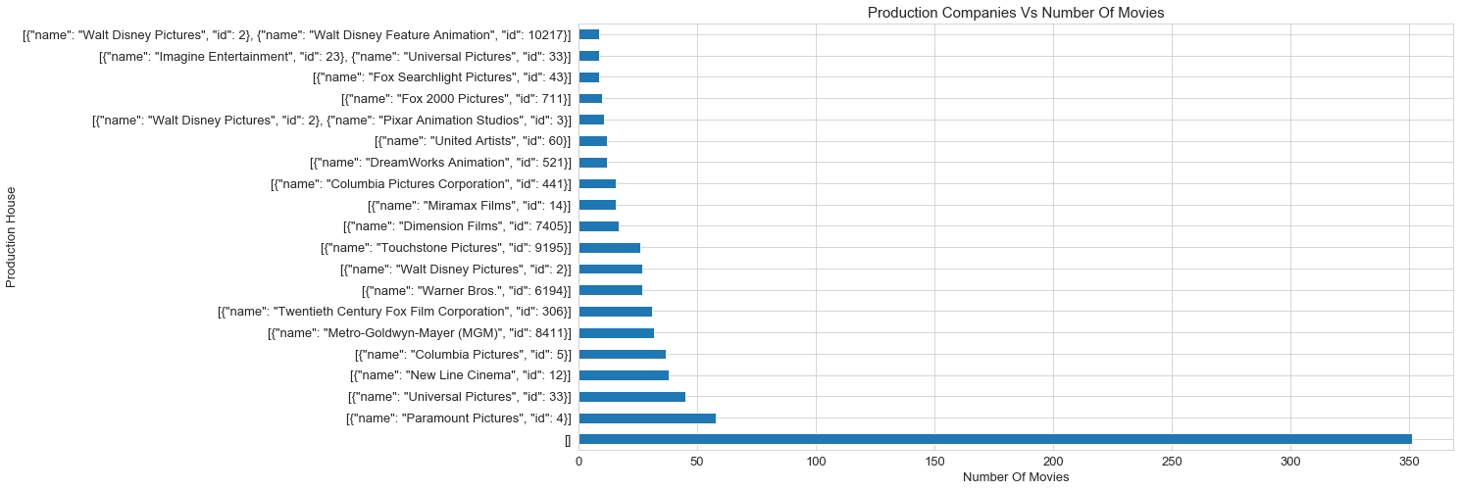Answer:-

4. You are going to invest all your life's savings in a production company. You have two choices "MarvelStudios" and "DC Comics". Which company would you bet on? This is an open ended question. Define your own metrics to measure which one is a better investment opportunity and defend your analysis.

**Answer:- Marvel Studious**

While Investing in a production house the important criteria I look for is the revenue and the popularity. So I will invest in the company whose revenue is high and more popularity. So between Marvel Studios and DC Comics I will invest in Marvel Studios because it has high revenue and more popularity when compared to DC comics.

SCREENSHOTS:-

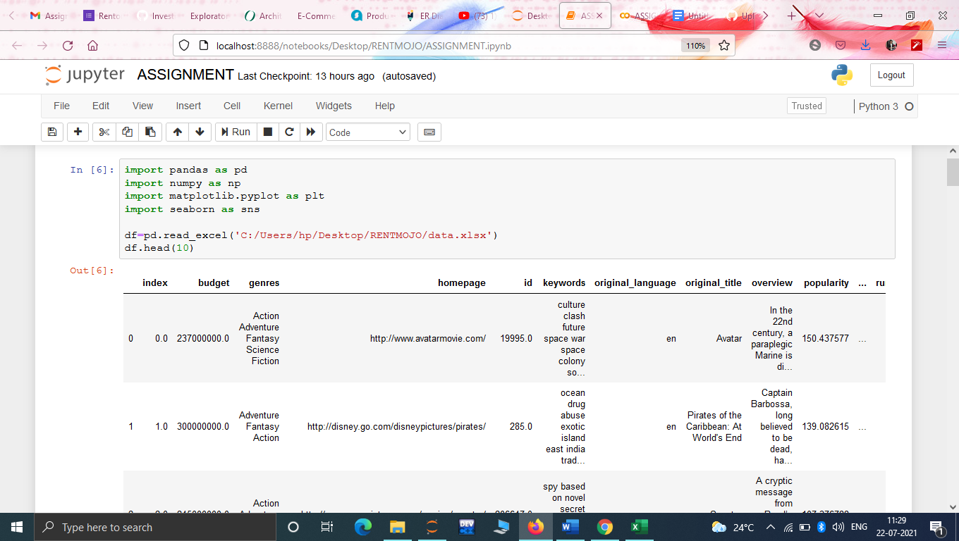

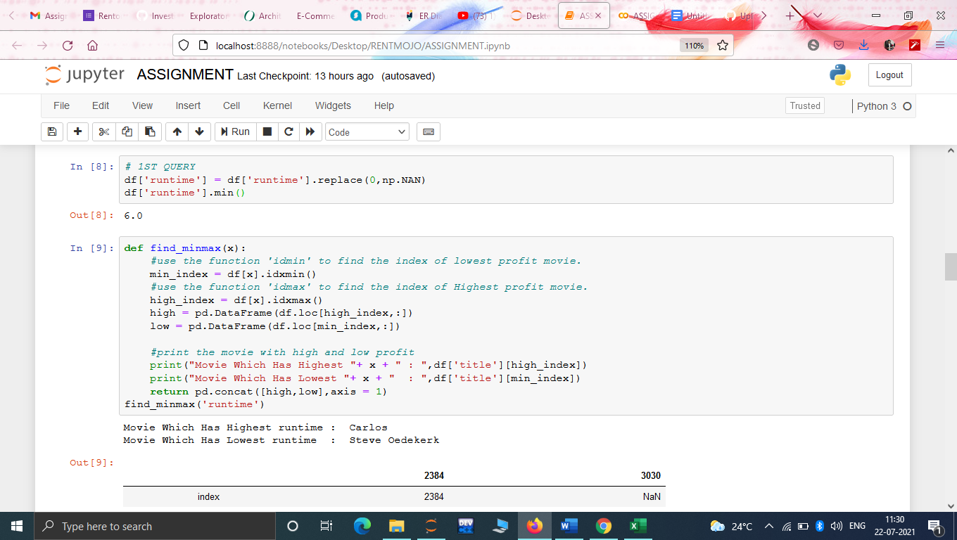

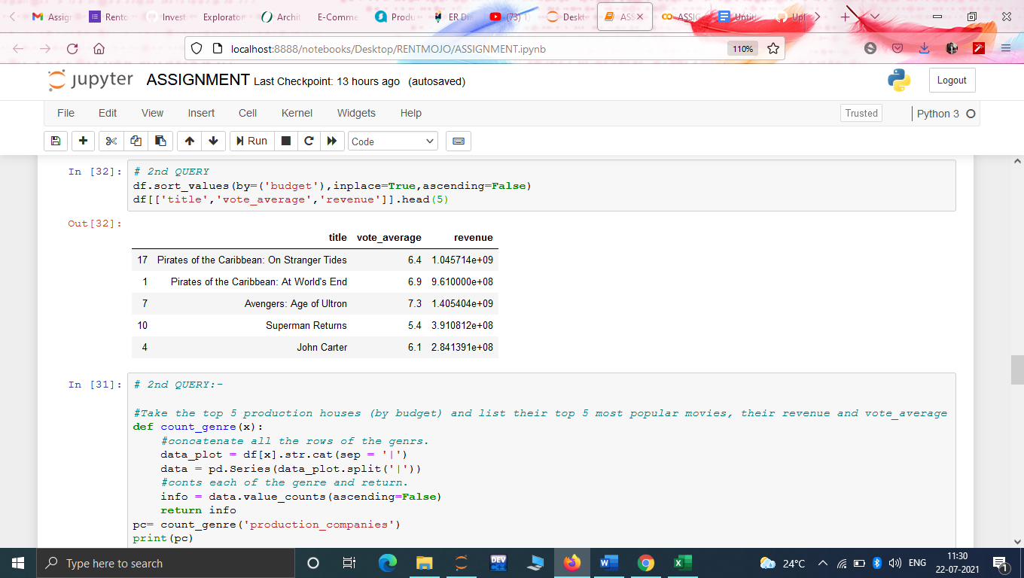

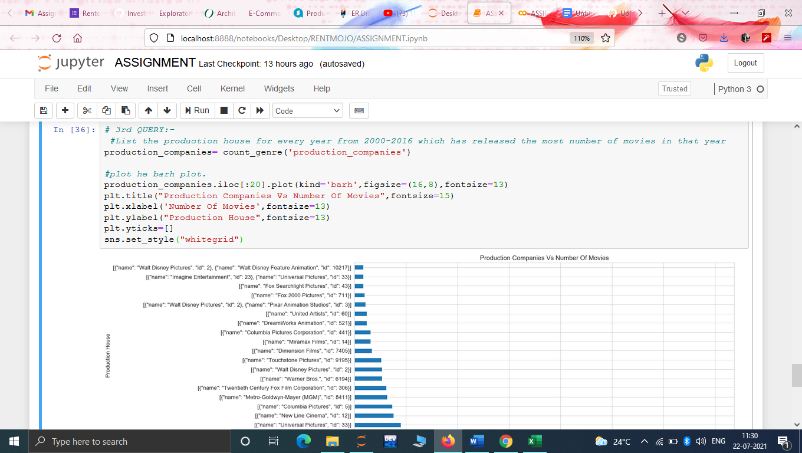

SET-2:-

I have designed an ER diagram base on the constraints given by you. It is mentioned below:-

**ER-DIAGRAM**

Customer

N

N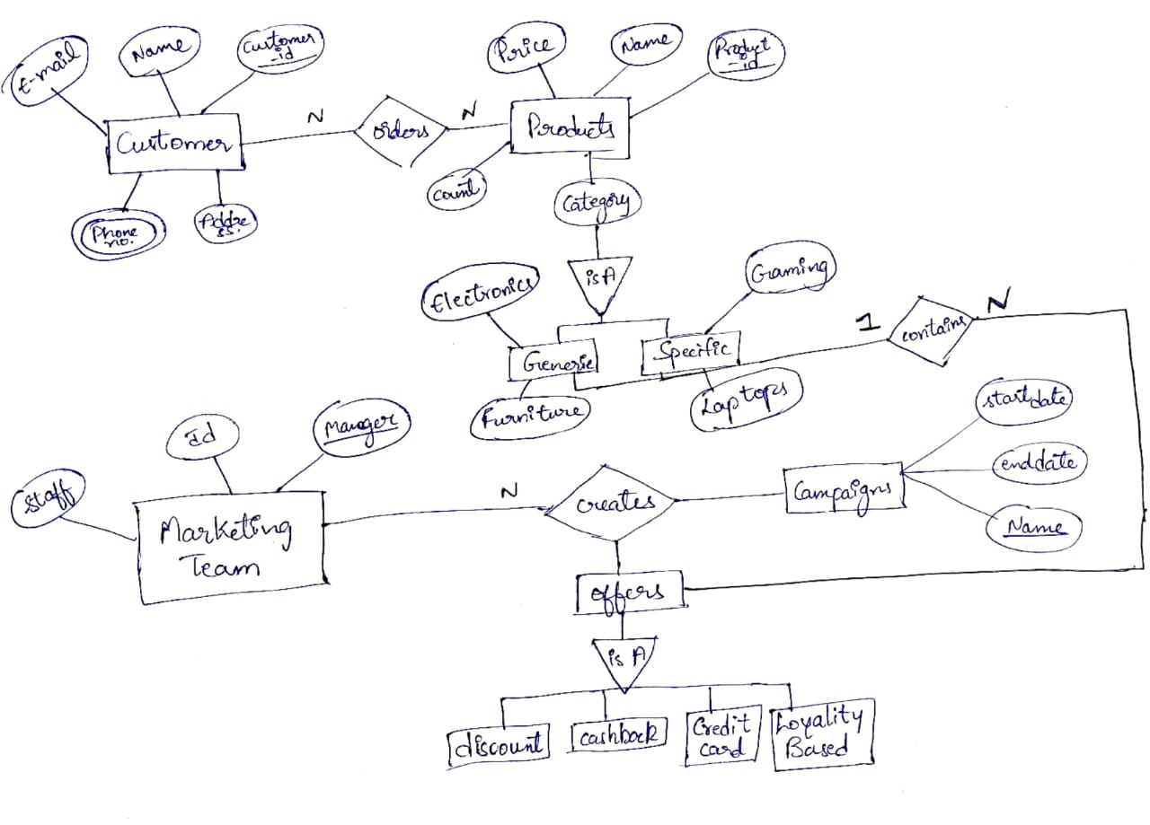

orders

Products

Is A

Is A

Campaigns

creates

Marketing Team

Specific

Generic

Specific

N

cashback

discount

Offers

N

cotains

1

Is A

Loyalty based

Credit card

