**Codecommit**

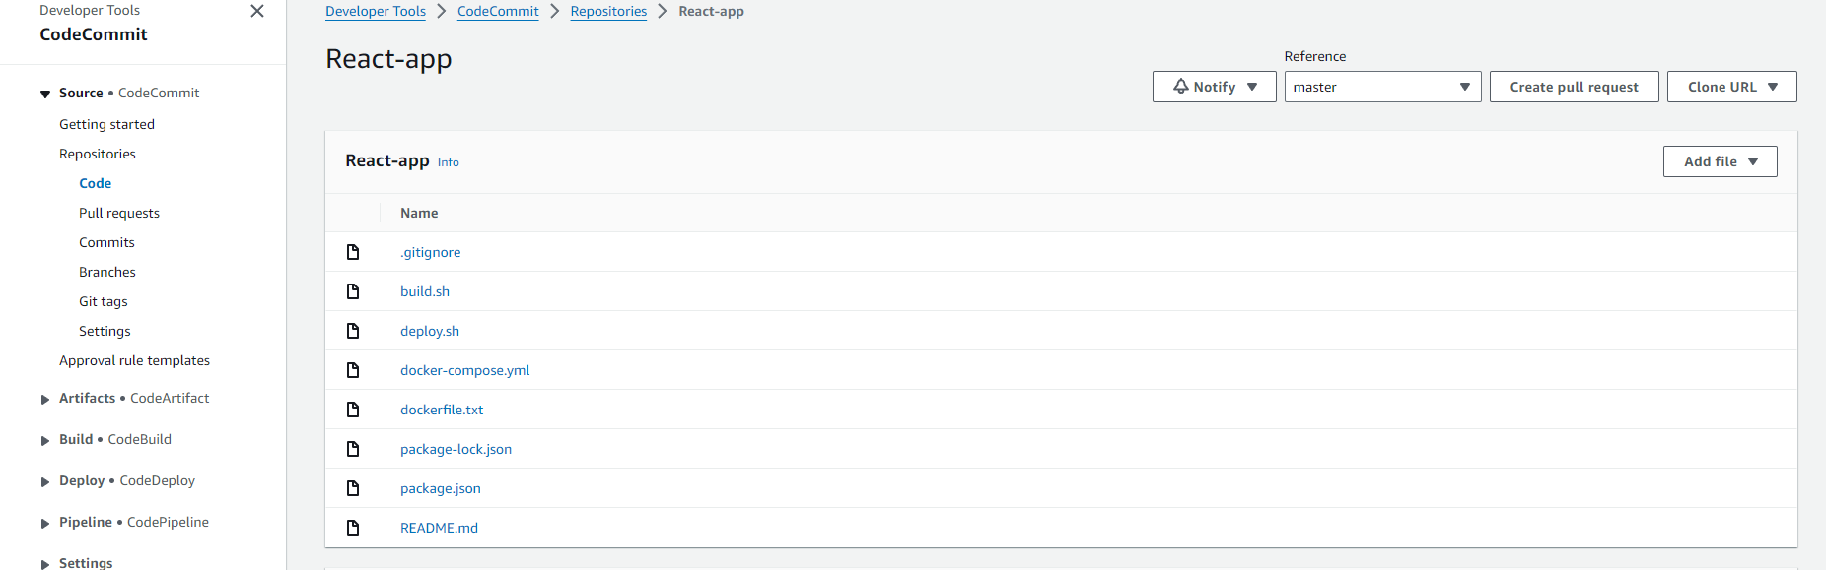

**Codebuild**

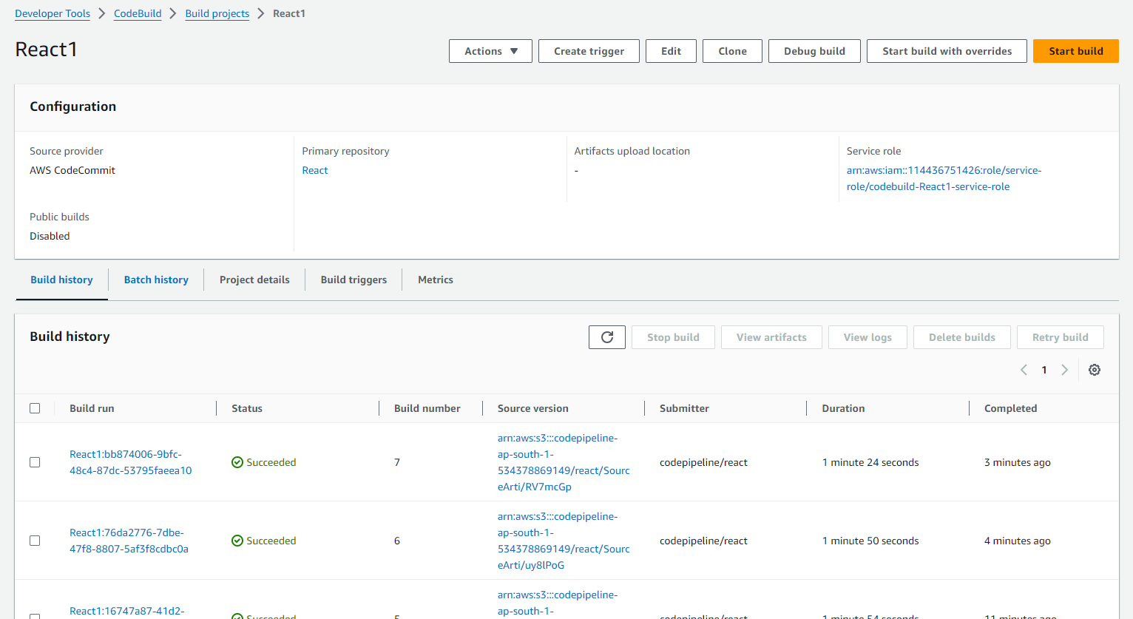

**Continuous Deployment(EBS)**

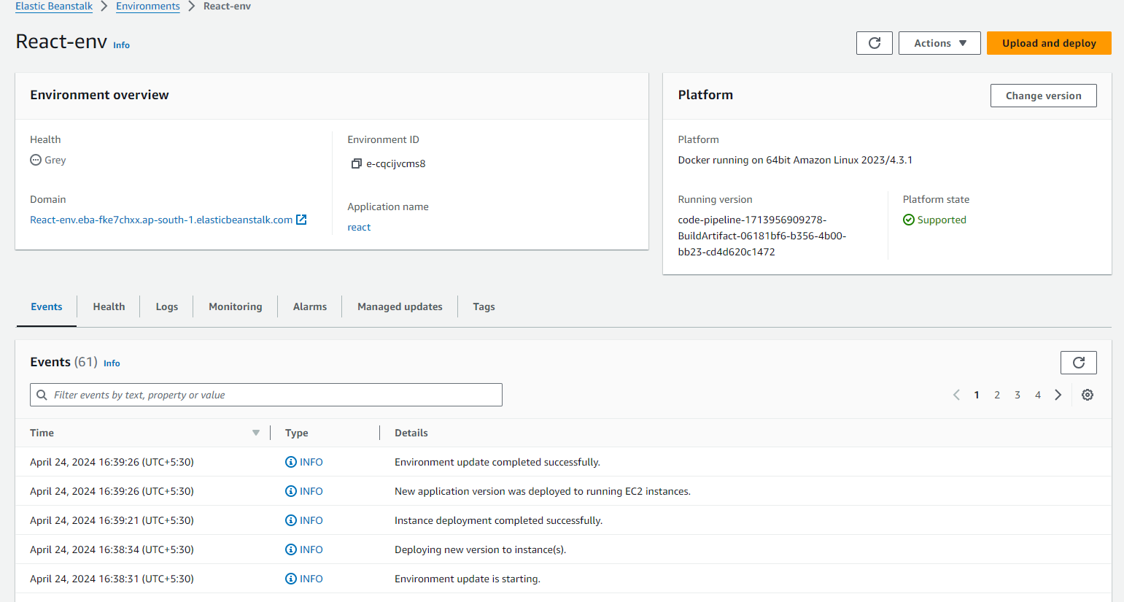

**Continuous Integeration (Codepipeline)**

