LAKIREDDY BALI REDDYCOLLEGE OF ENGINEERING
(AUTONOMOUS)



Department of Computer Science& Engineering

(Artificial Intelligence and Machine Learning)

Introduction to Artificial Intelligence and Machine Learning Lab (20AM51)

Name of the Student:

Registered Number:

Branch&Section:

AcademicYear: 2022 23

LAKIREDDY BALI REDDY COLLEGE OF ENGINEERING
(AUTONOMOUS)



CERTIFICATE

Certificate that this is a bonafied record of the practical work done in _____________________________________________________________Laboratory by __________________________________ with Regd. No. ______________________________ of __________________B.Tech Course_____________________ Semester in ______________________________________________________Branch during the Academic Year2022-23
No.of Experiments held:________

No.of Experiments Done: ________

2023 Signature of the Faculty

INTERNAL EXAMINER EXTERNAL EXAMINER
21761A4247
Artificial Intelligence and Machine Learning
LAB MANUAL

Q : Implement Linear and multi Linear Regression.

Introduction:
A:Linear Regression: Linear regression is a fundamental and widely used statistical technique in the field of artificial intelligence (AI) and machine learning. It is a supervised learning algorithm that aims to establish a linear relationship between a dependent variable and one or more independent variables. The goal of linear regression is to predict the value of the dependent variable based on the values of the independent variables.
In linear regression, the relationship between the variables is assumed to be linear, which means it can be represented by a straight line. The algorithm estimates the coefficients of the line that best fits the given data points, minimizing the overall difference between the predicted values and the actual values.
The basic form of a linear regression model can be expressed as:
Y = mx + c
where:
- Y is the dependent variable or the variable to be predicted.
- C is the intercept or the y-axis intercept of the line.
- M is the coefficient or the weight assigned to the independent variables x1, x2, ..., xn.
- x1, x2, ..., xn are the independent variables or the features used to predict the value of Y.
DATASET:
Dataset contains the features of Attendence and marks.
Where,
Attendence is considered as input attribute.
Marks is considered as target attribute.

CODE:

Q:Import Libraries.
import pandas as pd
#Load the Dataset.
df=pd.read_csv("D:/attendence.csv")
print(df)

OUTPUT:
ATTENDENCE MARKS
0 21 71
1 22 72
2 23 73
3 24 74
4 25 75
5 26 76
6 27 77
7 28 78
8 29 79
9 30 80
10 31 81
11 32 82
12 33 83
13 34 84
14 35 85
15 36 86
16 37 87
17 38 88
18 39 89
19 40 90

Q:Choose the dependent and independent attributes.
x=df[["ATTENDENCE"]]
y=df["MARKS"]
print(x)
print(x.shape)
print(y)
print(y.shape)

OUTPUT:
ATTENDENCE
0 21
1 22
2 23
3 24
4 25
5 26
6 27
7 28
8 29
9 30
10 31
11 32
12 33
13 34
14 35
15 36
16 37
17 38
18 39
19 40
(20, 1)

0 71
1 72
2 73
3 74
4 75
5 76
6 77
7 78
8 79
9 80
10 81
11 82
12 83
13 84
14 85
15 86
16 87
17 88
18 89
19 90
Name: MARKS, dtype: int64
(20,)

Q: #Split the dataset into training and testing
A:from sklearn.model_selection import train_test_split
x_train,x_test,y_train,y_test=train_test_split(x,y,test_size=0.3)
print(x_train.shape)
print(y_train.shape)
print(x_test.shape)
print(y_test.shape)

OUTPUT:
(14, 1)
(14,)
(6, 1)
(6,)

Q.Fit the linear regression model.

A: from sklearn.linear_model import LinearRegression
model=LinearRegression()
model.fit(x_train,y_train)
result=model.predict(x_test)
print(result)

OUTPUT:
[86. 85. 89. 83. 75. 87.]

Q:Find the accuracy.
A:from sklearn.metrics import r2_score
r=r2_score(y_test,result)
print(r)

OUTPUT:
1.0

Q:Find the error rate.
from sklearn.metrics import mean_absolute_error
r1=mean_absolute_error(y_test,result)
print(r1)

OUTPUT:
0.0

Q:Plotting
import matplotlib.pyplot as plt
plt.scatter(y_test,result)
plt.plot(y_test,result)
plt.show

OUTPUT:

<function matplotlib.pyplot.show(close=None, block=None)>
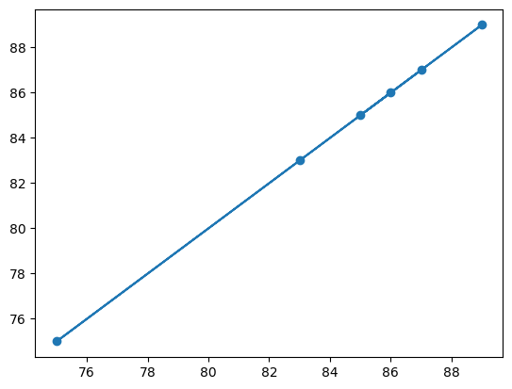

Q: Implement Multi Linear Regression.

Introduction:
Multi linear regression:
multiple linear regression, is an extension of simple linear regression that allows for the prediction of a dependent variable based on multiple independent variables. In multivariate linear regression, the relationship between the dependent variable and the independent variables is assumed to be a linear combination.
The multivariate linear regression model can be expressed as:
y = C + m1x1 + m2x2 + ... + mn*xn
where:
- y is the dependent variable or the variable to be predicted.
- C is the intercept or the y-axis intercept of the line.
- m1, m2, ..., mn are the coefficients or the weights assigned to the independent variables x1, x2, ..., xn.
- x1, x2, ..., xn are the independent variables or the features used to predict the value of y.
The coefficients b0, b1, b2, ..., bn are estimated using the ordinary least squares (OLS) method, which minimizes the sum of the squared differences between the predicted values and the actual values.
In multivariate linear regression, each independent variable contributes to the prediction of the dependent variable, and the coefficients represent the change in the dependent variable associated with a unit change in the corresponding independent variable, holding all other variables constant.
The assumptions for multivariate linear regression are similar to those for simple linear regression:
- Linearity: The relationship between the dependent variable and the independent variables is assumed to be linear.
- Independence: The observations are assumed to be independent of each other.
- Homoscedasticity: The variance of the errors is constant across all levels of the independent variables.
- Normality: The errors are assumed to be normally distributed.

DATASET:
The dataset consists features like Attendence,No of certifictions,marks etc.
Attendence and No of certifications considered as input attribute.
Marks are considered as target attribute.

CODE:

Q:Import the required libraries.
import pandas as pd
from sklearn.metrics import mean_absolute_error,mean_squared_error,r2_score
from sklearn.model_selection import train_test_split
import matplotlib.pyplot as plt
#Load the dataset
df=pd.read_csv("Attendence.csv")
df

OUTPUT:

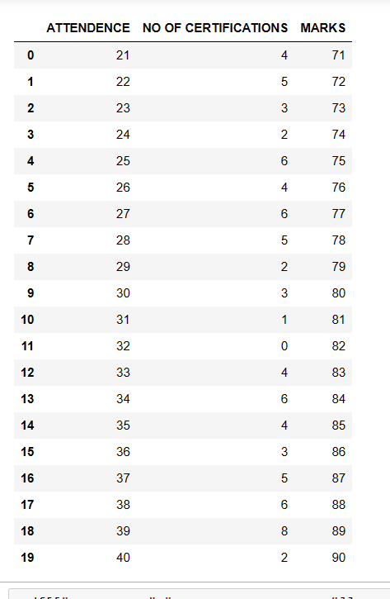

Q:Choose the dependent and independent attributes.
x=df[["ATTENDENCE","NO OF CERTIFICATIONS"]]
y=df["MARKS"]
print(x.shape)
print(y.shape)
OUTPUT:
(20, 2)
Name: MARKS, dtype: int64
(20,)
from sklearn.model_selection import train_test_split
x_train,x_test,y_train,y_test=train_test_split(x,y,test_size=0.3)
print(x_train.shape)
print(y_train.shape)
print(x_test.shape)
print(y_test.shape)
OUTPUT:
(14, 2)
(14,)
(6, 2)
(6,)

#Fit the linear regression model.
from sklearn.linear_model import LinearRegression
model=LinearRegression()
model.fit(x_train,y_train)
result=model.predict(x_test)
print(result)

OUTPUT:
[86. 85. 89. 83. 75. 87.]

#Find the accuracy.
from sklearn.metrics import r2_score
r=r2_score(y_test,result)
print(r)

OUTPUT:
1.0

#Find the error rate.
from sklearn.metrics import mean_absolute_error
r1=mean_absolute_error(y_test,result)
print(r1)

OUTPUT:
0.0

Q:Plotting
import matplotlib.pyplot as plt
plt.scatter(y_test,result)
plt.plot(y_test,result)
plt.show

OUTPUT:
<function matplotlib.pyplot.show(close=None, block=None)>

Q : Implement PolynomialRegression.

Introduction:

POLYNOMIAL REGRESSION:
Polynomial regression is a form of regression analysis used to model relationships between independent variables and a dependent variable. It is an extension of linear regression, where the relationship between variables is assumed to be linear. In polynomial regression, the relationship is modeled as a polynomial equation of a specified degree.
The polynomial equation is defined as:
y = β₀ + β₁x + β₂x² + ... + βₙxⁿ
where:
- y is the dependent variable,
- x is the independent variable,
- β₀, β₁, β₂, ..., βₙ are the coefficients to be estimated, and
- n is the degree of the polynomial.
Polynomial regression allows for more flexible modeling, as it can capture nonlinear relationships between variables. By including higher-order terms (x², x³, etc.) in the equation, polynomial regression can accommodate curved patterns in the data.
Polynomial regression can be used in various fields, such as economics, finance, social sciences, and engineering, where the relationships between variables are not linear. It provides a flexible and interpretable approach to capturing and analyzing nonlinear relationships in the data.

DATASET: WeatherHistory datset.

CODE:

import pandas as pd
import matplotlib.pyplot as plt

data=pd.read_csv("C:/Users/BHARGAVI/Downloads/archive/weatherHistory.csv")
data

OUTPUT:

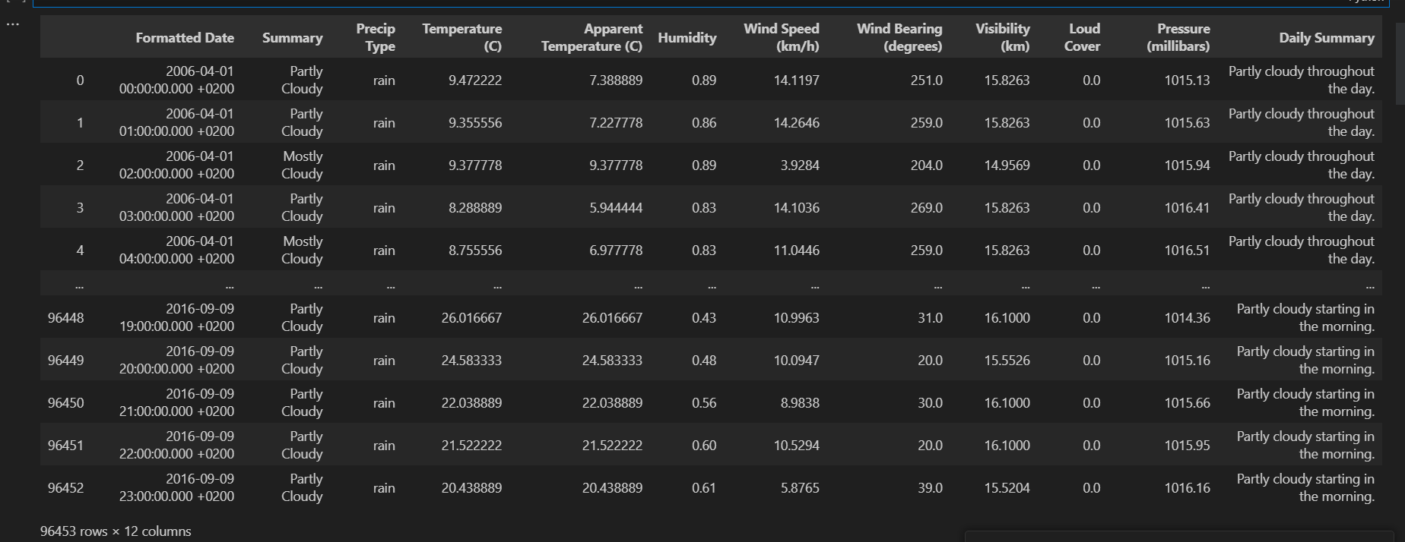

df=data.drop(['Loud Cover','Precip Type','Daily Summary','Summary','Formatted Date'],axis=1)
df

OUTPUT:

df.isnull().sum()

OUTPUT:
Temperature (C) 0
Apparent Temperature (C) 0
Humidity 0
Wind Speed (km/h) 0
Wind Bearing (degrees) 0
Visibility (km) 0
Pressure (millibars) 0
dtype: int64
#Correlation between the attributes.
df.corr()

OUTPUT:
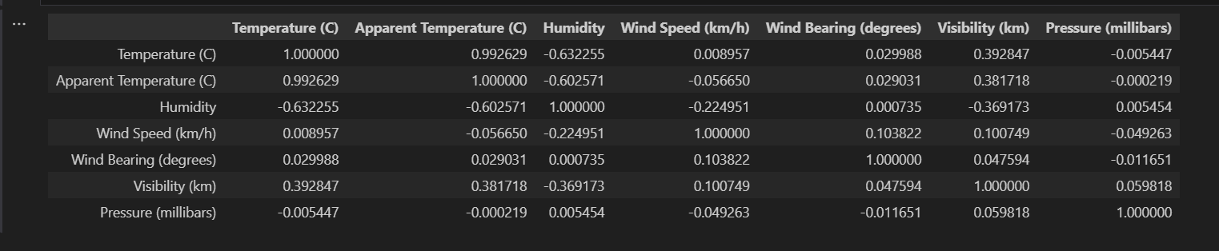

x=data['Humidity']
y=data['Temperature (C)']
plt.plot(x,y)

OUTPUT:

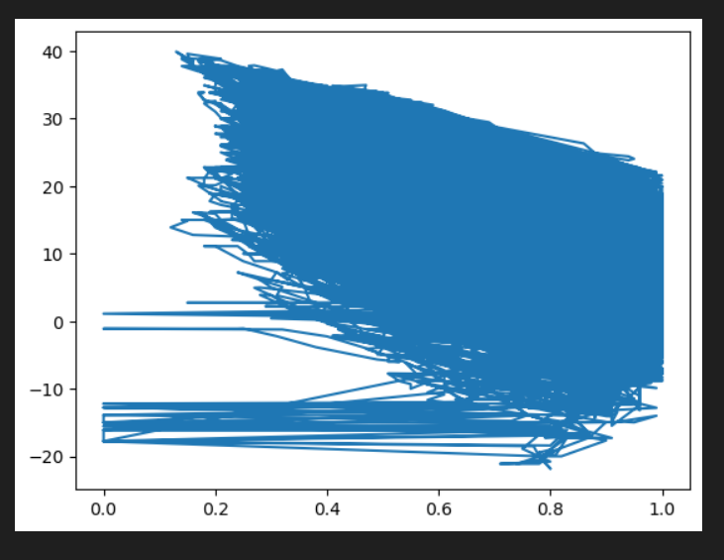

x=df[["Humidity"]]
x.shape

OUTPUT:
(96453, 1)

y=df["Temperature (C)"]
y.shape

OUTPUT:
(96453,)

from sklearn.model_selection import train_test_split
x_train,x_test,y_train,y_test=train_test_split(x,y,test_size=0.2)
print(x_train.shape)
print(x_test.shape)
print(y_train.shape)
print(y_test.shape)

OUTPUT:
(77162, 1)
(19291, 1)
(77162,)
(19291,)

from sklearn.preprocessing import PolynomialFeatures
from sklearn.linear_model import LinearRegression
p=PolynomialFeatures(degree=3)
x_train_poly=p.fit_transform(x_train)
x_test_poly=p.fit_transform(x_test)
model=LinearRegression()
model.fit(x_train_poly,y_train)

OUTPUT:
LinearRegression()
result=model.predict(x_test_poly)
result

OUTPUT:
array([ 6.14273716, 20.57593483, 15.64422201, ..., 19.84655099,
6.06683058, 5.96697777])

from sklearn.metrics import mean_absolute_error,mean_squared_error,r2_score
acc=r2_score(y_test,result)
acc

OUTPUT:
0.932857446082616
import numpy as np
#pred = 0.86
predarray = np.array([[0.56]])
model.predict(p.fit_transform(predarray))

OUTPUT:
array([17.57593229])

AIM : Write a program to demonstrate the working of Logistic Regression. Use appropriate dataset for Logistic Regression

Introduction:

Logistic regression is a supervised machine learning algorithm mainly used for classification tasks where the goal is to predict the probability that an instance of belonging to a given class. It is used for classification algorithms its name is logistic regression. it’s referred to as regression because it takes the output of the linear regression function as input and uses a sigmoid function to estimate the probability for the given class. The difference between linear regression and logistic regression is that linear regression output is the continuous value that can be anything while logistic regression predicts the probability that an instance belongs to a given class or not.

Terminologies involved in Logistic Regression:
Here are some common terms involved in logistic regression:
- Independent variables: The input characteristics or predictor factors applied to the dependent variable’s predictions.
- Dependent variable: The target variable in a logistic regression model, which we are trying to predict.
- Logistic function: The formula used to represent how the independent and dependent variables relate to one another. The logistic function transforms the input variables into a probability value between 0 and 1, which represents the likelihood of the dependent variable being 1 or 0.
- Odds: It is the ratio of something occurring to something not occurring. it is different from probability as probability is the ratio of something occurring to everything that could possibly occur.
- Log-odds: The log-odds, also known as the logit function, is the natural logarithm of the odds. In logistic regression, the log odds of the dependent variable are modeled as a linear combination of the independent variables and the intercept.
- Coefficient: The logistic regression model’s estimated parameters, show how the independent and dependent variables relate to one another.
- Intercept: A constant term in the logistic regression model, which represents the log odds when all independent variables are equal to zero.
- Maximum likelihood estimation: The method used to estimate the coefficients of the logistic regression model, which maximizes the likelihood of observing the data given the model.

Assumptions for Logistic regression
The assumptions for Logistic regression are as follows:
- Independent observations: Each observation is independent of the other. meaning there is no correlation between any input variables.
- Binary dependent variables: It takes the assumption that the dependent variable must be binary or dichotomous, meaning it can take only two values. For more than two categories softmax functions are used.
- Linearity relationship between independent variables and log odds: The relationship between the independent variables and the log odds of the dependent variable should be linear.
- No outliers: There should be no outliers in the dataset.
- Large sample size: The sample size is sufficiently large

Applying steps in logistic regression modeling:
The following are the steps involved in logistic regression modeling:
- Define the problem: Identify the dependent variable and independent variables and determine if the problem is a binary classification problem.
- Data preparation: Clean and preprocess the data, and make sure the data is suitable for logistic regression modeling.
- Exploratory Data Analysis (EDA): Visualize the relationships between the dependent and independent variables, and identify any outliers or anomalies in the data.
- Feature selection: Choose the independent variables that have a significant relationship with the dependent variable, and remove any redundant or irrelevant features.
- Model building: Train the logistic regression model on the selected independent variables and estimate the coefficients of the model.
- Model evaluation: Evaluate the performance of the logistic regression model using appropriate metrics such as accuracy, precision, recall, F1-score, or AUC-ROC.
- Model improvement: Based on the results of the evaluation, fine-tune the model by adjusting the independent variables, adding new features, or using regularization techniques to reduce overfitting.
- Model deployment: Deploy the logistic regression model in a real-world scenario and make predictions on new data.

Data Set : diabetes2.csv

#Import Required Libraries
import pandas as pd
import seaborn as sns
import matplotlib.pyplot as plt

#Load the Data Set and Display
data=pd.read_csv(r"C:\Users\Surendra Babu\Downloads\diabetes.csv")
data
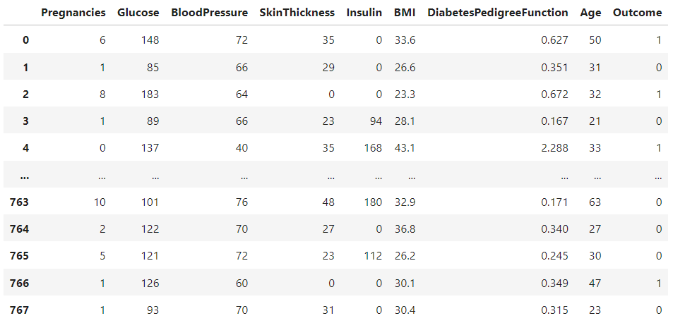

#Correlation

data.corr()
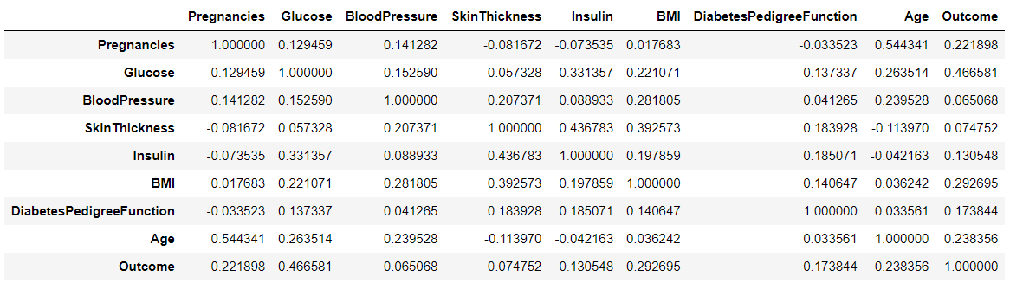

#Check if there are any Null Values
Pregnancies 0
Glucose 0
BloodPressure 0
SkinThickness 0
Insulin 0
BMI 0
DiabetesPedigreeFunction 0
Age 0
Outcome 0
dtype: int64

# Split the dataset into features and target

x=data.drop("Outcome",axis=1)
y=data["Outcome"]

# Split the dataset into training and testing data

from sklearn.model_selection import train_test_split
x_train, x_test, y_train, y_test= train_test_split(x, y, test_size= 0.2)
x_train.shape
y_train.shape

O/P:

(614,)

# Create the Logistic Regression Model and fit the model using the training data

from sklearn.linear_model import LogisticRegression
classifier = LogisticRegression()
classifier.fit(x_train, y_train)

O/P:

LogisticRegression()

# Make predictions on the test data
y_pred = classifier.predict(x_test)
y_pred

O/P:
array([1, 1, 0, 1, 0, 0, 1, 0, 0, 0, 1, 0, 0, 0, 0, 0, 0, 0, 0, 1, 0, 0,
0, 0, 0, 1, 0, 0, 0, 1, 0, 0, 0, 0, 0, 0, 0, 0, 0, 0, 1, 0, 0, 0,
0, 0, 0, 0, 0, 1, 1, 0, 0, 0, 0, 0, 1, 0, 1, 1, 0, 0, 0, 0, 0, 1,
0, 0, 0, 0, 0, 0, 0, 0, 0, 0, 0, 0, 0, 0, 0, 1, 1, 0, 0, 0, 1, 0,
1, 0, 0, 0, 0, 0, 0, 0, 1, 0, 0, 0, 0, 0, 0, 0, 1, 0, 0, 0, 0, 1,
1, 0, 0, 0, 0, 0, 1, 0, 0, 0, 0, 0, 0, 0, 0, 1, 1, 0, 0, 1, 0, 0,
0, 0, 0, 1, 0, 0, 1, 1, 0, 1, 1, 0, 1, 0, 0, 0, 0, 0, 0, 0, 1, 0],
dtype=int64)

# Print the confusion matrix

from sklearn.metrics import confusion_matrix
c=confusion_matrix(y_test,y_pred)
c

O/P:

array([[87, 10],
[33, 24]], dtype=int64)

# Print the classification report

from sklearn.metrics import classification_report
print(classification_report(y_test,y_pred))

O/P:

precision recall f1-score support

0 0.72 0.90 0.80 97
1 0.71 0.42 0.53 57

accuracy 0.72 154
macro avg 0.72 0.66 0.66 154
weighted avg 0.72 0.72 0.70 154

In [13]:

# Create the heatmap using seaborn

import seaborn as sns

import matplotlib.pyplot as plt

from sklearn.metrics import confusion_matrix

sns.heatmap(c,annot=True,cmap="YlGnBu")

plt.title("Confusion Matrix")

#Graph Plot
plt.scatter(y_test,y_pred,color='red')
plt.plot(y_test,y_pred,color='green')

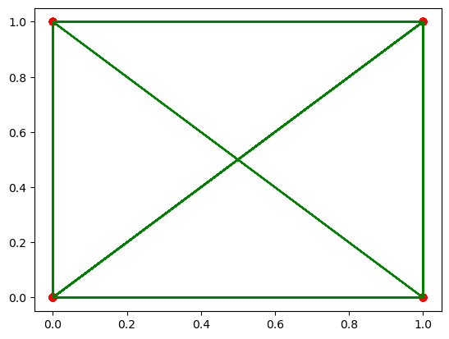

#Evaluation Parameters
from sklearn.metrics import precision_score,accuracy_score,f1_score,recall_score

print("precision_score : ",precision_score(y_test,y_pred))

O/P:
precision_score : 0.7058823529411765

print("accuracy_score : ",accuracy_score(y_test,y_pred))

O/P:
accuracy_score : 0.7207792207792207

print("f1_score",f1_score(y_test,y_pred))

O/P:
f1_score 0.5274725274725274

print("recall_score",recall_score(y_test,y_pred))

O/P:
recall_score 0.42105263157894735

AIM : Write a program to demonstrate the working of Random Forest classifier. Use appropriate dataset for Random Forest Classifier.

Introduction
Random forest is a supervised learning algorithm which is used for both classification as well as regression. But however, it is mainly used for classification problems. As we know that a forest is made up of trees and more trees means more robust forest. Similarly, random forest algorithm creates decision trees on data samples and then gets the prediction from each of them and finally selects the best solution by means of voting. It is an ensemble method which is better than a single decision tree because it reduces the over-fitting by averaging the result.

Working of Random Forest Algorithm
We can understand the working of Random Forest algorithm with the help of following steps −
- Step 1 − First, start with the selection of random samples from a given dataset.
- Step 2 − Next, this algorithm will construct a decision tree for every sample. Then it will get the prediction result from every decision tree.
- Step 3 − In this step, voting will be performed for every predicted result.
- Step 4 − At last, select the most voted prediction result as the final prediction result.
The following diagram will illustrate its working −
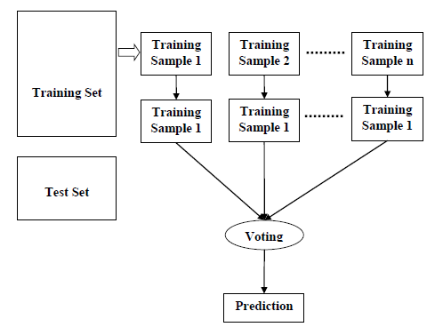
Data Set : diabetes2.csv


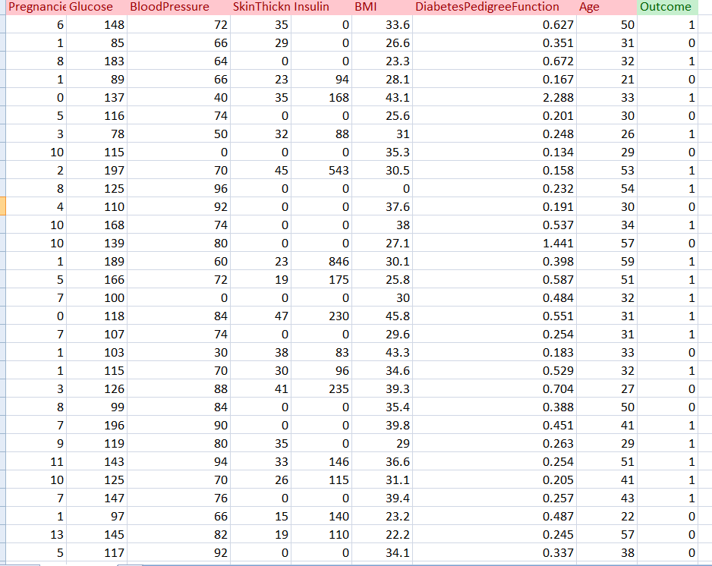

< program >

import pandas as pd

from sklearn.ensemble import RandomForestClassifier from sklearn.model_selection import train_test_split from sklearn.metrics import confusion_matrix

# Load the dataset

df = pd.read_csv("diabetes2.csv")

# Split the dataset into features and target

X = df.drop("Outcome", axis=1) y = df["Outcome"]

#Correlation

data.corr()

# Split the dataset into training and testing data

X_train, X_test, y_train, y_test = train_test_split(X, y, test_size=0.25, random_state=0)

print(X_train.shape)

print(X_test.shape)

print(y_train.shape)

print(y_test.shape)

O/P;
(576, 8)
(192, 8)
(576,)
(192,)

# Create the random forest classifier and fit the model using the training data

classifier = RandomForestClassifier(n_estimators=100, random_state=0) classifier.fit(X_train, y_train)
O/P:
RandomForestClassifier()

# Make predictions on the test data

y_pred = classifier.predict(X_test)
print(y_pred)

[1 1 0 0 0 1 0 1 1 1 0 1 0 0 1 0 0 0 0 1 0 1 0 0 1 1 0 0 0 0 1 0 0 1 1 1 0
0 0 0 0 1 0 0 0 0 0 0 0 0 1 0 0 0 0 0 0 0 0 1 0 0 0 0 1 0 0 0 0 0 0 0 0 1
0 0 0 1 0 0 0 0 1 0 0 1 1 0 1 0 0 0 0 1 0 0 0 0 0 0 0 1 0 0 1 0 0 0 1 0 1
0 1 0 0 0 0 0 0 0 0 0 0 0 0 0 0 1 1 1 0 0 0 1 0 0 0 0 0 1 1 0 0 0 0 1 0 0
0 0 0 0 0 0 0 1 0 0 0 1 0 0 0 1 1 0 0 0 0 1 1 0 0 0 0 1 0 0 0 0 0 0 1 0 1
1 0 0 1 0 0 0 0 0 0 1 1 1 0 0 0 0 0 0 1 0 1 0 0 1 0 0 0 0 0 0 1 0 0 0 1 0
0 0 0 1 0 0 0 1 0]

# Print the confusion matrix cm = confusion_matrix(y_test, y_pred) print("Confusion Matrix:")
cm
O/P:
Confusion Matrix:
Out[22]:
array([[115, 12],
[ 31, 34]], dtype=int64)

# Print the classification report
from sklearn.metrics import classification_report res = classification_report(y_test, y_pred) print("\nClassification Report:\n", res)
O/P:
Classification Report:
precision recall f1-score support

0 0.79 0.91 0.84 127
1 0.74 0.52 0.61 65

accuracy 0.78 192
macro avg 0.76 0.71 0.73 192
weighted avg 0.77 0.78 0.76 192

# Generate the confusion matrix
# Create the heatmap using seaborn

import seaborn as sns

import matplotlib.pyplot as plt

from sklearn.metrics import confusion_matrix

sns.heatmap(cm,annot=True,cmap="YlGnBu")

plt.title("Confusion Matrix")

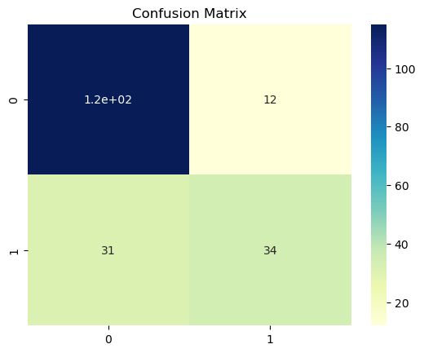

#In this code snippet, we set the fmt parameter of seaborn's heatmap function to "d",
#which specifies that the numbers should be displayed as integers (i.e., no decimal places).
#This will display the confusion matrix heatmap with full numbers instead of in scientific notation.
#Evaluation Parameters

from sklearn.metrics import precision_score,recall_score, f1_score, accuracy_score,confusion_matrix
print("Accuracy:", accuracy_score(y_test,y_pred))

Accuracy: 0.7760416666666666

print("Precision:", precision_score(y_test,y_pred,average="weighted"))

Precision: 0.7712381501886044

print('Recall:', recall_score(y_test,y_pred,average="weighted"))

Recall: 0.776041666666666

Aim: Write a program to demonstrate the working of Random Forest Regressor. Use appropriate dataset for Random Forest Regressor.

Random Forest Regressor:
Random forest regression is a supervised learning algorithm that uses an ensemble learning method for regression.
Random forest is a bagging technique and not a boosting technique. The trees in random forests run in parallel, meaning there is no interaction between these trees while building the trees.
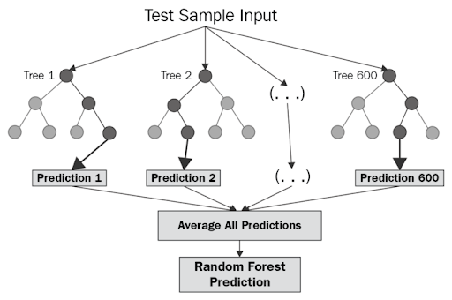

Algorithm:

- Design a specific question or data and get the source to determine the required data.
- Make sure the data is in an accessible format else convert it to the required format.
- Specify all noticeable anomalies and missing data points that may be required to achieve the required data.
- Create a machine-learning model.
- Set the baseline model that you want to achieve
- Train the data machine learning model.
- Provide an insight into the model with test data
- Now compare the performance metrics of both the test data and the predicted data from the model.
- If it doesn’t satisfy your expectations, you can try improving your model accordingly or dating your data, or using another data modeling technique.
- At this stage, you interpret the data you have gained and report accordingly.

Important Hyperparameters in Random Forest
Hyperparameters are used in random forests to either enhance the performance and predictive power of models or to make the model faster.

Hyperparameters to Increase the Predictive Power
n_estimators: Number of trees the algorithm builds before averaging the predictions.
max_features: Maximum number of features random forest considers splitting a node.
mini_sample_leaf: Determines the minimum number of leaves required to split an internal node.
criterion: How to split the node in each tree? (Entropy/Gini impurity/Log Loss)
max_leaf_nodes: Maximum leaf nodes in each tree

Hyperparameters to Increase the Speed
n_jobs: it tells the engine how many processors it is allowed to use. If the value is 1, it can use only one processor, but if the value is -1, there is no limit.
random_state: controls randomness of the sample. The model will always produce the same results if it has a definite value of random state and has been given the same hyperparameters and training data.
oob_score: OOB means out of the bag. It is a random forest cross-validation method. In this, one-third of the sample is not used to train the data; instead used to evaluate its performance. These samples are called out-of-bag samples.
Python code:
Step 1: Load Pandas library and the dataset using Pandas
Step 1: Load Pandas library and the dataset using Pandas
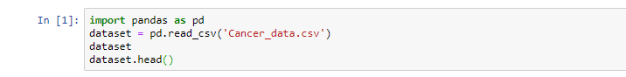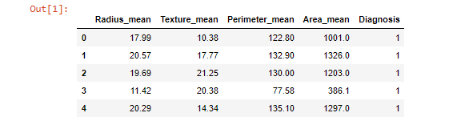
Step 2: Define the features and the target

Step 2: Define the features and the target
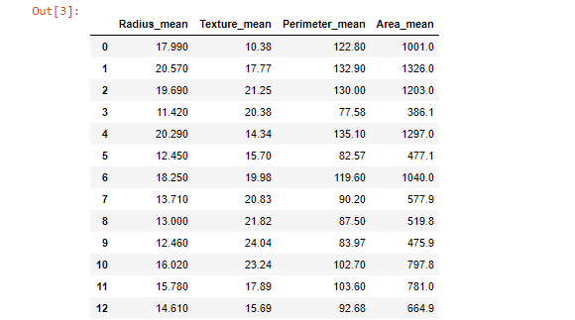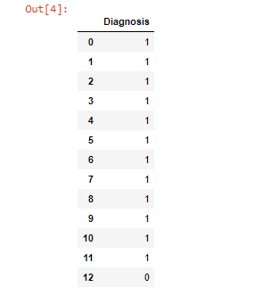

Step 3: Split the dataset into train and test sklearn
Step 4: Import the random forest classifier function from sklearn ensemble module. Build the random forest classifier model with the help of the random forest classifier function
Step 5: Predict values using the random forest classifier model
Step 6: Evaluate the random forest classifier model
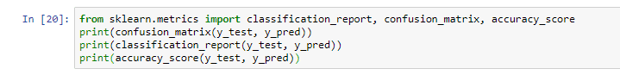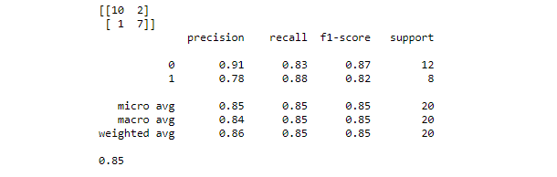

Feature Selection in Random Forest Algorithm Model
With the help of Scikit-Learn, we can select important features to build the random forest algorithm model in order to avoid the overfitting issue. There are two ways to do this:
- Visualize which feature is not adding any value to the model
- Take help of the built-in function SelectFromModel, which allows us to add a threshold value to neglect features below that threshold value.
Let us see if selecting features make any difference in the accuracy score of the model.
Step 7: Let us find out important features and visualize them using Seaborn
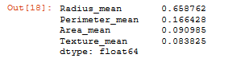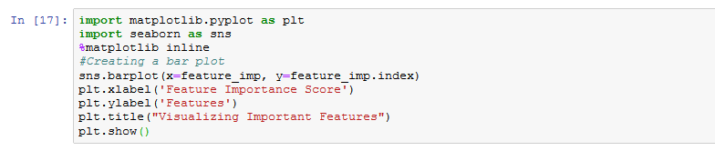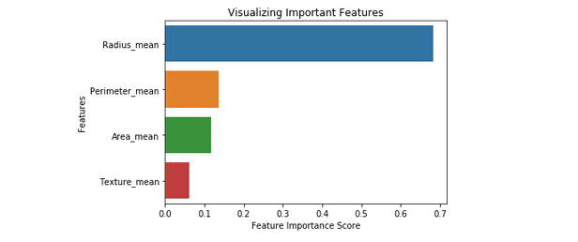
Now let us see how the ‘SelectFromModel’ function helps in building a random forest classifier model with important features.
Step 8: Import the SelectFromModel function. We will pass the classifier object we’ve created above. Also, we will add a threshold value of 0.1
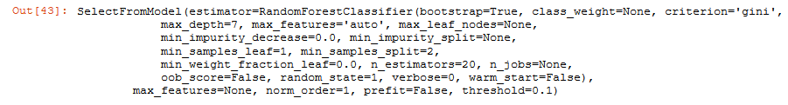
Step 9: With the help of the ‘transform’ method, we will pick the important features and store them in new train and test objects
Step 10: Let us now build a new random forest classifier model (so that we can compare the results of this model with the old one)
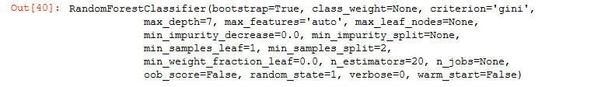
Step 11: Let us see the accuracy result of the old model
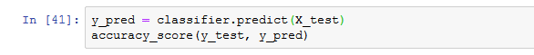
Step 12: Let us see the accuracy result of the new model after feature selection
Note: After the feature selection process, the accuracy score is decreased. But, we have successfully picked out the important features at a small cost of accuracy.
Also, automatic feature selection reduces the complexity of the model but does not necessarily increase the accuracy. In order to get the desired accuracy, we have to perform the feature selection process manually.

Step 13: To find Confusion Matrix:
y=confusion_matrix(y_test,y_pred)
y
Out[71]:

array([[107, 0],
[ 3, 44]], dtype=int64)

import seaborn as sns
sns.heatmap(y,annot=True,cmap="YlGnBu")
plt.title("Confusion Matrix")
Out[72]:

Text(0.5, 1.0, 'Confusion Matrix')
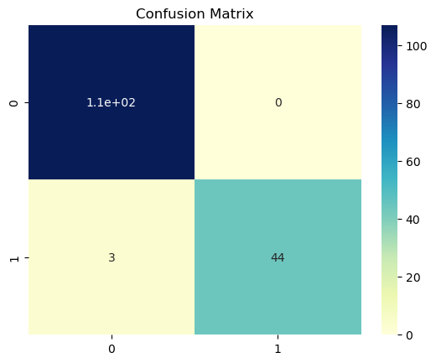

Aim: Write a program to demonstrate the working of the decision tree classifier. Use appropriate dataset for building the decision tree and apply this knowledge to classify a new sample.
Description:-
Decision Tree is one of the most powerful and popular algorithm. Decision-tree algorithm falls under the category of supervised learning algorithms. It works for both continuous as well as categorical output variables.

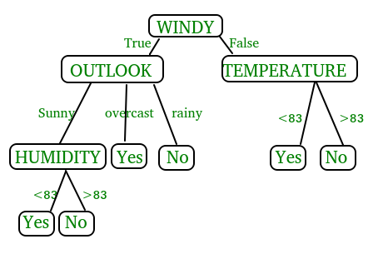

Pseudocode :
  - Find the best attribute and place it on the root node of the tree.
  - Now, split the training set of the dataset into subsets. While making the subset make sure that each subset of training dataset should have the same value for an attribute.
  - Find leaf nodes in all branches by repeating 1 and 2 on each subset.

While implementing the decision tree we will go through the following two phases:
  - Building Phase
    - Preprocess the dataset.
    - Split the dataset from train and test using Python sklearn package.
    - Train the classifier.
  - Operational Phase
    - Make predictions.
    - Calculate the accuracy.
Syntax:-
class sklearn.tree.DecisionTreeClassifier(*, criterion='gini', splitter='best', max_depth=None, min_samples_split=2, min_samples_leaf=1, min_weight_fraction_leaf=0.0, max_features=None, random_state=None, max_leaf_nodes=None, min_impurity_decrease=0.0, class_weight=None, ccp_alpha=0.0)
Parameters:-

- criterion{“gini”, “entropy”, “log_loss”}, default=”gini”
The function to measure the quality of a split. Supported criteria are “gini” for the Gini impurity and “log_loss” and “entropy” both for the Shannon information gain, see Mathematical formulation.
- splitter{“best”, “random”}, default=”best”
The strategy used to choose the split at each node. Supported strategies are “best” to choose the best split and “random” to choose the best random split.
- max_depthint, default=None
The maximum depth of the tree. If None, then nodes are expanded until all leaves are pure or until all leaves contain less than min_samples_split samples.
- min_samples_splitint or float, default=2
The minimum number of samples required to split an internal node:
- If int, then consider min_samples_split as the minimum number.
- If float, then min_samples_split is a fraction and ceil(min_samples_split * n_samples) are the minimum number of samples for each split.
Changed in version 0.18: Added float values for fractions.
- min_samples_leafint or float, default=1
The minimum number of samples required to be at a leaf node. A split point at any depth will only be considered if it leaves at least min_samples_leaf training samples in each of the left and right branches. This may have the effect of smoothing the model, especially in regression.
- If int, then consider min_samples_leaf as the minimum number.
- If float, then min_samples_leaf is a fraction and ceil(min_samples_leaf * n_samples) are the minimum number of samples for each node.
Changed in version 0.18: Added float values for fractions.
- min_weight_fraction_leaffloat, default=0.0
The minimum weighted fraction of the sum total of weights (of all the input samples) required to be at a leaf node. Samples have equal weight when sample_weight is not provided.
- max_featuresint, float or {“auto”, “sqrt”, “log2”}, default=None
The number of features to consider when looking for the best split:
- If int, then consider max_features features at each split.
- If float, then max_features is a fraction and max(1, int(max_features * n_features_in_)) features are considered at each split.
- If “auto”, then max_features=sqrt(n_features).
- If “sqrt”, then max_features=sqrt(n_features).
- If “log2”, then max_features=log2(n_features).
- If None, then max_features=n_features.
Deprecated since version 1.1: The "auto" option was deprecated in 1.1 and will be removed in 1.3.
Note: the search for a split does not stop until at least one valid partition of the node samples is found, even if it requires to effectively inspect more than max_features features.
- random_stateint, RandomState instance or None, default=None
Controls the randomness of the estimator. The features are always randomly permuted at each split, even if splitter is set to "best". When max_features < n_features, the algorithm will select max_features at random at each split before finding the best split among them. But the best found split may vary across different runs, even if max_features=n_features. That is the case, if the improvement of the criterion is identical for several splits and one split has to be selected at random. To obtain a deterministic behaviour during fitting, random_state has to be fixed to an integer. See Glossary for details.
- max_leaf_nodesint, default=None
Grow a tree with max_leaf_nodes in best-first fashion. Best nodes are defined as relative reduction in impurity. If None then unlimited number of leaf nodes.
- min_impurity_decreasefloat, default=0.0
A node will be split if this split induces a decrease of the impurity greater than or equal to this value.
The weighted impurity decrease equation is the following:
N_t / N * (impurity - N_t_R / N_t * right_impurity
- N_t_L / N_t * left_impurity)
where N is the total number of samples, N_t is the number of samples at the current node, N_t_L is the number of samples in the left child, and N_t_R is the number of samples in the right child.
N, N_t, N_t_R and N_t_L all refer to the weighted sum, if sample_weight is passed.
New in version 0.19.
- class_weightdict, list of dict or “balanced”, default=None
Weights associated with classes in the form {class_label: weight}. If None, all classes are supposed to have weight one. For multi-output problems, a list of dicts can be provided in the same order as the columns of y.
Note that for multioutput (including multilabel) weights should be defined for each class of every column in its own dict. For example, for four-class multilabel classification weights should be [{0: 1, 1: 1}, {0: 1, 1: 5}, {0: 1, 1: 1}, {0: 1, 1: 1}] instead of [{1:1}, {2:5}, {3:1}, {4:1}].
The “balanced” mode uses the values of y to automatically adjust weights inversely proportional to class frequencies in the input data as n_samples / (n_classes * np.bincount(y))
For multi-output, the weights of each column of y will be multiplied.
Note that these weights will be multiplied with sample_weight (passed through the fit method) if sample_weight is specified.
- ccp_alphanon-negative float, default=0.0
Complexity parameter used for Minimal Cost-Complexity Pruning. The subtree with the largest cost complexity that is smaller than ccp_alpha will be chosen. By default, no pruning is performed.

Info. About criterion:-

- Gini index:

- Gini Index is a metric to measure how often a randomly chosen element would be incorrectly identified.
- It means an attribute with lower gini index should be preferred.
- Sklearn supports “gini” criteria for Gini Index and by default, it takes “gini” value.
- Entropy:
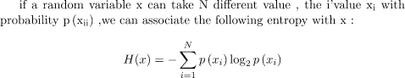
Entropy is the measure of uncertainty of a random variable, it characterizes the impurity of an arbitrary collection of examples. The higher the entropy the more the information content.
- Information Gain:-

- The entropy typically changes when we use a node in a decision tree to partition the training instances into smaller subsets. Information gain is a measure of this change in entropy.
- Sklearn supports “entropy” criteria for Information Gain and if we want to use Information Gain method in sklearn then we have to mention it explicitly.
Accuracy score
- Accuracy score is used to calculate the accuracy of the trained classifier.
Confusion Matrix
- Confusion Matrix is used to understand the trained classifier behavior over the test dataset or validate dataset.
Dataset:-Diabetes dataset is used in the Decision Tree Classifier.
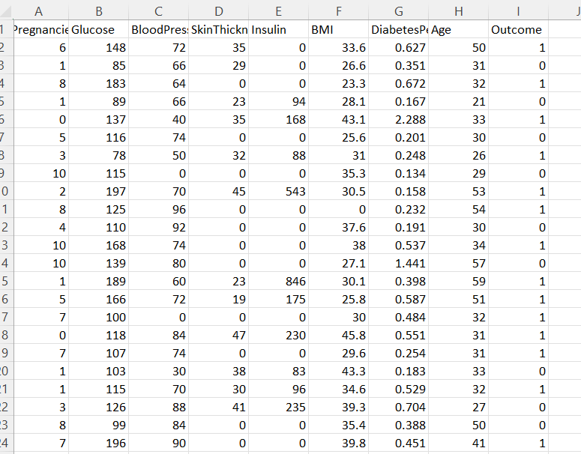

Dataset Description :-
Context -
This dataset is originally from the National Institute of Diabetes and Digestive and Kidney Diseases. The objective of the dataset is to diagnostically predict whether or not a patient has diabetes, based on certain diagnostic measurements included in the dataset. Several constraints were placed on the selection of these instances from a larger database. In particular, all patients here are females at least 21 years old of Pima Indian Heritage .
Context-
The datasets consist of several medical predictor (independent) variables and one target (dependent) variable, Outcome. Independent variables include the number of pregnancies the patient has had, their BMI, insulin level, age, and so on.
Attributes in the dataset:-
There are 9 columns in the dataset -
7- Integer
2-Decimal
#Pregnancies- Number of Times Pregnant.
# Glucose- Plasma glucose concentration a 2 hours in an oral glucose tolerance test.
#BloodPressure- Diastolic blood pressure (mm Hg).
#SkinThickness- Triceps skin fold thickness (mm).
#Insulin- 2-Hour serum insulin (mu U/ml).
#BMI- Body mass index (weight in kg/(height in m)^2).

# DiabetesPedigreeFunction- DiabetesPedigreeFunction.
#Age- Age(Years).
#Outcome- Class variable (0 or 1) 268 of 768 are 1, the others are 0.
0 – No Diabetes and 1 – Diabetes.

Python Code:-

import pandas as pd
data=pd.read_csv("C:/Users/ML Lab/Downloads/diabetes.csv")
data

Pregnancies | Glucose | BloodPressure | SkinThickness | Insulin | BMI | DiabetesPedigreeFunction | Age | Outcome
0 | 6 | 148 | 72 | 35 | 0 | 33.6 | 0.627 | 50 | 1
1 | 1 | 85 | 66 | 29 | 0 | 26.6 | 0.351 | 31 | 0
2 | 8 | 183 | 64 | 0 | 0 | 23.3 | 0.672 | 32 | 1
3 | 1 | 89 | 66 | 23 | 94 | 28.1 | 0.167 | 21 | 0
4 | 0 | 137 | 40 | 35 | 168 | 43.1 | 2.288 | 33 | 1
... | ... | ... | ... | ... | ... | ... | ... | ... | ...
763 | 10 | 101 | 76 | 48 | 180 | 32.9 | 0.171 | 63 | 0
764 | 2 | 122 | 70 | 27 | 0 | 36.8 | 0.340 | 27 | 0
765 | 5 | 121 | 72 | 23 | 112 | 26.2 | 0.245 | 30 | 0
766 | 1 | 126 | 60 | 0 | 0 | 30.1 | 0.349 | 47 | 1
767 | 1 | 93 | 70 | 31 | 0 | 30.4 | 0.315 | 23 | 0
768 rows × 9 columns

x=data.drop(["Outcome"],axis=1)
y=data['Outcome']
x
y
0 1
1 0
2 1
3 0
4 1
..
763 0
764 0
765 0
766 1
767 0
Name: Outcome, Length: 768, dtype: int64

from sklearn.model_selection import train_test_split
xtrain, xtest, ytrain, ytest= train_test_split(x, y, test_size= 0.25, random_state=0)
print(xtrain.shape)
print(xtest.shape)
print(ytrain.shape)
print(ytest.shape)

(576, 8)
(192, 8)
(576,)
(192,)

from sklearn.preprocessing import StandardScaler
st_x= StandardScaler()
xtrain= st_x.fit_transform(xtrain)
xtest= st_x.transform(xtest)
from sklearn.tree import DecisionTreeClassifier
classifier= DecisionTreeClassifier()
classifier.fit(xtrain, ytrain)
DecisionTreeClassifier()

ypred=classifier.predict(xtest)
ypred

array([1, 0, 0, 0, 0, 0, 1, 0, 0, 1, 1, 1, 0, 0, 1, 1, 1, 0, 1, 0, 1, 0,
0, 0, 0, 1, 0, 1, 0, 0, 0, 0, 0, 1, 0, 1, 0, 0, 1, 1, 1, 0, 0, 1,
1, 0, 0, 0, 1, 0, 1, 1, 1, 1, 0, 0, 0, 1, 0, 0, 0, 0, 0, 1, 1, 1,
1, 0, 0, 0, 0, 0, 0, 1, 1, 0, 0, 0, 0, 0, 0, 0, 0, 0, 0, 0, 0, 0,
1, 0, 1, 0, 0, 0, 1, 0, 0, 0, 0, 0, 0, 0, 0, 0, 1, 1, 0, 1, 0, 1,
0, 0, 1, 0, 1, 1, 1, 1, 0, 1, 0, 0, 0, 0, 0, 0, 0, 1, 0, 1, 0, 1,
0, 1, 1, 0, 1, 0, 1, 0, 0, 1, 0, 0, 1, 0, 0, 0, 0, 0, 0, 0, 0, 0,
1, 0, 0, 0, 0, 1, 0, 1, 0, 0, 1, 1, 1, 0, 0, 0, 0, 1, 1, 0, 0, 0,
1, 0, 0, 0, 0, 1, 0, 1, 1, 0, 1, 0, 0, 1, 0, 0], dtype=int64)

from sklearn.metrics import confusion_matrix
cm=confusion_matrix(ytest,ypred)
cm

array([[100, 30],
[ 25, 37]], dtype=int64)

from sklearn.metrics import accuracy_score
acc=accuracy_score(ytest,ypred)
acc
0.7135416666666666
#from sklearn.tree import export_graphviz
import matplotlib.pyplot as plt
from sklearn import tree
#fig, axes = plt.subplots(nrows = 1,ncols = 1,figsize = (4,4), dpi=300)
tree.plot_tree(model,feature_names =['BMI'],class_names=['Outcome'],filled=True)
plt.show('imagename1.png')

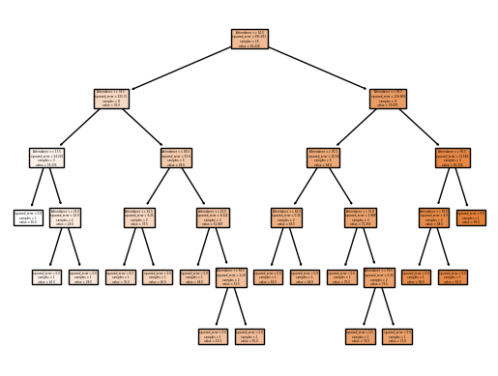

Aim: Write a program to demonstrate the working of the decision tree Regressor. Use appropriate dataset for building the decision tree and apply this knowledge to classify a new sample.

Decision Tree is a decision-making tool that uses a flowchart-like tree structure or is a model of decisions and all of their possible results, including outcomes, input costs, and utility.
Decision-tree algorithm falls und
the category of supervised learning algorithms. It works for both continuous as well as categorical output variables.

The branches/edges represent the result of the node and the nodes have either:

Conditions [Decision Nodes]
Result [End Nodes]
The branches/edges represent the truth/falsity of the statement and take makes a decision based on that in the example below which shows a decision tree that evaluates the smallest of three numbers:
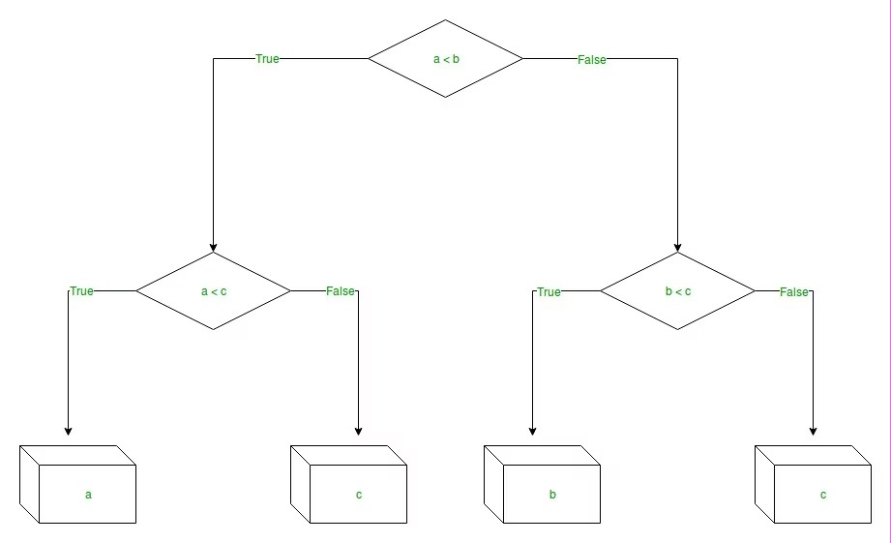

Decision Tree Regression:
Decision tree regression observes features of an object and trains a model in the structure of a tree to predict data in the future to produce meaningful continuous output. Continuous output means that the output/result is not discrete, i.e., it is not represented just by a discrete, known set of numbers or values.

Discrete output example: A weather prediction model that predicts whether or not there’ll be rain on a particular day.
Continuous output example: A profit prediction model that states the probable profit that can be generated from the sale of a product.
Here, continuous values are predicted with the help of a decision tree regression model.

Syntax:

sklearn.tree.DecisionTreeRegressor(*, criterion='squared_error', splitter='best', max_depth=None, min_samples_split=2, min_samples_leaf=1, min_weight_fraction_leaf=0.0, max_features=None, random_state=None, max_leaf_nodes=None, min_impurity_decrease=0.0, ccp_alpha=0.0)
Parameters:

criterion{“squared_error”, “friedman_mse”, “absolute_error”, “poisson”}, default=”squared_error”
The function to measure the quality of a split. Supported criteria are “squared_error” for the mean squared error, which is equal to variance reduction as feature selection criterion and minimizes the L2 loss using the mean of each terminal node, “friedman_mse”, which uses mean squared error with Friedman’s improvement score for potential splits, “absolute_error” for the mean absolute error, which minimizes the L1 loss using the median of each terminal node, and “poisson” which uses reduction in Poisson deviance to find splits.

New in version 0.18: Mean Absolute Error (MAE) criterion.

New in version 0.24: Poisson deviance criterion.

splitter{“best”, “random”}, default=”best”
The strategy used to choose the split at each node. Supported strategies are “best” to choose the best split and “random” to choose the best random split.

max_depthint, default=None
The maximum depth of the tree. If None, then nodes are expanded until all leaves are pure or until all leaves contain less than min_samples_split samples.

min_samples_splitint or float, default=2
The minimum number of samples required to split an internal node:

If int, then consider min_samples_split as the minimum number.

If float, then min_samples_split is a fraction and ceil(min_samples_split * n_samples) are the minimum number of samples for each split.

Changed in version 0.18: Added float values for fractions.

min_samples_leafint or float, default=1
The minimum number of samples required to be at a leaf node. A split point at any depth will only be considered if it leaves at least min_samples_leaf training samples in each of the left and right branches. This may have the effect of smoothing the model, especially in regression.

If int, then consider min_samples_leaf as the minimum number.

If float, then min_samples_leaf is a fraction and ceil(min_samples_leaf * n_samples) are the minimum number of samples for each node.

min_weight_fraction_leaffloat, default=0.0
The minimum weighted fraction of the sum total of weights (of all the input samples) required to be at a leaf node. Samples have equal weight when sample_weight is not provided.

max_featuresint, float or {“auto”, “sqrt”, “log2”}, default=None
The number of features to consider when looking for the best split:

If int, then consider max_features features at each split.

If float, then max_features is a fraction and max(1, int(max_features * n_features_in_)) features are considered at each split.

If “auto”, then max_features=n_features.

If “sqrt”, then max_features=sqrt(n_features).

If “log2”, then max_features=log2(n_features).

If None, then max_features=n_features.
random_stateint, RandomState instance or None, default=None
Controls the randomness of the estimator. The features are always randomly permuted at each split, even if splitter is set to "best". When max_features < n_features, the algorithm will select max_features at random at each split before finding the best split among them. But the best found split may vary across different runs, even if max_features=n_features. That is the case, if the improvement of the criterion is identical for several splits and one split has to be selected at random. To obtain a deterministic behaviour during fitting, random_state has to be fixed to an integer. See Glossary for details.

max_leaf_nodesint, default=None
Grow a tree with max_leaf_nodes in best-first fashion. Best nodes are defined as relative reduction in impurity. If None then unlimited number of leaf nodes.

min_impurity_decreasefloat, default=0.0
A node will be split if this split induces a decrease of the impurity greater than or equal to this value.

The weighted impurity decrease equation is the following:

N_t / N * (impurity - N_t_R / N_t * right_impurity
- N_t_L / N_t * left_impurity)
where N is the total number of samples, N_t is the number of samples at the current node, N_t_L is the number of samples in the left child, and N_t_R is the number of samples in the right child.

N, N_t, N_t_R and N_t_L all refer to the weighted sum, if sample_weight is passed.
ccp_alphanon-negative float, default=0.0
Complexity parameter used for Minimal Cost-Complexity Pruning. The subtree with the largest cost complexity that is smaller than ccp_alpha will be chosen. By default, no pruning is performed. See Minimal Cost-Complexity Pruning for details.
Data Set: Marks.csv

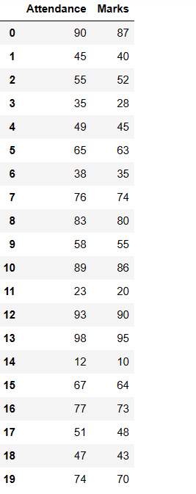

Python code:

import pandas as pd
data=pd.read_csv("D:/21761A4232/marks.csv")
data

Attendance Marks
0 90 87
1 45 40
2 55 52
3 35 28
4 49 45
5 65 63
6 38 35
7 76 74
8 83 80
9 58 55
10 89 86
11 23 20
12 93 90
13 98 95
14 12 10
15 67 64
16 77 73
17 51 48
18 47 43
19 74 70

x=data[['Attendance']]
y=data['Marks']

from sklearn.model_selection import train_test_split
xtrain,xtest,ytrain,ytest=train_test_split(x,y,test_size=0.2)
print(xtrain.shape)
print(xtest.shape)
print(ytrain.shape)
print(ytest.shape)
(16, 1)
(4, 1)
(16,)
(4,)

from sklearn.tree import DecisionTreeRegressor
model = DecisionTreeRegressor()
model.fit(xtrain,ytrain)
pred=model.predict(xtest)
pred

array([48., 40., 86., 73.])

#from sklearn.tree import export_graphviz
import matplotlib.pyplot as plt
from sklearn import tree
#fig, axes = plt.subplots(nrows = 1,ncols = 1,figsize = (4,4), dpi=300)
tree.plot_tree(model,feature_names =['Attendance'],class_names=['Marks'],filled=True)
plt.show('imagename.png')

AIM : Write a program to demonstrate the working of Random Forest classifier. Use appropriate dataset for Random Forest Classifier.

Introduction
Random forest is a supervised learning algorithm which is used for both classification as well as regression. But however, it is mainly used for classification problems. As we know that a forest is made up of trees and more trees means more robust forest. Similarly, random forest algorithm creates decision trees on data samples and then gets the prediction from each of them and finally selects the best solution by means of voting. It is an ensemble method which is better than a single decision tree because it reduces the over-fitting by averaging the result.

Working of Random Forest Algorithm
We can understand the working of Random Forest algorithm with the help of following steps −
- Step 1 − First, start with the selection of random samples from a given dataset.
- Step 2 − Next, this algorithm will construct a decision tree for every sample. Then it will get the prediction result from every decision tree.
- Step 3 − In this step, voting will be performed for every predicted result.
- Step 4 − At last, select the most voted prediction result as the final prediction result.
The following diagram will illustrate its working −
Data Set : diabetes2.csv

< program >

import pandas as pd

from sklearn.ensemble import RandomForestClassifier from sklearn.model_selection import train_test_split from sklearn.metrics import confusion_matrix

# Load the dataset

df = pd.read_csv("diabetes2.csv")

# Split the dataset into features and target

X = df.drop("Outcome", axis=1) y = df["Outcome"]

#Correlation

data.corr()

# Split the dataset into training and testing data

X_train, X_test, y_train, y_test = train_test_split(X, y, test_size=0.25, random_state=0)

print(X_train.shape)

print(X_test.shape)

print(y_train.shape)

print(y_test.shape)

O/P;
(576, 8)
(192, 8)
(576,)
(192,)

# Create the random forest classifier and fit the model using the training data

classifier = RandomForestClassifier(n_estimators=100, random_state=0) classifier.fit(X_train, y_train)
O/P:
RandomForestClassifier()

# Make predictions on the test data

y_pred = classifier.predict(X_test)
print(y_pred)

[1 1 0 0 0 1 0 1 1 1 0 1 0 0 1 0 0 0 0 1 0 1 0 0 1 1 0 0 0 0 1 0 0 1 1 1 0
0 0 0 0 1 0 0 0 0 0 0 0 0 1 0 0 0 0 0 0 0 0 1 0 0 0 0 1 0 0 0 0 0 0 0 0 1
0 0 0 1 0 0 0 0 1 0 0 1 1 0 1 0 0 0 0 1 0 0 0 0 0 0 0 1 0 0 1 0 0 0 1 0 1
0 1 0 0 0 0 0 0 0 0 0 0 0 0 0 0 1 1 1 0 0 0 1 0 0 0 0 0 1 1 0 0 0 0 1 0 0
0 0 0 0 0 0 0 1 0 0 0 1 0 0 0 1 1 0 0 0 0 1 1 0 0 0 0 1 0 0 0 0 0 0 1 0 1
1 0 0 1 0 0 0 0 0 0 1 1 1 0 0 0 0 0 0 1 0 1 0 0 1 0 0 0 0 0 0 1 0 0 0 1 0
0 0 0 1 0 0 0 1 0]

# Print the confusion matrix cm = confusion_matrix(y_test, y_pred) print("Confusion Matrix:")
cm
O/P:
Confusion Matrix:
Out[22]:
array([[115, 12],
[ 31, 34]], dtype=int64)

# Print the classification report
from sklearn.metrics import classification_report res = classification_report(y_test, y_pred) print("\nClassification Report:\n", res)
O/P:
Classification Report:
precision recall f1-score support

0 0.79 0.91 0.84 127
1 0.74 0.52 0.61 65

accuracy 0.78 192
macro avg 0.76 0.71 0.73 192
weighted avg 0.77 0.78 0.76 192

# Generate the confusion matrix
# Create the heatmap using seaborn

import seaborn as sns

import matplotlib.pyplot as plt

from sklearn.metrics import confusion_matrix

sns.heatmap(cm,annot=True,cmap="YlGnBu")

plt.title("Confusion Matrix")

#In this code snippet, we set the fmt parameter of seaborn's heatmap function to "d",
#which specifies that the numbers should be displayed as integers (i.e., no decimal places).
#This will display the confusion matrix heatmap with full numbers instead of in scientific notation.

#Evaluation Parameters

from sklearn.metrics import precision_score,recall_score, f1_score, accuracy_score,confusion_matrix
print("Accuracy:", accuracy_score(y_test,y_pred))

Accuracy: 0.7760416666666666

print("Precision:", precision_score(y_test,y_pred,average="weighted"))

Precision: 0.7712381501886044

print('Recall:', recall_score(y_test,y_pred,average="weighted"))

Recall: 0.776041666666666

AIM: Implementation of DFS for water jug problem:
Explanation:
Water Jug Problem is one of the most important problems to solve in Java. The water jug problem is a problem where we have two jugs, "i" liter jug and "j" liter jug (0 < i < j). Both jugs will initially be empty, and they don't have marking to measure small quantities. Now, we need to measure d liters of water by using these two jugs where d < j. We use the following three operations to measure small quantities by using the two jars:
- Empty a Jug.
- Fill a Jug
- We pour the water of one jug into another one until one of them is either full or empty.
In Java, we implement the logic for getting the minimum number of operations required to measure the d liter quantity of water.
There are various ways to solve water jug problems in Java, including GCD, BFS, and DP. In this section, we implement the logic for solving the Water Jug problem by using GCD.
Example: Water Jug Problem
Consider the following problem:
A Water Jug Problem: You are given two jugs, a 4-gallon one and a 3-gallon
one, a pump which has unlimited water which you can use to fill the jug, and
the ground on which water may be poured. Neither jug has any measuring
markings on it. How can you get exactly 2 gallons of water in the 4-gallon jug?
State Representation and Initial State – we will represent a state of the problem as a
tuple (x, y) where x represents the amount of water in the 4-gallon jug and y
represents the amount of water in the 3-gallon jug. Note 0 ≤ x ≤ 4, and 0 ≤ y ≤ 3.
Our initial state: (0,0)
Goal Predicate – state = (2,y) where 0 ≤ y ≤ 3.

Production rules for solving the water jug problem
Here, let x denote the 4-gallon jug and y denote the 3-gallon jug.
S.No. | Initial State | Condition | Final state | Description of action taken
1. | (x,y) | If x<4 | (4,y) | Fill the 4 gallon jug completely
2. | (x,y) | if y<3 | (x,3) | Fill the 3 gallon jug completely
3. | (x,y) | If x>0 | (x-d,y) | Pour some part from the 4 gallon jug
4. | (x,y) | If y>0 | (x,y-d) | Pour some part from the 3 gallon jug
5. | (x,y) | If x>0 | (0,y) | Empty the 4 gallon jug
6. | (x,y) | If y>0 | (x,0) | Empty the 3 gallon jug
7. | (x,y) | If (x+y)<7 | (4, y-[4-x]) | Pour some water from the 3 gallon jug to fill the four gallon jug
8. | (x,y) | If (x+y)<7 | (x-[3-y],y) | Pour some water from the 4 gallon jug to fill the 3 gallon jug.
9. | (x,y) | If (x+y)<4 | (x+y,0) | Pour all water from 3 gallon jug to the 4 gallon jug
10. | (x,y) | if (x+y)<3 | (0, x+y) | Pour all water from the 4 gallon jug to the 3 gallon jug
The listed production rules contain all the actions that could be performed by the agent in transferring the contents of jugs. But, to solve the water jug problem in a minimum number of moves, following set of rules in the given sequence should be performed:

Solution of water jug problem according to the production rules
S.No. | 4 gallon jug contents | 3 gallon jug contents | Rule followed
1. | 0 gallon | 0 gallon | Initial state
2. | 0 gallon | 3 gallons | Rule no.2
3. | 3 gallons | 0 gallon | Rule no. 9
4. | 3 gallons | 3 gallons | Rule no. 2
5. | 4 gallons | 2 gallons | Rule no. 7
6. | 0 gallon | 2 gallons | Rule no. 5
7. | 2 gallons | 0 gallon | Rule no. 9
On reaching the 7th attempt, we reach a state which is our goal state. Therefore, at this state, our problem is solved
Implementation of water jug problem Using Python:
print("Rule 1:Fill x\n Rule 2:Fill y\n Rule 3:Empty x\n Rule 4:Empty y\n Rule 5:From y to x\n Rule 6:From x to y\n Rule 7:From y to x complete\n Rule 8:From x to y complete\n")
cap_x = int(input("Enter the jug 1 capacity: "))
cap_y = int(input("Enter the jug 2 capacity: "))
req_lis = list(map(str,input("Enter the required amount of water and in the jug you needed with space seperate: ").split()))
req_amount = int(req_lis[0])
req_jug = req_lis[1]
x=y=0
while(True):
rule = int(input("Enter the rule: "))
if rule==1:
if x<cap_x:
x = cap_x
if rule==2:
if y<cap_y:
y = cap_y
if rule==3:
if x>0:
x = 0
if rule==4:
if y>0:
y = 0
if rule==5:
if 0<x+y>=cap_x and y>0:
x,y = cap_x,y-(cap_x-x)
if rule==6:
if 0<x+y>=cap_y and x>0:
x,y = x-(cap_y-y),cap_y
if rule==7:
if 0<x+y<=cap_x and y>=0:
x = x+y
y = 0
if rule==8:
if 0<x+y<=cap_y and x>=0:
y = x+y
x = 0
print("x :",x)
print("y :",y)
if req_jug=='x':
if req_amount==x:
print("Goal reached")
break
elif req_jug=='y':
if req_amount==y:
print("Goal reached")
break
output:
Rule 1:Fill x
Rule 2:Fill y
Rule 3:Empty x
Rule 4:Empty y
Rule 5:From y to x
Rule 6:From x to y
Rule 7:From y to x complete
Rule 8:From x to y complete

Enter the jug 1 capacity: 4
Enter the jug 2 capacity: 3
Enter the required amount of water and in the jug you needed with space seperate: 2 x
Enter the rule: 1
x : 4
y : 0
Enter the rule: 6
x : 1
y : 3
Enter the rule: 4
x : 1
y : 0
Enter the rule: 8
x : 0
y : 1
Enter the rule: 1
x : 4
y : 1
Enter the rule: 6
x : 2
y : 3
Goal reached

Implementation of water jug problem Using Java:
import java.util.Scanner;
public class Main
{
public static void main(String[] args) {
System.out.println("WATER JUG PROBLEM");
Scanner res=new Scanner(System.in);
System.out.println("ENTER CAPACITY OF JUG-1 :");
int x=res.nextInt();
System.out.println("ENTER CAPACITY OF JUG-2 :");
int y=res.nextInt();
System.out.println("ENTER THE GOAL STATE :");
int a=res.nextInt();
do{
System.out.println("ENTER rule num :");
int rule=res.nextInt();
if (rule==1){
if (x<4)
x=4;
}
else if (rule==2)
{
if (y<3)
y=3;
}
else if (rule==3)
{
if (x>0)
x=0;
}
else if (rule==4)
{
if (y>0)
y=0;
}
else if (rule==5)
{
if (x+y>=4 && y>0)
y=y-(4-x);x=4;
}

else if (rule==6)
{
if (x+y>=3 && x>0)
x=x-(3-y);y=3;
}
else if (rule==7)
{
if (x+y<=4 && y>=0)
x=x+y;y=0;
}
else if (rule==8)
{
if (x+y<=4 && y>=0)
y=x+y;x=0;
}
//if (x==a || y==a)
//System.out.println("goal reached");
//break;
System.out.println("x= "+x);
System.out.println("y= "+y);
}while(x!=a && y!=a);
System.out.println("GOAL REACHED");
}
}

Aim: Implement and demonstrate the Tic-Tac-Toe problem in python code.

Explanation:
There will be two players in a game. Two signs represent each player. The general signs used in the game are X and O. Finally, there will be a board with 9 boxes.
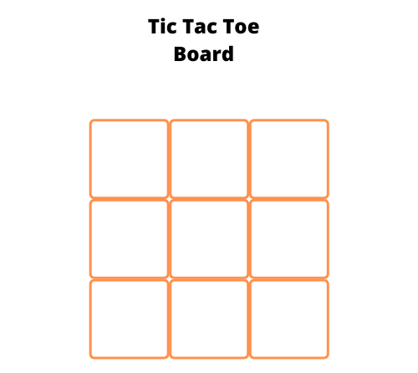
The gameplay will be as follows.
- First, one user will place their sign in one of the available empty boxes.
- Next, the second user will place their sign in one of the available empty boxes.
- The goal of the players is to place their respective signs completely row-wise or column-wise, or diagonally.
- The game goes on until a player wins the game or it ended up in a draw by filling all boxes without a winning match.
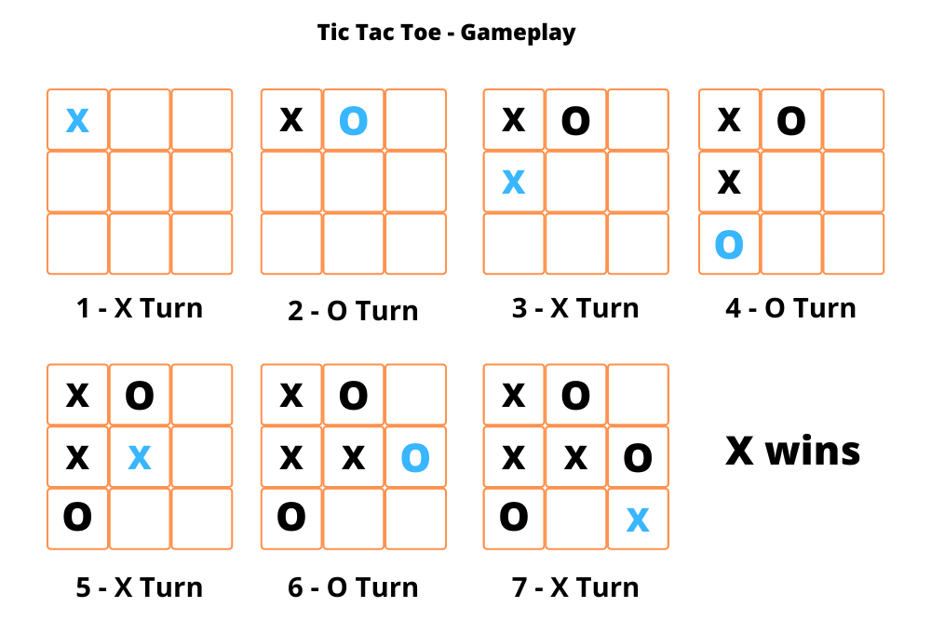The player X wins the game in the above gameplay. All boxes diagonally fill with X signs. So, the respective player wins the game. There are a total of 8 ways to arrange the same sign and win the game. Let’s see all the 8 arrangements that can win the game.
.
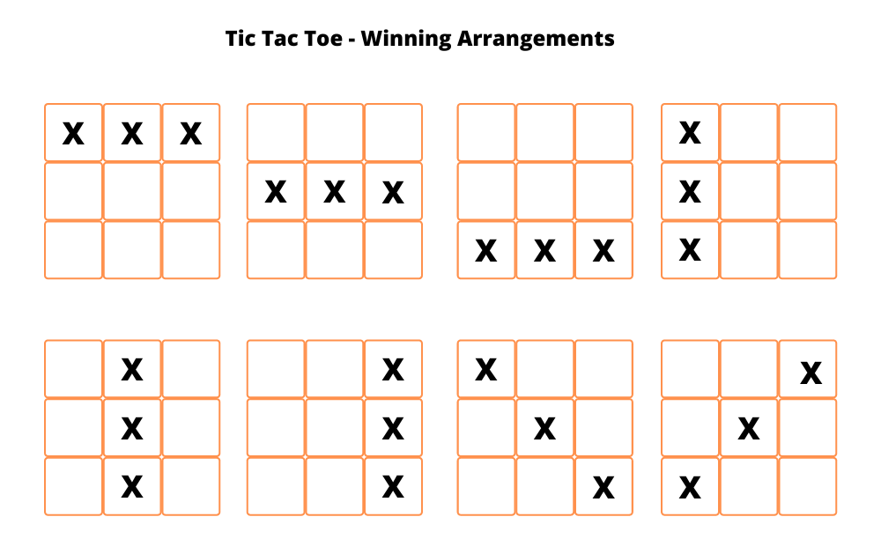

Algorithm
- Create a board using a 2-dimensional array and initialize each element as empty.
  - You can represent empty using any symbol you like. Here, we are going to use a hyphen. '-'.
- Write a function to check whether the board is filled or not.
  - Iterate over the board and return false if the board contains an empty sign or else return true.
- Write a function to check whether a player has won or not.
  - We have to check all the possibilities that we discussed in the previous section.
  - Check for all the rows, columns, and two diagonals.
- Write a function to show the board as we will show the board multiple times to the users while they are playing.
- Write a function to start the game.
  - Select the first turn of the player randomly.
  - Write an infinite loop that breaks when the game is over (either win or draw).
    - Show the board to the user to select the spot for the next move.
    - Ask the user to enter the row and column number.
    - Update the spot with the respective player sign.
    - Check whether the current player won the game or not.
    - If the current player won the game, then print a winning message and break the infinite loop.
    - Next, check whether the board is filled or not.
    - If the board is filled, then print the draw message and break the infinite loop.
  - Finally, show the user the final view of the board.
Implementation of Tic-tac-Toe using python code:
def print_board(board):
print('-------------')
for i in range(3):
row = '| '
for j in range(3):
row += board[i][j] + ' | '
print(row)
print('-------------')

def check_win(board, player):
for i in range(3):
if board[i][0] == player and board[i][1] == player and board[i][2] == player:
return True
if board[0][i] == player and board[1][i] == player and board[2][i] == player:
return True
if board[0][0] == player and board[1][1] == player and board[2][2] == player:
return True
if board[0][2] == player and board[1][1] == player and board[2][0] == player:
return True
return False

def tic_tac_toe():
board = [[' ' for _ in range(3)] for _ in range(3)]
players = ['X', 'O']
current_player = players[0]
print_board(board)
while True:
print(f"It's {current_player}'s turn.")
row = int(input('Enter row (0-2): '))
col = int(input('Enter column (0-2): '))
if board[row][col] != ' ':
print('That cell is already taken. Try again.')
continue
board[row][col] = current_player
print_board(board)
if check_win(board, current_player):
print(f'{current_player} wins!')
return
if all([cell != ' ' for row in board for cell in row]):
print("It's a tie!")
return
current_player = players[(players.index(current_player) + 1) % 2]

tic_tac_toe()
Output:
-------------
| | | |
-------------
| | | |
-------------
| | | |
-------------
It's X's turn.
Enter row (0-2): 1
Enter column (0-2): 2
-------------
| | | |
-------------
| | | X |
-------------
| | | |
-------------
It's O's turn.
Enter row (0-2): 1
Enter column (0-2): 1
-------------
| | | |
-------------
| | O | X |
-------------
| | | |
-------------
It's X's turn.
Enter row (0-2): 0
Enter column (0-2): 2
-------------
| | | X |
-------------
| | O | X |
-------------
| | | |
-------------

It's O's turn.
Enter row (0-2): 2
Enter column (0-2): 2
-------------
| | | X |
-------------
| | O | X |
-------------
| | | O |
-------------
It's X's turn.
Enter row (0-2): 1
Enter column (0-2): 0
-------------
| | | X |
-------------
| X | O | X |
-------------
| | | O |
-------------
It's O's turn.
Enter row (0-2): 0
Enter column (0-2): 0
-------------
| O | | X |
-------------
| X | O | X |
-------------
| | | O |
-------------
O wins!

AIM: Implement and demonstrate FIND-S algorithm for finding the most specific hypothesis based on agiven set of training data samples. Read the training data from a .csv file.

Explanation:
The find-S algorithm is a basic concept learning algorithm in machine learning. The find-S algorithm finds the most specific hypothesis that fits all the positive examples. We have to note here that the algorithm considers only those positive training example. The find-S algorithm starts with the most specific hypothesis and generalizes this hypothesis each time it fails to classify an observed positive training data. Hence, the Find-S algorithm moves from the most specific hypothesis to the most general hypothesis.
Important Representation :
- ? indicates that any value is acceptable for the attribute.
- specify a single required value ( e.g., Cold ) for the attribute.
- ϕindicates that no value is acceptable.
- The most general hypothesis is represented by: {?, ?, ?, ?, ?, ?}
- The most specific hypothesis is represented by: {ϕ, ϕ, ϕ, ϕ, ϕ, ϕ}
Steps Involved In Find-S :
- Start with the most specific hypothesis.
h = {ϕ, ϕ, ϕ, ϕ, ϕ, ϕ}
- Take the next example and if it is negative, then no changes occur to the hypothesis.
- If the example is positive and we find that our initial hypothesis is too specific then we update our current hypothesis to a general condition.
- Keep repeating the above steps till all the training examples are complete.
- After we have completed all the training examples we will have the final hypothesis when can use to classify the new examples.

Implementation of Find-S Algorithm

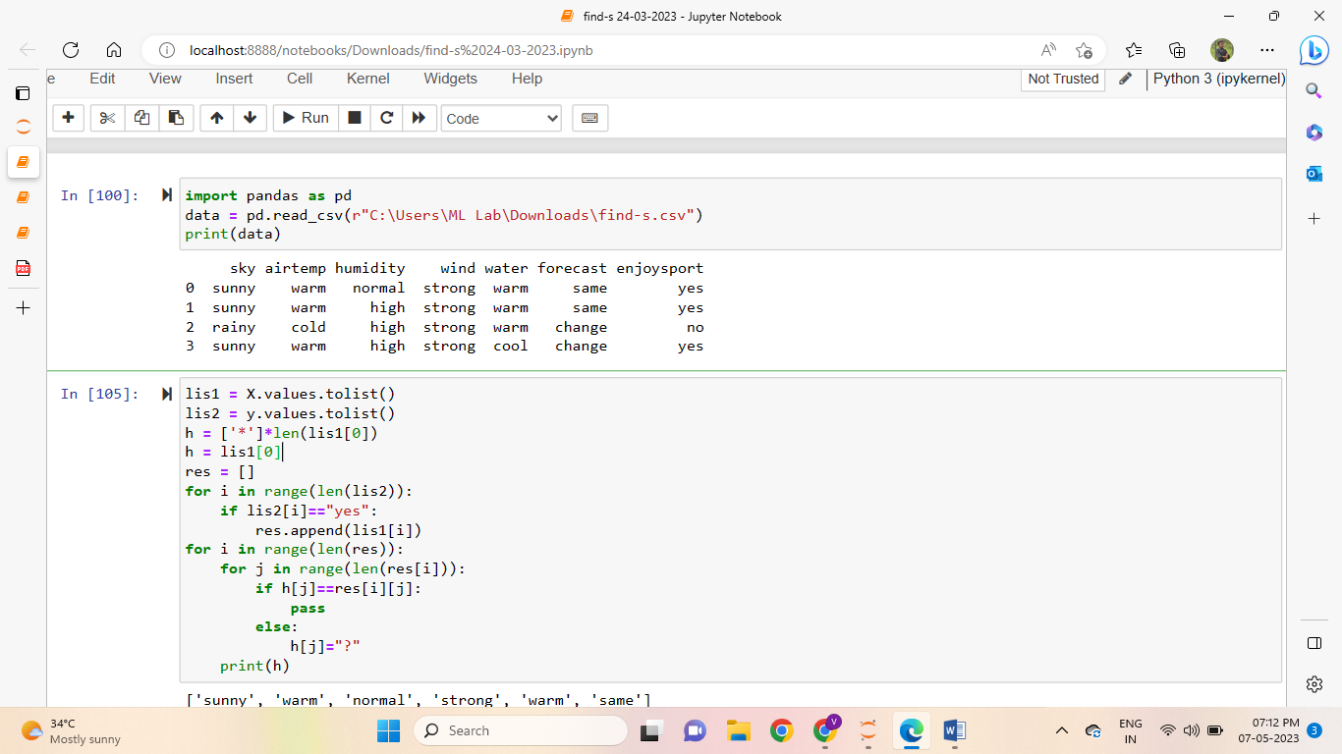

Output:

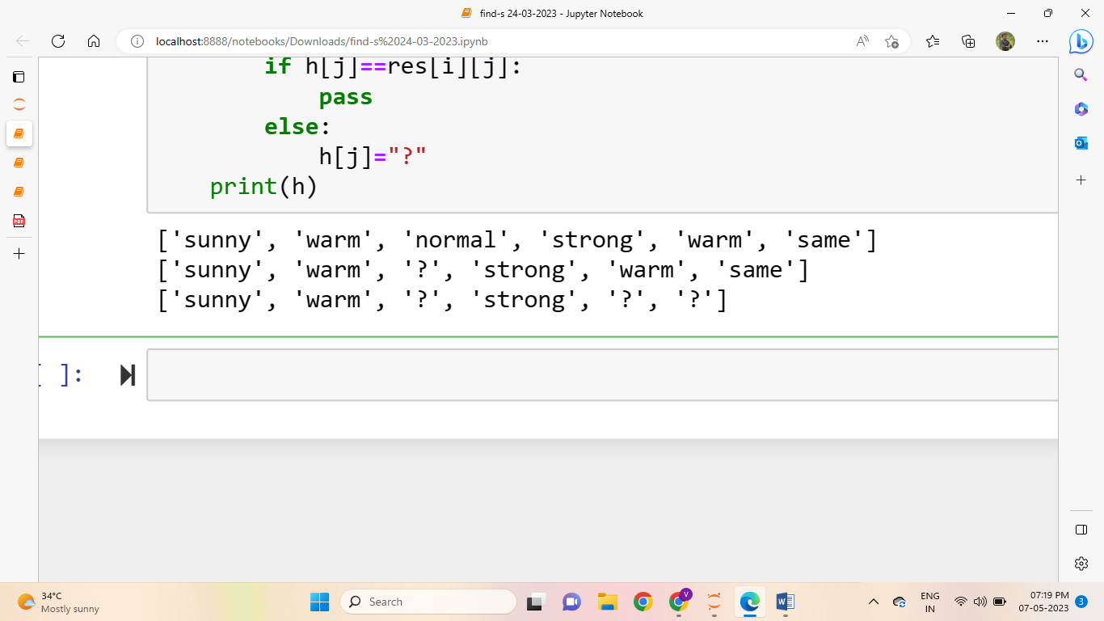

AIM: For a given set of training data examples stored in a .csv file, implement and demonstrate the Candidate Elimination algorithm to output a description of the set of all hypothesis consistent withthe training examples.
Explanation:
The candidate elimination algorithm incrementally builds the version space given a hypothesis space H and a set E of examples. The examples are added one by one; each example possibly shrinks the version space by removing the hypotheses that are inconsistent with the example. The candidate elimination algorithm does this by updating the general and specific boundary for each new example.
- You can consider this as an extended form of the Find-S algorithm.
- Consider both positive and negative examples.
- Actually, positive examples are used here as the Find-S algorithm (Basically they are generalizing from the specification).
- While the negative example is specified in the generalizing form.
Terms Used:
- Concept learning: Concept learning is basically the learning task of the machine (Learn by Train data)
- General Hypothesis: Not Specifying features to learn the machine.
- G = {‘?’, ‘?’,’?’,’?’…}: Number of attributes
- Specific Hypothesis: Specifying features to learn machine (Specific feature)
- S= {‘pi’,’pi’,’pi’…}: The number of pi depends on a number of attributes.
- Version Space: It is an intermediate of general hypothesis and Specific hypothesis. It not only just writes one hypothesis but a set of all possible hypotheses based on training data-set.
Algorithm:
Step1: Load Data set
Step2: Initialize General Hypothesis and Specific Hypothesis.
Step3: For each training example
Step4: If example is positive example
if attribute_value == hypothesis_value:
Do nothing
else:
replace attribute value with '?' (Basically generalizing it)
Step5: If example is Negative example
Make generalize hypothesis more specific.

Example:
Consider the dataset given below:
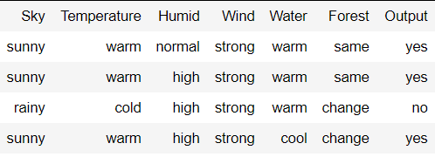
Algorithmic steps:
Initially : G = [[?, ?, ?, ?, ?, ?], [?, ?, ?, ?, ?, ?], [?, ?, ?, ?, ?, ?],
[?, ?, ?, ?, ?, ?], [?, ?, ?, ?, ?, ?], [?, ?, ?, ?, ?, ?]]
S = [Null, Null, Null, Null, Null, Null]

For instance 1 : <'sunny','warm','normal','strong','warm ','same'> and positive output.
G1 = G
S1 = ['sunny','warm','normal','strong','warm ','same']

For instance 2 : <'sunny','warm','high','strong','warm ','same'> and positive output.
G2 = G
S2 = ['sunny','warm',?,'strong','warm ','same']

For instance 3 : <'rainy','cold','high','strong','warm ','change'> and negative output.
G3 = [['sunny', ?, ?, ?, ?, ?], [?, 'warm', ?, ?, ?, ?], [?, ?, ?, ?, ?, ?],
[?, ?, ?, ?, ?, ?], [?, ?, ?, ?, ?, ?], [?, ?, ?, ?, ?, 'same']]
S3 = S2

For instance 4 : <'sunny','warm','high','strong','cool','change'> and positive output.
G4 = G3
S4 = ['sunny','warm',?,'strong', ?, ?]

At last, by synchronizing the G4 and S4 algorithm produce the output.

Output :
G = [['sunny', ?, ?, ?, ?, ?], [?, 'warm', ?, ?, ?, ?]]
S = ['sunny','warm',?,'strong', ?, ?]
The Candidate Elimination Algorithm (CEA) is an improvement over the Find-S algorithm for classification tasks. While CEA shares some similarities with Find-S, it also has some essential differences that offer advantages and disadvantages. Here are some advantages and disadvantages of CEA in comparison with Find-S:
Advantages of CEA over Find-S:
- Improved accuracy: CEA considers both positive and negative examples to generate the hypothesis, which can result in higher accuracy when dealing with noisy or incomplete data.
- Flexibility: CEA can handle more complex classification tasks, such as those with multiple classes or non-linear decision boundaries.
- More efficient: CEA reduces the number of hypotheses by generating a set of general hypotheses and then eliminating them one by one. This can result in faster processing and improved efficiency.
- Better handling of continuous attributes: CEA can handle continuous attributes by creating boundaries for each attribute, which makes it more suitable for a wider range of datasets.
Disadvantages of CEA in comparison with Find-S:
- More complex: CEA is a more complex algorithm than Find-S, which may make it more difficult for beginners or those without a strong background in machine learning to use and understand.
- Higher memory requirements: CEA requires more memory to store the set of hypotheses and boundaries, which may make it less suitable for memory-constrained environments.
- Slower processing for large datasets: CEA may become slower for larger datasets due to the increased number of hypotheses generated.
- Higher potential for overfitting: The increased complexity of CEA may make it more prone to overfitting on the training data, especially if the dataset is small or has a high degree of noise.

Implementation of Candidate algorithm:
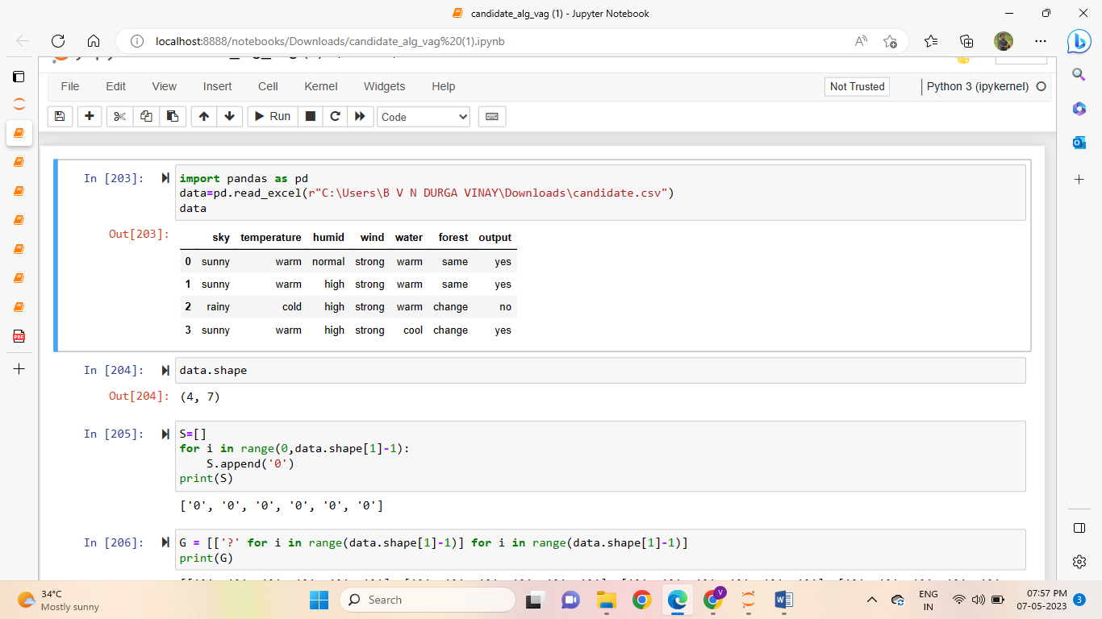
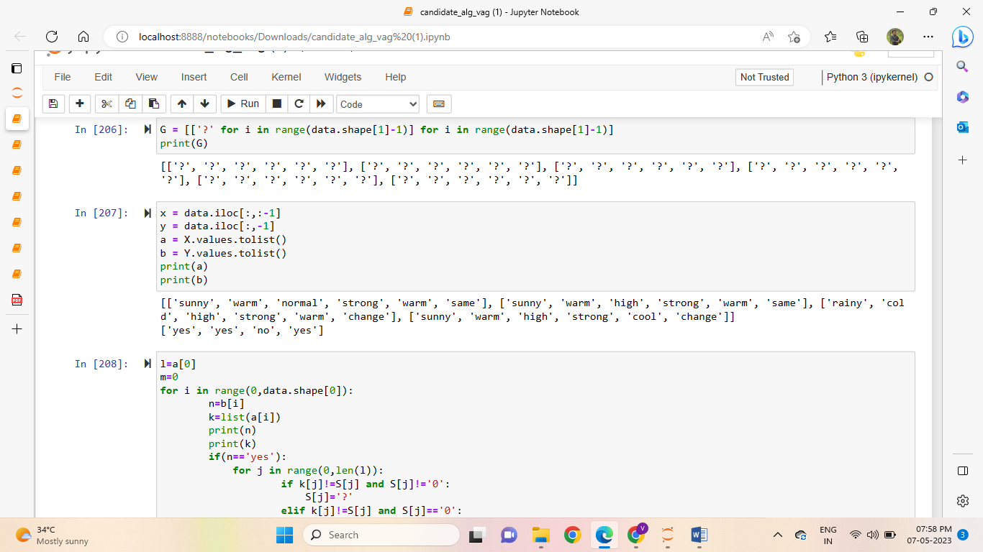
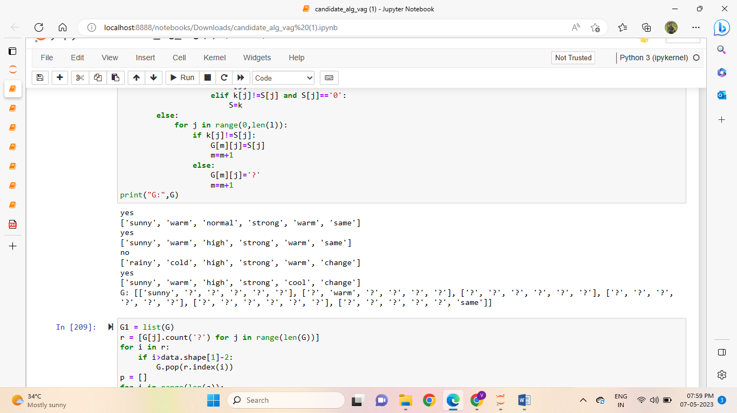
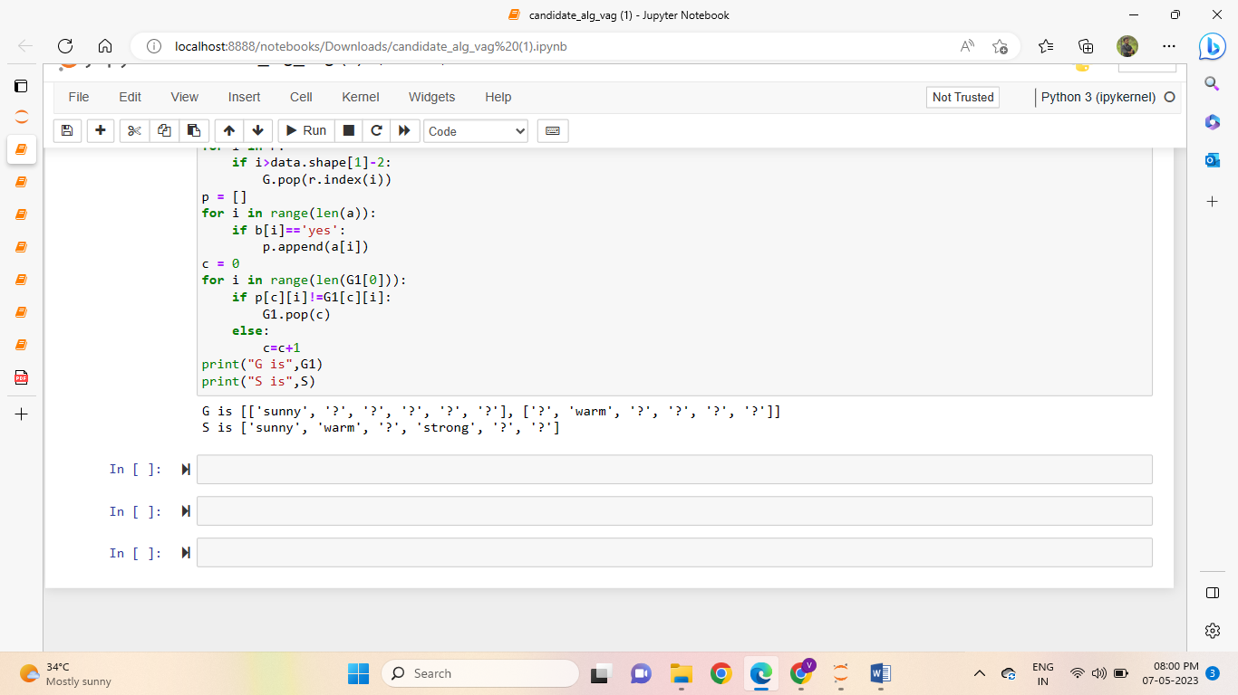
Output:
ARTIFICIAL INTELLIGENCE
1.WATER JUG PROBLEM
2.TIC TAC TOE
3.MONKEY BANANA PROBLEM
4.TOWERS OF HANOI

1.WATER JUG PROBLEM
Description:
The Water Jug Problem, also known as the Die Hard Water Jug Problem, is a classic puzzle that involves using two jugs of different capacities to measure a specific amount of water. The problem can be stated as follows:
You are given two empty jugs, Jug A and Jug B, with capacities of x and y liters, respectively, where x and y are positive integers. You also have access to a water source. The goal is to measure a target amount of water, T liters, using these jugs.

The following actions are allowed:
1. Filling a jug: You can fill either Jug A or Jug B from the water source until the jug is completely full.
2. Emptying a jug: You can empty the entire content of either Jug A or Jug B.
3. Pouring water: You can pour the contents of one jug into the other jug until the pouring jug is empty or the receiving jug is full.
The objective is to determine a sequence of actions that allows you to measure exactly T liters of water using the available jugs. It is important to note that the measurements do not have to be exact multiples of the jug capacities.

This problem is often used to illustrate concepts of problem-solving, mathematical reasoning, and optimization strategies. Different variations of the Water Jug Problem exist with varying capacities and target amounts, but the basic principles remain the same.
Algorithm:
The algorithm to solve the water jug problem using state space search can be outlined as follows:
- Represent the problem as a state space graph with nodes as states and edges as transitions.
- Initialize the open list with the initial state (0, 0).
- Repeat the following steps until the open list is empty:
  - Choose a state from the open list and remove it from the list.
  - If the state is the goal state, return the solution.
  - Otherwise, generate all possible successor states using the production rules and add them to the open list if they have not been visited before.
- If the goal state is not reached, return failure.
Python code:
print("Water Jug Problem")
x, y = 0, 0
c = int(input("Enter the goal state: "))
while True:
r = int(input("Enter the rule number: "))

if r == 1:
if x < 4:
x, y = 4, y
if r == 2:
if y < 3:
x, y = x, 3
if r == 3:
if x > 0:
x, y = 0, y
if r == 4:
if y > 0:
x, y = x, 0
if r == 5:
if y > 0 and 0 < x + y >= 4:
x, y = 4, (y - (4 - x))
if r == 6:
if 0 < x + y >= 3 and x > 0:
x, y = (x - (3 - y)), 3
if r == 7:
if 0 < x + y <= 4 and y >= 0:
x, y = (x + y), 0
if r == 8:
if 0 <= x + y <= 3 and x >= 0:
x, y = 0, x + y

print("Current state is: (%d,%d)" % (x, y))

if x == c:
print("Goal State is reached")
break
output:
Water Jug Problem
Enter te goal state:2
Enter the rule no:1
current state is : (4,0)
Enter the rule no:6
current state is : (1,3)
Enter the rule no:4
current state is : (1,0)
Enter the rule no:8
current state is : (0,1)
Enter the rule no:1
current state is : (4,1)
Enter the rule no:6
current state is : (2,3)
Goal State is reached

Java Code:
import java.util.*;

public class Main {
public static void main(String[] args) {
int x = 0, y = 0, g, c1, c2, r, c;
Scanner read = new Scanner(System.in);
System.out.println("Enter the capacity of jug 1:");
c1 = read.nextInt();
System.out.println("Enter the capacity of jug 2:");
c2 = read.nextInt();
System.out.println("Enter the goal state:");
c = read.nextInt();

while (true) {
System.out.println("Enter the Rule:");
r = read.nextInt();

if (r == 1) {
if (x < c1) {
x = c1;
}
}

if (r == 2) {
if (y < c2) {
y = c2;
}
}

if (r == 3) {
if (x > 0) {
x = 0;
}
}

if (r == 4) {
if (y > 0) {
y = 0;
}
}

if (r == 5) {
if ((0 < x + y && x + y >= c1) && y > 0) {
y = y - (c1 - x);
x = c1;
}
}

if (r == 6) {
if (((0 < x + y) && (x + y >= c2)) && x > 0) {
x = x - (c2 - y);
y = c2;
}
}

if (r == 7) {
if ((0 < x + y && x + y <= c1) && y >= 0) {
x = x + y;
y = 0;
}
}

if (r == 8) {
if ((0 < x + y && x + y <= c1) && x >= 0) {
y = x + y;
x = 0;
}
}

System.out.println("Current state is: (" + x + "," + y + ")");

if (x == c) {
System.out.println("Goal State is reached");
break;
}
}
}
}
2.TIC-TAC-TOE PROBLEM
Description:
Tic-tac-toe, also known as noughts and crosses, is a classic paper-and-pencil game played on a grid of 3x3 squares. The game involves two players, typically referred to as "X" and "O," who take turns marking empty squares in an attempt to form a line of three of their symbols horizontally, vertically, or diagonally.

The following is a description of the basic rules and mechanics of tic-tac-toe:
1. Game Setup: The game begins with an empty 3x3 grid. The players decide who will be "X" and who will be "O."
2. Player Turns: The players take turns placing their respective symbols ("X" or "O") in any empty square on the grid.
3. Winning Condition: The objective of the game is to be the first player to form a line of three of their symbols either horizontally, vertically, or diagonally. If a player successfully achieves this, they win the game. If all squares on the grid are filled and no player has won, the game is a draw.
4. Valid Moves: Players can only place their symbol in an empty square. They cannot overwrite or remove their opponent's symbol or place their symbol on an already occupied square.
5. Game Termination: The game terminates when either a player wins by forming a line of three symbols, or when the game ends in a draw.

Tic-tac-toe is a simple and easy-to-learn game, but it can still involve strategy and critical thinking. Skilled players can anticipate their opponent's moves and plan their own moves strategically to maximize their chances of winning or forcing a draw. The game has been studied extensively, and with optimal play from both players, it always ends in a draw.

algorithm to implementing Tic Tac Toe:
- Create a 3x3 grid to represent the Tic Tac Toe board.
- Start with an empty board, where all cells are unmarked.
- Define two players: Player 1 (X) and Player 2 (O).
- Determine the starting player (either randomly or based on user input).
- Repeat the following steps until the game is over:
  - Display the current state of the board.
  - Prompt the current player for their move (either by inputting the position or using an AI algorithm).
  - Verify if the move is valid. If not, repeat step 5b.
  - Update the board with the player's move.
  - Check if the current player has won the game by having three marks in a row, column, or diagonal. If so, declare the current player as the winner and end the game.
  - If the board is full and no player has won, declare the game as a draw and end the game.
  - Switch to the next player.
- Display the final state of the board and the outcome of the game (winner or draw).
- End the game.
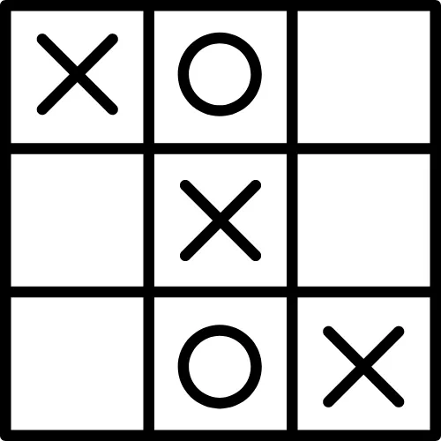
Python Code:
tic = [[1,2,3],
[4,5,6],
[7,8,9]]
p = [0,2,3]
p[1] = input("Enter player 1 name = ")
p[2] = input("Enter player 2 name = ")
print("Tic Tac Toe Board:")
for i in tic:
print(i)

# Insertion function
def insertAt(place, i):
for j in range(len(tic)):
for k in range(len(tic[j])):
if tic[j][k] == place:
if i == 1:
tic[j][k] = "X"
else:
tic[j][k] = "O"

# Verification of places
def verify(i):
if ((1 and 2 and 3) not in tic[0]) and ((4 and 5 and 6) not in tic[1]) and ((7 and 8 and 9) not in tic[2]):
print("Draw!! Try again")
exit(0)
# Horizontal lines
elif tic[0][0] == tic[0][1] == tic[0][2]:
print(f"Hurrah! player {p[i]} won the match")
exit(0)
elif tic[1][0] == tic[1][1] == tic[1][2]:
print(f"Hurrah! player {p[i]} won the match")
exit(0)
elif tic[2][0] == tic[2][1] == tic[2][2]:
print(f"Hurrah! player {p[i]} won the match")
exit(0)
# Diagonal lines
elif tic[0][0] == tic[1][1] == tic[2][2]:
print(f"Hurrah! player {p[i]} won the match")
exit(0)
elif tic[0][2] == tic[1][1] == tic[2][0]:
print(f"Hurrah! player {p[i]} won the match")
exit(0)
# Vertical lines
elif tic[0][0] == tic[1][0] == tic[2][0]:
print(f"Hurrah! player {p[i]} won the match")
exit(0)
elif tic[0][1] == tic[1][1] == tic[2][1]:
print(f"Hurrah! player {p[i]} won the match")
exit(0)
elif tic[0][2] == tic[1][2] == tic[2][2]:
print(f"Hurrah! {p[i]} won the match")
exit(0)

# Displaying the tic-tac-toe panel
def disp():
for i in tic:
print(i)

i = 1
for itr in range(9):
place = int(input(f"{p[i]}, Enter a position = "))
if i == 1:
insertAt(place, i)
disp()
verify(i)
i = 2
else:
insertAt(place, i)
disp()
verify(i)
i = 1
Output:
Enter player 1 name = chanti
Enter player 2 name = bunty
Tic Tac Toe Board:
[1, 2, 3]
[4, 5, 6]
[7, 8, 9]
chanti, Enter a position = 1
['X', 2, 3]
[4, 5, 6]
[7, 8, 9]
bunty, Enter a position = 2
['X', 'O', 3]
[4, 5, 6]
[7, 8, 9]
chanti, Enter a position = 4
['X', 'O', 3]
['X', 5, 6]
[7, 8, 9]
bunty, Enter a position = 5
['X', 'O', 3]
['X', 'O', 6]
[7, 8, 9]
chanti, Enter a position = 7
['X', 'O', 3]
['X', 'O', 6]
['X', 8, 9]
Hurrah! player chanti won the match

3.MONKEY BANANA PROBLEM
Description:
The Monkey and Banana Problem, also known as the Monkey and Banana Puzzle, is a classic logic puzzle. It involves a monkey trying to reach a banana hanging from the ceiling by climbing on boxes. The problem can be described as follows:
A monkey is in a room with a banana hanging from the ceiling. The room contains several boxes that the monkey can stack and climb on. The goal is for the monkey to reach the banana and obtain it.
Rules:
1. The monkey can only do one of the following actions at a time: move left, move right, move up, move down, or stack a box.
2. The monkey can only climb on top of a stack of boxes if the stack is stable (i.e., it won't tip over).
3. The monkey can only stack or unstack a single box at a time.
4. The monkey can't jump or reach the banana directly without climbing on boxes.
Objective:
The monkey needs to figure out the sequence of actions required to reach the banana, considering the constraints and rules mentioned above.
The challenge in the Monkey and Banana Problem is to determine the optimal sequence of moves that allows the monkey to reach the banana efficiently. It requires logical thinking, problem-solving, and understanding the limitations and possibilities of the monkey's actions.

Solving the Monkey and Banana Problem often involves considering different strategies, visualizing the problem, and analyzing the potential consequences of each move.
Algorithm:
Initialize the starting state of the room with the monkey, banana, and boxes.
Create an empty stack to store the sequence of moves taken by the monkey.
While the monkey has not reached the banana:
a. Check if the monkey is directly below the banana. If so, the monkey can directly climb and obtain the banana.
b. Otherwise, iterate through the available actions (move left, move right, move up, move down, stack box) in a predefined order.
For each action, check if it is valid and leads to a new state.
If the action is valid, apply it to generate a new state of the room and update the monkey's position and stack of boxes.
Push the action onto the stack to remember the sequence of moves taken.
Recursively call the algorithm with the updated state of the room.
c. If none of the available actions lead to the monkey reaching the banana, backtrack by popping the last action from the stack and reverting the state of the room accordingly.
Once the monkey reaches the banana, the algorithm terminates.
Output the sequence of moves stored in the stack as the solution to the problem.

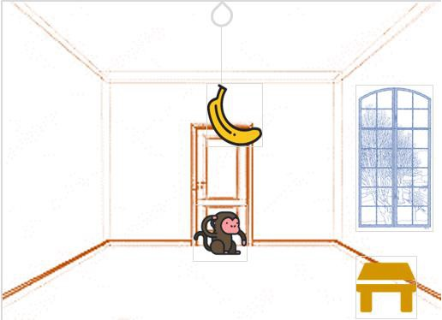

Python code:
move(state(middle,onbox,middle,hasnot),
grasp,
state(middle,onbox,middle,has)).
move(state(P,onfloor,P,H),
climb,
state(P,onbox,P,H)).
move(state(P1,onfloor,P1,H),
drag(P1,P2),
state(P2,onfloor,P2,H)).
move(state(P1,onfloor,B,H),
walk(P1,P2),
state(P2,onfloor,B,H)).
canget(state(_,_,_,has)).
canget(State1) :-
move(State1,_,State2),
canget(State2).

Output:
| ?- [monkey_banana].
compiling D:/TP Prolog/Sample_Codes/monkey_banana.pl for byte code...
D:/TP Prolog/Sample_Codes/monkey_banana.pl compiled, 17 lines read - 2167 bytes written, 19 ms

(31 ms) yes
| ?- canget(state(atdoor, onfloor, atwindow, hasnot)).

true ?

yes
| ?- trace
.
The debugger will first creep -- showing everything (trace)

yes
{trace}
| ?- canget(state(atdoor, onfloor, atwindow, hasnot)).
1 1 Call: canget(state(atdoor,onfloor,atwindow,hasnot)) ?
2 2 Call: move(state(atdoor,onfloor,atwindow,hasnot),_52,_92) ?
2 2 Exit:move(state(atdoor,onfloor,atwindow,hasnot),walk(atdoor,_80),state(_80,onfloor,atwindow,hasnot)) ?
3 2 Call: canget(state(_80,onfloor,atwindow,hasnot)) ?
4 3 Call: move(state(_80,onfloor,atwindow,hasnot),_110,_150) ?
4 3 Exit: move(state(atwindow,onfloor,atwindow,hasnot),climb,state(atwindow,onbox,atwindow,hasnot)) ?
5 3 Call: canget(state(atwindow,onbox,atwindow,hasnot)) ?
6 4 Call: move(state(atwindow,onbox,atwindow,hasnot),_165,_205) ?
6 4 Fail: move(state(atwindow,onbox,atwindow,hasnot),_165,_193) ?
5 3 Fail: canget(state(atwindow,onbox,atwindow,hasnot)) ?
4 3 Redo: move(state(atwindow,onfloor,atwindow,hasnot),climb,state(atwindow,onbox,atwindow,hasnot)) ?
4 3 Exit: move(state(atwindow,onfloor,atwindow,hasnot),drag(atwindow,_138),state(_138,onfloor,_138,hasnot)) ?
5 3 Call: canget(state(_138,onfloor,_138,hasnot)) ?
6 4 Call: move(state(_138,onfloor,_138,hasnot),_168,_208) ?
6 4 Exit: move(state(_138,onfloor,_138,hasnot),climb,state(_138,onbox,_138,hasnot)) ?
7 4 Call: canget(state(_138,onbox,_138,hasnot)) ?
8 5 Call: move(state(_138,onbox,_138,hasnot),_223,_263) ?
8 5 Exit: move(state(middle,onbox,middle,hasnot),grasp,state(middle,onbox,middle,has)) ?
9 5 Call: canget(state(middle,onbox,middle,has)) ?
9 5 Exit: canget(state(middle,onbox,middle,has)) ?
7 4 Exit: canget(state(middle,onbox,middle,hasnot)) ?
5 3 Exit: canget(state(middle,onfloor,middle,hasnot)) ?
3 2 Exit: canget(state(atwindow,onfloor,atwindow,hasnot)) ?
1 1 Exit: canget(state(atdoor,onfloor,atwindow,hasnot)) ?

true ?

(78 ms) yes

4.TOWERS OF HANOI
Description:
The Towers of Hanoi is a classic mathematical puzzle that involves moving a stack of disks from one peg to another peg with the help of a third peg. The problem can be described as follows:

There are three pegs labeled A, B, and C, and there are n disks of different sizes. Initially, all the disks are stacked on peg A, with the largest disk at the bottom and the smallest disk at the top. The goal is to move the entire stack of disks from peg A to peg C, while following the rules and constraints of the puzzle.

Rules:
1. Only one disk can be moved at a time.
2. A larger disk cannot be placed on top of a smaller disk.
3. Only the topmost disk of a peg can be moved.

Objective:
The objective of the Towers of Hanoi puzzle is to find the optimal sequence of moves that allows you to transfer the entire stack of disks from peg A to peg C, using peg B as an intermediate peg.

Algorithm for solving the Towers of Hanoi problem:
1. If the number of disks is 1, simply move the disk from the source peg to the destination peg and return.
2. Recursively solve the subproblem of moving n-1 disks from the source peg to the auxiliary peg, using the destination peg as the auxiliary peg.
3. Move the largest disk (bottom disk) from the source peg to the destination peg.
4. Recursively solve the subproblem of moving the n-1 disks from the auxiliary peg to the destination peg, using the source peg as the auxiliary peg.
5. The problem is now reduced to the subproblem with n-1 disks, and the process continues until all disks are moved to the destination peg.

Pseudocode for the recursive algorithm:
function TowersOfHanoi(n, source, destination, auxiliary):
if n == 1:
move disk from source to destination
return
TowersOfHanoi(n-1, source, auxiliary, destination)
move largest disk from source to destination
TowersOfHanoi(n-1, auxiliary, destination, source)

To solve the Towers of Hanoi problem, you can call the function with the number of disks (n), the source peg (A), the destination peg (C), and the auxiliary peg (B). The algorithm will recursively move the disks following the rules of the puzzle until all the disks are transferred to the destination peg.

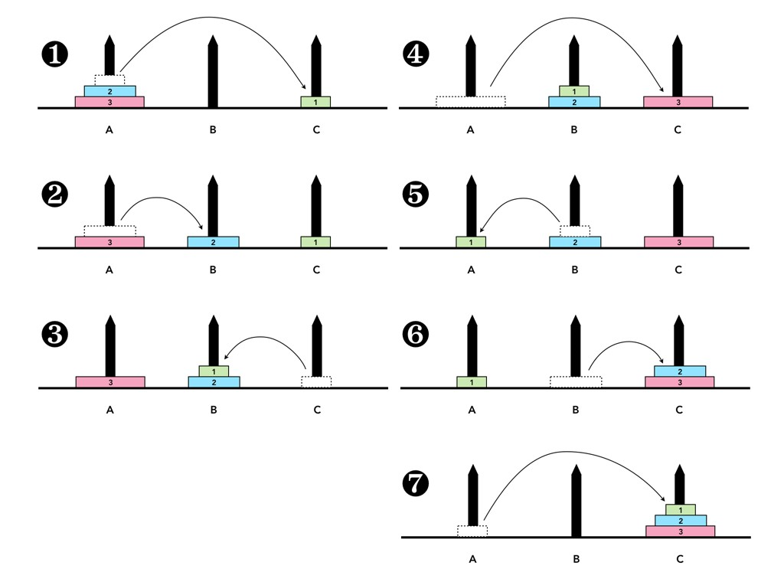
Python code:
# Creating a recursive function
def tower_of_hanoi(disks, source, auxiliary, target):
if(disks == 1):
print('Move disk 1 from rod {} to rod {}.'.format(source, target))
return
# function call itself
tower_of_hanoi(disks - 1, source, target, auxiliary)
print('Move disk {} from rod {} to rod {}.'.format(disks, source, target))
tower_of_hanoi(disks - 1, auxiliary, source, target)

disks = int(input('Enter the number of disks: '))
# We are referring source as A, auxiliary as B, and target as C
tower_of_hanoi(disks, 'A', 'B', 'C') # Calling the function

output:
Enter the number of disks: 3
Move disk 1 from rod A to rod C.
Move disk 2 from rod A to rod B.
Move disk 1 from rod C to rod B.
Move disk 3 from rod A to rod C.
Move disk 1 from rod B to rod A.
Move disk 2 from rod B to rod C.
Move disk 1 from rod A to rod C.

