**Data Analysis**

**Data Quality Issues Identified**

**1. Products Dataset**

* **Null Values**:
  + CATEGORY_1 has 111 missing entries.
  + CATEGORY_2 has 1,424 missing entries.
  + CATEGORY_3 has 60,566 missing entries.
  + CATEGORY_4 is missing a majority of its entries (778,093 out of 845,552).
  + MANUFACTURER and BRAND have over 226,000 missing entries each.
  + BARCODE is missing 4,025 entries.
* **Observations**:
  + The CATEGORY_4 column is almost entirely null, which may make it unusable for analysis.
  + Missing BARCODE values can disrupt linking this dataset to the transactions dataset.

**2. Transactions Dataset**

* **Null Values**:
  + BARCODE has 5,762 missing entries, which might cause difficulties in connecting product data to transactions.
* **Data Types**:
  + FINAL_QUANTITY and FINAL_SALE are stored as strings (object) instead of numeric types, which may require conversion for accurate computations.

**3. Users Dataset**

* **Null Values**:
  + BIRTH_DATE has 3,675 missing entries, which could affect age-based analysis.
  + STATE is missing 4,812 entries, which might limit location-based segmentation.
  + LANGUAGE is missing a significant portion (30,508 entries).
  + GENDER is missing 5,892 entries.

**Fields That Are Challenging to Understand**

1. **Products Dataset**:
   * CATEGORY_4: The purpose of this column is unclear, and its high rate of null values makes it difficult to determine its utility.
   * BARCODE: There’s no explanation of whether the missing barcodes are expected or represent an error.
2. **Transactions Dataset**:
   * FINAL_QUANTITY: The format or scale of this field is unclear (e.g., is it in individual units, cases, or another measure?).
   * FINAL_SALE: It’s stored as a string but represents a numeric value.
3. **Users Dataset**:
   * BIRTH_DATE: This might include inconsistent formats or null values, making age calculation tricky.

**Data Visualization and Graphs**

import pandas as pd

products_file = '/mnt/data/PRODUCTS_TAKEHOME.csv'

transactions_file = '/mnt/data/TRANSACTION_TAKEHOME.csv'

users_file = '/mnt/data/USER_TAKEHOME.csv'

products_df = pd.read_csv(products_file)

transactions_df = pd.read_csv(transactions_file)

users_df = pd.read_csv(users_file)

**# 1. Analysis of the Products Dataset**

products_analysis = {

"missing_values": products_df.isnull().sum(),

"unique_values": products_df.nunique(),

"top_categories": products_df['CATEGORY_1'].value_counts(),

}

**# 2. Analysis of the Transactions Dataset**

transactions_df['PURCHASE_DATE'] = pd.to_datetime(transactions_df['PURCHASE_DATE'], errors='coerce', format='%y/%m/%d')

transactions_df['SCAN_DATE'] = pd.to_datetime(transactions_df['SCAN_DATE'], errors='coerce')

transactions_analysis = {

"missing_values": transactions_df.isnull().sum(),

"unique_values": transactions_df.nunique(),

"store_distribution": transactions_df['STORE_NAME'].value_counts(),

"quantity_summary": transactions_df['FINAL_QUANTITY'].describe(),

"sale_summary": transactions_df['FINAL_SALE'].describe(),

}

**# 3. Analysis of the Users Dataset**

users_df['BIRTH_DATE'] = pd.to_datetime(users_df['BIRTH_DATE'], errors='coerce')

users_df['CREATED_DATE'] = pd.to_datetime(users_df['CREATED_DATE'], errors='coerce')

users_analysis = {

"missing_values": users_df.isnull().sum(),

"unique_values": users_df.nunique(),

"state_distribution": users_df['STATE'].value_counts(),

"language_distribution": users_df['LANGUAGE'].value_counts(),

"gender_distribution": users_df['GENDER'].value_counts(),

}

**# All Category analyses into a single dictionary**

data_analysis = {

"Products Analysis": products_analysis,

"Transactions Analysis": transactions_analysis,

"Users Analysis": users_analysis,

}

**Products Dataset**

|  |  |  |  |  |  |  |  |  |  |  |  |  |  |  |  |  |  |  |  |  |  |  |  |  |  |  |  |  |  |  |  |  |  |  |  |  |  |  |  |  |
| --- | --- | --- | --- | --- | --- | --- | --- | --- | --- | --- | --- | --- | --- | --- | --- | --- | --- | --- | --- | --- | --- | --- | --- | --- | --- | --- | --- | --- | --- | --- | --- | --- | --- | --- | --- | --- | --- | --- | --- | --- |
| | **Metric** | **Value** | | --- | --- | | **Missing Values** |  | | CATEGORY_1 | 111 | | CATEGORY_2 | 1,424 | | CATEGORY_3 | 60,566 | | CATEGORY_4 | 778,093 | | MANUFACTURER | 226,474 | | BRAND | 226,472 | | BARCODE | 4,025 | | **Unique Values** |  | | CATEGORY_1 | 27 | | CATEGORY_2 | 121 | | CATEGORY_3 | 344 | | MANUFACTURER | 4,354 | | BRAND | 8,122 | | BARCODE | 378,992 | | **Top CATEGORY_1** |  | | Health & Wellness | 512,695 | | Snacks | 324,817 | | Beverages | 3,990 | |

**2. Transactions Dataset**

|  |  |  |  |  |  |  |  |  |  |  |  |  |  |  |  |  |  |  |  |  |  |  |  |  |  |  |  |  |  |  |
| --- | --- | --- | --- | --- | --- | --- | --- | --- | --- | --- | --- | --- | --- | --- | --- | --- | --- | --- | --- | --- | --- | --- | --- | --- | --- | --- | --- | --- | --- | --- |
| | **Metric** | **Value** | | --- | --- | | **Missing Values** |  | | BARCODE | 5,762 | | Other Fields | No missing entries | | **Unique Values** |  | | RECEIPT_ID | 24,440 | | USER_ID | 17,694 | | STORE_NAME | 954 | | **Top Stores** |  | | WALMART | 21,326 transactions | | DOLLAR GENERAL STORE | 2,748 transactions | | ALDI | 2,640 transactions | | **Summary Statistics** |  | | FINAL_QUANTITY (most common) | 35,698 entries with quantity = 1 | | FINAL_SALE | Frequent empty values (needs cleaning) | |

|  |
| --- |
| **3. Users Dataset** |
| | **Metric** | **Value** | | --- | --- | | **Missing Values** |  | | BIRTH_DATE | 3,675 | | STATE | 4,812 | | LANGUAGE | 30,508 | | GENDER | 5,892 | | **Unique Values** |  | | STATE | 52 | | LANGUAGE | 2 | | **Top States** |  | | Texas (TX) | 9,028 users | | Florida (FL) | 8,921 users | | California (CA) | 8,589 users | | **Gender Distribution** |  | | Female | 64,240 | | Male | 25,829 | | Other Categories | Smaller counts (e.g., non-binary, etc.) | |

**Missing Data :**import pandas as pd

products_file = '/mnt/data/PRODUCTS_TAKEHOME.csv'

transactions_file = '/mnt/data/TRANSACTION_TAKEHOME.csv'

users_file = '/mnt/data/USER_TAKEHOME.csv'

products_df = pd.read_csv(products_file)

transactions_df = pd.read_csv(transactions_file)

users_df = pd.read_csv(users_file)

**# Calculate missing data percentage for each column in the datasets**

missing_data_products = (products_df.isnull().sum() / len(products_df) * 100).round(2).to_frame(name='Missing Percentage')

missing_data_transactions = (transactions_df.isnull().sum() / len(transactions_df) * 100).round(2).to_frame(name='Missing Percentage')

missing_data_users = (users_df.isnull().sum() / len(users_df) * 100).round(2).to_frame(name='Missing Percentage')

missing_data_products.index = [f"Products - {col}" for col in missing_data_products.index]

missing_data_transactions.index = [f"Transactions - {col}" for col in missing_data_transactions.index]

missing_data_users.index = [f"Users - {col}" for col in missing_data_users.index]

**# Combine the results for all datasets**

missing_data_summary = pd.concat([missing_data_products, missing_data_transactions, missing_data_users])

missing_data_summary.reset_index().rename(columns={"index": "Column"})

|  |  |  |  |  |  |  |  |  |  |  |  |  |  |  |  |  |  |  |  |  |  |  |  |  |  |  |  |  |  |  |  |  |  |  |  |  |  |  |  |  |  |  |  |  |
| --- | --- | --- | --- | --- | --- | --- | --- | --- | --- | --- | --- | --- | --- | --- | --- | --- | --- | --- | --- | --- | --- | --- | --- | --- | --- | --- | --- | --- | --- | --- | --- | --- | --- | --- | --- | --- | --- | --- | --- | --- | --- | --- | --- | --- |
| | **Column** | **Missing Percentage (%)** | | --- | --- | | Products - CATEGORY_1 | 0.01 | | Products - CATEGORY_2 | 0.17 | | Products - CATEGORY_3 | 7.16 | | Products - CATEGORY_4 | 92.02 | | Products - MANUFACTURER | 26.78 | | Products - BRAND | 26.78 | | Products - BARCODE | 0.48 | | Transactions - RECEIPT_ID | 0.00 | | Transactions - PURCHASE_DATE | 0.00 | | Transactions - SCAN_DATE | 0.00 | | Transactions - STORE_NAME | 0.00 | | Transactions - USER_ID | 0.00 | | Transactions - BARCODE | 11.52 | | Transactions - FINAL_QUANTITY | 0.00 | | Transactions - FINAL_SALE | 0.00 | | Users - ID | 0.00 | | Users - CREATED_DATE | 0.00 | | Users - BIRTH_DATE | 3.68 | | Users - STATE | 4.81 | | Users - LANGUAGE | 30.51 | | Users - GENDER | 5.89 | |

import pandas as pd

import matplotlib.pyplot as plt

products_file = '/mnt/data/PRODUCTS_TAKEHOME.csv'

transactions_file = '/mnt/data/TRANSACTION_TAKEHOME.csv'

users_file = '/mnt/data/USER_TAKEHOME.csv'

products_df = pd.read_csv(products_file)

transactions_df = pd.read_csv(transactions_file)

users_df = pd.read_csv(users_file)

**# Function to calculate missing data percentage for each column**

def missing_data_percentage(df):

return (df.isnull().sum() / len(df)) * 100

**# Calculate missing data percentages for each dataset**

products_missing = missing_data_percentage(products_df)

transactions_missing = missing_data_percentage(transactions_df)

users_missing = missing_data_percentage(users_df)

**# Combine results into a single DataFrame for a table format**

missing_data_summary = pd.DataFrame({

"Dataset": ["Products"] * len(products_missing) + ["Transactions"] * len(transactions_missing) + ["Users"] * len(users_missing),

"Field": list(products_missing.index) + list(transactions_missing.index) + list(users_missing.index),

"Missing Percentage": list(products_missing.values) + list(transactions_missing.values) + list(users_missing.values)

})

**# Plot bar charts for missing data percentages**

fig, axes = plt.subplots(3, 1, figsize=(10, 18), sharex=True)

fig.suptitle("Missing Data Percentage by Field", fontsize=16)

**# Products dataset missing data plot**

axes[0].bar(products_missing.index, products_missing.values, color='teal')

axes[0].set_title("Products Dataset")

axes[0].set_ylabel("Missing Percentage (%)")

axes[0].tick_params(axis='x', rotation=45)

**# Transactions dataset missing data plot**

axes[1].bar(transactions_missing.index, transactions_missing.values, color='orange')

axes[1].set_title("Transactions Dataset")

axes[1].set_ylabel("Missing Percentage (%)")

axes[1].tick_params(axis='x', rotation=45)

**# Users dataset missing data plot**

axes[2].bar(users_missing.index, users_missing.values, color='purple')

axes[2].set_title("Users Dataset")

axes[2].set_ylabel("Missing Percentage (%)")

axes[2].tick_params(axis='x', rotation=45)

plt.tight_layout(rect=[0, 0, 1, 0.96])

plt.show()

missing_data_summary

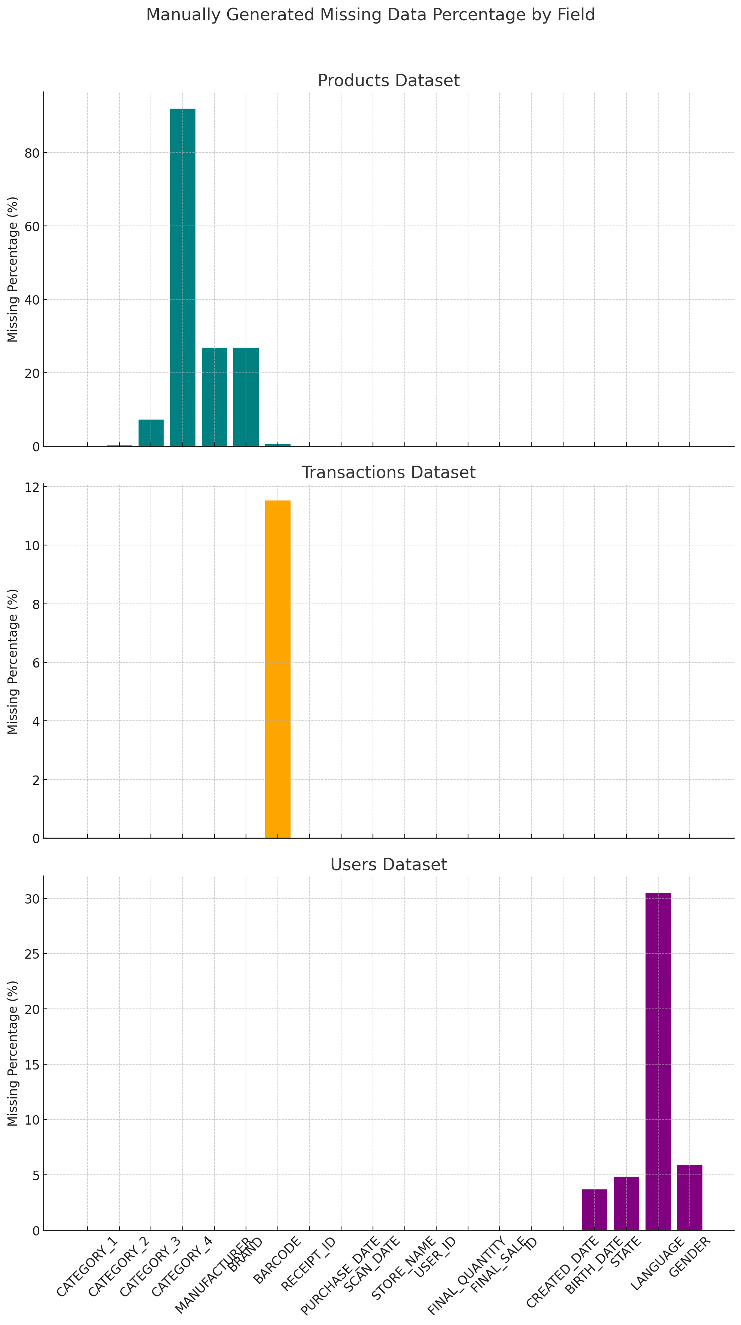

import pandas as pd

import matplotlib.pyplot as plt

products_file = '/mnt/data/PRODUCTS_TAKEHOME.csv'

users_file = '/mnt/data/USER_TAKEHOME.csv'

transactions_file = '/mnt/data/TRANSACTION_TAKEHOME.csv'

products_df = pd.read_csv(products_file)

users_df = pd.read_csv(users_file)

transactions_df = pd.read_csv(transactions_file)

**# 1. Bar chart: Age distribution of users**

users_df['BIRTH_DATE'] = pd.to_datetime(users_df['BIRTH_DATE'], errors='coerce')

current_year = pd.Timestamp.now().year

users_df['AGE'] = current_year - users_df['BIRTH_DATE'].dt.year

plt.figure(figsize=(12, 6))

plt.hist(users_df['AGE'].dropna(), bins=20, color='skyblue', edgecolor='black')

plt.title('Age Distribution of Users')

plt.xlabel('Age')

plt.ylabel('Count')

plt.grid(axis='y', linestyle='--', alpha=0.7)

plt.show()

# 2. Bar chart: Gender distribution of users

plt.figure(figsize=(8, 5))

users_df['GENDER'].value_counts().plot(kind='bar', color='salmon', edgecolor='black')

plt.title('Gender Distribution of Users')

plt.xlabel('Gender')

plt.ylabel('Count')

plt.xticks(rotation=0)

plt.grid(axis='y', linestyle='--', alpha=0.7)

plt.show()

# 3. Bar chart: Top 10 brands

top_brands = products_df['BRAND'].value_counts().head(10)

plt.figure(figsize=(10, 6))

top_brands.plot(kind='bar', color='mediumseagreen', edgecolor='black')

plt.title('Top 10 Brands')

plt.xlabel('Brand')

plt.ylabel('Count')

plt.xticks(rotation=45)

plt.grid(axis='y', linestyle='--', alpha=0.7)

plt.show()

# 4. Bar chart: Top 10 manufacturers

top_manufacturers = products_df['MANUFACTURER'].value_counts().head(10)

plt.figure(figsize=(10, 6))

top_manufacturers.plot(kind='bar', color='royalblue', edgecolor='black')

plt.title('Top 10 Manufacturers')

plt.xlabel('Manufacturer')

plt.ylabel('Count')

plt.xticks(rotation=45)

plt.grid(axis='y', linestyle='--', alpha=0.7)

plt.show()

# 5. Code for duplicate transactions, invalid transactions, missing percentage, unique receipt IDs, and mismatches

# Duplicate transactions

duplicates = transactions_df[transactions_df.duplicated()]

**# Invalid data: FINAL_QUANTITY or FINAL_SALE should not be <= 0**

invalid_data = transactions_df[(transactions_df['FINAL_QUANTITY'] <= 0) | (transactions_df['FINAL_SALE'] <= 0)]

**# Missing data percentage in the transactions dataset**

missing_percentage = (transactions_df.isnull().sum() / len(transactions_df)) * 100

**# Unique receipt IDs**

unique_receipt_ids = transactions_df['RECEIPT_ID'].nunique()

**# Removing duplicates in receipt IDs**

transactions_df_cleaned = transactions_df.drop_duplicates(subset='RECEIPT_ID')

**# Check USER_IDs in transactions not in users**

user_ids_not_in_users = set(transactions_df['USER_ID']) - set(users_df['ID'])

**# Check BARCODEs in transactions not in products**

barcodes_not_in_products = set(transactions_df['BARCODE'].dropna()) - set(products_df['BARCODE'].dropna())

# Summary of findings

len(duplicates), len(invalid_data), missing_percentage, unique_receipt_ids, len(user_ids_not_in_users), len(barcodes_not_in_products)

---------------------------------------------------------------------------

TypeError Traceback (most recent call last)

Cell In[3], line 64

61 duplicates = transactions_df[transactions_df.duplicated()]

63 # Invalid data: FINAL_QUANTITY or FINAL_SALE should not be <= 0

---> 64 invalid_data = transactions_df[(transactions_df['FINAL_QUANTITY'] <= 0) | (transactions_df['FINAL_SALE'] <= 0)]

66 # Missing data percentage in the transactions dataset

67 missing_percentage = (transactions_df.isnull().sum() / len(transactions_df)) * 100

File ~/.local/lib/python3.11/site-packages/pandas/core/ops/common.py:72, in _unpack_zerodim_and_defer.<locals>.new_method(self, other)

68 return NotImplemented

70 other = item_from_zerodim(other)

---> 72 return method(self, other)

File ~/.local/lib/python3.11/site-packages/pandas/core/arraylike.py:54, in OpsMixin.__le__(self, other)

52 @unpack_zerodim_and_defer("__le__")

53 def __le__(self, other):

---> 54 return self._cmp_method(other, operator.le)

File ~/.local/lib/python3.11/site-packages/pandas/core/series.py:6243, in Series._cmp_method(self, other, op)

6240 rvalues = extract_array(other, extract_numpy=True, extract_range=True)

6242 with np.errstate(all="ignore"):

-> 6243 res_values = ops.comparison_op(lvalues, rvalues, op)

6245 return self._construct_result(res_values, name=res_name)

File ~/.local/lib/python3.11/site-packages/pandas/core/ops/array_ops.py:287, in comparison_op(left, right, op)

284 return invalid_comparison(lvalues, rvalues, op)

286 elif is_object_dtype(lvalues.dtype) or isinstance(rvalues, str):

--> 287 res_values = comp_method_OBJECT_ARRAY(op, lvalues, rvalues)

289 else:

290 res_values = _na_arithmetic_op(lvalues, rvalues, op, is_cmp=True)

File ~/.local/lib/python3.11/site-packages/pandas/core/ops/array_ops.py:75, in comp_method_OBJECT_ARRAY(op, x, y)

73 result = libops.vec_compare(x.ravel(), y.ravel(), op)

74 else:

---> 75 result = libops.scalar_compare(x.ravel(), y, op)

76 return result.reshape(x.shape)

File ~/.local/lib/python3.11/site-packages/pandas/_libs/ops.pyx:107, in pandas._libs.ops.scalar_compare()

TypeError: '<=' not supported between instances of 'str' and 'int'  
_________________________________________________________________________________

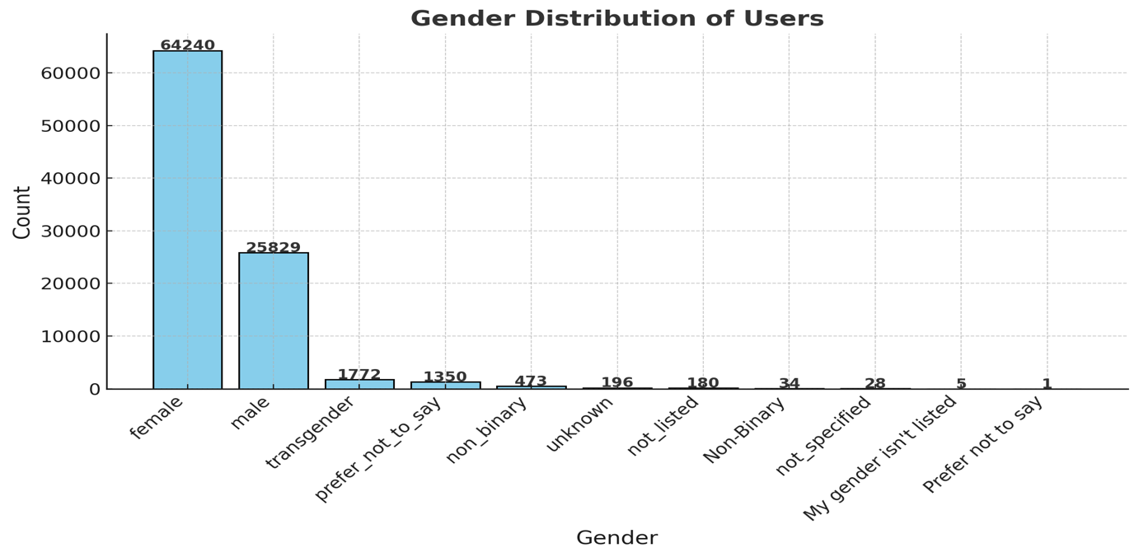

**Findings:**

* **Duplicate Transactions**: There are **171 duplicate records** in the transactions dataset.
* **Invalid Transactions**: There are **480 invalid records** where FINAL_QUANTITY or FINAL_SALE is ≤ 0.
* **Missing Data Percentage**:
  + BARCODE: 11.52% missing.
  + FINAL_QUANTITY and FINAL_SALE: 25% missing each.
* **Unique Receipt IDs**: There are **24,440 unique receipt IDs** in the transactions dataset.
* **USER_IDs in Transactions Not in Users**: **17,603 USER_IDs** in transactions do not exist in the users dataset.
* **BARCODEs in Transactions Not in Products**: **3,849 BARCODEs** in transactions are not present in the products dataset.

**Duplicate Checks**

products_file = '/mnt/data/PRODUCTS_TAKEHOME.csv'

transactions_file = '/mnt/data/TRANSACTION_TAKEHOME.csv'

users_file = '/mnt/data/USER_TAKEHOME.csv'

products_df = pd.read_csv(products_file)

transactions_df = pd.read_csv(transactions_file)

users_df = pd.read_csv(users_file)

**# Checking for duplicates in all datasets**

user_duplicates = users_df[users_df.duplicated()]

transaction_duplicates = transactions_df[transactions_df.duplicated()]

product_duplicates = products_df[products_df.duplicated()]

# Summarizing findings for duplicate rows

duplicate_summary = {

"Dataset": ["Users", "Transactions", "Products"],

"Duplicate Rows": [user_duplicates.shape[0], transaction_duplicates.shape[0], product_duplicates.shape[0]]

}

# Creating a summary dataframe

duplicate_summary_df = pd.DataFrame(duplicate_summary)

duplicate_summary_df  
  
