Assignment - 5.4
R.LOKESH 2303A51649
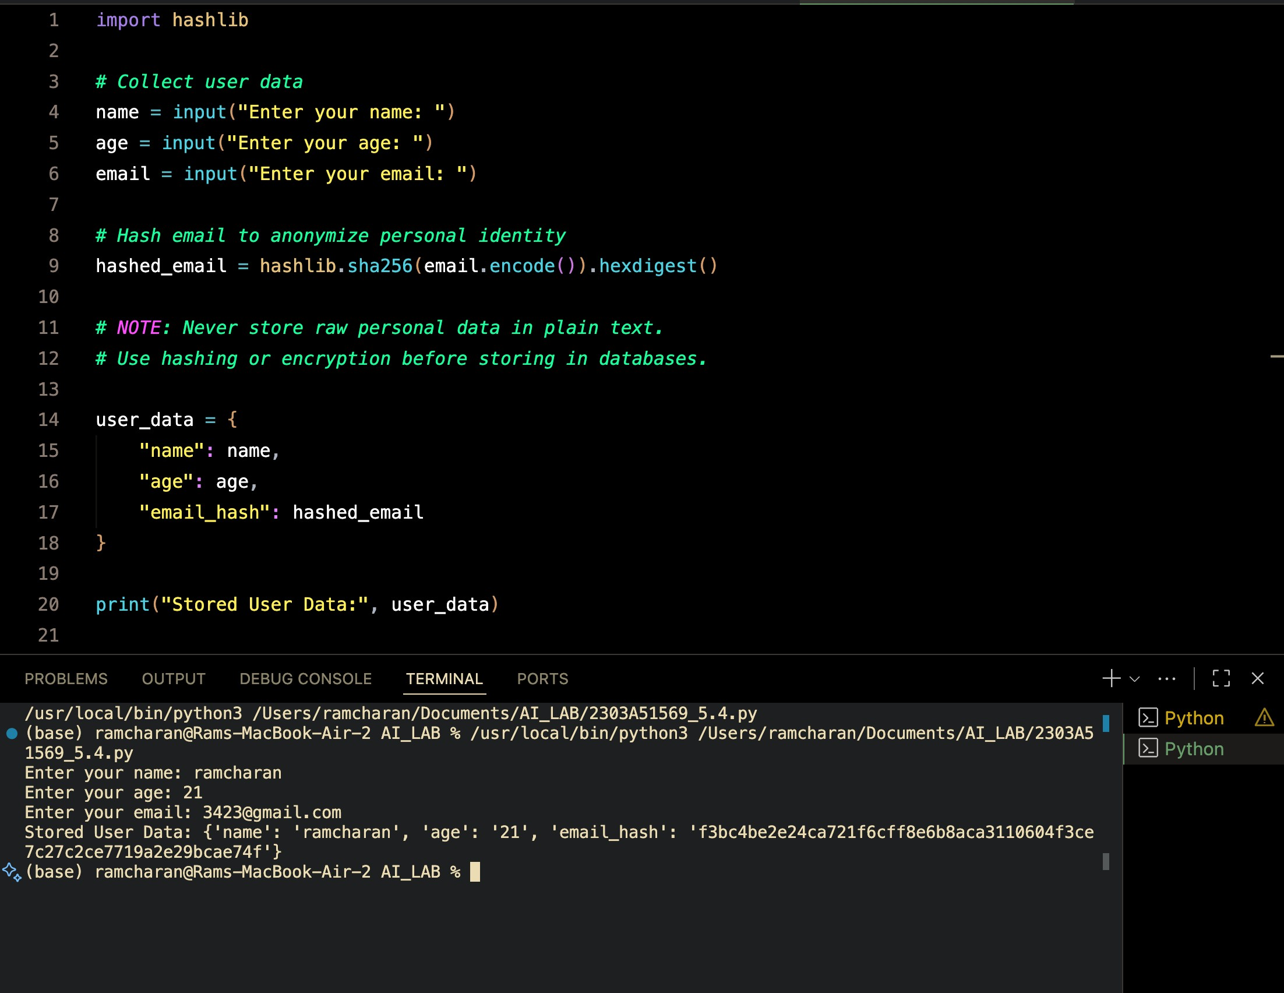
Prompt to Copilot
Generate a Python script that collects user name, age, and email. Add comments on how to anonymize or protect this data.
Prompt to Copilot
Generate a Python function for sentiment analysis and handle potential bias in data.
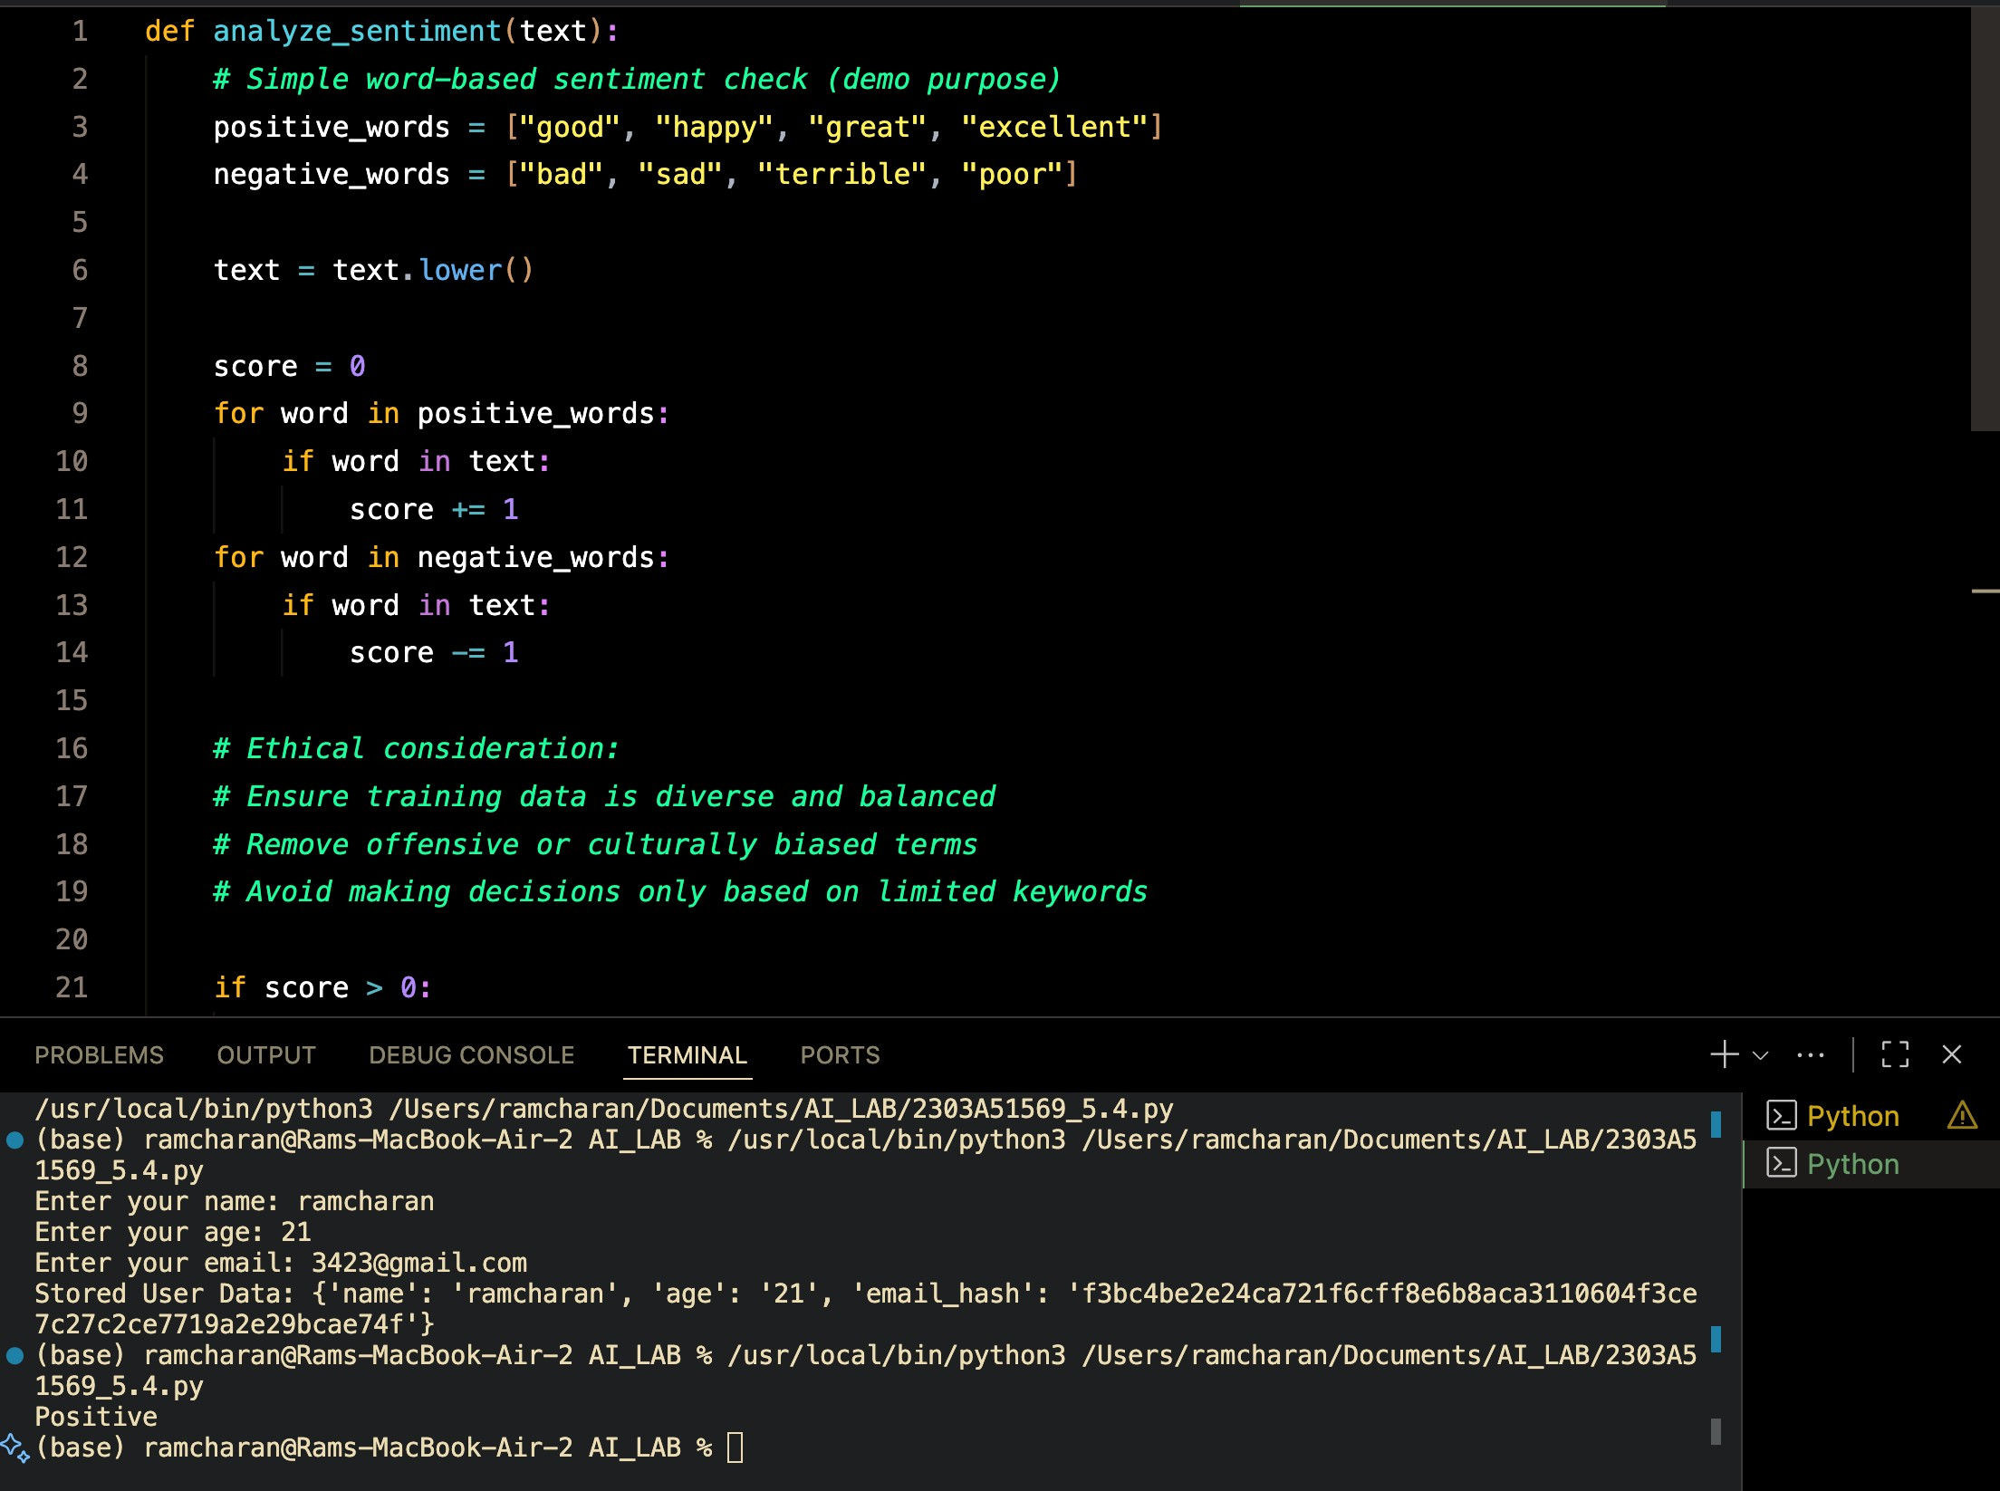
Generate product recommendation code that follows fairness and transparency.
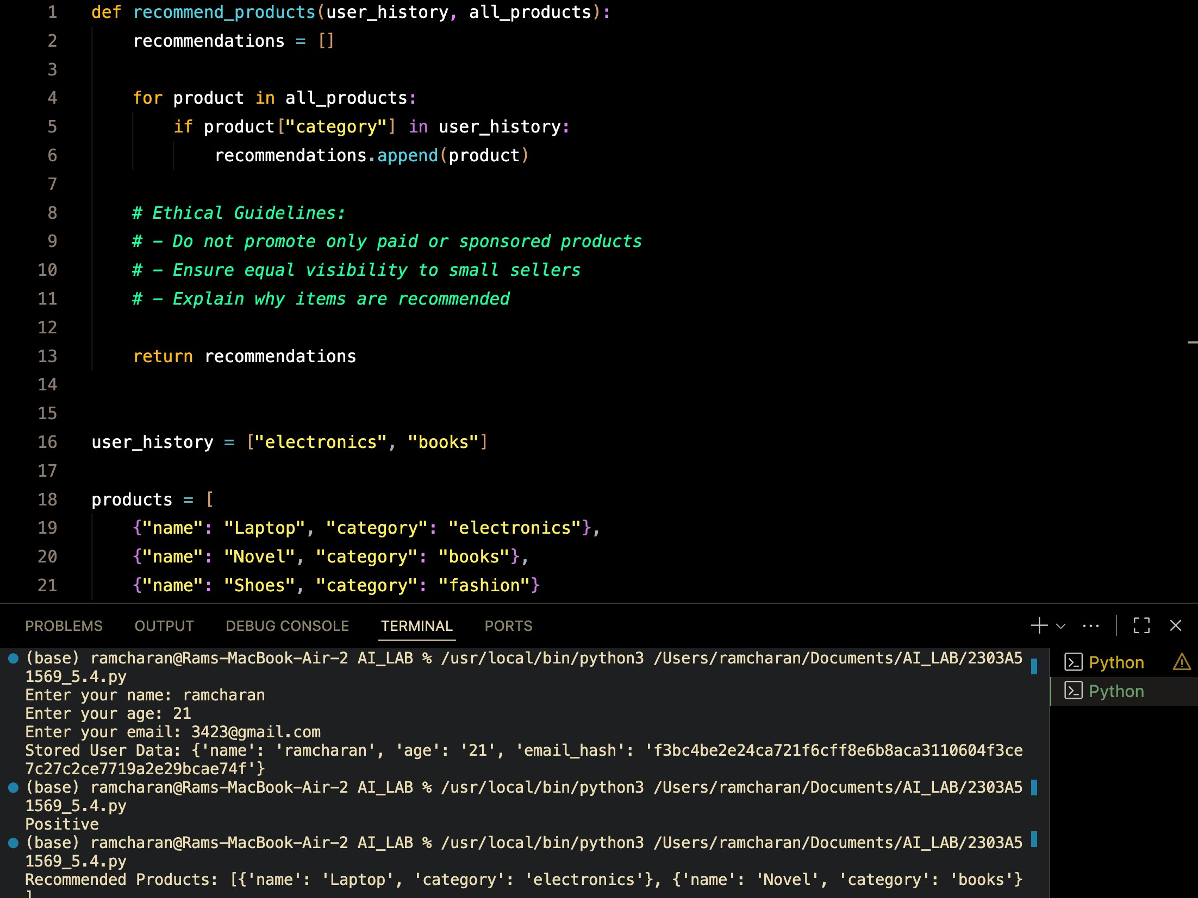

Generate logging functionality that avoids sensitive data.
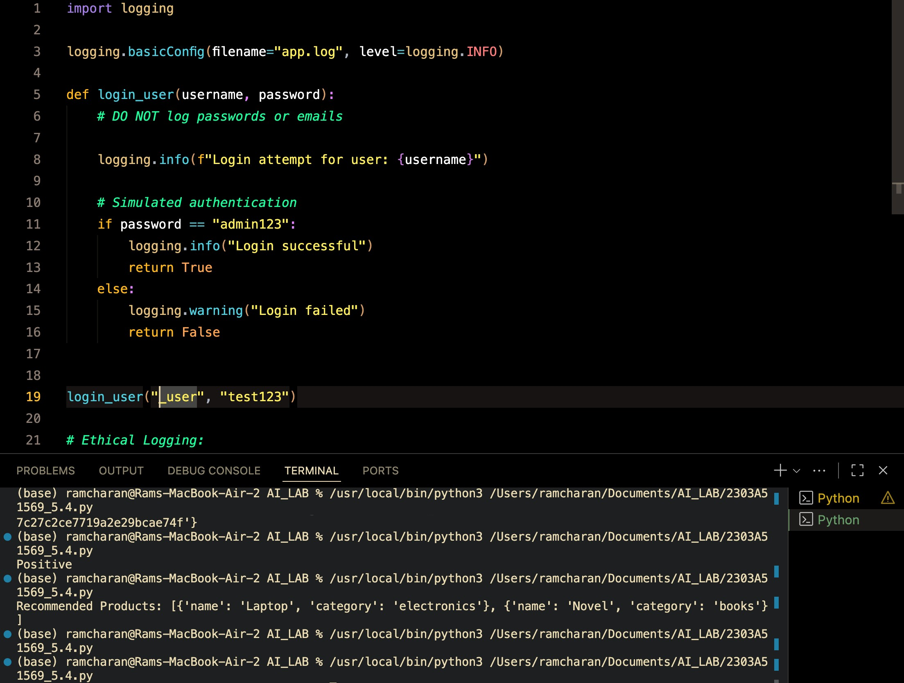
Generate ML model code and add responsible usage documentation.
