ASSIGNMENT - 6.4 2303A51649
TASK 1 PROMPT : #Complete the methods to:
#1. Display student details
#2. Check if student's marks are above class average

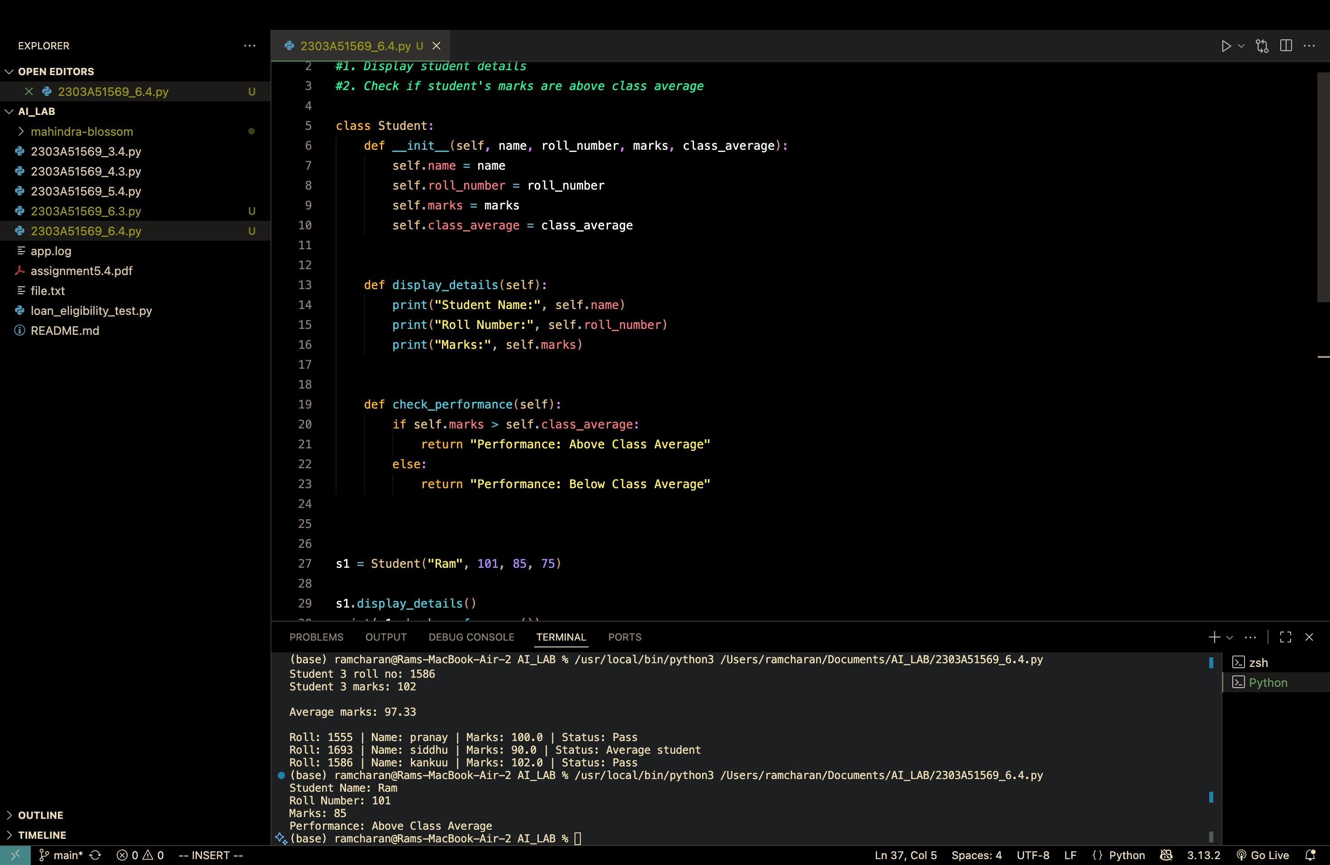
TASK 2 PROMPT :
#Identify even numbers, calculate their square, and print them.
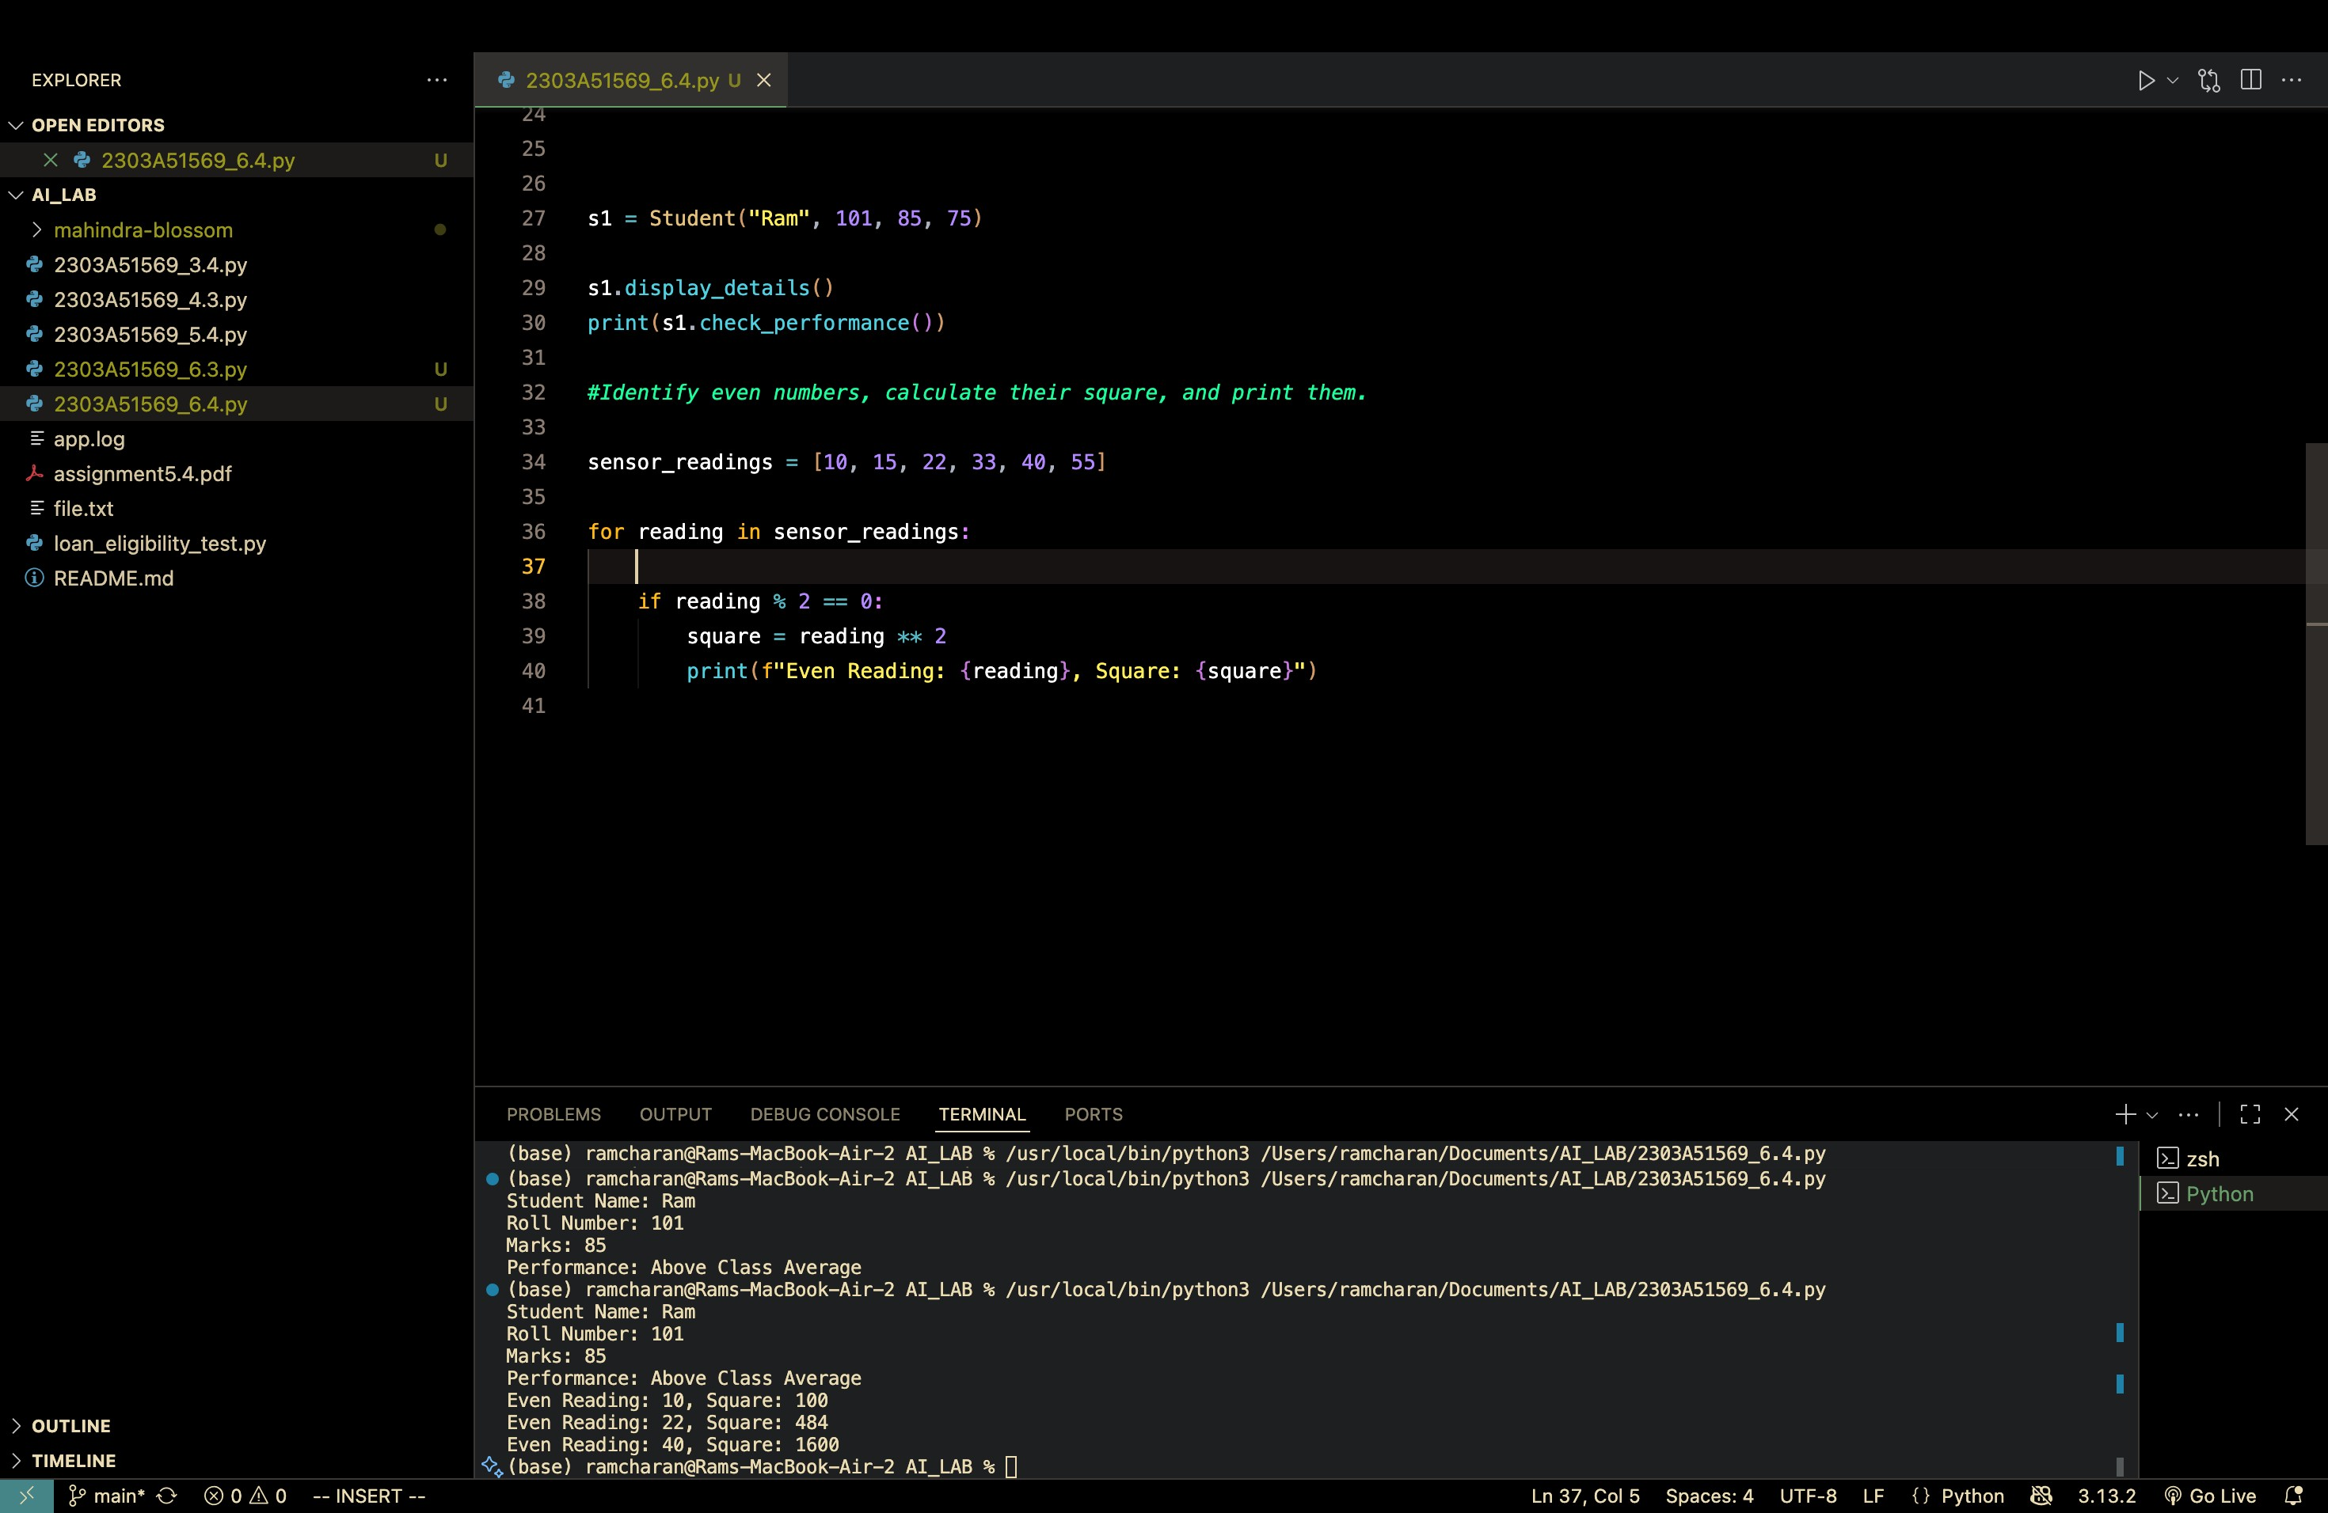
TASK 3 PROMPT :
#Generate deposit and withdrawal methods with balance validation.
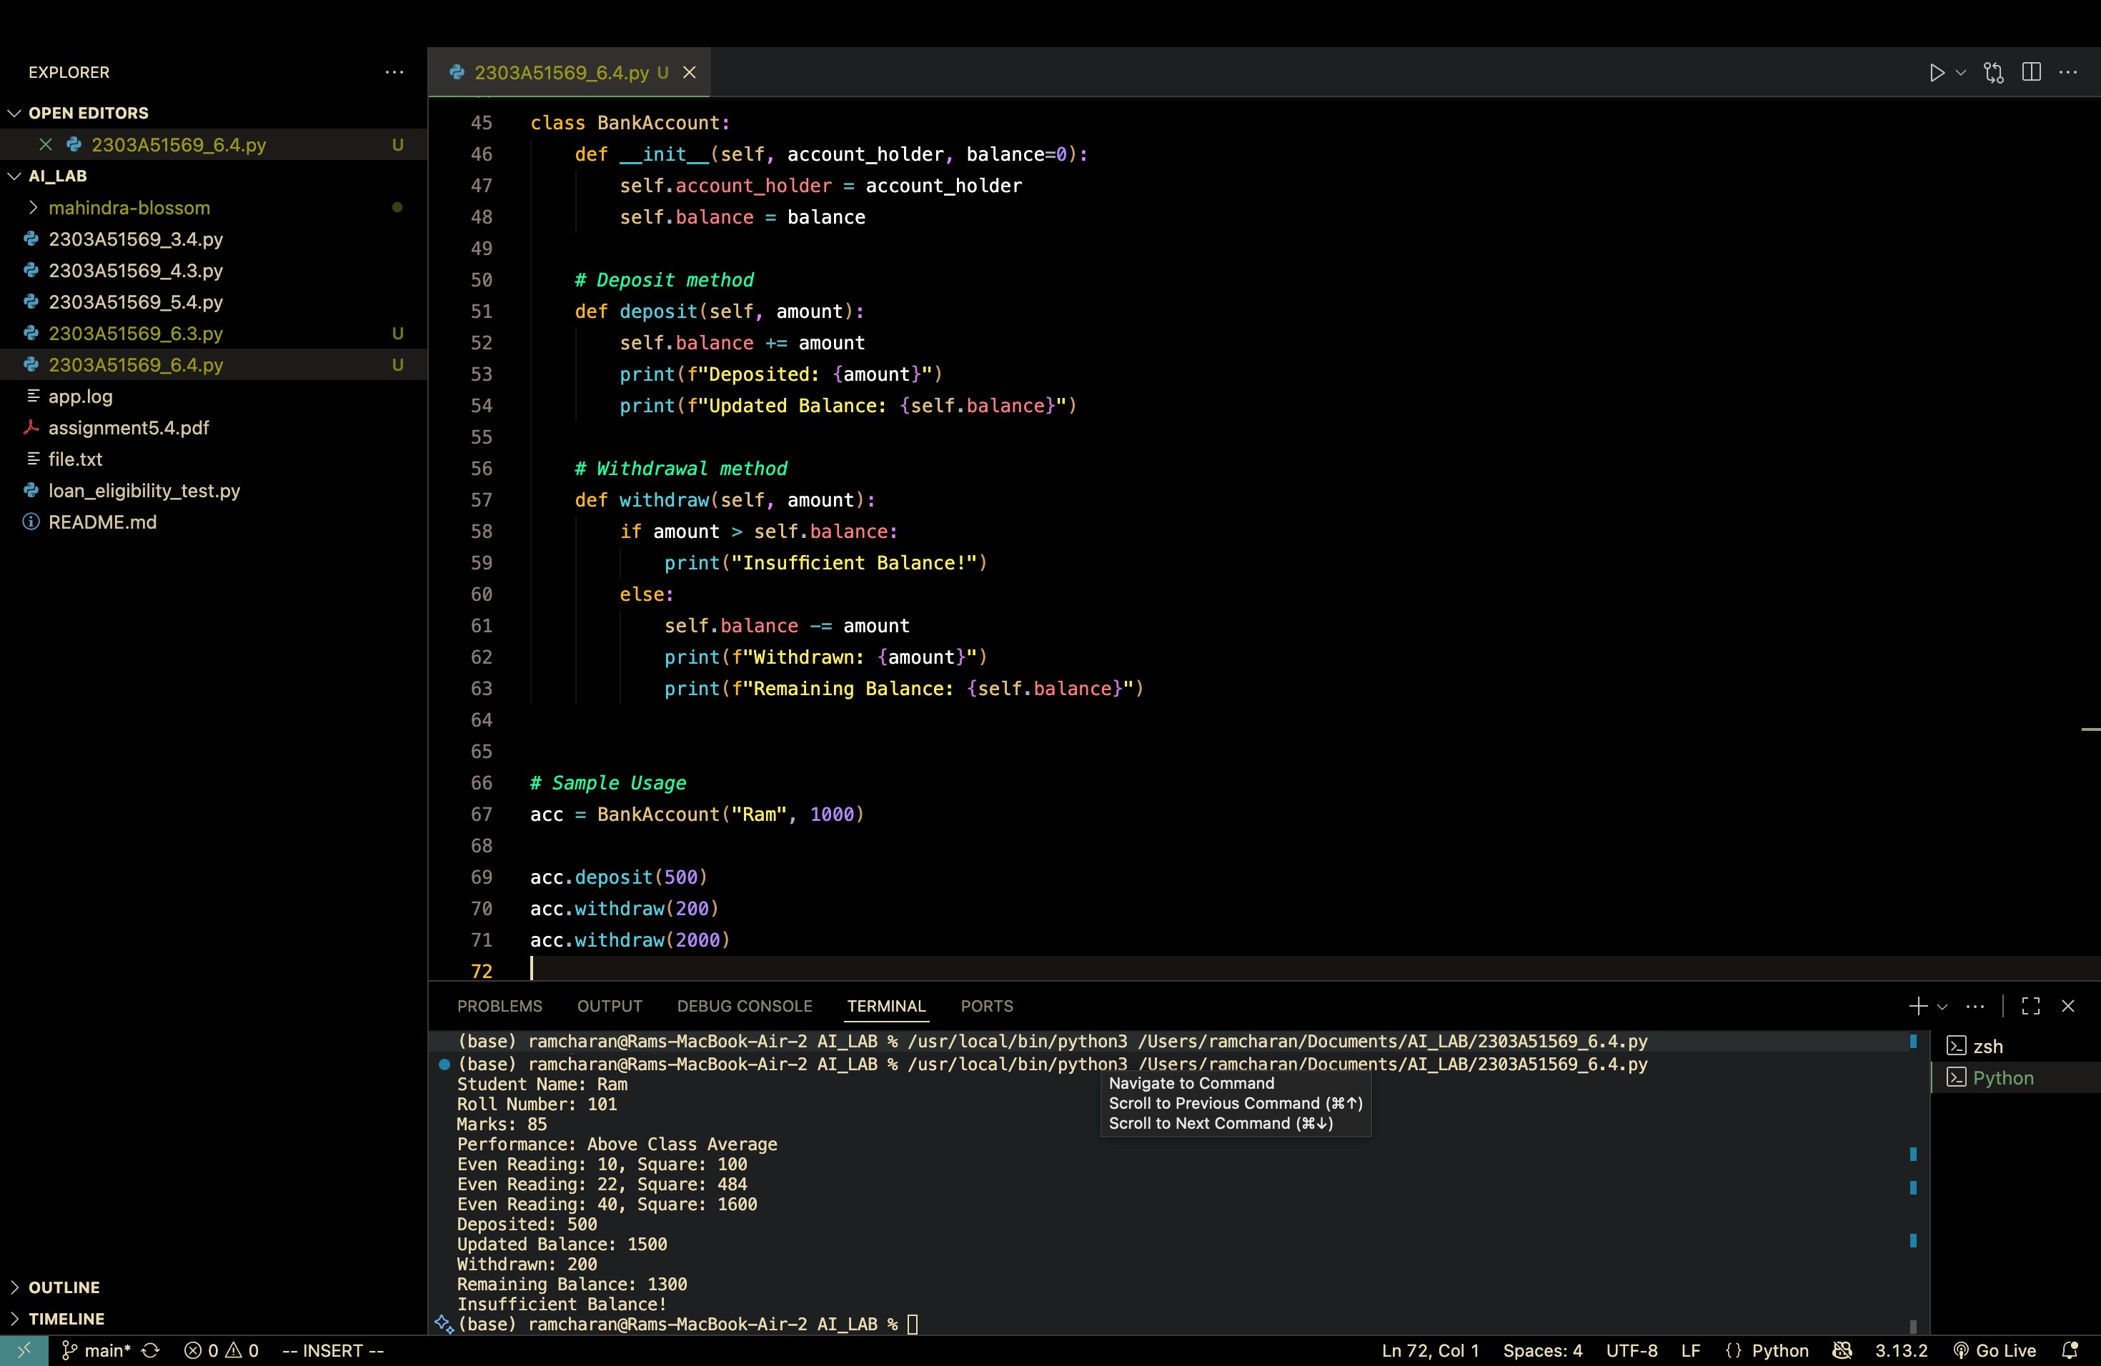
TASK. 4 PROMPT :
#Generate a while loop to print students scoring above 75.
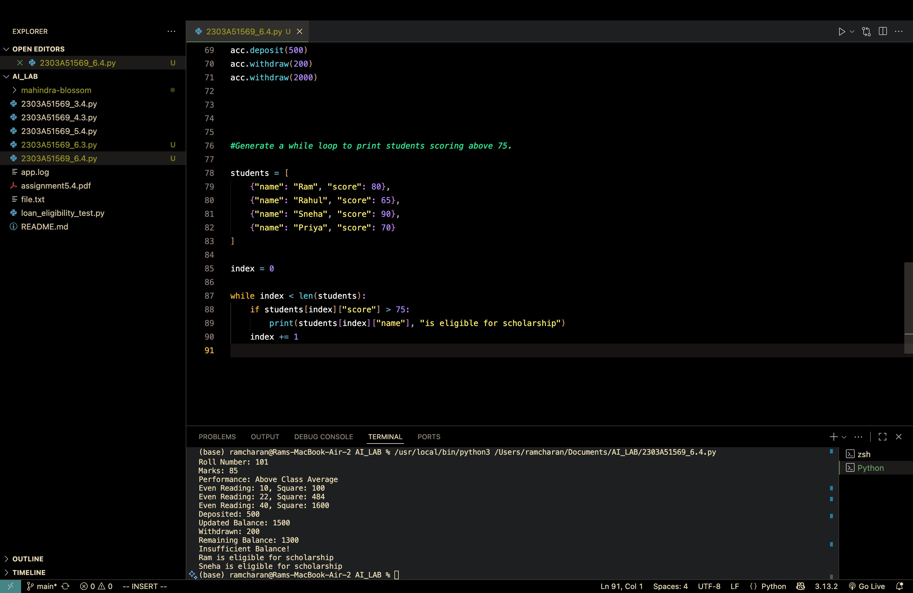
TASK 5 PROMPT :
#Generate methods to add/remove items, calculate total, and apply discount.
