# ODD protocol

Table of Contents

Purpose and patterns 1

Entities, state variables and scales 2

Individuals 2

Popuations 2

Landscape units 2

Spatial and temporal scales 2

Process overview and scheduling 3

Design concepts 7

Basic principles 7

Initialization 9

Initialization of landscape 9

Initialization of populations 9

Model parameter overview 9

Input data 9

Submodels 9

Landscape 9

Environmental stochasticity 9

Reproduction 10

Survival & Development 10

Emigration 11

Transfer 11

Settlement 11

Aging 12

## Purpose and patterns

The RangeShifter model is a single species, spatially-explicit and stochastic individual-based model (IBM), built around the integration of two fundamental components: population dynamics and dispersal behaviour. In this specific use case, population dynamics, represented as stage-structured, only-female populations, with overlapping generations, and dispersal (explicitly modeled in its three phases of emigration, transfer and settlement accounting for stage specificity) are played out on top of gridded multi-habitat landscape.

This landscape includes environmental stochasticity.

Individuals are the basic entity of the model.

few words

## Entities, state variables and scales

### Individuals

Individuals are the basic entities of the RangeShifter model. Each individual has a unique ID number and, in this specific use case, is defined by the following state variables:

* status
* initial (natal) and current location
* age and stage

### Popuations

Populations are defined by the individuals occupying a single cell and they represent the scale at which individuals interact and density dependencies act. Populations are characterized by their size and location and the number in each stage class.

### Landscape units

The model runs over a grid-based map.  
In this specifc use case, each cell stores a habitat quality index. Each cell is defined as suitable or not suitable for a species based on the presence/absence of habitat, and it is characterized by a species’ nature of demographic density dependence. An additional state variable is an environmental noise value $ϵ$.

### Spatial and temporal scales

The cell size (resolution) is 1000m x 1000m. The cell resolution represents the spatial scale at which the two fundamental processes of population dynamics and dispersal occur. This means that the density dependency in the model (on survival, ) etc.) acts at the cell scale and the same scale is used as a single step unit for discrete movement models. There are three distinct temporal scales. The highest-level one has years as units and represents the scale at which variations in the abiotic environment are modeled. The intermediate scale is the species’ reproductive season. The model simulates 1 reproductive season per year. Finally, the smallest time scale is represented by the number of steps that emigrants take during the movement phase of dispersal. This is determined by the maximum number of steps and per-step mortality.

## Process overview and scheduling

$\color{red}{\text{Please revise the following figures. You might need to adapt them according to your use case.}}$

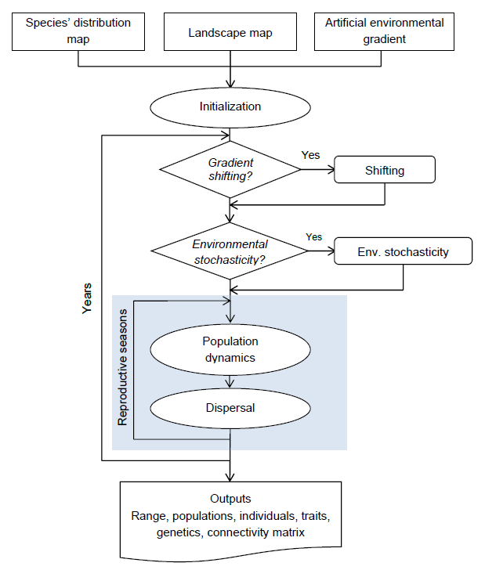

General model workflow and schedule. The core of the model highlighted in blue is expanded in the flow chart in Fig. 2

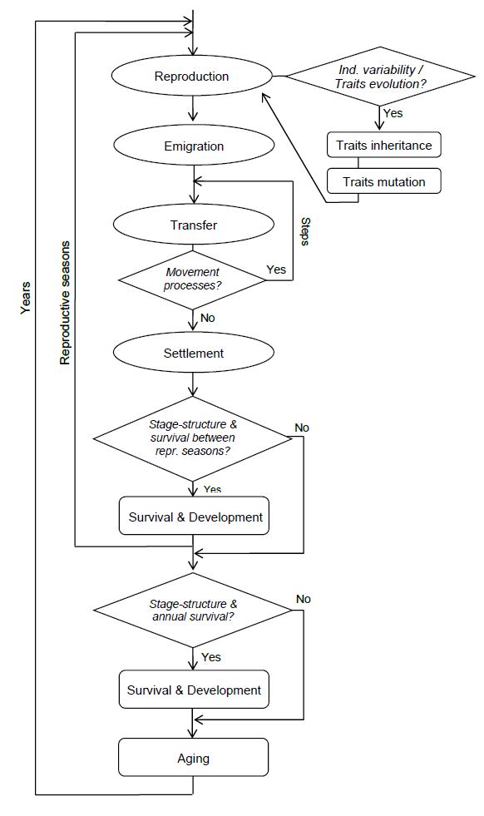

Flowchart of the core model

At the beginning of each year, reproduction is the first process to be modelled. Reproduction is followed by dispersal. After each reproductive season, survival and successive development of all the stages are modelled. Aging occurs at the end of the year.

## Design concepts

### Basic principles

#### Emergence

#### Adaption

#### Objectives

#### Learning

Not applicable

#### Prediction

Not applicable

#### Sensing

Not applicable

#### Interaction

No interaction is considered in the model.

#### Stochasticity

Environmental stochasticity is considered in the model. It acts on the fecundity $ϕ$.

#### Collectives

Not applicable

#### Observation

##### Range

The output *Sim0_Range.txt* contains the following general information regarding the species’ range: Replicate number, year, reproductive season within the year, total number of individuals, total number of individuals in each stage, total number of juveniles born, total number of cells occupied by a population capable of breeding, ratio between occupied and suitable cells, species range in term of maximum and minimum coordinates of cells occupied by breeding populations.

##### Occupancy

This output reports the cell probability of occupancy by a breeding population. This is only permissible for multiple replicates. Data will be recorded at the beginning of the year before any other process (and only once a year no matter the number of reproductive seasons per year). Two files will be produced: 1. *Sim0_Occupancy.txt*: This file contains a list of all the cells in the landscape (x and y coordinates). The remaining columns give the occupancy probability of the cell at defined time steps. The occupancy probability is obtained by dividing the number of times (replicates) that the cell has been occupied in a given year by the total number of replicates. 2. *Sim0_Occupancy_Stats.txt*: Summary occupancy statistics, i.e. the mean ratio between occupied and suitable cells (Mean_OccupSuit) and its standard error (Std_error) at the set time interval.

##### Populations

The population output, *Sim0_Pop.txt* contains statistics regarding each population present in the landscape at a given time interval. Data are collected before reproduction at each reproductive season at the specified yearly interval and at the end of the simulation. This output file contains the following information: Replicate number, year, reproductive season, cell location, species number, number of individuals in the population, the number of individuals in each stage (NInd_stageX), the number of juveniles born (NJuvs).

##### Individuals

This output, *Sim0_Rep0_Inds.txt*, contains information regarding each individual at a given time step. To avoid the production of huge files, a separate file is saved for each replicate (here assumed to be 0). Data are recorded after settlement and before aging, in order that dispersal data for individuals which die may be reported. Individuals data for year $T$ therefore correspond to Population summary data for year $T+1$ (and individuals which die in year $T$ must be excluded for the data to match at population level). For each individual the following data are collected: Replicate number, year, reproductive season within the year, species number, individual ID, individuals status, natal cell and current cell. If the individual has crossed an absorbing landscape or ‘no-data’ boundary, the current cell will be missing, age, stage, distance moved in meters (linear distance from the centre of the starting cell to the centre of the arrival cell - DistMoved); if the individual has crossed an absorbing landscape or ‘no-data’ boundary, the distance moved will be missing (set to -1), number of steps taken for movement models.

Status codes of individuals

|  |  |
| --- | --- |
| Status code | Description |
| 0 | Initial status in natal patch/philopatric recruit |
| 1 | Disperser |
| 2 | Disperser awaiting settlement in possible suitable cell |
| 3 | Waiting between dispersal events |
| 4 | Completed settlement |
| 5 | Completed settlement in a suitable neighbouring cell |
| 6 | Died during transfer by failing to find a suitable patch (includes exceeding the maximum number of steps or crossing an absorbing boundary) |
| 7 | Died during transfer by constant, step-dependent, habitat-dependent or distance-dependent mortality |
| 8 | Failed to survive annual (demographic) mortality |
| 9 | Exceeded maximum age |

## Initialization

### Initialization of landscape

### Initialization of populations

The number of seeded individuals per hectare in each cell is determined by half of $1/b$.

The proportion of individuals that is initialised at each stage class is set via a numeric vector $PropStages$. It has as many entries as number of stages, starting from the juvenile stage (0). The age is set approximately in accordance with the number of years taken to pass through the stage and the survival rate of the respective stage.

### Model parameter overview

## Input data

## Submodels

### Landscape

A real landscape is imported consisting of continuous values, ranging from 0.0 to 100.0, that represent percentages of habitat cover or quality.

In addition, the demographic density dependence $1/b$ is given in units of the number of individuals per hectare. The given density dependence is interpreted as the maximum density reached in cells with 100% habitat. All other cells hold the respective fraction of the density dependence.

$\color{red}{\text{You might want to include further information on the landscape here.}}$

### Environmental stochasticity

In RangeShifter, environmental stochasticity is implemented using a first order autoregressive process to generate time series of the noise value $ϵ$ (Ruokolainen et al. 2009):

$$ϵ_{t+1}=κϵ_{t}+ω_{t}\sqrt{1-κ^{2}}$$

where $κ$ is the autocorrelation coefficient and $ω$ is a random normal variable drawn from $N(0,σ)$. Changing $ω$ changes the amplitude of the fluctuations. The spatial scale of the variation is local (each cell fluctuates independently), and is always applied on a yearly basis. Different degrees of spatial autocorrelation are not implemented in the current version.

The noise affects the species’ fecundity $ϕ$ through the following equation:

$$ϕ_{x,y,t}=ϕ_{x,y,0}+ϕ*ϵ_{t}$$

where $x$ and $y$ are the cell coordinates and $ϕ$ is the fecundity in absence of stochasticity. In the absence of an environmental gradient, $ϕ_{x,y,0}$ is equal to $ϕ$.

### Reproduction

At the beginning of each year, reproduction is the first process to be modelled. Reproduction is followed by dispersal. After each reproductive season, survival and successive development of all the stages are modelled. Aging occurs at the end of the year.

Generations overlap and individuals are classified in different stages (e.g. immature vs. breeding individuals) differing in their demographic parameters. Individuals are characterized by their age and stage. Each stage has a certain fecundity $ϕ$, survival $σ$ and probability of developing to the next stage $γ$. The parameters are provided through classical transition matrices (Caswell 2001). However, these are not solved analytically as is typical for matrix models but, instead, the parameters are applied stochastically in an individual-based fashion. At each reproductive season, two parameters control the likelihood that each individual / female reproduces:  
* First, it is determined whether a reproductively mature female is a potential reproducer.Only those mature females that are able to reproduce, are potential breeders.  
* Potential breeders all reproduce with set probability $ϕ$.

In this specific use case, an asexual/only-female model was implemented. To avoid the problem of offspring developing to the next stage in the same year without losing the offspring stage, and hence the chance for simulating post-natal dispersal, an explicit juvenile stage (stage 0) is added:

$$A=\left(\begin{matrix}0 & 0 & ϕ \\ 1.0 & σ(1-γ) & 0 \\ 0 & σγ & σ\end{matrix}\right)$$

Juveniles have to develop to stage 1 in the same year they are born. It is important to note that juvenile mortality can be accounted for in two ways. Either it is included in adult fecundity $ϕ$ (by appropriately reducing its value), and $σ_{0}γ_{0-1}$ is equal to 1.0. This is how it is typically accounted for in matrix models. Or, alternatively, $ϕ$ is equal to the true maximum fecundity and $σ_{0}γ_{0-1}$ is less than 1.0. Only the first approach allows straightforward direct comparison with standard analytical matrix models. The parameters in the matrix are used in a stochastic way at the individual level. Each individual/female at stage $s$, if it reproduces, produces a number of offspring given by Poisson($ϕ_{s}$).

### Survival & Development

Reproduction is first followed by dispersal. Only then survival and successive development of all the stages are modelled.

In this specific use case, survival is density dependent. Density dependence in survival is implemented as an exponential decay:

$$σ_{i}=σ_{0,i}*e^{-C_{σ}bN_{t}}$$

where $σ_{i}$ is the survival probability of stage $i$, $σ_{0,i}$ is its survival probability at low densities, $b$ is the strength of density dependence and $N_{t}$ is the total number of individuals in the local population at time $t$. To allow for the possibility of having different strengths of density dependence in different processes, we introduce the coefficient $C_{σ}$, which scales the strength of density dependence in survival relative to the strength of density dependence $b$ in fecundity. Bernoulli trials $Bern(σ_{i})$ determine if an individual develops to the next stage or not.

In this specific use case, development is neither density nor stage dependent. Bernoulli trials $Bern(γ)$ determine if an individual develops to the next stage or not.

### Emigration

Emigration is the first phase of dispersal. It is modeled as the probability that an individual will leave its natal patch during the present year. If a stage having non-zero $d$ can last for more than one year, an individual has multiple opportunities to emigrate, each with probability $d$, and hence the realised overall emigration rate will be larger than $d$. The emigration probability $d$ is density-independent, and hence constant.

Emigration probability is modelled stage-specific. Thus, each stage has different emigration parameter.

### Transfer

Transfer is the second phase of dispersal, and consists of the movement of an individual starting from when it emigrates from its natal cell and ending with settlement in another cell or mortality. The main components of this phase are the individual movement ability and navigation capacity in response to the characteristics of the environment. The interaction between these components and their associated costs will determine the distance moved, the movement path and the chance of surviving the transfer phase.

The movement model is fully individual-based and explicitly decribes the movement behaviour of individuals with a level of detail, and hence parameters, which is probably close to the most parsimonious for a mechanisctic movement model.

A simple correlated random walk without any bias is implemented. This model is implemented in continuous space on the top of the landscape grid. Individuals take steps of a constant step length (metres); the direction is sampled from a wrapped Cauchy distribution having a correlation parameter $ρ$ in the range 0 to 1 (Zollner & Lima 1999; Barton et al. 2009). All individuals take each step simultaneously.

### Settlement

Settlement, or immigration, is the last phase of dispersal, when the organism stops in a new cell of breeding habitat. Dispersing individuals are not allowed to settle in their natal cell.

At each step (made simultaneously) dispersing individuals each evaluate their current cell for the possibility of settling. The individual decides to stop if there is suitable habitat; this is a necessary condition.

To avoid having individuals moving perpetually because they cannot find suitable conditions to settle, the model includes a per-step mortality and a maximum number of steps. The maximum number of steps defines the maximum time length of the transfer period. When an individual reaches the maximum number of steps, it stops where it is regardless of the suitability of the location.In the next season, if still alive, it will move again.

Additionally, a minimum number of steps that each individual must take before settlement is set simulating situations where animals, in a ‘dispersal mode’, will keep moving and not consider settling even if suitable conditions are available (e.g. Barton et al. 2012).

### Aging

Aging occurs at the end of each year.