<!DOCTYPE html>

<html lang="en" dir="ltr">

<head>

<meta charset="utf-8">

<link rel="stylesheet" href="https://stackpath.bootstrapcdn.com/bootstrap/4.3.1/css/bootstrap.min.css"

integrity="sha384-ggOyR0iXCbMQv3Xipma34MD+dH/1fQ784/j6cY/iJTQUOhcWr7x9JvoRxT2MZw1T"

crossorigin="anonymous">

<title>👨🏽‍💻 La Morrilla 👩🏼‍💻</title>

</head>

<body>

<br>

<div class="form-row">

<div class="form-group col-md-7">

<div class="card-header" style="font-size:150%; font-family:Monaco; color:#2645C1;">Dear Morrilla</div>

<div class="card-body">

<h5 class="card-title" style="color:#30BF13;">To the best girl werita of the world...</h5>

<p align="justify" class="card-text" style="font-size:120%; font-family:Monaco;">

Hello morrilla, you know that you are very

important for me,You have been with me in

very important times of my life. we had good moments,

funny moments and bad moments , but didn't matters because

you always tried to help me.

</p>

<p align="justify" class="card-text" style="font-size:120%; font-family:Monaco;">

I got a special perspective of you, I don't know how to thank you all that

I learned of you, your shape to take the problems or your intelligence are amazing.

I wish that all your dreams and your wishes comes true.

</p>

<p align="justify" class="card-text" style="font-size:120%; font-family:Monaco;">

I want to be better than you, but you always do anything awesome 😡.

You are the best and don't forget that !!!

My no-secret friend.

</p>

<p align="justify" class="card-text" style="font-size:120%; font-family:Monaco;">

I know that sometimes I'm a little distracted but I've never forget you.

I hope that this can resolve my forgotten chocolate 😬.

See you Morrilla!.

</p>

<h2 style="color:#8128E7;">ALV</h2>

<pre class="card-text" style="font-size:120%; font-family:Monaco;">

A ----> Angry Girl

L ----> Loyal Girl

V ----> Vain Girl

</pre>

</div>

</div>

<div class="form-group col-md-5">

<img src="IMG.jpg" class="card-img-top" style="border-radius: 20px;">

<div class="card-body">

<h5 class="card-title" style="color:#FF0000;">print("Programmers")</h5>

<p class="card-text" style="font-size:120%; font-family:Monaco;">

We love the amazing world of programming

because we can change all. Build anything and develop all that

we want!. You are my biggest challenger!.</p>

</div>

</div>

</div>

</body>

<script src="https://code.jquery.com/jquery-3.3.1.slim.min.js"

integrity="sha384-q8i/X+965DzO0rT7abK41JStQIAqVgRVzpbzo5smXKp4YfRvH+8abtTE1Pi6jizo"

crossorigin="anonymous">

</script>

<script src="https://cdnjs.cloudflare.com/ajax/libs/popper.js/1.14.7/umd/popper.min.js"

integrity="sha384-UO2eT0CpHqdSJQ6hJty5KVphtPhzWj9WO1clHTMGa3JDZwrnQq4sF86dIHNDz0W1"

crossorigin="anonymous">

</script>

<script src="https://stackpath.bootstrapcdn.com/bootstrap/4.3.1/js/bootstrap.min.js"

integrity="sha384-JjSmVgyd0p3pXB1rRibZUAYoIIy6OrQ6VrjIEaFf/nJGzIxFDsf4x0xIM+B07jRM"

crossorigin="anonymous">

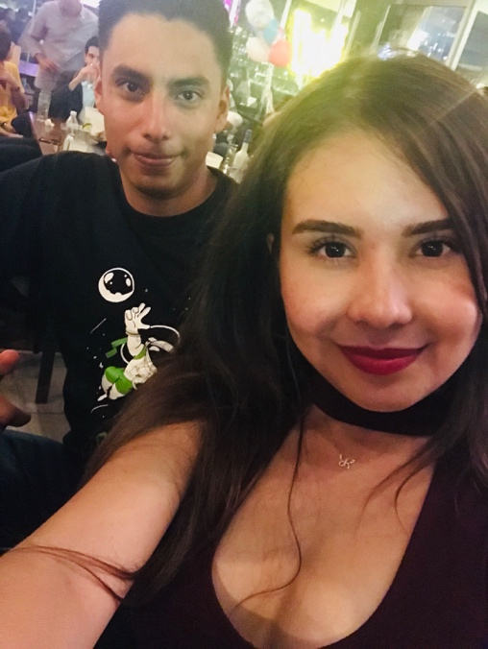 </script>

</html>

**IF YOU DO NOT UNDERSTAND THIS ONLY FOLLOW THE FOLLOWING QR CODE …**