OAuth2 Authorization Server Config

This class extends AuthorizationServerConfigurerAdapter and is responsible for generating tokens specific to a client.Suppose, if a user wants to login to www.xyz.com via facebook then facebook auth server will be generating tokens for Devglan.In this case, Devglan becomes the client which will be requesting for authorization code on behalf of user from facebook - the authorization server.Following is a similar implementation that facebook will be using.

Using in-memory credentials with client_id as devglan-client and CLIENT_SECRET as devglan-secret.But you are free to use JDBC implementation too.

@EnableAuthorizationServer: Enables an authorization server.AuthorizationServerEndpointsConfigurer defines the authorization and token endpoints and the token services.

## OAuth2 Resource Server Config

Resource in our context is the REST API which we have exposed for the crud operation.To access these resources, client must be authenticated.In real-time scenarios, whenever an user tries to access these resources, the user will be asked to provide his authenticity and once the user is authorized then he will be allowed to access these protected resources.

Testing the Application

Lets test the app with Postman.

Run Application.java as a java application.We will be using postman to test the OAuth2 implementation.

**Generate AuthToken**:In the header we have username and password as Alex123 and password respectively as Authorization header.As per Oauth2 specification, Access token request should use application/x-www-form-urlencoded.Following is the setup.

[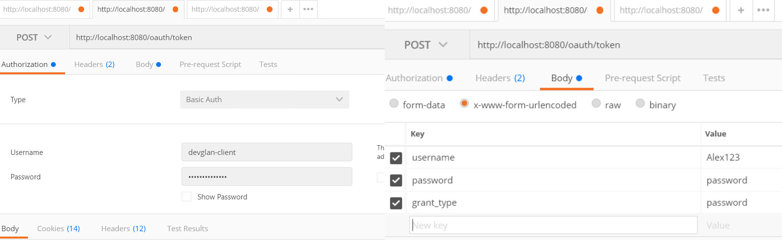](https://imgur.com/1T0dhV7)

Once you make the request you will get following result.It has access token as well as refresh token.

[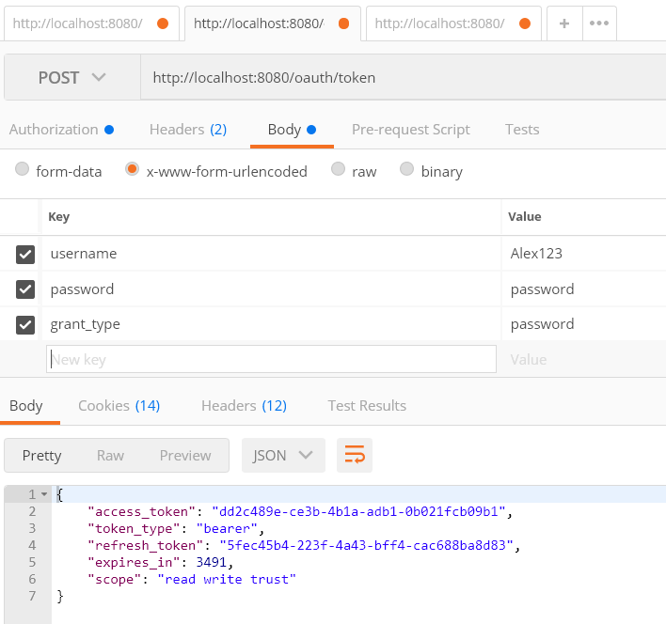](https://imgur.com/sP3uLm8)**Accessing Resource Without Token**

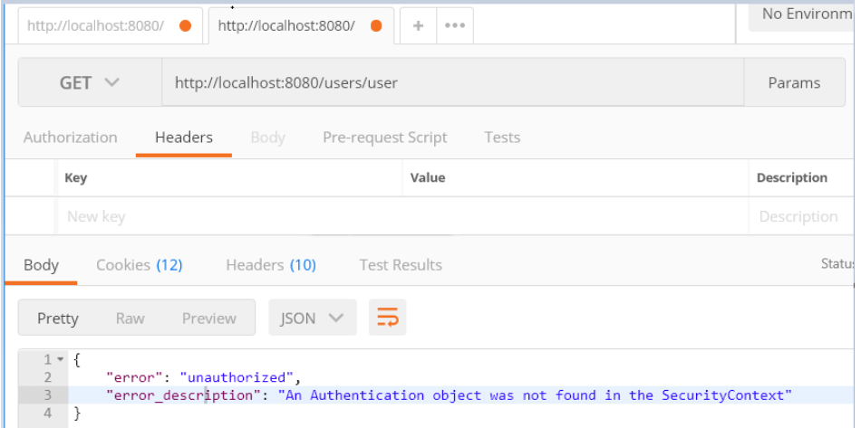

**Accessing Resource With Token**

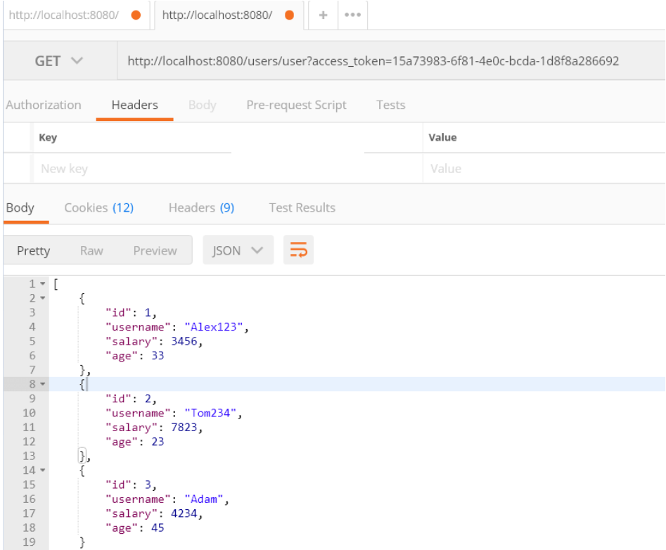

**Using refresh token to refresh the token**

Usually, the token expiry time is very less in case of oAuth2 and you can use following API to refresh token once it is expired.

[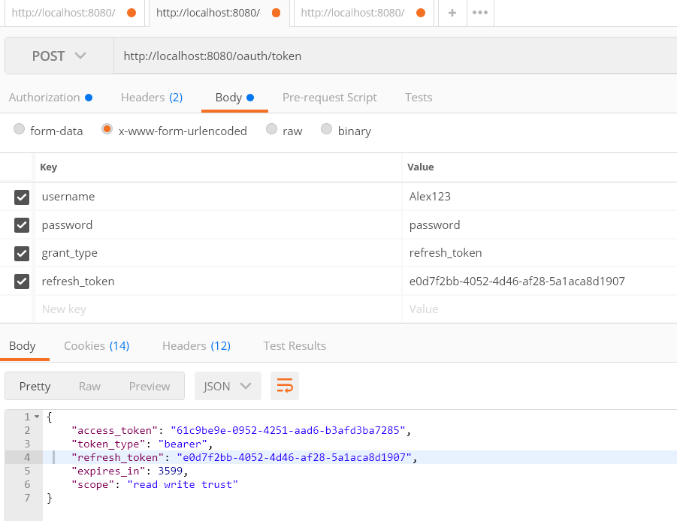](https://imgur.com/ugZMxX7)