Mid-term Progress Report
  - James Donohue
  - COSC 645-701

Overview
This project applies data-mining and predictive-modeling techniques to the 2025 NFL season to forecast weekly game outcomes. Using Python, pandas, and scikit-learn, the project builds a classification model that predicts whether a team will win or lose based on performance statistics. All team and schedule data are obtained from the NFLVerse nflreadr library, which provides weekly data in a structured format.
The main objective is to discover which statistical variables—such as passing yards, turnovers, and penalties—are most predictive of team success, and to generate data-driven win probabilities for upcoming matchups.
Progress and Achievements
- Data Acquisition & Preparation:
Retrieved team-level and schedule data for the 2025 season using nfl.load_team_stats() and nfl.load_schedules().
Cleaned, sorted, and merged the two DataFrames into a single dataset containing 148 columns of offensive, defensive, and special-teams statistics.
- Feature Engineering:
Added a binary target column win (1 = win, 0 = loss) derived from each game’s result, and an is_home flag identifying home-team performance.
Implemented three-game rolling averages for each numeric feature to capture current team form and reduce week-to-week volatility.
- Model Development & Evaluation:
Trained a logistic-regression classifier to predict win/loss outcomes. Evaluated model accuracy using a classification report and confusion matrix. This achieved roughly 87 percent accuracy on the held-out test set.
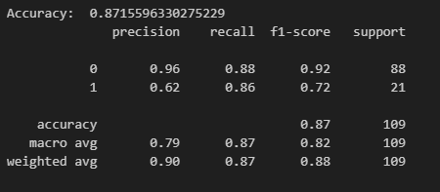
Figure 1. Classification Report
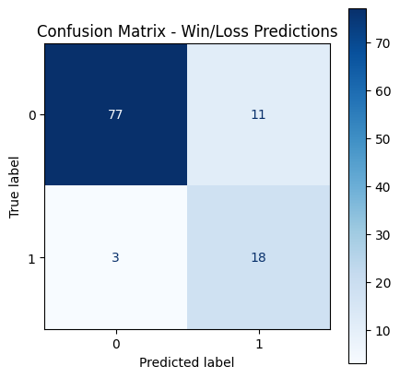
Figure 2. Confusion Matrix
- Automated Weekly Predictions:
Designed a dynamic process that automatically detects the most recently completed week and generates predictions for all upcoming matchups.
The model outputs a home-win probability and complementary away-win probability for each game.
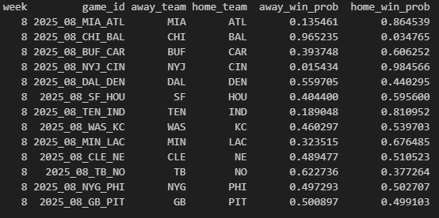
Figure 3. Upcoming Week Probability Chart
- Version Control & Backup:
Initialized a local Git repository in VS Code and connected it to GitHub for version control and remote backup. All commits are documented, enabling rollback and transparent iteration tracking.

On-Track Evaluation
According to the schedule in the initial plan, progress is on track:
Phase | Planned Timeline | Status
Data Collection & Exploration | Weeks 5 – 6 | ✅ Completed
Model Training & Testing | Weeks 7 – 8 | ✅ Completed
Mid-Term Report | Week 9 | ✅ Completed
Model performance has met and even exceeded early expectations. The workflow successfully updates each week as new games conclude, demonstrating consistency with the proposed milestone plan.

Difficulties and Workarounds
DataFrame Merging Challenges
- Challenge: The primary difficulty encountered was merging the team statistics DataFrame with the schedule DataFrame. Initially, each dataset had a different structure — team stats contained a row for every team per week (32 rows per week), while the schedule data included only one row per matchup (16 rows per week). This mismatch caused merge inconsistencies and duplicate rows.
- Solution: The problem was solved by transforming the schedule data into a team-centric format, creating both a “home view” and an “away view,” and concatenating them before merging. This ensured each team-week pair matched correctly to its corresponding game and eliminated duplication.
Feature Selection for Model Training
- Challenge: With nearly 150 columns of available statistics from nflreadr, deciding which variables were most useful for predicting wins was complex. Many metrics were highly correlated or redundant (for example, both total offensive yards and passing/rushing breakdowns).
- Solution: Through iterative testing and analysis, I narrowed the feature set to key performance indicators such as passing yards, rushing touchdowns, turnovers, sacks suffered, and penalties. These metrics provided a balance between offensive, defensive, and efficiency measures, resulting in strong model performance (≈87% accuracy) while keeping the model interpretable.

Next Steps
- Expand Metric Coverage:
Plan to include a broader set of team and player-level performance metrics available from nflreadr to enhance prediction accuracy. Incorporating detailed player statistics—such as quarterback efficiency, rushing attempts per running back, and receiver target share—will allow for richer regression-based analysis in addition to team-level classification.
- Introduce Regression Modeling:
Alongside the current win/loss classification model, a regression model will be developed to estimate expected point differential or win probability as a continuous variable. This approach will complement the binary model and provide a more nuanced understanding of predicted game outcomes.
- Integrate Weekly Updates and Model Validation:
The project will continue to integrate new weekly data as games conclude, updating both team averages and model parameters. The predicted probabilities for each week will be compared with actual outcomes to evaluate model calibration and overall predictive consistency across the season.
- Refinement and Final Presentation:
For the final report, the notebook will include comparative visualizations of predicted versus actual results, feature importance trends, and accuracy progression over time. The goal is to demonstrate how incremental improvements—more metrics, regression analysis, and ongoing retraining—enhance the model’s predictive reliability.

References
Sharda, R., Delen, D., & Turban, E. (2023). Analytics, Data Science, and Artificial Intelligence: Systems for Decision Support (11th ed.). Pearson.
NFLverse Team. (2024). nflreadr: Access and manage data from the NFLverse project (R package version 1.4.0). Retrieved from https://nflverse.nflverse.com

